首先要创建一个bot。访问
https://telegram.me/botfather

创建机器人后会生成token

然后访问
https://api.telegram.org/botXXX:YYYY/getUpdates
https://api.telegram.org/bot630456142:AAEMrnfC9b_pRX9YkAW4fQqkEpSvktKtaHs/getUpdates
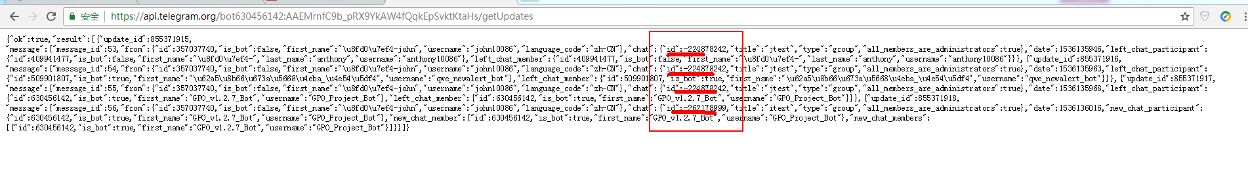
botXXX:YYYY 指的是bot+token，一定要加上bot前缀
id指的就是当前群组group的id（如：-262178999）
。
搜索："chat":{"id"

参考文档
https://blog.csdn.net/hc13097240190/article/details/80745446

需Python2.7
cd /usr/local/src
wget https://www.python.org/ftp/python/2.7.15/Python-2.7.15.tgz
tar xvf Python-2.7.15.tgz
cd ./Python-2.7.15
mkdir /usr/local/python2.7
./configure --prefix=/usr/local/python2.7 --with-ssl
make && make install
mv /usr/bin/python /usr/bin/python.bak
ln -s /usr/local/python2.7/bin/python2.7 /usr/bin/python

---pip安装，下载py文件：
wget https://bootstrap.pypa.io/get-pip.py
上传至服务器之后执行：
yum install openssl-devel -y
/usr/local/python2.7/bin/python2.7 get-pip.py

安装相应模块
pip install telegram
pip install python-telegram-bot

例
#!/usr/bin/python
# -*- encoding: utf-8 -*-
import sys
import time
from datetime import *
from telegram import Bot

NowTime=(datetime.now() + timedelta(minutes=10)).strftime("%H:%M")
bot = Bot(token = "630456142:AAEMrnfC9b_pRX9YkAW4fQqkEpSvktKtaHs")
#content = sys.argv[1]
content='【发布提醒】project %s将例行发包，请知' % NowTime
bot.send_message("-262178999", content)

其他：
pip is configured with locations that require TLS/SSL, however the ssl module in Python is not available.
查看openssl安装包，发现缺少openssl-devel包
[root@localhost ~]# rpm -aq|grep openssl
openssl-1.0.1e-57.el6.x86_64

yum安装openssl-devel
[root@localhost ~]# yum install openssl-devel -y
查看安装结果
[root@localhost ~]# rpm -aq|grep openssl
openssl-1.0.1e-57.el6.x86_64
openssl-devel-1.0.1e-57.el6.x86_64

重新对python2.7进行编译安装

-bash: pip: command not found
[root@localhost ~]# find / -name pip
/usr/local/python2.7/bin/pip <-----------
/usr/local/python2.7/lib/python2.7/site-packages/pip
/root/.cache/pip

=====
[root@localhost ~]# ln -sv /usr/local/python2.7/bin/pip /usr/bin/pip

