# docker-compose遇到的问题

1

WARNING: Found orphan containers (infra_redis_test_60009) for this project. If you removed or renamed this service in your compose file, you can run this command with the --remove-orphans flag to clean it up.

主要是目录名重复了不能在同一个名称目录下比如 /a/b/redis 与 /a/c/redis 只要是redis名称一致 就是同一个目录

2 运行报错

docker: Error response from daemon: failed to create shim task

docker: Error response from daemon: failed to create shim task

[root@host-192-168-0-58 nginx]# docker-compose config

docker: Error response from daemon: failed to create shim task: OCI runtime create failed: container_linux.go:318: starting container process caused "permission denied": unknown.



解决 docker 启动镜像报错：docker: Error response from daemon: failed to create shim: OCI runtime create failed

解决办法

找不到 runc 或者升级 runc

下载 runc 替换系统中这三个地方

下载地址：<https://github.com/opencontainers/runc/tags>

/usr/local/bin/  
/usr/local/sbin/  
/usr/bin/

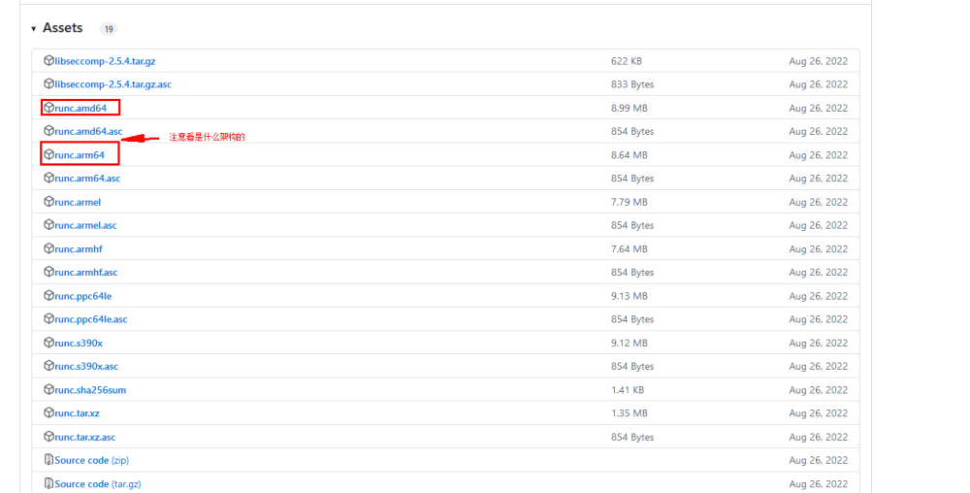

下载并重命名

mv runc.arm64 runc

复制并替换到系统中

cp runc /usr/local/bin/  
cp runc /usr/local/sbin/  
cp runc /usr/bin/

完成！

<https://learnku.com/articles/68979>

3

docker-compose 启动 java 容器时报错 library initialization failed - unable to allocate file descriptor table

解决:  
在 /etc/systemd/system/ 或者 /usr/lib/systemd/system/  
找到 docker.service 文件，在 ExecStart=/usr/bin/dockerd 后面添加 --default-ulimit nofile=65536:65536 参数  
  
重启 docker 生效  
  
 systemctl daemon-reload  
  
 systemctl restart docker

<https://www.cnblogs.com/iyiluo/p/16785601.html>

4 permission denied

# /var/run/docker.sock: connect: permission denied

<https://blog.csdn.net/hey_girl_/article/details/124080877>