**1、获取yaml文件**

<https://kubernetes.github.io/ingress-nginx/deploy/>

|  |
| --- |
| Bare metal clusters¶  This section is applicable to Kubernetes clusters deployed on bare metal servers, as well as "raw" VMs where Kubernetes was installed manually, using generic Linux distros (like CentOS, Ubuntu...)  For quick testing, you can use a NodePort. This should work on almost every cluster, but it will typically use a port in the range 30000-32767.  **kubectl apply -f https://raw.githubusercontent.com/kubernetes/ingress-nginx/controller-v1.1.1/deploy/static/provider/baremetal/deploy.yaml**  For more information about bare metal deployments (and how to use port 80 instead of a random port in the 30000-32767 range), see bare-metal considerations. |

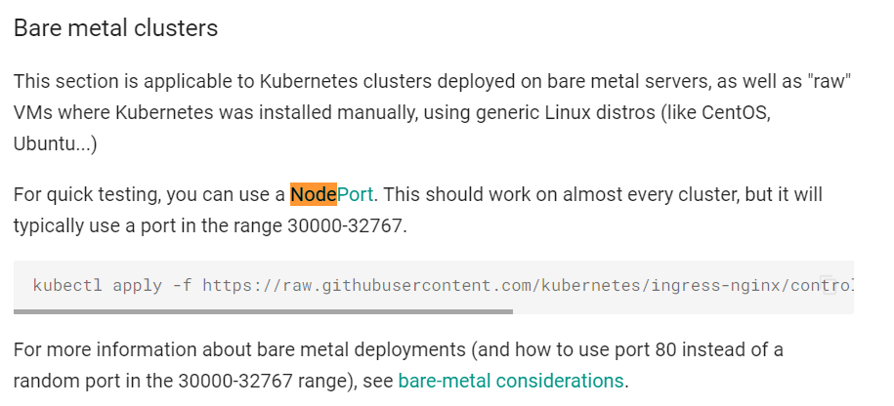

1. **应用**

**2.1 直接使用（网络不稳定）**

|  |
| --- |
| kubectl apply -f https://raw.githubusercontent.com/kubernetes/ingress-nginx/controller-v1.1.1/deploy/static/provider/baremetal/deploy.yaml |

**2.2 修改配置文件再使用（修改为阿里地址）**

|  |
| --- |
| **#**wget https://raw.githubusercontent.com/kubernetes/ingress-nginx/controller-v1.1.1/deploy/static/provider/baremetal/deploy.yaml |

**搜索**dnsPolicy: ClusterFirst

hostNetwork: true #添加

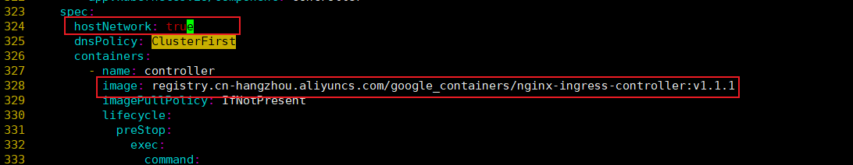

**搜索**#grep k8s.gcr.io deploy.yaml



|  |
| --- |
| image: k8s.gcr.io/ingress-nginx/controller:v1.1.1@sha256:0bc88eb15f9e7f84e8e56c14fa5735aaa488b840983f87bd79b1054190e660de  image: k8s.gcr.io/ingress-nginx/kube-webhook-certgen:v1.1.1@sha256:64d8c73dca984af206adf9d6d7e46aa550362b1d7a01f3a0a91b20cc67868660  image: k8s.gcr.io/ingress-nginx/kube-webhook-certgen:v1.1.1@sha256:64d8c73dca984af206adf9d6d7e46aa550362b1d7a01f3a0a91b20cc67868660 |

**2.2.1 image那一整行修改为阿里镜像地址**

找到关键字controller:v1.1.1

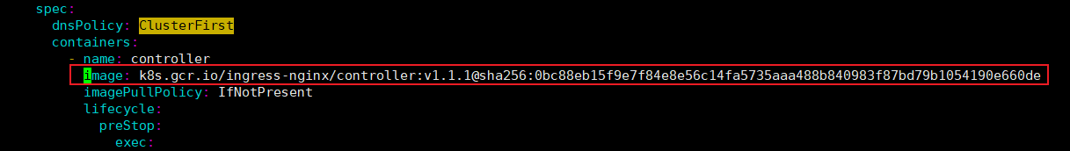

**修改后**

**image: registry.cn-hangzhou.aliyuncs.com/google_containers/nginx-ingress-controller:v1.1.1**

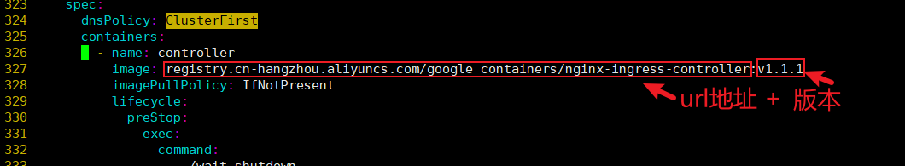

找到关键字 kube-webhook-certgen（有两处）

image: k8s.gcr.io/ingress-nginx/controller:v1.1.1@sha256:0bc88eb15f9e7f84e8e56c14fa5735aaa488b840983f87bd79b1054190e660de

修改为

image: registry.cn-hangzhou.aliyuncs.com/google_containers/kube-webhook-certgen:v1.1.1

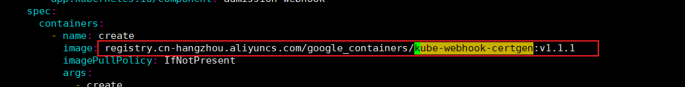

**2.2.3获取阿里云地址**

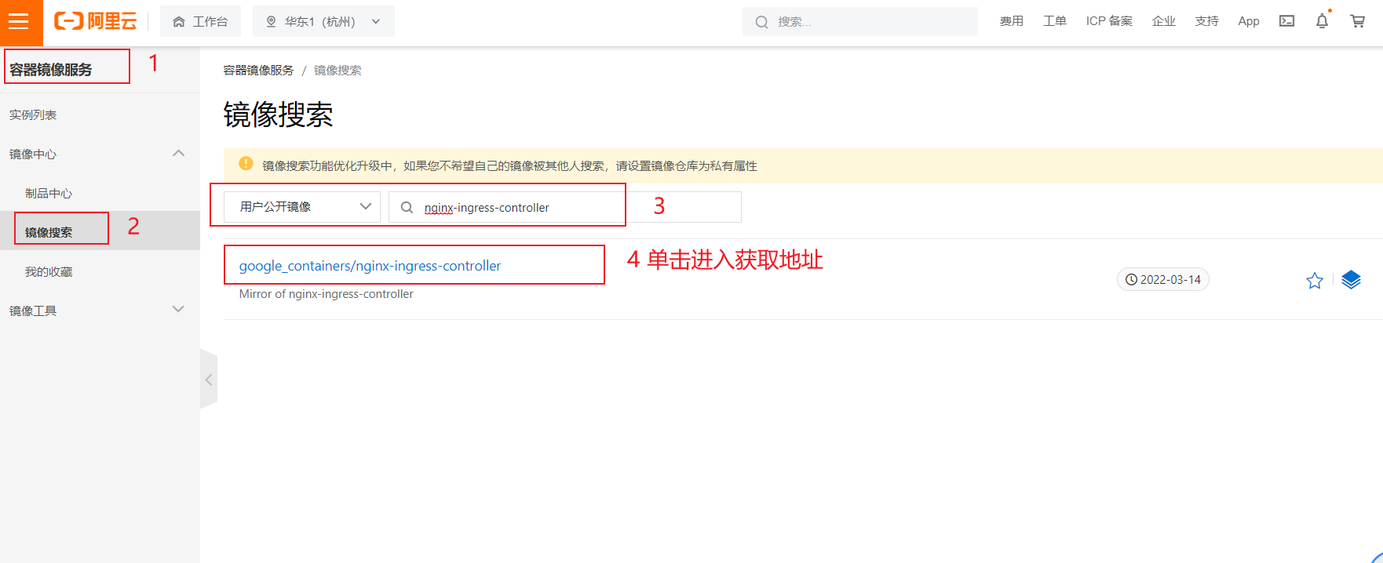

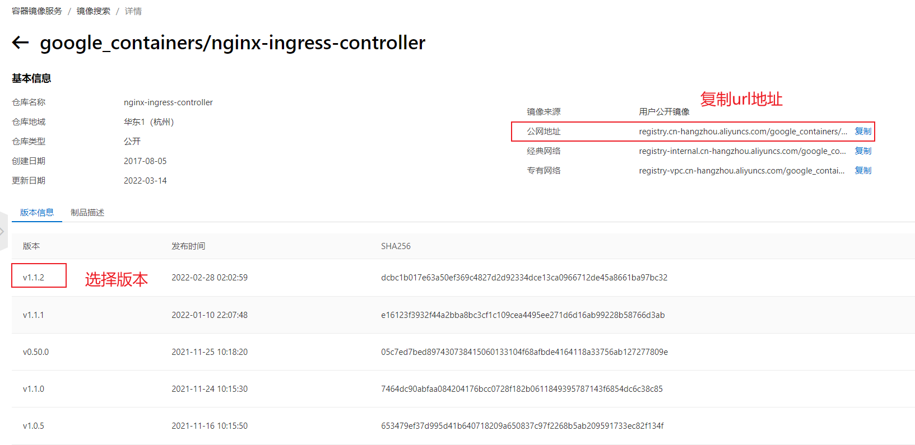

google_containers/nginx-ingress-controller

**2.2.4 kubectl apply -f ingress-nginx.yaml**

|  |
| --- |
| #mv deploy.yaml ingress-nginx.yaml  #kubectl apply -f ingress-nginx.yaml |

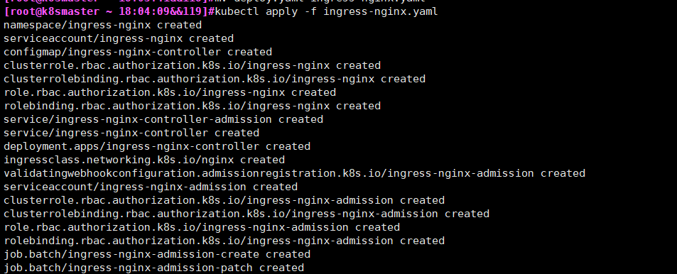

**2.2.5 附件ingress-nginx.yaml**

