# rancher部署k8s

docker run --privileged -d --restart=unless-stopped -p 80:80 -p 443:443 -v /data/rancher:/var/lib/rancher --name rancher rancher/rancher:stable

或者

version: "3"  
services:  
 rancher:  
 container_name: rancher  
 hostname: rancher  
 privileged: true  
 restart: always  
 image: rancher/rancher:stable  
 volumes:  
 - ./data:/var/lib/rancher  
 - /etc/localtime:/etc/localtime:ro  
 ports:  
 - "80:80"  
 - "443:443"  
 environment:  
 - TZ="Asia/Shanghai"

登录rancher页面

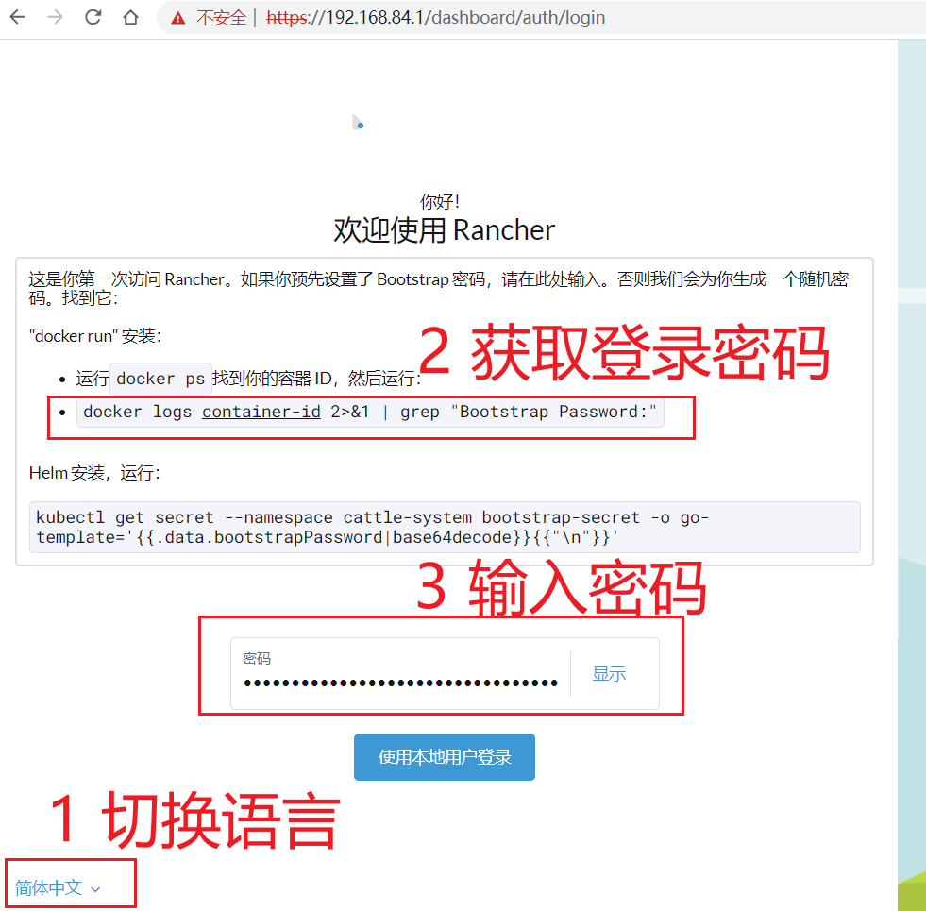

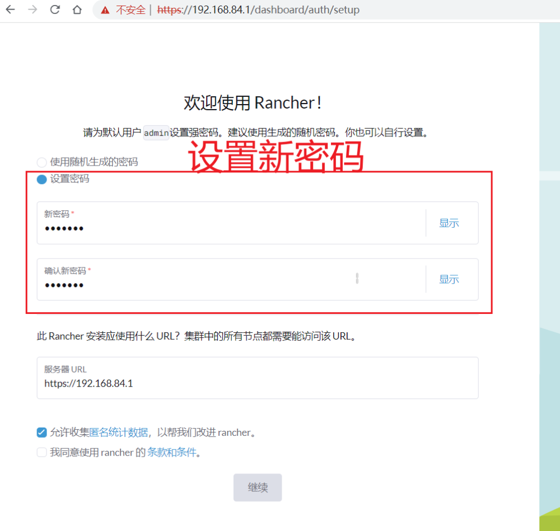

docker logs rancher 2>&1 | grep "Bootstrap Password:"

# 国内加速

进入全局设置，找到设置 -> system-default-registry选项，点击**☰**设置。

镜像地址是：registry.cn-hangzhou.aliyuncs.com

