下载文件

<https://github.com/flannel-io/flannel/releases> flannel

<https://github.com/etcd-io/etcd/releases> etcd

<https://github.com/kubernetes/kubernetes/releases> kubernetes

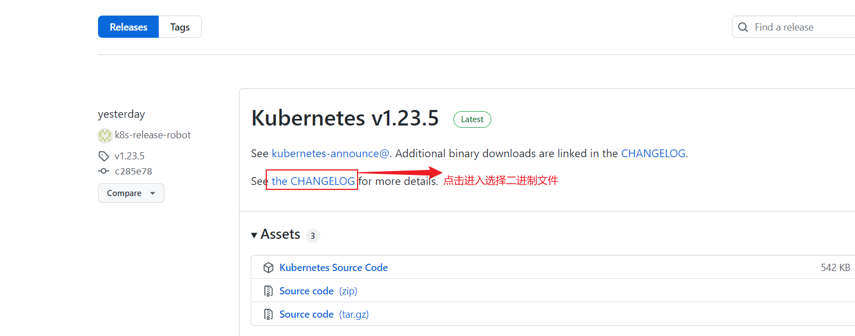

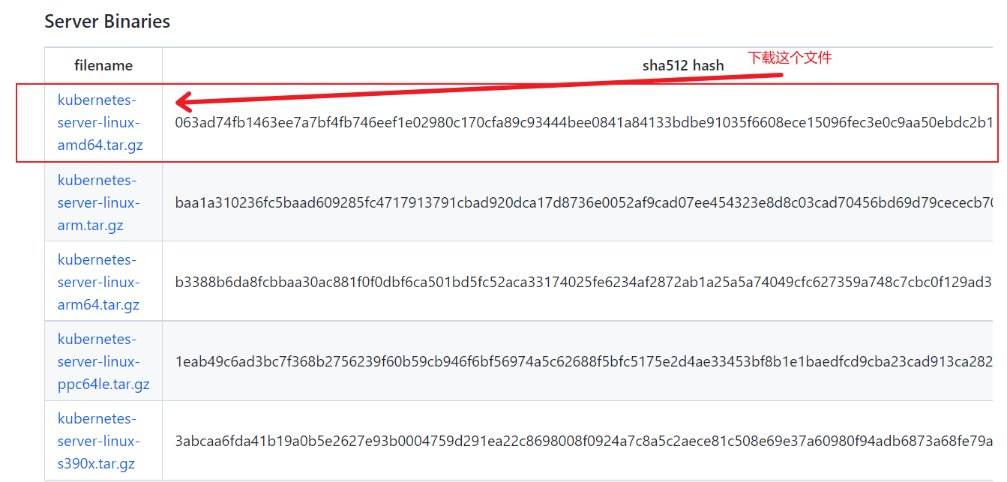

#mkdir -pv ~/k8s/etcd-cert

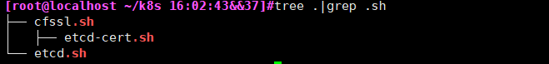

cfssl.sh etcd.sh 放到~/k8s下

etcd-cert.sh 放到~/k8s/etcd-cert 下

下载cfssl执行文件，用于生成自签名证书

|  |
| --- |
| [root@localhost ~/k8s 16:04:12&&41]#cat cfssl.sh  curl -L https://pkg.cfssl.org/R1.2/cfssl_linux-amd64 -o /usr/local/bin/cfssl  curl -L https://pkg.cfssl.org/R1.2/cfssljson_linux-amd64 -o /usr/local/bin/cfssljson  curl -L https://pkg.cfssl.org/R1.2/cfssl-certinfo_linux-amd64 -o /usr/local/bin/cfssl-certinfo  chmod +x /usr/local/bin/cfssl /usr/local/bin/cfssljson /usr/local/bin/cfssl-certinfo |

执行~/k8s/etcd-cert/etcd-cert.sh 生成etcd用证书，主要修改下面两项，再执行

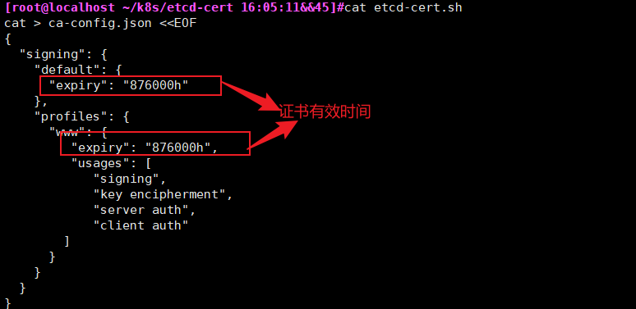

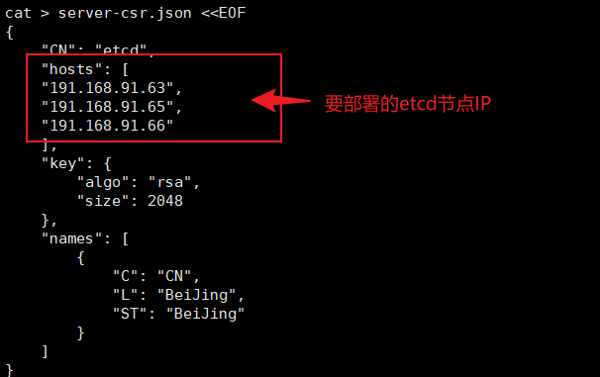

[root@localhost ~/k8s 16:13:37&&51]#tar xf etcd-v3.3.10-linux-amd64.tar.gz

[root@localhost ~/k8s 16:13:43&&52]#cd etcd-v3.3.10-linux-amd64/

[root@localhost ~/k8s/etcd-v3.3.10-linux-amd64 16:14:11&&55]#mkdir /opt/etcd/{cfg,bin,ssl} -pv

[root@localhost ~/k8s/etcd-v3.3.10-linux-amd64 16:15:56&&65]#mv etcd etcdctl /opt/etcd/bin/

**helm下载**

<https://github.com/helm/helm/releases> helm

