**docker部署zabbix**

1. **准备数据库**

**非docker部署（需要先部署好）**

**创建 database 指定字符集**

|  |
| --- |
| create database zabbix character set utf8 collate utf8_bin; create user zabbix@localhost identified by 'zabbix'; grant all privileges on zabbix.* to zabbix@localhost;  grant all privileges on zabbix.* to'zabbix'@'%' identified by 'zabbix'; quit; |

**2、创建网络**

|  |
| --- |
| docker network create --subnet 172.20.0.0/16 --ip-range 172.20.240.0/20 zabbix-net |

**3、启动Zabbix Java gateway实例**

|  |
| --- |
| docker run --name zabbix-java-gateway -t \  --network=zabbix-net \  --restart unless-stopped \  -d zabbix/zabbix-java-gateway:latest |

**4、部署zabbix-server**

|  |
| --- |
| docker run --name zabbix-server-mysql -t \  -v /etc/localtime:/etc/localtime \  -v /etc/timezone:/etc/timezone \  -v /data/zabbix/alertscripts:/usr/lib/zabbix/alertscripts \  -v /data/zabbix/externalscripts:/usr/lib/zabbix/externalscripts \  -e DB_SERVER_HOST="192.168.31.11" \  -e MYSQL_DATABASE="zabbix" \  -e MYSQL_USER="zabbix" \  -e MYSQL_PASSWORD="zabbix" \  -e MYSQL_ROOT_PASSWORD="123.com" \  -e ZBX_JAVAGATEWAY="zabbix-java-gateway" \  -e ZBX_JAVAGATEWAY_ENABLE="true" \  --network=zabbix-net \  -p 10051:10051 \  --restart unless-stopped \  -d zabbix/zabbix-server-mysql:latest |

-e ZBX_JAVAGATEWAY="zabbix-java-gateway" \ #连接ZBX_JAVAGATEWAY

-e ZBX_JAVAGATEWAY_ENABLE="true" \ #开启ZBX_JAVAGATEWAY_ENABLE

**5、部署访问web**

**5.1 为防止部分中文乱码**

中文乱码解决办法：

从windows的字体目录下获取楷体的字体文件,

windows下的字体文件位于：C:\Windows\Fonts

|  |
| --- |
| mkdir -p /zabbix/assets/fonts  将字体文件上传到/zabbix/assets/fonts  ln -sv SIMKAI.TTF DejaVuSans.ttf |

**5.2 解决时间相差5小时**

**先运行容器，将容器内的php7文件拷贝到宿主机**

|  |
| --- |
| docker run --name zabbix-web-nginx-mysql -t \  -e ZBX_SERVER_HOST="zabbix-server-mysql" \  -e DB_SERVER_HOST="192.168.31.11" \  -e MYSQL_DATABASE="zabbix" \  -e MYSQL_USER="zabbix" \  -e MYSQL_PASSWORD="zabbix" \  -e MYSQL_ROOT_PASSWORD="123.com" \  --network=zabbix-net \  -p 80:8080 \  --restart unless-stopped \  -d zabbix/zabbix-web-nginx-mysql:latest |

|  |
| --- |
| mkdir /zabbix/etc  docker cp zabbix-web-nginx-mysql:/etc/php7 /zabbix/etc  vim /zabbix/etc/php7/php-fpm.d/zabbix.conf |

**原来的注释掉**

|  |
| --- |
| ; php_value[date.timezone] = ${PHP_TZ}  php_value[date.timezone] = Asia/Shanghai #添加 |

如下图

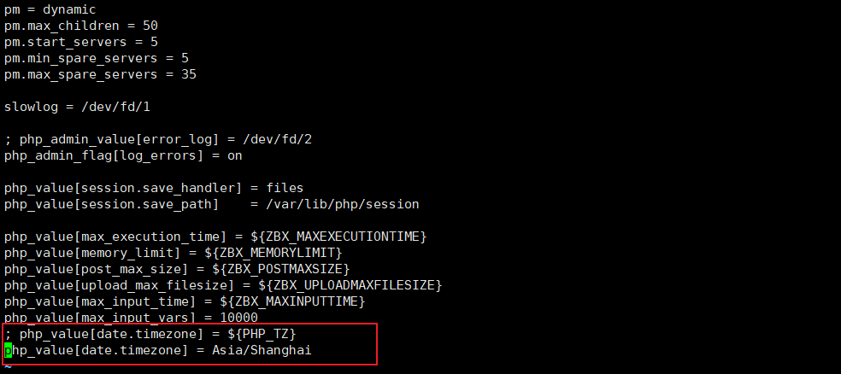

**最终运行命令如下**

|  |
| --- |
| docker run --name zabbix-web-nginx-mysql -t \  -v /etc/localtime:/etc/localtime \  -v /etc/timezone:/etc/timezone \  -v /zabbix/assets/fonts:/usr/share/zabbix/assets/fonts \  -v /zabbix/etc/php7:/etc/php7 \  -e ZBX_SERVER_HOST="zabbix-server-mysql" \  -e DB_SERVER_HOST="192.168.31.11" \  -e MYSQL_DATABASE="zabbix" \  -e MYSQL_USER="zabbix" \  -e MYSQL_PASSWORD="zabbix" \  -e MYSQL_ROOT_PASSWORD="123.com" \  --network=zabbix-net \  -p 80:8080 \  --restart unless-stopped \  -d zabbix/zabbix-web-nginx-mysql:latest |

**6、访问**

<http://192.168.31.11/zabbix>

Admin/zabbix

**7、部署zabbix_agent**

**7.1非docker部署**

**7.2 docker部署(有待进一步研究)**

|  |
| --- |
| docker run --name zabbix-agent \  -e ZBX_HOSTNAME="宿主机IP或者主机名" \  -e ZBX_SERVER_HOST="zabbix-server宿主机IP或者容器IP" \  --network=zabbix-net \  -d zabbix/zabbix-agent:alpine-5.0-latest |