**Centos7 Zabbix-5.4源码部署**

## **1、卸载旧版本 PHP：**

|  |
| --- |
| yum remove php-* |

## **2、安装 7.2 版本 PHP：**

|  |
| --- |
| rpm -Uvh https://mirror.webtatic.com/yum/el7/epel-release.rpm  rpm -Uvh https://mirror.webtatic.com/yum/el7/webtatic-release.rpm  yum install -y php72w php72w-opcache php72w-xml php72w-gd php72w-devel php72w-mysqlnd php72w-intl php72w-mbstring php72w-pear php72w-pdo php72w-fpm php72w-bcmath |

## **3、安装 Golang**

Zabbix 前端服务依赖 Golang。

|  |
| --- |
| rpm --import <https://mirror.go-repo.io/centos/RPM-GPG-KEY-GO-REPO>  curl -s https://mirror.go-repo.io/centos/go-repo.repo | tee /etc/yum.repos.d/go-repo.repo  yum install golang  go env -w GOPROXY=https://goproxy.cn #由于编译过程需要联网下载依赖包，配置 go mod 代理由于编译过程需要联网下载依赖包，配置 go mod 代理  go env #显示如下，说明成功 |

## **4、部署 MySQL**

注意 Zabbix 要求数据库版本在 5.7.35 以上，并且 database 字符集要求是 utf8，校验集为 utf8_bin。

**4.1安装依赖**

|  |
| --- |
| yum install -y gcc mysql-devel net-snmp-devel pcre*\  curl-devel libxml2 libxml2-devel \  automake libssh2-devel libevent-devel httpd libcurl-devel.x86_64 \  kernel-devel openssl-devel popt-devel |

**4.2、创建 database 指定字符集。**

|  |
| --- |
| create database zabbix character set utf8 collate utf8_bin; create user zabbix@localhost identified by 'zabbix'; grant all privileges on zabbix.* to zabbix@localhost;  grant all privileges on zabbix.* to'zabbix'@'%' identified by 'zabbix'; quit; |

## **5、源码编译部署 Zabbix**

**5.1、创建zabbix用户**

|  |
| --- |
| roupadd --system zabbix  useradd --system -g zabbix -d /usr/lib/zabbix -s /sbin/nologin -c "Zabbix Monitoring System" zabbix  mkdir -m u=rwx,g=rwx,o= -p /usr/lib/zabbix  chown zabbix:zabbix /usr/lib/zabbix |

**5.2、下载并解压源码包**

|  |
| --- |
| wget https://cdn.zabbix.com/zabbix/sources/stable/5.4/zabbix-5.4.9.tar.gz  tar -xzvf zabbix-5.4.9.tar.gz  cd zabbix-5.4.9 |

**5.3、编译安装**

|  |
| --- |
| ./configure --prefix=/usr/local/zabbix \  --enable-server \  --enable-agent \  -enable-agent2 \  --enable-proxy \  --with-mysql \  --enable-ipv6 \  --with-libcurl \  --with-net-snmp \  --with-libxml2 \  --with-ssh2 \  --enable-webservice \  --enable-java \  --with-ldap \  --with-unixodbc \  --with-openssl |

--enable-java 需要安装jdk

--with-ldap 需要安装yum install -y openldap openldap-devel -y

**5.4部署 Zabbix Server**

|  |
| --- |
| useradd zabbix  mkdir /usr/local/zabbix/logs  mkdir /usr/local/zabbix/trap  mkdir /usr/local/zabbix/socket  mkdir /usr/local/zabbix/pid  chown -R zabbix.zabbix /usr/local/zabbix/ |

**5.5、Zabbix Server 配置文件**

编辑 /usr/local/zabbix/etc/zabbix_server.conf 文件

|  |
| --- |
| #Zabbix Server 地址  SourceIP=192.168.91.13  #日志文件目录  LogFile=/usr/local/zabbix/logs/zabbix_server.log  ##Pid 文件目录  PidFile=/usr/local/zabbix/pid/zabbix_server.pid  ##Socket 文件目录  SocketDir=/usr/local/zabbix/socket  #数据库连接信息  DBHost=192.168.91.13  DBPort=12345  DBName=zabbix  DBUser=zabbix  DBPassword=zabbix  DBSocket=/data/mysql/run/mysql.sock  Timeout=4  LogSlowQueries=3000  #允许所有地址访问  StatsAllowedIP=0.0.0.0  #配置缓存  CacheSize=1G  #snmp trap 目录  SNMPTrapperFile=/usr/local/zabbix/trap/zabbix_traps  ##开启 snmp trap  StartSNMPTrapper=1  #拉取 snmp 信息的线程数  StartProxyPollers=20 |

**5.6、初始化数据库**

|  |
| --- |
| cd /usr/local/src/zabbix-5.4.9/database/mysql  mysql -u zabbix -p zabbix < schema.sql  mysql -u zabbix -p zabbix < images.sql  mysql -u zabbix -p zabbix < data.sql |

以上三条指令将目的执行sql脚本，构建zabbix数据库的结构，每次都要输入mysql中zabbix账户的密码

或者登陆mysql

|  |
| --- |
| source /usr/local/src/zabbix-5.4.9/database/mysql/schema.sql  source /usr/local/src/zabbix-5.4.9/database/mysql/images.sql  source /usr/local/src/zabbix-5.4.9/database/mysql/data.sql |

**5.7、配置 Zabbix Server 系统服务**

5.7.1 编辑 /usr/lib/systemd/system/zabbix-server.service 文件：

|  |
| --- |
| [Unit]  Description=Zabbix Server  After=syslog.target  After=network.target  After=mysql.service  After=mysqld.service  After=mariadb.service  After=postgresql.service  After=pgbouncer.service  After=postgresql-9.4.service  After=postgresql-9.5.service  After=postgresql-9.6.service  After=postgresql-10.service  After=postgresql-11.service  After=postgresql-12.service  After=postgresql-13.service  [Service]  Environment="CONFFILE=/usr/local/zabbix/etc/zabbix_server.conf"  EnvironmentFile=-/etc/sysconfig/zabbix-server  Type=forking  Restart=on-failure  PIDFile=/usr/local/zabbix/pid/zabbix_server.pid  KillMode=control-group  ExecStart=/usr/local/zabbix/sbin/zabbix_server -c $CONFFILE  ExecStop=/bin/kill -SIGTERM $MAINPID  RestartSec=10s  TimeoutSec=0  [Install]  WantedBy=multi-user.target |

**5.7.2 启动 Zabbix Server，并设置开机自动启动**

|  |
| --- |
| systemctl daemon-reload  systemctl enable zabbix-server.service  systemctl start zabbix-server.service |

**5.8、拷贝与配置zabbix启动文件**

|  |
| --- |
| cd /usr/local/src/zabbix-5.4.9  cp misc/init.d/fedora/core/zabbix_* /etc/init.d/  chmod 755 /etc/init.d/zabbix_*  sed -i "s#BASEDIR=/usr/local#BASEDIR=/usr/local/zabbix#g" /etc/init.d/zabbix_server  sed -i "s#BASEDIR=/usr/local#BASEDIR=/usr/local/zabbix#g" /etc/init.d/zabbix_agentd  **#服务端**  chkconfig --add zabbix_server  chkconfig zabbix_server on  chkconfig --list|grep zabbix_server    **#客户端**  chkconfig --add zabbix_agentd  chkconfig zabbix_agentd on  chkconfig --list|grep zabbix_agentd |

**5.9、启动zabbix_server**

|  |
| --- |
| **service zabbix_server start** |

## **部署 Zabbix Web**

**6.1、修改/etc/php.ini的配置并重启php-fpm**

|  |
| --- |
| sed -ri 's/(post_max_size =).*/\1 16M/g' /etc/php.ini  sed -ri 's/(max_execution_time =).*/\1 300/g' /etc/php.ini  sed -ri 's/(max_input_time =).*/\1 300/g' /etc/php.ini  sed -i '/;date.timezone/a date.timezone = Asia/Shanghai' /etc/php.ini  systemctl restart php-fpm |

**6.2、拷贝前端文件**

Zabbix 前端是 PHP 编写的，所以必须运行在支持 PHP 的 Web 服务器上，使用 Apache HTTP 作为 Web 服务器。

建议使用子目录替代 HTML 根目录。可以使用下列命令，以创建一个子目录并复制 Zabbix 的前端文件到这个目录下。

|  |
| --- |
| mkdir -p /var/www/html/zabbix  cd /usr/local/src/zabbix-5.4.9 && cp -a ./ui/* /var/www/html/zabbix/ |

**6.3、配置 PHP 文件**

编辑 /var/www/html/zabbix/conf/zabbix.conf.php 文件：

|  |
| --- |
| <?php  //MySQL 连接信息  $DB['TYPE'] = 'MYSQL';  $DB['SERVER'] = '127.0.0.1';  $DB['PORT'] = '12345';  $DB['DATABASE'] = 'zabbix';  $DB['USER'] = 'zabbix';  $DB['PASSWORD'] = 'yourpassword';  // Schema name. Used for PostgreSQL.  $DB['SCHEMA'] = '';  // Used for TLS connection.  $DB['ENCRYPTION'] = false;  $DB['KEY_FILE'] = '';  $DB['CERT_FILE'] = '';  $DB['CA_FILE'] = '';  $DB['VERIFY_HOST'] = false;  $DB['CIPHER_LIST'] = '';  // Vault configuration. Used if database credentials are stored in Vault secrets manager.  $DB['VAULT_URL'] = '';  $DB['VAULT_DB_PATH'] = '';  $DB['VAULT_TOKEN'] = '';  // Use IEEE754 compatible value range for 64-bit Numeric (float) history values.  // This option is enabled by default for new Zabbix installations.  // For upgraded installations, please read database upgrade notes before enabling this option.  $DB['DOUBLE_IEEE754'] = true;  #Zabbix Server 信息  $ZBX_SERVER = 'localhost';  $ZBX_SERVER_PORT = '10051';  $ZBX_SERVER_NAME = 'ZABBIX-SERVER-1';  $IMAGE_FORMAT_DEFAULT = IMAGE_FORMAT_PNG; |

### 6.4、启动 Apache HTTP 服务，设置开机自动启动

|  |
| --- |
| systemctl start httpd  systemctl enable httpd |

**6.5、访问**

[http://IP/zabbix/](http://192.168.91.13/zabbix/)

6.4.1 问题1



|  |
| --- |
| 把localohst改为127.0.0.1  $DB['SERVER'] = '127.0.0.1'; |

6.4.2 问题2



|  |
| --- |
| mysql -u root -p --socket=/data/mysql/run/mysql.sock  mysql> grant all privileges on zabbix.* to'zabbix'@'%' identified by 'zabbix';  mysql> flush privileges; |

**成功显示页面**

默认用户名 Admin，密码 zabbix 。

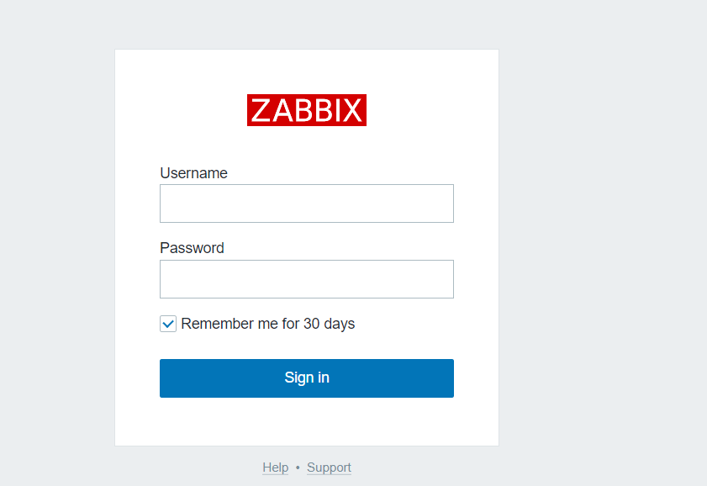

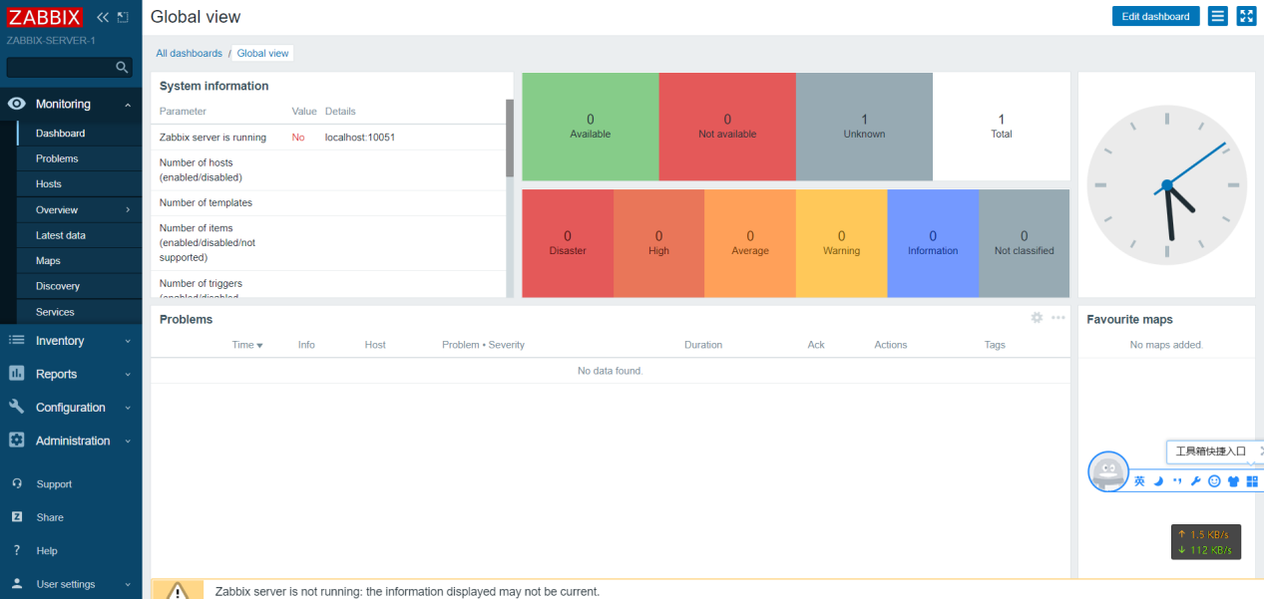

6.4.3 问题3

[Z3001] connection to database 'zabbix' failed: [2002] Can't connect to local MySQL server through socket '/var/lib/mysql/mysql.sock' (2)



添加

|  |
| --- |
| DBSocket=/data/mysql/run/mysql.sock |

6.4.4 php参数配置

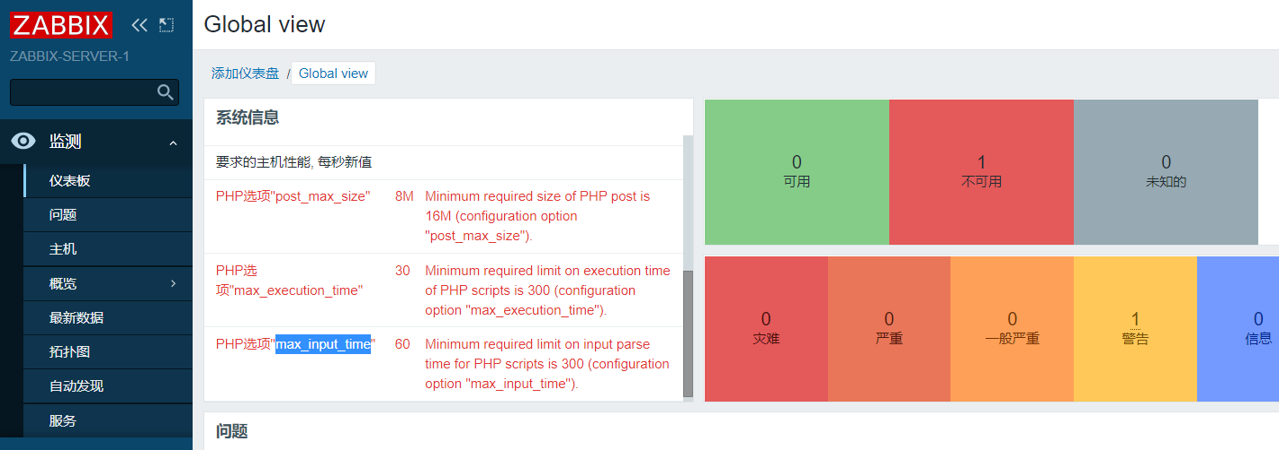

编辑/etc/php.ini，依次修改为建议值。修改完后记得重启。systemctl restart httpd



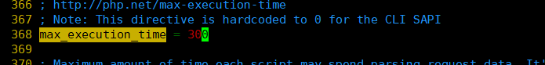

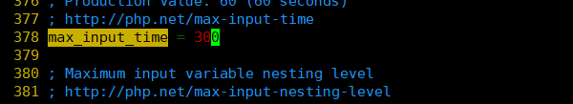

[Global view](http://192.168.91.13/zabbix/zabbix.php?action=dashboard.view&dashboardid=1)

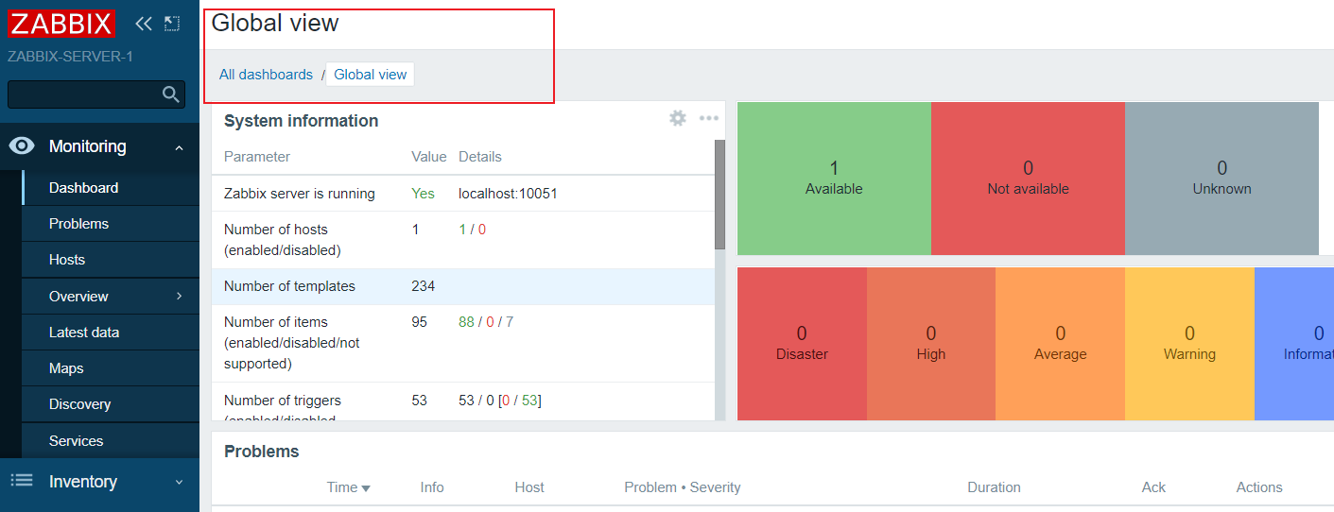

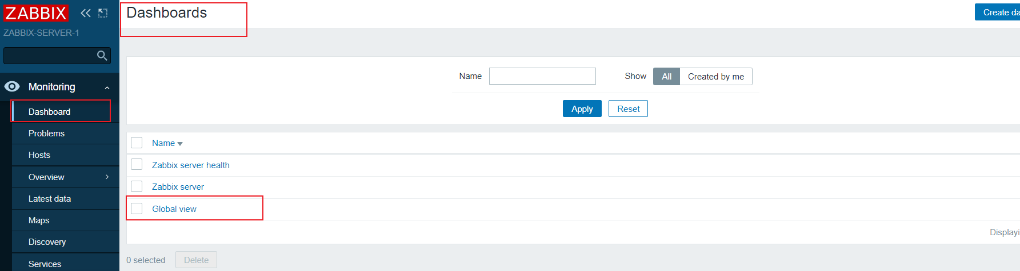

**6.6、修改http端口**

|  |
| --- |
| vim /etc/httpd/conf/httpd.conf    访问 http://192.168.91.13:8080/zabbix |

## **7、部署 Zabbix Agent**

Zabbix Agent 用于收集服务器的监控数据（CPU，内存等等）发送给 Zabbix Server，在部署 Zabbix Server 的服务器上部署 Zabbix Agent 监控自己。

**7.1、Zabbix Agent 配置文件**

编辑 /usr/local/zabbix/etc/zabbix_agentd.conf 文件：

|  |
| --- |
| #Pid 文件目录  PidFile=/usr/local/zabbix/pid/zabbix_agentd.pid  #Zabbix Agent 日志目录  LogFile=/usr/local/zabbix/logs/zabbix_agentd.log  #允许所有地址访问  #Server=0.0.0.0/0 此处只允许zabbix_server访问  Server=192.168.91.13  #Zabbix Server 地址，由于Zabbix Server 服务器和 Zabbix Agent 在一台机器上，因此用 127.0.0.1 通信即可  ServerActive=127.0.0.1  Hostname=Zabbix server  AllowRoot=1  Include=/usr/local/zabbix/etc/zabbix_agentd.conf.d/*.conf  UnsafeUserParameters=1 |

### **7.2配置 Zabbix Agent 系统服务**

7.2.1 编辑 /usr/lib/systemd/system/zabbix-agentd.service 文件：

|  |
| --- |
| [Unit]  Description=Zabbix Agent  After=syslog.target  After=network.target  [Service]  Environment="CONFFILE=/usr/local/zabbix/etc/zabbix_agentd.conf"  EnvironmentFile=-/etc/sysconfig/zabbix-agent  Type=forking  Restart=on-failure  PIDFile=/usr/local/zabbix/pid/zabbix_agentd.pid  KillMode=control-group  ExecStart=/usr/local/zabbix/sbin/zabbix_agentd -c $CONFFILE  ExecStop=/bin/kill -SIGTERM $MAINPID  RestartSec=10s  User=root  Group=root  [Install]  WantedBy=multi-user.target |

7.2.2 启动 Zabbix Server，并设置开机自动启动。

|  |
| --- |
| systemctl daemon-reload  systemctl enable zabbix-agentd.service  systemctl start zabbix-agentd.service |

**7.3、启动agent**

|  |
| --- |
| service zabbix_agentd start |

## **8、部署 Zabbix Agent2**

安装 gcc 等基础编译环境，由于使用 go 编写，因此需要配置 go 编译环境，下载并配置 go 语言编译环境，go部署详见第3步骤。[安装golang](#_3、安装 Golang)

**8.1、Zabbix Agent2 配置文件**

编辑 /usr/local/zabbix/etc/zabbix_agent2.conf 文件：

|  |
| --- |
| #Pid 文件目录  PidFile=/usr/local/zabbix/pid/zabbix_agentd2.pid  #Zabbix Agent 日志目录  LogFile=/usr/local/zabbix/logs/zabbix_agentd2.log  #允许所有地址访问  #Server=0.0.0.0/0 此处只允许zabbix_server访问  Server=192.168.91.13  #Zabbix Server 地址，由于Zabbix Server 服务器和 Zabbix Agent 在一台机器上，因此用 127.0.0.1 通信即可  ServerActive=127.0.0.1  Hostname=Zabbix server  #AllowRoot=1  Include=/usr/local/zabbix/etc/zabbix_agentd.conf.d/*.conf  UnsafeUserParameters=1 |

### **8.2配置 Zabbix Agent2 系统服务**

8.2.1 编辑 /usr/lib/systemd/system/zabbix-agent2.service 文件：

|  |
| --- |
| [Unit]  Description=Zabbix Agent 2  After=syslog.target  After=network.target  [Service]  Environment="CONFFILE=/usr/local/zabbix/etc/zabbix_agent2.conf"  EnvironmentFile=-/etc/sysconfig/zabbix-agent2  Type=simple  Restart=on-failure  PIDFile=/usr/local/zabbix/pid/zabbix_agentd2.pid  KillMode=control-group  ExecStart=/usr/local/zabbix/sbin/zabbix_agent2 -c $CONFFILE  ExecStop=/bin/kill -SIGTERM $MAINPID  RestartSec=10s  User=root  Group=root  [Install]  WantedBy=multi-user.target |

8.2.2 启动 Zabbix Server，并设置开机自动启动。

|  |
| --- |
| systemctl daemon-reload  systemctl enable zabbix-agent2.service  systemctl start zabbix-agent2.service |

## **9、zabbix汉化**

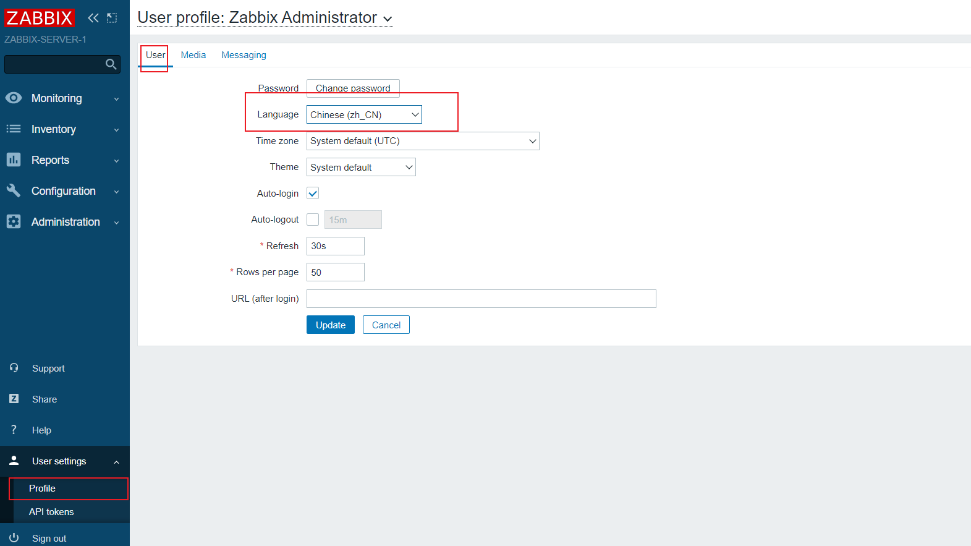

中文乱码解决办法：

从windows的字体目录下获取楷体的字体文件,

windows下的字体文件位于：C:\Windows\Fonts

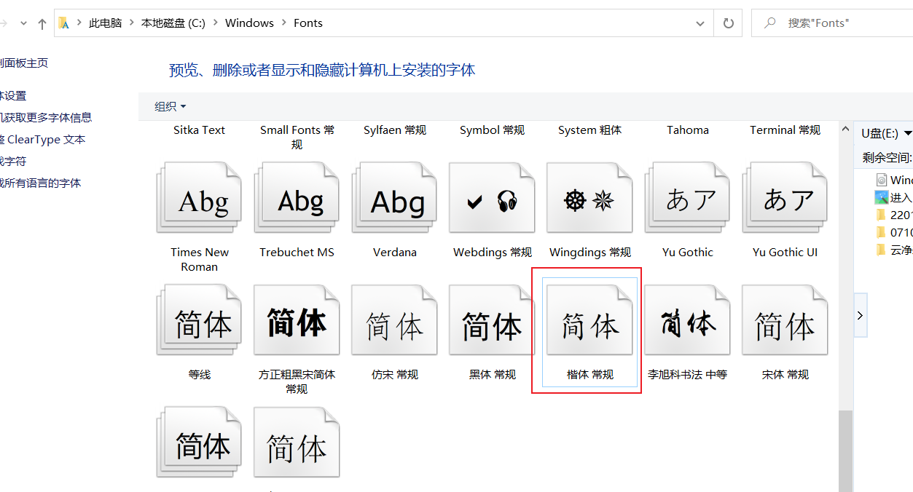

然后上传到zabbix的web目录下assets/fonts目录，如/var/www/html/zabbix/assets/fonts

|  |
| --- |
| mv SIMKAI.TTF SIMKAI.ttf  mv DejaVuSans.ttf DejaVuSans.ttf.bak  ln -sv SIMKAI.ttf DejaVuSans.ttf |

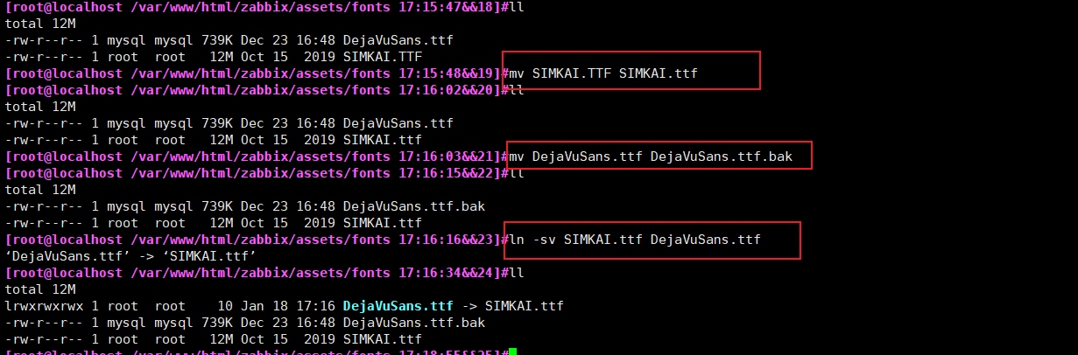

刷新页面之后，恢复正常

**10、参考URL**

<https://xie.infoq.cn/article/6d5aac26894d7cf1da491792c>

<https://www.cnblogs.com/leixixi/p/14630300.html>

<https://www.cnblogs.com/architectforest/p/12911721.html>

<https://blog.cactifans.com/2020/05/19/Zabbix5.0%E7%89%88%E6%9C%ACAgent2%E5%AE%89%E8%A3%85/>