# [VsCode](https://so.csdn.net/so/search?q=VsCode&spm=1001.2101.3001.7020" \t "https://blog.csdn.net/m0_38039437/article/details/_blank)**设置打开新文件不覆盖源文件位置**

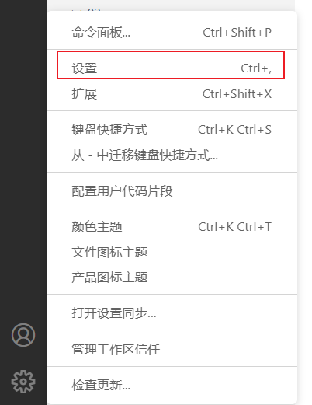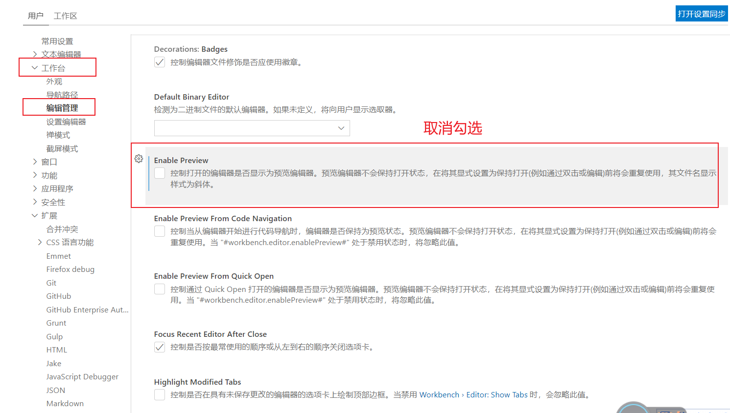

**打开新文件夹不覆盖原窗口**

