# **ceph本地镜像源搭建**

**1、添加阿里云ceph镜像源**

|  |
| --- |
| [Ceph]  name=Ceph packages for $basearch  baseurl=https://mirrors.aliyun.com/ceph/rpm-nautilus/el7/$basearch  enabled=1  gpgcheck=0  type=rpm-md  gpgkey=https://mirrors.aliyun.com/ceph/keys/release.asc  priority=1  [Ceph-noarch]  name=Ceph noarch packages  baseurl=https://mirrors.aliyun.com/ceph/rpm-nautilus/el7/noarch  enabled=1  gpgcheck=0  type=rpm-md  gpgkey=https://mirrors.aliyun.com/ceph/keys/release.asc  priority=1  [ceph-source]  name=Ceph source packages  baseurl=https://mirrors.aliyun.com/ceph/rpm-nautilus/el7/SRPMS  enabled=1  gpgcheck=0  type=rpm-md  gpgkey=https://mirrors.aliyun.com/ceph/keys/release.asc  priority=1 |

**PS: 标红部分与参考文档略有不同**

**2、清缓存**

|  |
| --- |
| yum clean all && yum makecache fast |

**3、仅下载镜像源包组**

这么做的好处就是仅仅把最新所需要的包下载了下来，如果通过同步镜像的方式，会把一些暂时无用的包下载下来，占用空间！

|  |
| --- |
| yum install --downloadonly --downloaddir=/data/mirrors/ceph/ ceph ceph-radosgw ntp ceph-deploy |

PS：其中--downloadonly表示仅下载，--downloaddir指定下载到哪个目录

1. **下载依赖文件**

**cd /data/mirrors/ceph (注意修改版本号-标记部分)**

**ceph -v 查看**

|  |
| --- |
| wget mirrors.aliyun.com/ceph/rpm-nautilus/el7/SRPMS/ceph-14.2.22-0.el7.src.rpm  wget mirrors.aliyun.com/ceph/rpm-nautilus/el7/SRPMS/ceph-deploy-2.0.1-0.src.rpm  wget mirrors.aliyun.com/ceph/rpm-nautilus/el7/noarch/ceph-deploy-2.0.1-0.noarch.rpm  wget mirrors.aliyun.com/ceph/rpm-nautilus/el7/noarch/ceph-grafana-dashboards-14.2.22-0.el7.noarch.rpm  wget mirrors.aliyun.com/ceph/rpm-nautilus/el7/noarch/ceph-mgr-dashboard-14.2.22-0.el7.noarch.rpm  wget mirrors.aliyun.com/ceph/rpm-nautilus/el7/noarch/ceph-mgr-diskprediction-cloud-14.2.22-0.el7.noarch.rpm  wget mirrors.aliyun.com/ceph/rpm-nautilus/el7/noarch/ceph-mgr-diskprediction-local-14.2.22-0.el7.noarch.rpm  wget mirrors.aliyun.com/ceph/rpm-nautilus/el7/noarch/ceph-mgr-rook-14.2.22-0.el7.noarch.rpm  wget mirrors.aliyun.com/ceph/rpm-nautilus/el7/noarch/ceph-mgr-ssh-14.2.22-0.el7.noarch.rpm  wget mirrors.aliyun.com/ceph/rpm-nautilus/el7/noarch/ceph-release-1-1.el7.noarch.rpm  wget mirrors.aliyun.com/ceph/rpm-nautilus/el7/SRPMS/ceph-release-1-1.el7.src.rpm  wget mirrors.aliyun.com/ceph/rpm-nautilus/el7/SRPMS/ceph-medic-1.0.4-16.g60cf7e9.el7.src.rpm  wget mirrors.aliyun.com/ceph/rpm-nautilus/el7/noarch/repodata/repomd.xml  wget mirrors.aliyun.com/ceph/rpm-nautilus/el7/SRPMS/repodata/repomd.xml  wget mirrors.aliyun.com/ceph/rpm-nautilus/el7/noarch/repodata/a4bf0ee38cd4e64fae2d2c493e5b5eeeab6cf758beb7af4eec0bc4046b595faf-filelists.sqlite  wget mirrors.aliyun.com/ceph/rpm-nautilus/el7/noarch/repodata/a4bf0ee38cd4e64fae2d2c493e5b5eeeab6cf758beb7af4eec0bc4046b595faf-filelists.sqlite.bz2  wget mirrors.aliyun.com/ceph/rpm-nautilus/el7/noarch/repodata/183278bb826f5b8853656a306258643384a1547c497dd8b601ed6af73907bb22-other.sqlite.bz2  wget mirrors.aliyun.com/ceph/rpm-nautilus/el7/SRPMS/repodata/52bf459e39c76b2ea2cff2c5340ac1d7b5e17a105270f5f01b454d5a058adbd2-filelists.sqlite.bz2  wget mirrors.aliyun.com/ceph/rpm-nautilus/el7/SRPMS/repodata/4f3141aec1132a9187ff5d1b4a017685e2f83a761880884d451a288fcedb154e-primary.sqlite.bz2  wget mirrors.aliyun.com/ceph/rpm-nautilus/el7/SRPMS/repodata/0c554884aa5600b1311cd8f616aa40d036c1dfc0922e36bcce7fd84e297c5357-other.sqlite.bz2  wget mirrors.aliyun.com/ceph/rpm-nautilus/el7/noarch/repodata/597468b64cddfc386937869f88c2930c8e5fda3dd54977c052bab068d7438fcb-primary.sqlite.bz2 |

**5、安装nginx**

**6、配置nginx**

|  |
| --- |
| server  {  listen 80;  server_name 192.168.91.110;  access_log /data/nginx/logs/ceph/access.log main;  location / {  root /data/mirrors;  index index.html index.htm;  autoindex on;  autoindex_exact_size off;  autoindex_localtime on;  limit_rate 1024M;  }  } |

**7、重启nginx服务**

|  |
| --- |
| nginx -t  nginx -s reload |

**8、创建本地源**

yum install createrepo -y

createrepo -pdo /data/mirrors/ceph/ /data/mirrors/ceph/

后续如果有更新增加或删减包，使用以下命令更新

createrepo --update /data/mirrors/ceph/

至此一个本地ceph源镜像就配置完成了

**9、其他服务器配置本地源**

|  |
| --- |
| cat > /etc/yum.repos.d/ceph.repo << EOF  [Ceph]  name=Ceph packages for $basearch  baseurl=http://192.168.91.110/ceph  gpgcheck=0  priority=1  [Ceph-noarch]  name=Ceph noarch packages  baseurl=http://192.168.91.110/ceph  gpgcheck=0  priority=1  [ceph-source]  name=Ceph source packages  baseurl=http://192.168.91.110/ceph  gpgcheck=0  priority=1  EOF |

**10、测试**

yum install -y ceph-deploy

报错

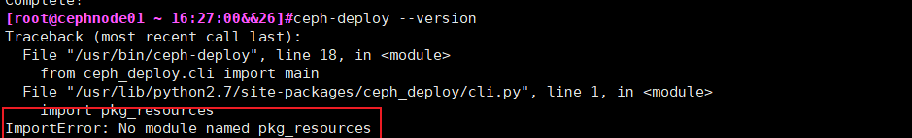

解决：

[root@cephnode01 ~ 16:28:01&&28]#wget <https://bootstrap.pypa.io/pip/2.7/get-pip.py>

[root@cephnode01 ~ 16:30:21&&29]#python get-pip.py

[root@cephnode01 ~ 16:33:27&&30]#ceph-deploy --version



**11、参考URL**

<https://developer.aliyun.com/article/781694>

**12、报错**

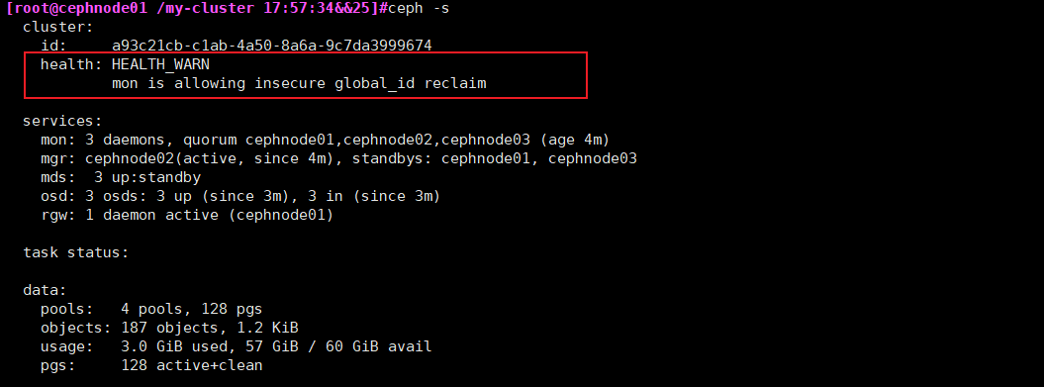

**mon is allowing insecure global_id reclaim**

**解决办法：**

禁用不安全模式

ceph config set mon auth_allow_insecure_global_id_reclaim false

