**Redis集群部署**

**本例共6台虚拟机（192.168.91.[11-16]）3主3从**

1、下载Redis4.0.2安装包

#cd /usr/local/src/

#wget http://download.redis.io/releases/redis-4.0.2.tar.gz

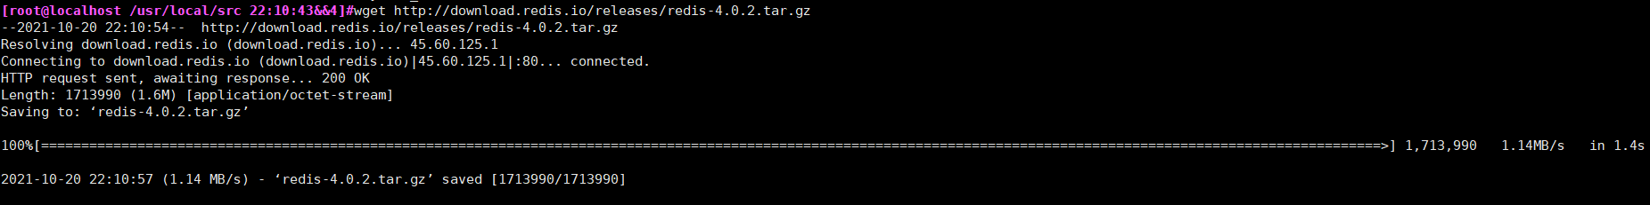

2、解压、编译、安装redis-4.0.2：

#tar -zxvf redis-4.0.2.tar.gz -C /usr/local/

#cd /usr/local/redis-4.0.2

#make && make install

#ln -sfv /usr/local/redis-4.0.2 /usr/local/redis-cluster

3、创建文件夹

(集群中 Redis 节点的端口号为 9001-9006 ，端口号即集群下各实例文件夹。数据存放在 端口号/data 文件夹中)

#mkdir -pv /usr/local/redis-cluster/{data,pid,logs,bin}

4、复制执行脚本

(在 /usr/local/redis-cluster 下创建 bin 文件夹，用来存放集群运行脚本，并把安装好的 Redis 的 src 路径下的运行脚本拷贝过来)

|  |
| --- |
| #cd /usr/local/redis-cluster && mv redis.conf redis-9001.conf  #cd /usr/local/redis-cluster/src && cp mkreleasehdr.sh redis-benchmark redis-check-aof redis-check-dump redis-cli redis-server redis-trib.rb /usr/local/redis-cluster/bin/  #ll /usr/local/redis-cluster/bin/ |

|  |
| --- |
| #vim /usr/local/redis-cluster/redis-9001.conf  port 9001  daemonize yes  bind 127.0.0.1 192.168.91.11  cluster-enabled yes  cluster-config-file redis-9001.conf  dir /usr/local/redis-cluster/data/  pidfile /usr/local/redis-cluster/pid/redis-9001.pid  logfile /usr/local/redis-cluster/logs/redis-9001.log  cluster-node-timeout 15000  appendonly yes |

启动脚本 #vim /etc/init.d/redis

|  |
| --- |
| #!/bin/sh  ## Simple Redis init.d script conceived to work on Linux systems  ## as it does use of the /proc filesystem.  PATH=/usr/local/redis-cluster/bin:/sbin:/usr/bin:/bin  REDISPORT=9001  EXEC=/usr/local/redis-cluster/bin/redis-server  CLIEXEC=/usr/local/redis-cluster/bin/redis-cli  PIDFILE=/usr/local/redis-cluster/pid/redis-9001.pid  CONF="/usr/local/redis-cluster/redis-9001.conf"  case "$1" in  start)  if [ -f $PIDFILE ]  then  echo "$PIDFILE exists, process is already running or crashed"  else  echo "Starting Redis server..."  $EXEC $CONF  fi  ;;  stop)  if [ ! -f $PIDFILE ]  then  echo "$PIDFILE does not exist, process is not running"  else  PID=$(cat $PIDFILE)  echo "Stopping ..."  $CLIEXEC -p $REDISPORT shutdown  while [ -x /proc/${PID} ]  do  echo "Waiting for Redis to shutdown ..."  sleep 1  done  echo "Redis stopped"  fi  ;;  *)  echo "Please use start or stop as first argument"  ;;  esac |

#chmod a+x /etc/init.d/redis

#service redis start

#netstat -anptu | grep 9001

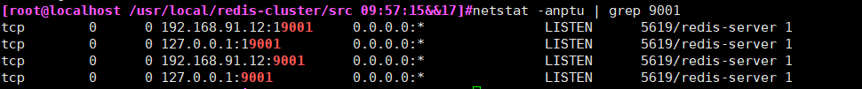

5、启动

#/usr/local/redis-cluster/bin/redis-server /usr/local/redis-cluster/redis-9001.conf



查一下是否启动成功：ps -el | grep redis

6、安装集群所需软件  
由于 Redis 集群需要使用 ruby 命令，所以我们需要安装 ruby 和相关接口。

yum install ruby -y

yum install rubygems -y

gem install redis

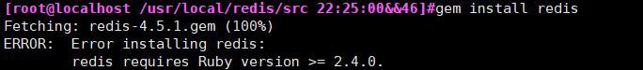

**方式一（在线安装，速度快方便）**

卸载当前ruby（当前使用centos系统）

|  |
| --- |
| #yum remove ruby |

下载ruby稳定版

|  |
| --- |
| #cd /usr/local/src && wget <https://cache.ruby-lang.org/pub/ruby/3.0/ruby-3.0.2.tar.gz>  #tar zxf ruby-3.0.2.tar.gz && cd ruby-3.0.2  #./configure --prefix=/usr/local/ruby  #make  #make install |

|  |
| --- |
| 查看安装后的版本  #/usr/local/ruby/bin/ruby -v |

设置环境变量

|  |
| --- |
| #vi /etc/profile  export PATH=$PATH:/usr/local/ruby/bin:  #source /etc/profile  #echo $PATH |

镜像加速

|  |
| --- |
| #gem sources --add https://gems.ruby-china.com/ --remove https://rubygems.org/  #gem sources -l |

|  |
| --- |
| #gem install redis |

**以上步骤其他5个节点也是如此操作（注意修改IP和端口号）**

最后创建集群（任意一台。本次在11上）

#/usr/local/redis/bin/redis-trib.rb create --replicas 1 192.168.91.11:9001 192.168.91.12:9002 192.168.91.13:9003 192.168.91.14:9004 192.168.91.15:9005 192.168.91.16:9006

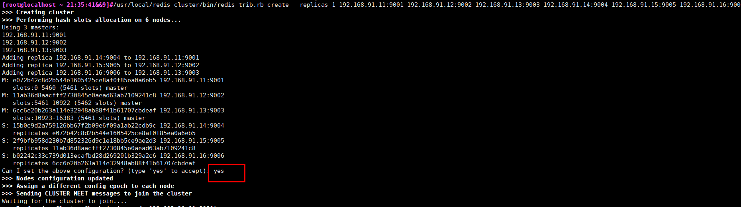

#/usr/local/redis/bin/redis-cli -c -h 192.168.91.11 -p 9001

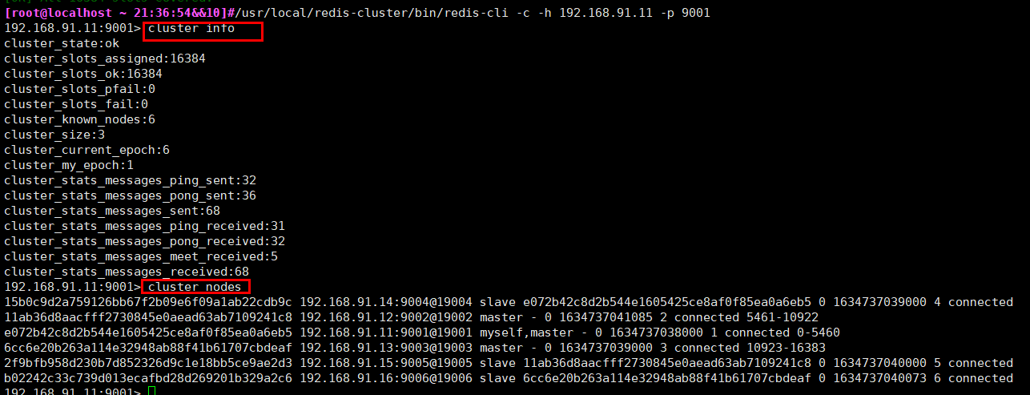

检查集群状态

#redis-trib.rb check 192.168.91.11:9001

**设置一个 mafly：**  
你会发现，当我们 set name mafly 时，出现了 Redirected to slot 信息并自动连接到了9002节点。这也是集群的一个数据分配特性，这里不详细说了。



**参考url:**

<https://www.cnblogs.com/mafly/p/redis_cluster.html>

<https://blog.csdn.net/qq_30242987/article/details/99729702>

<https://www.icode9.com/content-2-330853.html>

<https://blog.whsir.com/post-2659.html>

<https://ruby-china.org/wiki/install_ruby_guide/>

**其他**

**方式二（在线安装，很慢。）**

|  |
| --- |
| 解决方案：先安装rvm，再把ruby版本提升至2.3.0   1. 安装curl ：yum install curl 2. 安装RVM：curl -L get.rvm.io | bash -s stable     #gpg2 --keyserver hkp://pool.sks-keyservers.net --recv-keys 409B6B1796C275462A1703113804BB82D39DC0E3 7D2BAF1CF37B13E2069D6956105BD0E739499BDB  **gpg --keyserver hkp://keys.gnupg.net --recv-keys 409B6B1796C275462A1703113804BB82D39DC0E3**  这个没试过  #curl -sSL https://rvm.io/mpapis.asc | gpg2 --import -  #curl -sSL https://rvm.io/pkuczynski.asc | gpg2 --import -  三个命令试着来  一般是最后一个成功    成功后再次运行 curl -L get.rvm.io | bash -s stable    支持curl成功   1. source /usr/local/rvm/scripts/rvm 2. 查看rvm库中已知的ruby版本：   rvm list known     1. 安装一个ruby版本：   rvm install 2.6.3   1. 使用一个ruby版本：rvm use 2.6.3 2. 设置默认版本：ruby --version 3. 卸载一个已知版本：rvm remove 2.0.0 4. 安装redis 5. [root@localhost ~ 21:33:20&&6]#gem install redis   **Fetching redis-4.5.1.gem**  **Successfully installed redis-4.5.1**  **Parsing documentation for redis-4.5.1**  **Installing ri documentation for redis-4.5.1**  **Done installing documentation for redis after 1 seconds**  **1 gem installed** |