1. <https://dashboard.ngrok.com/get-started>
2. https://dashboard.ngrok.com/get-started/setup

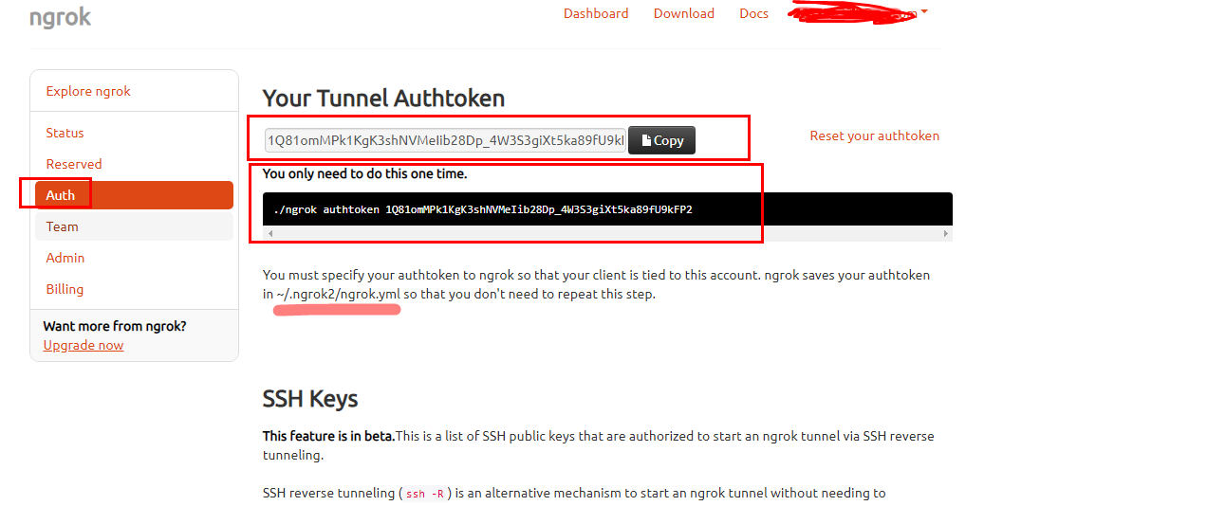

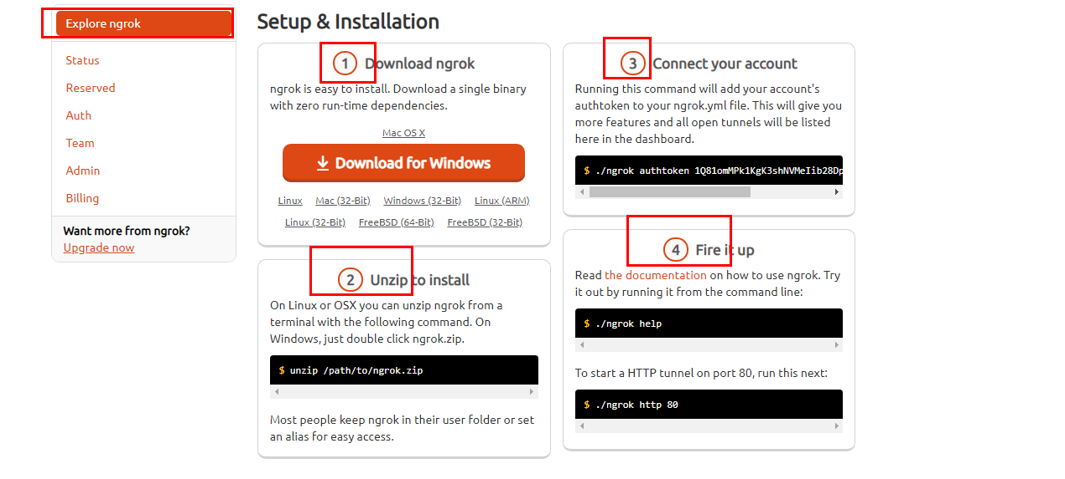

放入后台：

screen -S ngrok

 ./ngrok http 80

screen -r ngrok

