### **一、准备war包**

|  |
| --- |
| a.下载war包：[cachecloud-web.war](http://124.222.77.220/redis-ecs/cachecloud-web.war)  b.也可以clone源码，自行打包：  //clone项目  git clone https://github.com/sohutv/cachecloud.git  //打包  mvn clean package |

### **二 数据库导入sql**

|  |
| --- |
| mysql> create database db_cachecloud; mysql> grant all privileges on db_cachecloud.* to cachecloud@‘%‘ identified by ‘cachecloud‘;  mysql -h 192.168.1.14 -ucachecloud -pcachecloud mysql> use db_cachecloud  mysql> source ~/cachecloud-main/cachecloud-web/sql/2.0.sql  mysql> source ~/cachecloud-main/cachecloud-web/sql/update 2.0 to 3.0.sql |

### **三 修改配置**

cp cachecloud-web/src/main/resources/application-open.yml cachecloud-web/target/

vim application-open.yml

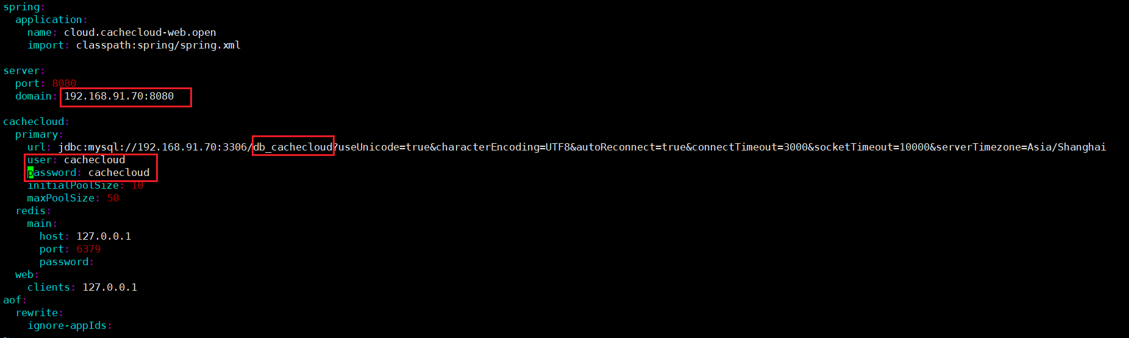

### **四 启动**

nohup java -jar -Dspring.profiles.active=open cachecloud-web.war &

### **五 访问**

<http://192.168.91.70:8080/>

admin/admin

### **六 参考**

<https://github.com/sohutv/cachecloud/blob/main/cachecloud-web/src/main/resources/static/wiki/quickstart/index.md>

<http://192.168.91.70:8080/wiki/quickstart/index>

<https://www.cnblogs.com/yjt1993/p/14808887.html>

<https://www.136.la/shida/show-160871.html>