# maxscale读写分离

参考文档

<https://www.cnblogs.com/backups/p/maridb_maxscale.html>

<https://dbaplus.cn/news-160-3379-1.html>

<https://www.cnblogs.com/elsons/p/15763248.html> （一主一从）

<https://www.modb.pro/db/29574>

<https://dbaplus.cn/news-11-558-1.html>

### 遇到的问题

主库状态处于down（主库是正常开启的）

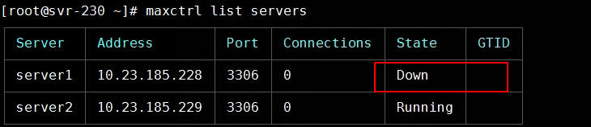

通过查看maxscale.log,发现maxscale连接主库超时，且通过命令mysql -h 10.23.185.228 -uroot -p 发现很卡

maxscale.log

2023-02-22 10:12:15 error : [Read-Write-Service] Failed to connect to server 'server1' ([10.23.185.228]:3306) when checking authentication user credentials and permissions: 2013 Lost connection to MySQL server at 'handshake: reading inital communication packet', system error: 110

2023-02-22 10:12:15 error : Monitor timed out when connecting to server server1[10.23.185.228:3306] : 'Lost connection to MySQL server at 'handshake: reading inital communication packet', system error: 110'

2023-02-22 10:12:15 warning: [Read-Write-Service] User 'maxscale' is missing the SHOW DATABASES privilege. This means that MaxScale cannot see all databases and authentication can fail.

2023-02-22 10:12:15 warning: No valid master server found.

2023-02-22 10:12:15 warning: 'server1' is not a valid master candidate because it is down.

2023-02-22 10:12:15 error : No Master can be determined

2023-02-22 10:12:15 notice : Server changed state: server1[10.23.185.228:3306]: server_down. [Running] -> [Down]

2023-02-22 10:12:18 error : Failure loading users data from backend [10.23.185.228:3306] for service [Read-Write-Service]. MySQL error 2013, Lost connection to MySQL server at 'handshake: reading inital communication packet', system error: 110

### 解决办法

在/etc/my.cnf中加入参数skip-name-resolve，并重启主库mysql

[Mysqld]  
skip-name-resolve

重启maxscale，此时查看是能连接到主库了

