安装

|  |
| --- |
| wget https://www.percona.com/downloads/XtraBackup/Percona­XtraBackup­  2.4.9/binary/tarball/percona­xtrabackup­2.4.9­Linux­x86_64.tar.gz  tar xf percona­xtrabackup­2.4.9­Linux­x86_64.tar.gz  cp percona­xtrabackup­2.4.9­Linux­x86_64/bin/* /usr/bin/ |

问题：

**innobackupex: /usr/lib64/libstdc++.so.6: version `GLIBCXX_3.4.15' not found (required by**

**innobackupex)**

|  |
| --- |
| strings /usr/lib64/libstdc++.so.6 | grep GLIBCXX |

GLIBCXX_3.4

GLIBCXX_3.4.1

GLIBCXX_3.4.2

GLIBCXX_3.4.3

GLIBCXX_3.4.4

GLIBCXX_3.4.5

GLIBCXX_3.4.6

GLIBCXX_3.4.7

GLIBCXX_3.4.8

GLIBCXX_3.4.9

GLIBCXX_3.4.10

GLIBCXX_3.4.11

GLIBCXX_3.4.12

GLIBCXX_3.4.13

GLIBCXX_FORCE_NEW

GLIBCXX_DEBUG_MESSAGE_LENGTH

发现的确没有GLIBCXX_3.4.15

那么需要下载相关文件并替代

|  |
| --- |
| wget http://ftp.de.debian.org/debian/pool/main/g/gcc-4.8/libstdc++6-4.8-  dbg_4.8.4-1_amd64.deb |

|  |
| --- |
| ar -x libstdc++6-4.8-dbg_4.8.4-1_amd64.deb  tar xvf data.tar.xzcd //usr/local/src/usr/lib/x86_64-linux-gnu/debug && cp libstdc++.so.6.0.19  /usr/lib64/  cd /usr/lib64/ && rm -f libstdc++.so.6  ln -s libstdc++.so.6.0.19 libstdc++.so.6 |

再次查看解决

|  |
| --- |
| strings /usr/lib64/libstdc++.so.6 | grep GLIBCXX |

URL:https://yq.aliyun.com/articles/673518?msgid=10443869

depress解压缺少工具qpress解压办法。

|  |
| --- |
| wget http://www.quicklz.com/qpress-11-linux-x64.tar  tar xvf qpress-11-linux-x64.tar  cp qpress /usr/bin |

解决 ***"/lib64/libc.so.6: version `GLIBC_2.18' not found***

***(required by /lib64/libstdc++.so.6)"***

|  |
| --- |
| curl ­O http://ftp.gnu.org/gnu/glibc/glibc­2.18.tar.gz  tar zxf glibc­2.18.tar.gz && cd glibc­2.18/  mkdir build && cd build/  ../configure ­­prefix=/usr  make ­j4  make install |

**Can't locate Digest/MD5.pm in @INC**

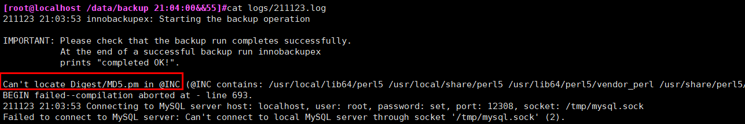

解决方法：

|  |
| --- |
| yum -y install perl-Digest-MD5 |

**Failed to connect to MySQL server as DBD**

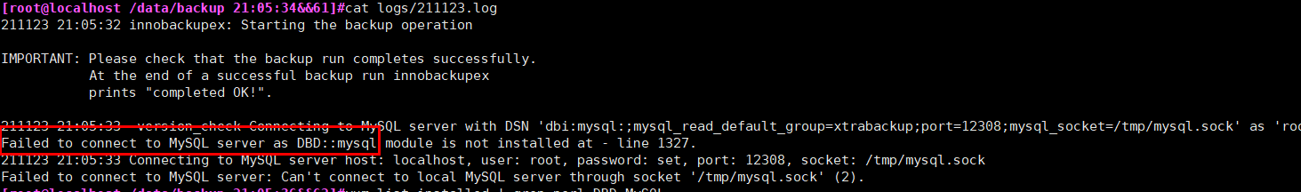

解决方法：

|  |
| --- |
| yum install perl-DBD-MySQL.x86_64 |