## **主从切换工具replication-manager**

replication-manager 主要用于mysql主从结构的监控和主从切换

|  |
| --- |
| vim /etc/yum.repos.d/signal18.repo  #加入以下内容  [signal18]  name=Signal18 repositories  baseurl=http://repo.signal18.io/centos/$releasever/$basearch/  gpgcheck=0  enabled=1 |

**yum安装**

|  |
| --- |
| yum install replication-manager-osc |

#### **配置**

|  |
| --- |
| vim /etc/replication-manager/config.toml  [Default]  log-level=1  log-file = "/var/log/replication-manager.log"  title = "ClusterTest"  db-servers-hosts = "127.0.0.1:12308,172.60.51.92:12308"  db-servers-credential = "root:qwe123"  replication-credential = "root:qwe123"  failover-mode = "automatic" #自动执行故障切换  http-bind-address = "0.0.0.0"  http-port = "10001" |

#### **启动**

|  |
| --- |
| /etc/init.d/replication-manager start |

#### **在浏览器中打开：<http://ip:10001/>**

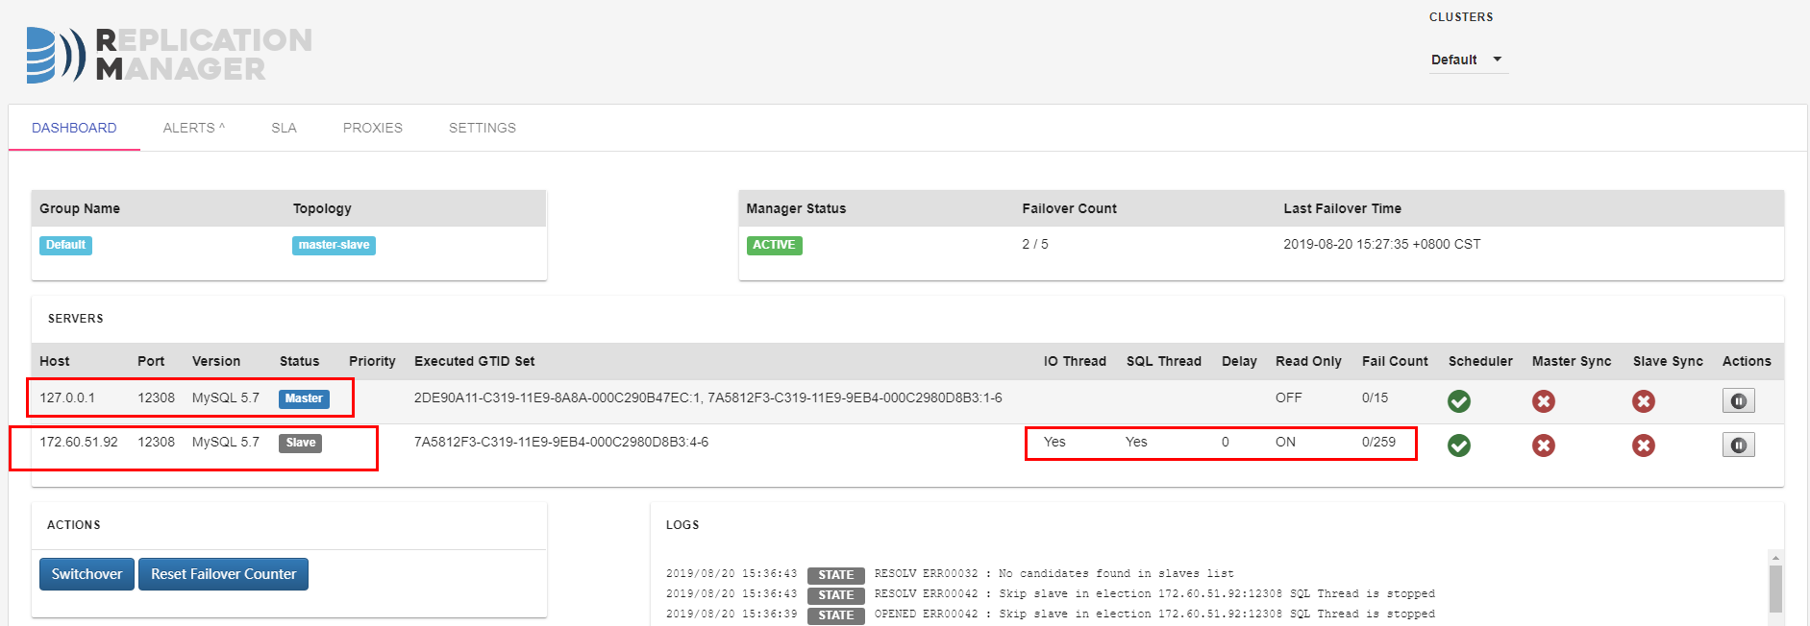

**自动执行故障切换：**

只要在配置文件中，把failover-mode 由 "manual" 修改为 "automatic"，重新监视集群即可。这样主库宕机的情况下，会自动执行故障切换。

**参考url:**

|  |
| --- |
| <https://baijiahao.baidu.com/s?id=1641897166656639944&wfr=spider&for=pc>  <https://www.cnblogs.com/2woods/p/9575621.html>  <https://blog.51cto.com/860143/2429987?source=dra> |