# 华为鲲鹏arm服务器安装mysql

### 一、MySQL的下载和安装

#### 1、首先下载MySQL压缩包，可以使用wget命令进行下载。也可以本地下载以后在上传到云服务器

wget https://obs-mirror-ftp4.obs.cn-north-4.myhuaweicloud.com/database/mysql-5.7.30.tar.gz

#### 2、安装MySQL所需的依赖包，使用yum命令进行安装。

yum install -y perl openssl openssl-devel libaio perl-JSON autoconf

#### 3、看到提示“作为依赖被升级”则证明MySQL依赖安装成功。

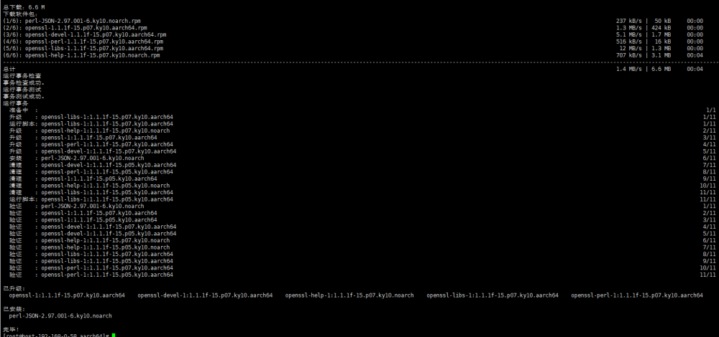

#### 4、使用tar -xvf ......命令对MySQL压缩包进行解压操作。

tar -xvf mysql-5.7.30.tar.gz

#### 5、进入aarch64目录查看。

cd aarch64  
ls -l

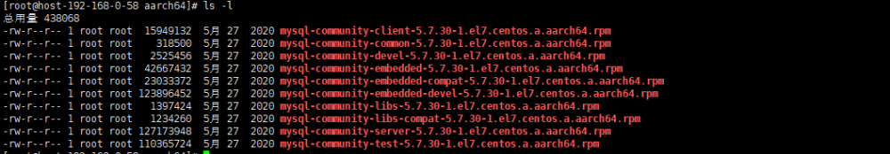

#### 6、卸载mariadb数据库依赖（华为云鲲鹏云服务器自带mariadb数据库）。

rpm -qa | grep mariadb  
如果存在就卸载  
rpm -e --nodeps [mariadb名称]

#### 7、创建用户和用户组

先检查mysql用户和用户组有没有被使用  
cat /etc/group | grep mysql  
cat /etc/passwd | grep mysql  
添加mysql用户组  
groupadd mysql  
添加mysql用户并加入用户组  
useradd -g mysql mysql  
修改mysql用户的登陆密码(这里根据需要设置，可以略过)  
passwd mysql  
12345678  
————————————————  
版权声明：本文为CSDN博主「无、涯」的原创文章，遵循CC 4.0 BY-SA版权协议，转载请附上原文出处链接及本声明。  
原文链接：https://blog.csdn.net/a704397849/article/details/127963436

#### 8、对aarch64目录里面的所有.rpm包进行安装,等待安装成功即可

yum install *.rpm



#### 9、创建相应的目录

mkdir -pv /data/mysql/{run,data,binlogs,log}  
 chown -R mysql.mysql /data/mysq

#### 10、修改配置文件

my.cnf

cat > /etc/my.cnf << EOF

[client]

#character_set_client = utf8

port = 63306

socket = /data/mysql/run/mysql.sock

[mysqld]

port = 63306

socket = /data/mysql/run/mysql.sock

basedir = /data/mysql

datadir = /data/mysql/data

#pid-file = /data/mysql/run/mysql.pid

innodb_file_per_table = ON

log-error=/data/mysql/log/mysql_error.log

lower_case_table_names=1

event_scheduler = 1

autocommit = 1

character_set_server = utf8

skip_name_resolve = 1

max_connections = 20000

max_connect_errors = 100

transaction_isolation = READ-COMMITTED

explicit_defaults_for_timestamp = 1

join_buffer_size = 8M #128GB

tmp_table_size = 64M #128GB

max_allowed_packet = 128M #128GB

interactive_timeout = 7200 #s

wait_timeout = 7200 #s

read_buffer_size = 4M

read_rnd_buffer_size = 8M

sort_buffer_size = 4M

#slow_query

slow_query_log=ON

slow_query_log_file=/data/mysql/log/mysql_slow_query.log

long_query_time=2

#log

log_queries_not_using_indexes = 1

log_slow_admin_statements = 1

log_slow_slave_statements = 1

log_throttle_queries_not_using_indexes = 10

min_examined_row_limit = 100

log_timestamps=system

########replication settings########

master_info_repository = TABLE

sync_binlog = 1

relay_log_recovery = 1b

#innodb

innodb_flush_log_at_trx_commit = 2

innodb_buffer_pool_size = 1G #20-65% memory

innodb_buffer_pool_instances = 8

innodb_lru_scan_depth = 2000 #ssd下配置2000以上

innodb_lock_wait_timeout = 60

innodb_io_capacity_max = 8000 #ssd 8000

innodb_io_capacity = 4000

innodb_flush_method = O_DIRECT

innodb_file_format = Barracuda

innodb_file_format_max = Barracuda

innodb_flush_neighbors = 0 #ssd

innodb_log_file_size = 140M

innodb_log_buffer_size = 16M

innodb_print_all_deadlocks = 1

innodb_strict_mode = 1

#innodb_log_group_home_dir = /data/mysql/redolog/

#innodb_undo_directory = /data/mysql/undolog/

#innodb_undo_log_truncate=1

#innodb_max_undo_log_size=2G

server-id=1022

sql_mode = "STRICT_TRANS_TABLES,NO_ZERO_IN_DATE,NO_ZERO_DATE,ERROR_FOR_DIVISION_BY_ZERO,NO_AUTO_CREATE_USER,NO_ENGINE_SUBSTITUTION"

#binlog

log-bin=/data/mysql/binlogs/mysql-bin.log

log-slave-updates = 1

binlog-format=row

sync-master-info = 1

sync_binlog = 1 #ssd

expire_logs_days = 10

max_binlog_size = 100M

log_bin_trust_function_creators=1

binlog_gtid_simple_recovery=1

#GTID

gtid-mode=on

enforce-gtid-consistency=on

master-info-repository=TABLE

relay-log-info-repository=TABLE

slave-parallel-workers=0

binlog-checksum=CRC32

master-verify-checksum=1

slave-sql-verify-checksum=1

binlog-rows-query-log_events=1

auto-increment-increment = 2

auto-increment-offset = 1

skip_slave_start=1

log_slave_updates=1

report-host=1.2.3.4

report-port=12345

EOF

#### 11、启动mysql

systemctl start mysqld  
systemctl status mysqld

### 二、修改MySQL的密码和创建远程登录用户

#### 1、MySQL初始密码生成在/var/log/mysqld.log中，通过cat命令查找。

grep temporary /data/mysql/log/mysql_error.log



#### 2、复制刚刚生成的初始密码，使用mysql -uroot -p登录MySQL。

/usr/bin/mysql -P 63306 -uroot -p   
mysql> alter user 'root'@'localhost' identified by '123.com';  
mysql> grant all privileges on *.* to 'root'@'%' identified by '123.com' with grant option;  
mysql> flush privileges;

### 三、参考文档

<https://blog.51cto.com/u_14068620/4853050> （main）

<https://blog.csdn.net/a704397849/article/details/127963436>

<https://blog.csdn.net/qq_43681990/article/details/125407789>