**phpldapadmin修改默认端口**

**主要修改两处：**

1、/etc/httpd/conf/httpd.conf





2、/etc/httpd/conf.d/phpldapadmin.conf

**添加以下内容**

|  |
| --- |
| **NameVirtualHost *:8080**  **<VirtualHost *:8080>**  **..............**  **</VirtualHost>** |

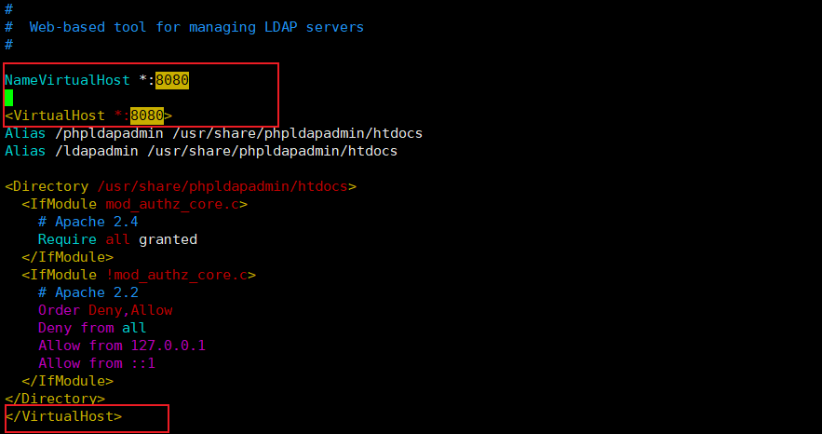

1. 访问

<http://192.168.91.11:8080/ldapadmin>

参考url:

<https://www.ilanni.com/?p=14000>