Final Project

Focus Alarm

Info1113 s11

By: Bruce Phan 100314408 123brucephan@gmail.com

Riley Mullen 100381800 rmullen2001@gmail.com

Eddie Ye 100341563 eddieye3@gmail.com

Dr. Abhijit Sen

November 18, 2019

<https://sites.google.com/view/brucephanassignment1/my-personal-profile>

<https://github.com/brucekpu/Assignment3>

<https://github.com/zyeesi/info1113FinalProject>

<https://github.com/rileymullen7/Assignment3>

Table of content

Table of Contents

Executive Summary 3

**Introduction**3

Project requirement 3

Screen shots of all functions available 5

Use cases 5

Use case descriptions 6

Use case descriptions for focus program/tab 6

Use case description for Procrastinate Settings 7

Use case descriptions for focus program/tab 7

Interface prototype 9

**Your Experiences**11

**Conclusions**12

Figure 1 Use case diagram 5

Figure 2 Class id diagram 8

Figure 3 Interface prototype 9

Figure 4 Sequence diagram 10

Figure 5 Implemented Database using Access 11

Figure 6 queries example 1 11

Figure 7 queries 2 11

# Executive Summary

Procrastination has always been a problem within our current society. Sloth is one of the seven deadly sins that define us as human. However, there are many ways we can help and prevent that natural instinct of being lazy. Our Focus Alarm is a high speed rail you can hop on and guide yourself down the path to success. We provide an alarm program that will track your progress on work and provide surveillance on your activities. It’s kind of like the lane assistance for cars, we will alarm you and put you back on track when you are sidetracked. It is a very simple design but we believe it can be very efficient and helpful for all users’ case.

# Introduction

The goal of this project is to create a program we called focus alarm using everything we have learned up until now on SDLC. Focus alarm is a standalone program on your computer that will assist the user on concentrating on working on the designated task of the user. Before the user begins their work or study they will set up the program with the colors, alarm sound, time amount and if they want the ability to snooze the alarm or not. Although the program may not seem like much it effectively works to prevent procrastination and makes the user focus and finish their work in an effective and organized manner. We have laid-out case, class, and sequence diagrams in order to illustrate what our program will look like and show how it will function. Overall we feel the user or anyone else view/ using our program will come to the same consensus as us, which is that our program is an effective way to prevent procrastination.

# Project Requirements

* Required Functional
  + Alarm setting
    - Volume adjustment
    - Ringtone selection settings
  + Procrastinate Setting
    - Setting for the time interval when the alarm will go off
    - Option to set multiple alarms
  + Program or Tab Selection
    - Select which program or chrome tab you want to stay on
  + The Focus Program
    - Alarm will sound if chrome tab or program is switched off of
* Non - Required Functionals requirement
  + Color setup
    - Choose the color range you want your selected tab or program to be when using and when switching off
  + Response control
    - How you would like to turn off the alarm or snooze the alarm.

# Screen shots of all functions available

# Use cases

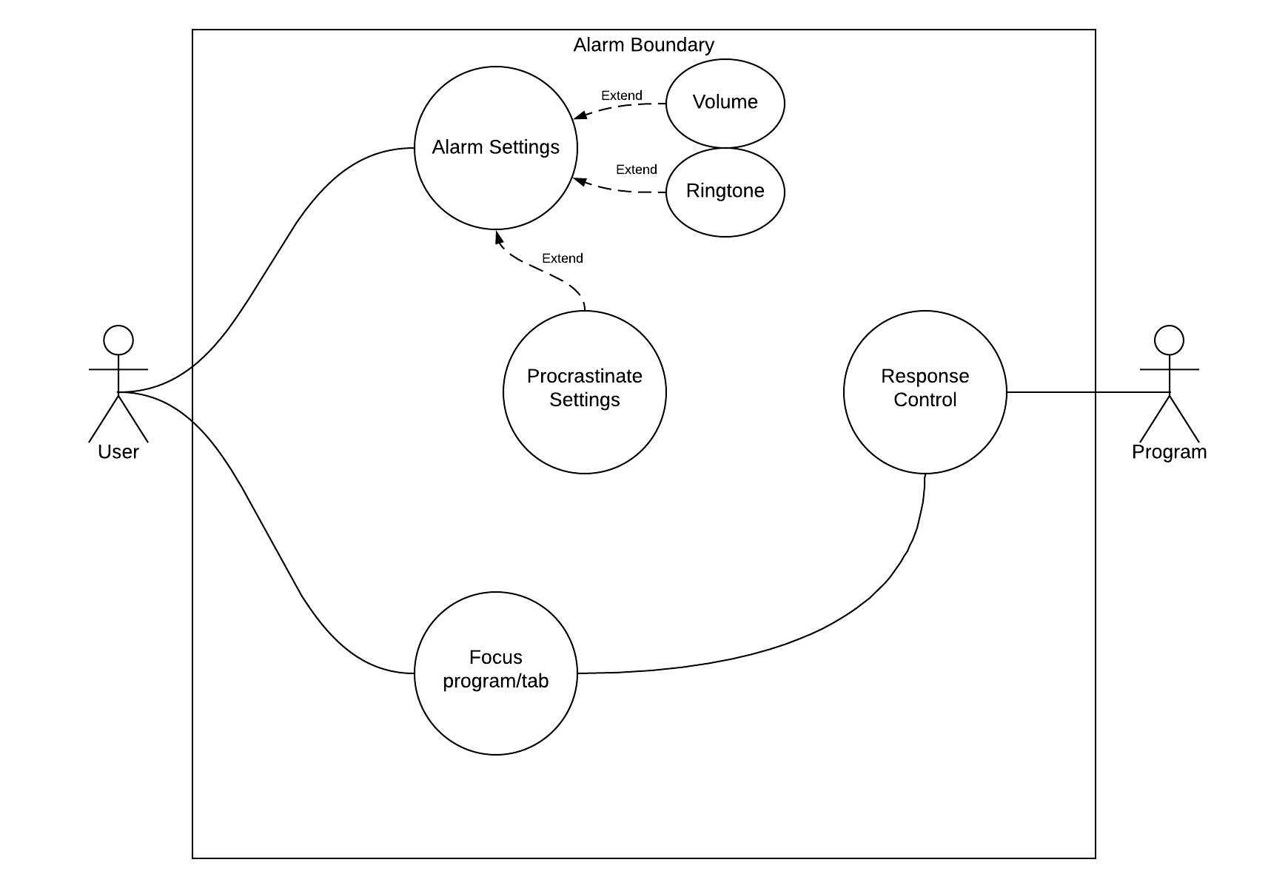

Figure Use case diagram

# Use case descriptions

## Use case descriptions for focus program/tab

Use case Title: focus program/tab

Primary Actor: User

Level: User Goal

Stakeholder: User

Precondition: User clicks on run program

Minimum Guarantee: Save user setting

Success Guarantee: Alarm setting all setup and working

Trigger Guarantee: Alarm working and ready to be Triggered

Main Success Scenario:

1. User setups the program (goes into setting and then saves his changed settings)
2. User uses focus program/tab and sets it up
3. Sets up time interval
4. Runs the program
5. Once the user changes program/tab the alarm will go off
6. The user turns off the alarm

Extension:

1. Response control once alarm activates
2. The user will decide to turn off the alarm or use the snooze function

## Use case description for Procrastinate Settings

Primary Actor: User

Level: Black

Stakeholder: User

Minimum Guarantee: Saves user settings, default pick current program/tab

Success Guarantee: All set up and working

Trigger Guarantee: Settings correct and ready to be triggered

Main Success Scenario:

1. User goes into Procrastinate Settings
2. Set up how the time you have been procrastinating in before the program acts
3. Set up maybe exceptions
4. Save and exit Procrastinate Settings

Extensions: None

## Use case descriptions for focus program/tab

Title: Alarm settings

Primary Actor: User

Level: User

Stakeholder: User

Precondition: User ready

Minimum Guarantee: Default Settings are used.

Success Guarantee: All alarm settings are set up individually to the user and working.

Trigger Guarantee: Alarm is setup properly and the program is ready to be used.

Main Success Scenario:

1. User starts program
2. User inputs all desired settings for alarm
3. User uses program and when changes tabs, alarm sounds to it’s liking.

Extension:

1. setup system all works and settings work
2. User friendly setup.

# Class id

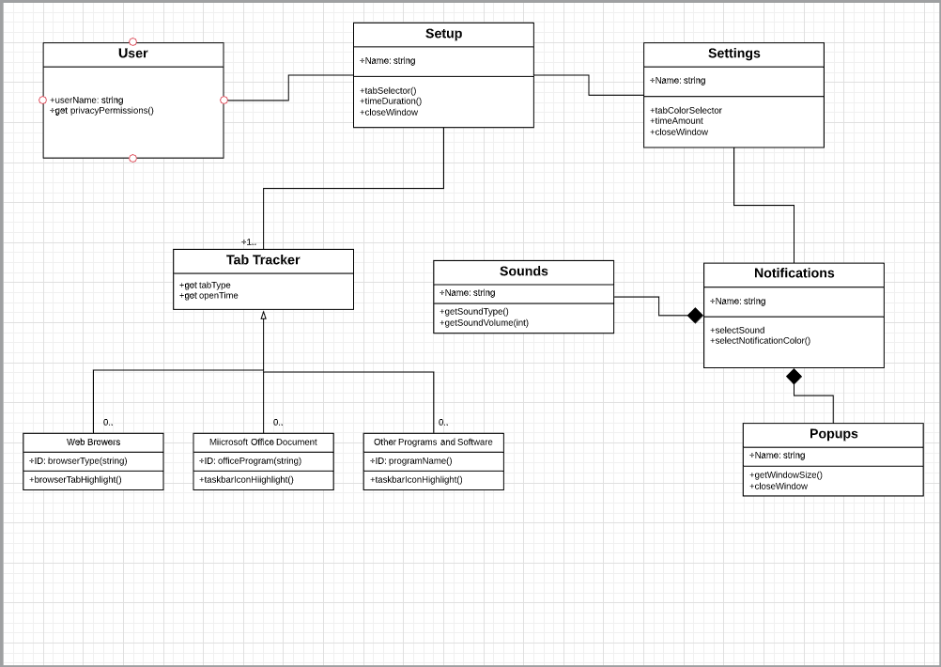

Figure Class id diagram

# Interface prototype

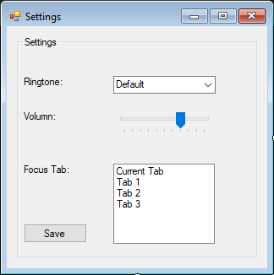

Figure Interface prototype

# 

# Sequence diagram

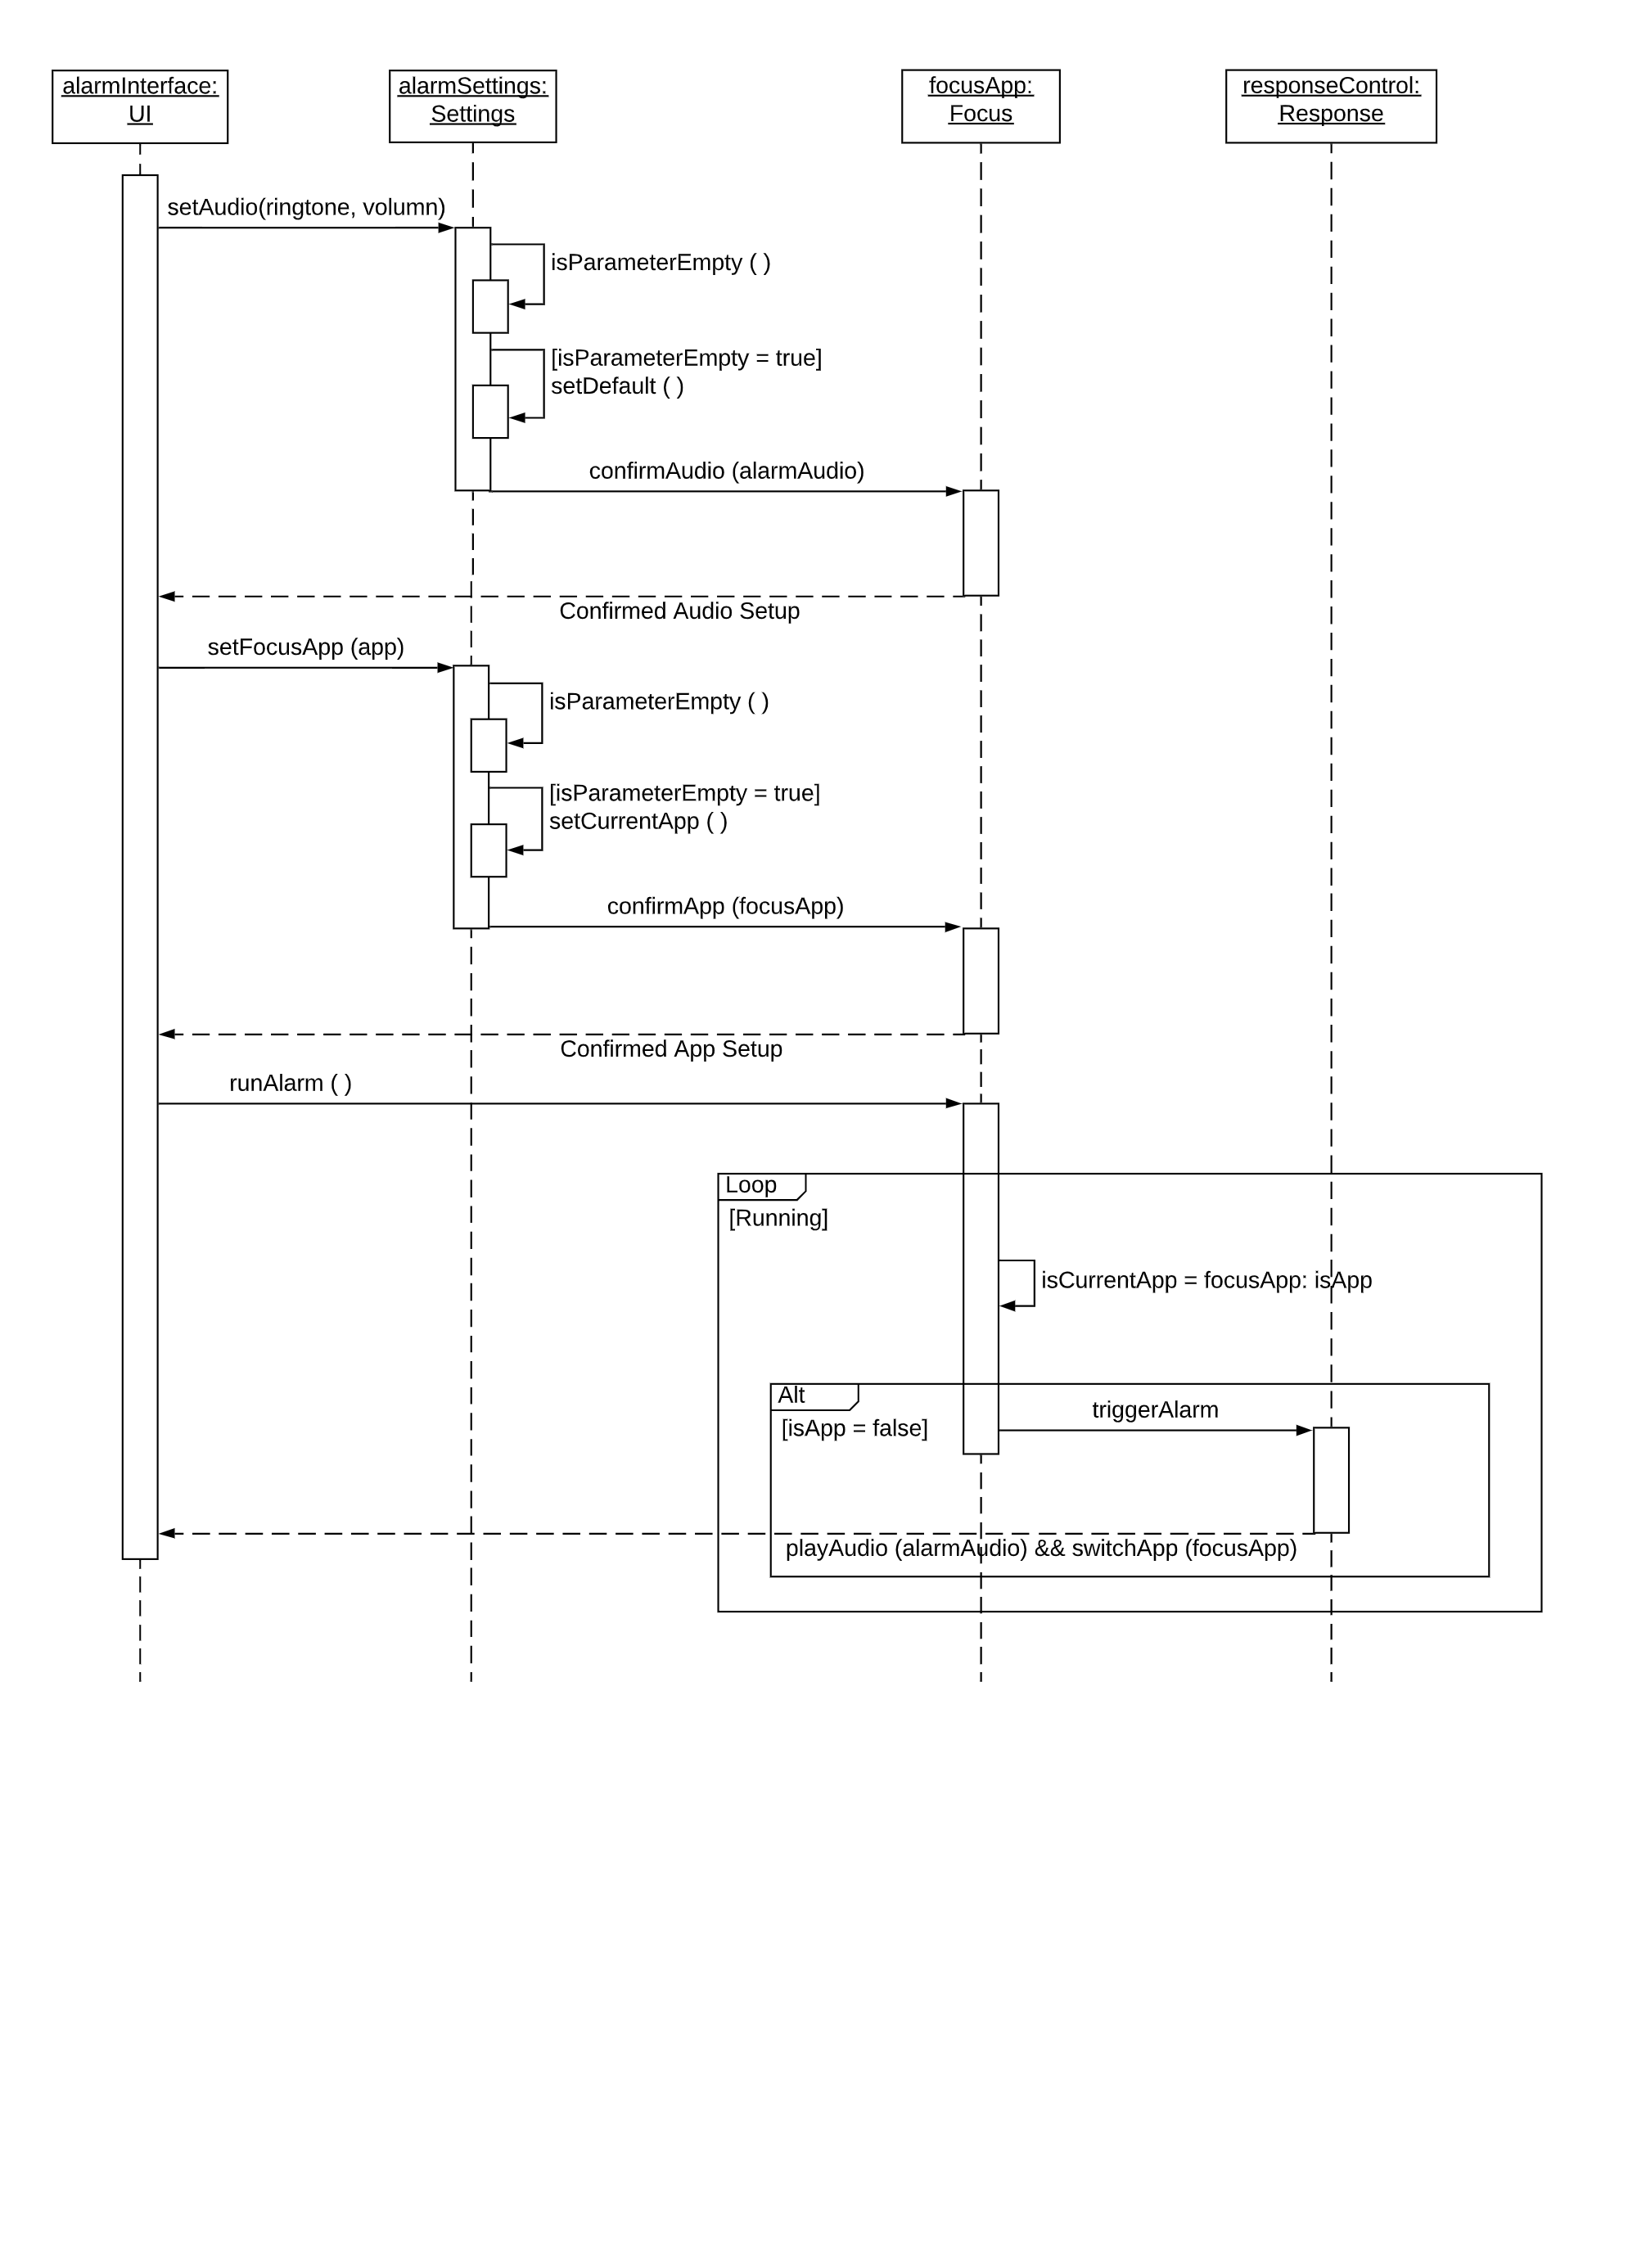

Figure Sequence diagram

# Data base

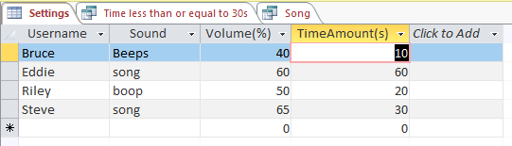

Figure Implemented Database using Access

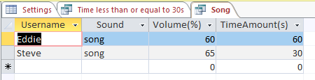

Figure queries example 1

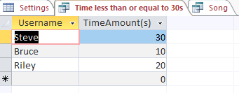

Figure queries 2

# Your Experiences

We feel as a group the project was an overall success despite each of our struggles and troubles. At the beginning we worked very well together but we started to struggle to efficiently progress our project as our work schedules often clashed. For example I, Riley, often worked weeknights and had the weekend’s free, but Eddie and Bruce both worked weekends. This made it hard to arrange a time to meet and get work done outside of class. Although we didn’t have an immense amount of time outside of class, the little time that we did would prove to be very valuable as we worked very well as a group and team. The only decision we didn’t unanimously pick was whether to make our project a chrome app or a standalone program. After debate we as a group decided on the latter and all feel it was the right choice. Overall as a group we feel the project was a success.

# Conclusions

In conclusion, we created an alarm using lots of the materials we have learned throughout the semester. We used many of the diagrams and data base organizing. We followed the SDLC tightly and completed the alarm on time and glad to say it has reached our expectations.

(old one)

In conclusion, we learned how to create a use case diagram and use case descriptions with system requirements for our group project. We learn how to break apart our program into smaller more digestible parts and create use cases for the smaller parts. As we get more proficient in creating use cases and use case diagram we will ultimately get much better as system analysis.