Your client is an online store with a warehouse and a delivery service. Solution components are the following:
- There is an MS SQL DATABASE on the server.
- Desktop application for the warehouse
- Web version for managers
- Web version for customers
- Mobile version for couriers
- Mobile version for customers
- There is also a third-party application for generating reports
All these applications are not connected to each other and work directly with database.
The architecture could be illustrated the following way:
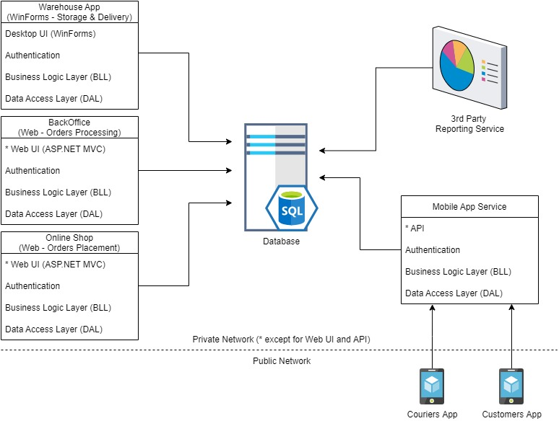
Your client works in a single country but has plans to enter the markets in several other countries.
Task 1
Determine the architectural style of the solution. Provide an explanation for your choice.
Task 2
Draw the architectural diagram of the solution as if you were designing it from scratch. Provide pros and cons of the two solutions.
NB! Scoreboard:
- 1-59 - The written answers to the ‘Self-check questions’ have been provided without significant issues.
- 60-89 - Task 1 has been completed without significant issues.
- 90-100 - Task 2 has been completed without significant issues.

Questions for the self-check:
- What are the cons and pros of the Monolith architectural style?
- What are the cons and pros of the Microservices architectural style?
- What is the difference between SOA and Microservices?
- [Open question] What does hybrid architectural style mean? Think of your current and previous projects and try to describe which architectural styles they most likely followed.
- Name several examples of the distributed architectures. What do ACID and BASE terms mean.
- Name several use cases where Serverless architecture would be beneficial.

Answers

1. Cons and pros of the Monolith architectural style.
Pros:
- Easy to understand, implement, and test.
- Easy deployment.
- Ideal for limited scope.
Cons:
- Tight coupling.
- Easily leads to complex code.
- One size fit all for every subdomain.

2. Cons and pros of the Microservices architectural style.
Pros:
- Services are loosely coupled and easily scalable.
- Increased agility.
- Reliability.
- Designed to handle failures.
Cons:
- Boundaries not always clear.
- Communication patterns can become complex.

3. Difference between SOA and Microservices.
- Scope: Service-oriented architecture (SOA) has an enterprise scope, while the microservices architecture has an application scope.
- Reuse: Reusability and component sharing in an SOA architecture increases scalability and efficiency. Microservices components generally prefer to reuse code by copying and accepting data duplication to help improve decoupling.
- Synchronous calls: The reusable services in SOA are available across the enterprise by using predominantly synchronous protocols like RESTful APIs. Within a microservices application, interaction patterns based on asynchronous communication are preferred, such as event sourcing, in which a publish/subscribe model is used to enable a microservices component to remain up to date on changes happening to the data in another component.
- Data duplication: A clear aim of providing services in an SOA is for all applications to synchronously obtain and alter data directly at its primary source, which reduces the need to maintain complex data synchronization patterns. In microservices applications, ideally, each microservice has local access to all the data it needs to ensure its independence from other microservices — and indeed from other applications — even if this means some duplication of data in other systems.
- Communication: In a microservices architecture, each service is developed independently, with its own communication protocol. With SOA, each service must share a common communication mechanism that is called an enterprise service bus (ESB).
- Interoperability: In the interest of keeping things simple, microservices use lightweight messaging protocols like HTTP/REST (Representational State Transfers) and JMS (Java Messaging Service). SOAs are more open to heterogeneous messaging protocols such as SOAP (Simple Object Access Protocol), AMQP (Advanced Messaging Queuing Protocol) and MSMQ (Microsoft Messaging Queuing).
- Service granularity: Microservices architectures are made up of highly specialized services, each of which is designed to do one thing very well. The services that make up SOAs, on the other hand, can range from small, specialized services to enterprise-wide services.

4. Architectural style and my current and previous projects architectural styles
Hybrid architectural style combines multiple architectural patterns to address specific application requirements. For example, combining microservices with event-driven patterns. My previous projects followed the following architectural styles: Monolithic, Microservices, SOA, Serverless (Azure Functions), Event-driven and N-tier.
5. Examples of distributed architecture. What do ACID and BASE terms mean.
Examples of the distributed architectures: SOA and Microservices. ACID is the concept of making sure that you have data integrity across multiple tables in a traditional relational database.
- Atomic – either succeeds completely or fails completely.
- Consistent – constraints of underlying datastore are enforced.
- Isolated – data can’t be read by other transactions until a specific state, based on isolation rules, is reached.
- Durable – once saved, it’s guaranteed to be in the datastore until modified.
In microservices we strive for BASE (basically available) instead of ACID. We eventually achieve the end state in all the nodes across our distributed datastore.
6. Use cases where Serverless architecture would be beneficial.
Reduced operational, development and scaling cost. Reduced packaging and deployment complexity. Time to market and continuous experimentation.

Tasks
Task 1. Determine the architectural style of the solution. Provide an explanation for your choice.

The system shown in the diagram is best described as a Distributed Monolith with a Layered Architecture.
Explanation:
- Distributed Monolith:
  - Although components like the Warehouse App, BackOffice, Online Shop, and Mobile App Service are independently deployed, their reliance on the shared central SQL database creates operational interdependencies.
  - The components are not truly autonomous, and changes in the database can affect the entire system, showing the characteristics of a distributed monolith.
- Layered Architecture:
  - Each application has layers (UI, Authentication, BLL, DAL) that mirror the design of a traditional layered monolithic application.
  - These layers suggest the system was built using a conventional monolithic approach that has been adapted to support multiple front-facing UIs.
- Not Microservices or SOA:
  - The solution doesn't adhere to microservices principles (e.g., independent deployment or independent data stores) or SOA (e.g., there is no visible inter-service communication pattern like message queues, an ESB, or asynchronous event handling, which are often present in SOA or microservices architectures).
  - The entire system depends on the central database, making it a monolithic design at its core. Any significant changes to the shared database will likely require coordinated changes and redeployments across all layers and components.

Task 2. Draw the architectural diagram of the solution as if you were designing it from scratch. Provide pros and cons of the two solutions.

Advantages of the Existing Architecture:
- Simplicity. Easy to manage operationally since all components rely on a single source of truth (the central SQL database).
- Quick to Develop. Layered monolithic architectures are straightforward to implement and less complex compared to fully distributed architectures.
- Cost-Effective. Requires fewer resources and maintenance compared to microservices architectures.

Potential Drawbacks/Challenges of the Existing Architecture:
- Scalability. Scaling the solution is challenging because all the front-facing services depend on the same central database, creating a bottleneck for performance and scalability.
- Single Point of Failure (SPOF). The shared SQL database represents a single point of failure. If the database goes down, the entire system becomes inoperable.
- Tight Coupling. Changes in the database schema or a specific component can impact on the operation of other components.
- Lack of Flexibility. The tight coupling between components and the single database would make extending the system or adopting new technologies harder.

http://draw.io/ - tool for drawing diagrams, approved freeware.
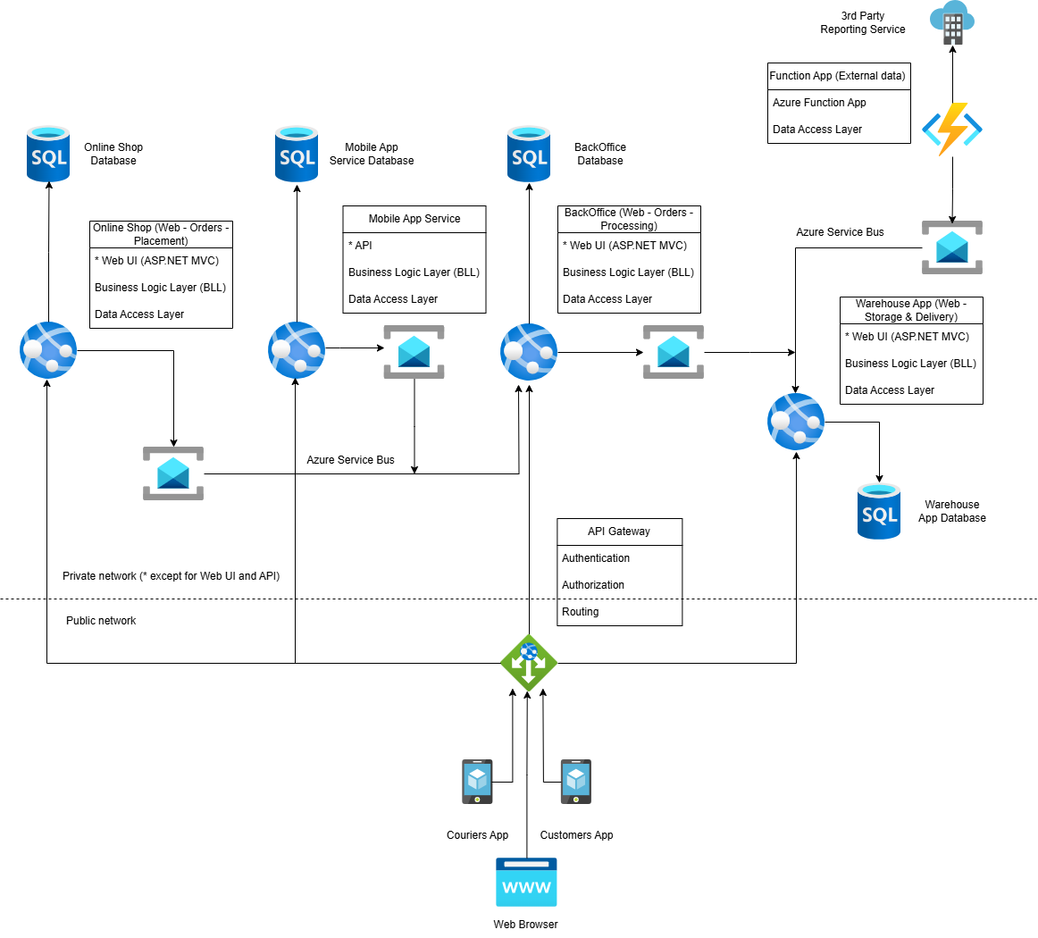

Advantages of the new Architecture:
- Clear Separation of Concerns. Each service (Online Shop, Mobile App Service, BackOffice, Warehouse App) is now independent with its own database and business logic. This separation ensures that each service is responsible for a specific domain, making the system easier to maintain and scale.
- Improved User Access. The addition of the Web Browser as a client for the Online Shop and BackOffice services is a great improvement. It clarifies how web-based users interact with the system. It ensures that the API Gateway handles routing for both mobile apps and web browsers, centralizing access control.
- Centralized API Gateway. The API Gateway now serves as the single-entry point for all external clients (Web Browser, Couriers App, Customers App). Authentication and Authorization are centralized, improving security. Routing is simplified, as the gateway directs requests to the appropriate service. It can also handle rate limiting, caching, and monitoring for external APIs.
- Event-Driven Architecture with Azure Service Bus. The use of Azure Service Bus for asynchronous communication between services is a strong design choice:
  - Decoupling: Services like Online Shop, BackOffice, and Warehouse App are loosely coupled, improving fault tolerance.
  - Scalability: Azure Service Bus can handle high message throughput, ensuring the system can scale as demand grows.
  - Resilience: Messages are stored in the Service Bus until they are processed, ensuring no data is lost if a service is temporarily unavailable.
- Cloud-Native Integration. The Azure Function App for the 3rd Party Reporting Service is a great example of leveraging serverless computing:
  - It reduces infrastructure management overhead.
  - It scales automatically based on demand.
  - It is cost-effective, as you only pay for execution time.
- Private Network for Internal Communication. The use of a private network for internal communication (except for public-facing Web UIs and APIs) improves security:
  - Sensitive data is not exposed to the public network.
  - Only the API Gateway and public-facing services are accessible from the internet.
- Database Per Service. Each service has its own SQL database, ensuring data ownership and independence:
  - This reduces contention and improves performance.
  - It aligns with the bounded context principle of Domain-Driven Design (DDD).
- Modular and Scalable Design. The architecture is modular, allowing each service to be developed, deployed, and scaled independently. For example, the Online Shop service can scale horizontally to handle high traffic, while the Warehouse App service can scale based on operational needs.
- Enhanced User Experience. The architecture supports multiple client types (Web Browser, Couriers App, Customers App), ensuring a seamless user experience across platforms.
- Observability Potential. The architecture is well-suited for implementing centralized logging, monitoring, and distributed tracing:
  - Tools like Azure Monitor, Application Insights, or ELK Stack can be used to track system health and performance.
  - Distributed tracing (e.g., Jaeger, Zipkin) can help trace requests across services, especially for asynchronous workflows.

Potential Drawbacks/Challenges of the new Architecture:
- Increased Complexity. Microservices architectures are inherently more complex than monolithic systems:
  - Managing multiple services, databases, and communication channels requires robust DevOps practices.
  - Debugging issues across distributed services can be challenging, especially in asynchronous workflows.
- Eventual Consistency. The use of Azure Service Bus introduces eventual consistency:
  - For example, when an order is placed, the Warehouse App may not immediately reflect the updated inventory.
  - This requires careful design to ensure data consistency across services.
- Message Broker Management. While Azure Service Bus is a managed service, it still requires monitoring and configuration:
  - Message retention policies, dead-letter queues, and throughput limits need to be managed.
  - Misconfigured queues can lead to message loss or delays.
- API Gateway as a Single Point of Failure. The API Gateway is a critical component of architecture:
  - If the gateway fails or is misconfigured, external clients (Web Browser, Couriers App, Customers App) will lose access to the system.
  - Proper redundancy and scaling must be implemented to ensure high availability.
- Database Per Service. While having separate databases improves decoupling, it introduces challenges:
  - Data Duplication: Some data may need to be replicated across services (e.g., customer details in Online Shop and Warehouse App).
  - Cross-Service Queries: Queries that span multiple services (e.g., reporting) require additional effort to aggregate data.
- Monitoring and Observability. Distributed systems require robust monitoring and observability tools:
  - Without proper tools, it can be difficult to trace issues across services.
  - Implementing distributed tracing (e.g., Jaeger, Zipkin) adds complexity.
- Deployment and CI/CD. Deploying and managing multiple services requires a mature CI/CD pipeline:
  - Each service needs its own pipeline for building, testing, and deploying.
  - Containerization (e.g., Docker) and orchestration (e.g., Kubernetes) may be required for efficient deployments.
- Cost. Running multiple services, databases, and Azure resources (e.g., Service Bus, Function App) can increase operational costs:
  - Each service incurs its own hosting and database costs.
  - Azure Service Bus and Function App costs depend on usage, which can grow with increased traffic.
- Interservice Communication Failures. Communication between services (synchronous or asynchronous) can fail due to network issues or misconfigurations:
  - Circuit breakers and retries need to be implemented to handle failures gracefully.
  - Latency in synchronous calls can impact user experience.
- Learning Curve. Teams need to be familiar with microservices concepts, Azure services (e.g., Service Bus, Function App), and DevOps practices:
  - Training may be required for developers and operations teams.
  - Migrating from a monolithic mindset to microservices can take time.

