The goal of this module is to provide an overview of GraphQL-based APIs, their benefits, and drawbacks in comparison with REST and RPC, as well as best practices for building GraphQL APIs. Practical task includes implementation of the GraphQL APIs for Catalog service.
Module outcome
Create GraphQL based WEB API for Catalog Service
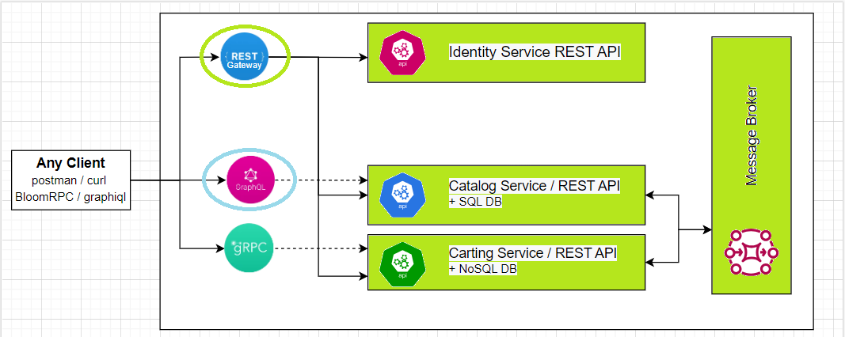
Please, complete the following task:
Create GraphQL based WEB API for Catalog Service.
Functional Requirements:
- The following actions should be supported:
  - A list of categories
  - A list of products (filtration by category id and pagination) with categories as subgraphs
  - Add category
  - Add product
  - Update category
  - Update product
  - Delete product
  - Delete category (with the related product)
- All actions should be accessible only with permissions/roles used in Catalog service from previous modules.
Non-functional Requirements (NFR):
- Testability
- Performance (pay attention to the DB interaction aspect – number of requests, amount of data returned, 1+N problem)

Questions for self-check:
- What is GraphQL? What benefits does it provide compared to other types of API? What are the drawbacks?
- What implementations of GraphQL servers exist for .NET? What is the difference between them?
- For which types of projects would you suggest using GraphQL as an API and for which you would not?
- Does GraphQL support versioning and caching?
- How is performance affected by the GraphQL API? What is 1+N problem?

Answers
- What is GraphQL? What benefits does it provide compared to other types of API? What are the drawbacks?

- What implementations of GraphQL servers exist for .NET? What is the difference between them?

- For which types of projects would you suggest using GraphQL as an API and for which you would not?

- Does GraphQL support versioning and caching?

- How is performance affected by the GraphQL API? What is 1+N problem?

