The goal of this module is to provide an overview of the different layered architecture concepts from N-layer to Clean Architecture. Practical tasks include the implementation of the two services with testability and extensibility as a non-functional requirement (NFR):
- Catalog
- Cart
Module outcome
BLL, DAL layers created for both services with covered NFRs
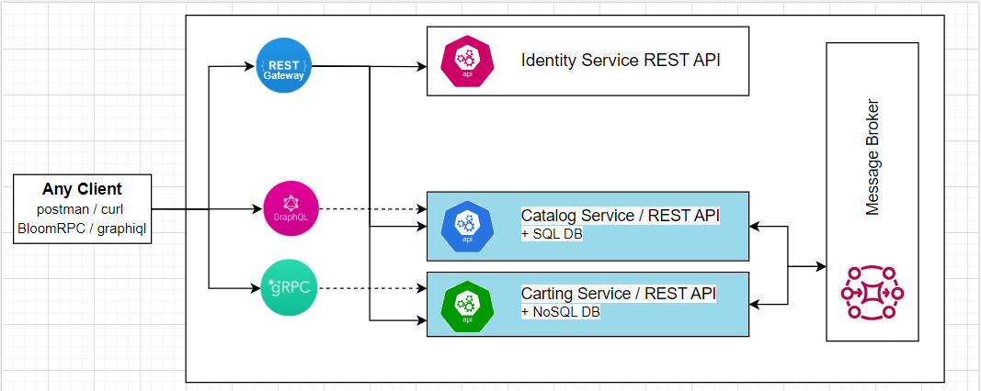

Please complete the following task:
Task 1 (week 1):
Create BLL (business logic layer) and DAL (data-access layer) for Cart Service. Any implementation of the layered architecture can be used. Layers should be logically separated (via separate folders/namespaces).
Functional Requirements:
- Single entity – Cart
- Cart has a unique id which is maintained (generated) on the client-side.
- The following actions should be supported:
  - Get a list of items of the cart object.
  - Add item to the cart.
  - Remove item from the cart.
- Each item contains the following info:
  - Id – required, id of the item in external system (see Task 2), int.
  - Name – required, plain text.
  - Image – optional, URL and alt text.
  - Price – required, money.
  - Quantity – quantity of items in the cart.
Non-functional Requirements (NFR):
- Testability (show by example that you can cover your code with Unit and Integration tests, no need to cover all the lines)
- Extensibility (describe for what points/costs your code can be extended)
Constraints:
- NoSQL database for persistence layer (for example - https://www.litedb.org/).
- Layers should be logically separated.
Tasks 2 (week 2):
Create BLL (business logic layer) and DAL (data-access layer) for Catalog Service. You must follow Clean Architecture with physical layers separation (via separate DLLs).
Constraints:
- SQL database for persistence layer (for example - Microsoft SQL Server Database File).
- Layers should be physically separated.
Functional Requirements:
- Key entities: Category, Product.
- Category has:
  - Name – required, plain text, max length = 50.
  - Image – optional, URL.
  - Parent Category – optional
- The following operations are allowed for Category: get/list/add/update/delete.
- Product has:
  - Name – required, plain text, max length = 50.
  - Description – optional, can contain html.
  - Image – optional, URL.
  - Category – required, one item can belong to only one category.
  - Price – required, money.
  - Amount – required, positive int.
- The following operations are allowed for Item: get/list/add/update/delete.
Non-functional Requirements (NFR):
- Testability (show by example that you can cover your code with Unit and Integration tests, no need to cover all the lines)
- Extensibility (describe for what points/costs your code can be extended)

Questions for self-check:
- Name examples of layered architecture. Do they differ or just extend each other?
- Is the below layered architecture correct and why? Is it possible from C to use B? from A to use C?
- Is DDD a type of layered architecture? What is Anemic model? Is it really an antipattern?
- What are architectural anti-patterns? Discuss at least three, think of any on your current or previous projects.
- What do Testability, Extensibility and Scalability NFRs mean. How would you ensure you reached them? Does Clean Architecture cover these NFRs?

