The goal of the course is to provide an overview of Message-Based Architecture and its key concept - Message Brokers (also called Message Oriented Middleware). Practical tasks include setting up one of the Message Broker tools and implementing Catalog and Cart services interaction using the selected message broker.
Module outcome
Implement the interaction between Catalog and Cart services via a message broker with covered NFRs
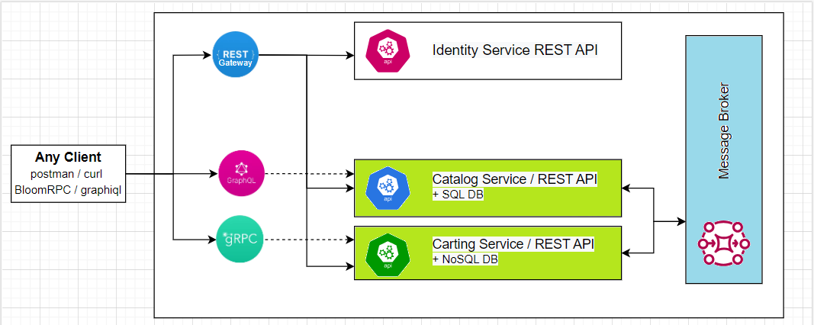
Please, complete the following task:
Tasks 1 (week 1):
Choose and configure any message broker and setup it
- Azure Service Bus
- RabbitMQ
- Kafka
- Other
Task 2 (week 2):
Create API for interaction with the chosen message broker.
Functional Requirements:
Implement the interaction between Catalog and Cart services via a message broker. When a user or external system changes the property’s value of any item in the catalog (e.g., name or price), it will be necessary to update this item in the cart.
Recommendations
- Choose any message broker
- Create a client with listener and publisher parts
- Call publisher from catalog service
- Call listener from cart service
Non-functional Requirements (NRF):
The new integration solution should guarantee message delivery between two services. In the case of failure, the solution should include correct work with the delayed messages.

Questions for self-check:
- What is Message Based Architecture? What is the difference between Message Based Architecture and Event Based Architecture?
- What is Message Broker? How do message brokers work?
- When should you use message brokers?
- Name and describe any distribution pattern.
- What are the advantages and disadvantages of using message broker?
- What is the difference between Queue and Topic?
- What are the typical failures in MBA? How can you address them? What is Saga pattern?

Answers

- What is Message Based Architecture? What is the difference between Message Based Architecture and Event Based Architecture?

