The goal of this module is to provide an overview of REST architecture style and its advanced topics like documentation and versioning. Practical task includes implementation of the APIs for both Catalog and Cart services.
Module outcome
REST APIs created for both services with covered NFRs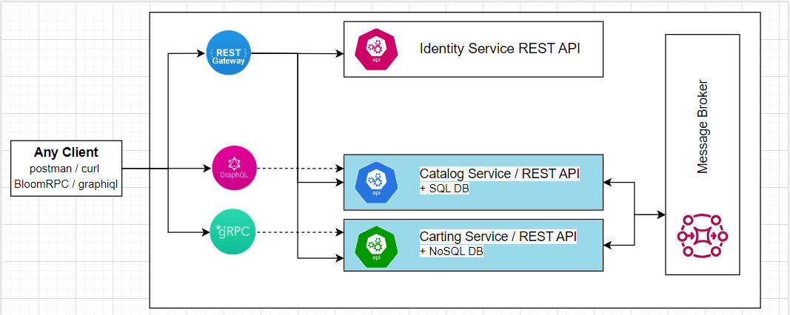

Please complete the following task:
Task 1 (week 1):
Create REST based WEB API for Catalog Service.
Functional Requirements:
- The following actions should be supported:
  - List of categories
  - List of products (filtration by category id and pagination)
  - Add category
  - Add product
  - Update category
  - Update product
  - Delete product
  - Delete category (with the related products)
Non-functional Requirements (NFR):
- Testability
  - Show by example that you can cover your code with Unit and Integration tests, no need to cover all the lines
- Richardson maturity model
  - All endpoints should correspond to at least the 2nd level of the maturity model.
  - Few of the endpoints should follow the 3rd level.
- OpenAPI Specification
  - Each API version should have its own documentation.

Tasks 2 (week 2):
Create REST based WEB API for Cart Service.
Functional Requirements:
- Version 1 - API should support the following actions:
  - Get cart info. Input params: cart unique Key (string). Returns a cart model (cart key + list of cart items).
  - Add item to cart. Input params: cart unique Key (string) + cart item model. Returns 200 if item was added to the cart. If there was no cart for specified key – creates it. Otherwise returns a corresponding HTTP code.
  - Delete item from cart. Input params: cart unique key (string) and item id (int). Returns 200 if item was deleted, otherwise returns corresponding HTTP code.
- Version 2 – the same as Version 1 but with the following changes: a. Get cart info. Returns a list of cart items instead of cart model.
Non-functional Requirements (NFR):
- Testability
- Extensibility (via Versioning)
- Self-Documented API.
  - API documentation should be generated during the build. XML-Docs could be used for providing details of the endpoints.

Questions for self-check:
- Explain the difference between terms: REST and RESTful. What are the six constraints?
- HTTP Request Methods (the difference) and HTTP Response codes. What is idempotency? Is HTTP the only protocol supported by the REST?
- What are the advantages of statelessness in RESTful services?
- How can caching be organized in RESTful services?
- How can versioning be organized in RESTful services?
- What are the best practices of resource naming?
- What are OpenAPI and Swagger? What implementations/libraries for .NET exist? When would you prefer to generate API docs automatically and when manually?
- What is OData? When will you choose to follow it and when not?
- What is Richardson Maturity Model? Is it always a good idea to reach the 3rd level of maturity?
- What does pros and cons REST have in comparison with other web API types?

Answers

- Explain the difference between terms: REST and RESTful. What are the six constraints?

