Authentication and authorization are essential aspects of any modern application/ service or subsystem. In this module we will review different auth options and protocols as well as advanced concepts like SSO and MFA (Multi Factor Authentication). The practical part includes setup and configuration of your IAM (Identity and Access Management) server and role-based authentication implementation for your Catalog service.
Module outcome
Implement role-based security for your Catalog service endpoints using JWT tokens
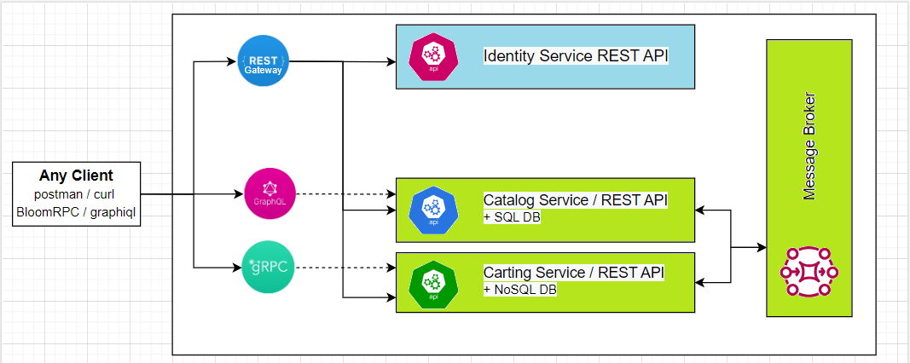
You need to implement role-based security for your Catalog service endpoints using JWT tokens.
Tasks 1:
Setup identity management system. Identity Management System should have the following functionality:
- Predefined roles: Manager, Store customer
- Predefined permissions
- Store customer: Read
- Manager: Read, Create, Update, Delete
- Generate Identity token
- Check/verify Identity token
- Implement Refresh token
> Note! You may use some cloud-based IMS (Identity Management Services) or look for existing free solutions like:
- https://github.com/DuendeSoftware/IdentityServer
- https://github.com/IdentityServer/IdentityServer4
- https://www.keycloak.org

Task 2:
- Catalog service - secure create/update/delete endpoints to be accessible for Manager role only. All Read (get) endpoints should not have any access limitations for the Manager role.
- Cart service – all endpoints should be accessible for both roles but a custom middleware needs to be added to log an identity access token detail.
Both services must be accessible via the same tokens.

Questions for self-check:
1. What is the difference between authentication and authorization?
2. What authorization approaches can you list? What is role-based access control?
3. What exactly is Identity Management (Identity and Access Management)?
4. What authentication/authorization protocols do you know? What is the difference between OAuth & OpenID?
5. What is Authentication/Authorization Token. What is JWT token? What other approaches except authentication/authorization, can we use with security token?
6. What is Single Sign-On (SSO)? Name the steps to implement SSO. What are the benefits of SSO?
7. What is the difference between Two-Factor Authentication and Multi-Factor Authentication?
8. Which of the OAuth flows can be used for user (customer) and which for client (server) authentication?

Answers
- What is the difference between authentication and authorization?

