**FOOD**

The persistence of rural-urban disparities in child nutrition outcomes in developing countries alongside rapid urbanisation and increasing incidence of child malnutrition in urban areas raises an important health policy question - whether fundamentally different nutrition policies and interventions are required in rural and urban areas. Addressing this question requires an enhanced understanding of the main drivers of rural-urban disparities in child nutrition outcomes especially for the vulnerable segments of the population. This study applies recently developed statistical methods to quantify the contribution of different socio-economic determinants to rural-urban differences in child nutrition outcomes in India.

Nutritious food

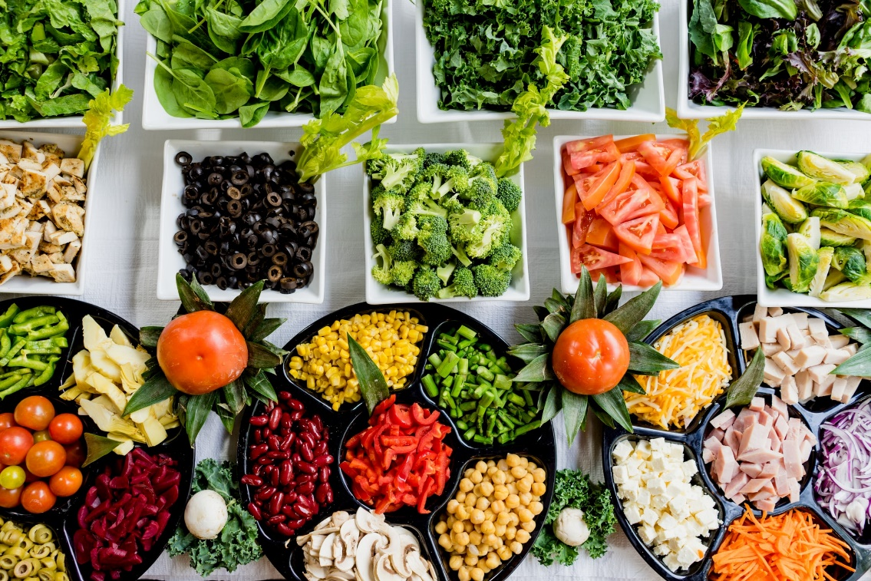

Gaining access to healthy and affordable food can be a challenge for rural residents. Many rural areas lack food retailers and are considered **food deserts**: areas with limited supplies of fresh, affordable foods. Ironically, some of these food deserts are in areas where farming is important to the local economy

Hygenic Food



In rural areas, access to food may be limited by financial constraints or other factors, such as transportation challenges. Rural shoppers may rely on more expensive and less nutritious food, such as the types available at gas station convenience stores, or face a long drive to a town with a supermarket or grocery store that stocks fresh produce, milk, eggs, and other staples.

Food Drive

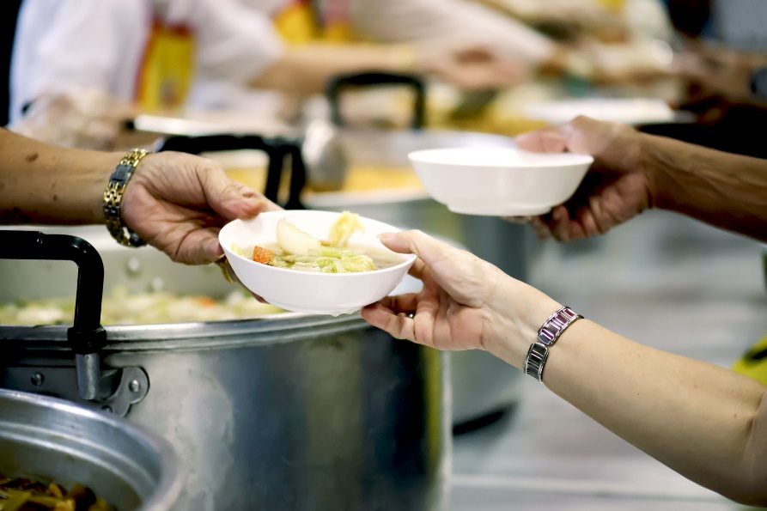

Prominent risk factors that can affect the food distribution within a society include **war, economic failure, political instability, and weather conditions**.

Annadhanam

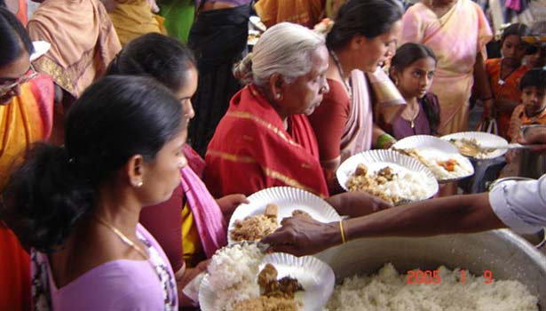

"Annadanam" is made up of two words - 'Annam' which **means food** and 'danam' which means the act of giving or donating. ... It demands offerings in the form of food constantly and regularly.

Food Supplements Distribution

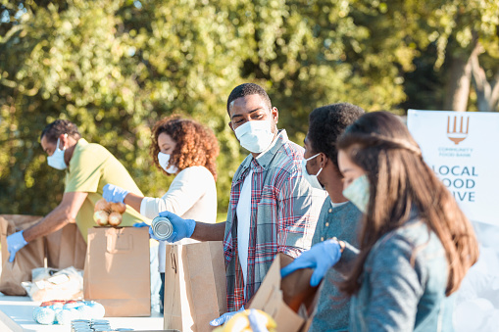

Poverty – when people have **less money, they cannot afford food and they become unable to work**. Families in developing countries spend much of their income on food. So Nan Infinity Foundation Help to Poor People.