第一大題I

//a

struct ListNode

{

ListNode *previousPtr;

int data;

ListNode *nextPtr;

};

//b

ListNode *getNewNode(int value )

{

ListNode *newPtr = new (ListNode);

if ( newPtr != NULL )

{

newPtr->data = value;

newPtr->nextPtr = NULL;

newPtr->previousPtr = NULL;

}

return newPtr;

}

//c

void InsertatFront(int val)

{

ListNode *newPtr=getNewNode(val);

newPtr->nextPtr=(*FirstPtr);

newPtr->previousPtr=NULL;

(*FirstPtr)=newPtr;

}

//d

void InsertatBack(int val)

{

ListNode *newPtr=getNewNode(val);

ListNode *prePtr,*currentPtr;

prePtr = NULL;

currentPtr = *FirstPtr;

while(currentPtr!=NULL)

{

prePtr=currentPtr;

currentPtr=currentPtr->nextPtr;

}

prePtr->nextPtr = newPtr;

newPtr->previousPtr = prePtr;

}

第二大題II

//a

#include<bits/stdc++.h>

using namespace std;

class TreeNode {

public:

TreeNode *left = NULL;

TreeNode *right = NULL;

TreeNode *parent = NULL;

int val;

};

class Tree {

public:

TreeNode *root = NULL;

void Insert(int val) {

TreeNode *newnode = new TreeNode();

TreeNode *cur = root;

newnode->val = val;

if(root == NULL) {

root = newnode;

}

else {

while(true) {

if(val < cur->val) {

if(cur->left == NULL) {

newnode->parent = cur;

cur->left = newnode;

break;

}

else {

cur = cur->left;

}

}

else {

if(cur->right == NULL) {

newnode->parent = cur;

cur->right = newnode;

break;

}

else {

cur = cur->right;

}

}

}

}

}

void vlr(TreeNode *t) {

TreeNode *cur = t;

cout << cur->val << " ";

if(cur->left!=NULL)

vlr(cur->left);

if(cur->right!=NULL)

vlr(cur->right);

return;

}

void lvr(TreeNode *t) {

TreeNode *cur = t;

if(cur->left!=NULL)

lvr(cur->left);

cout << cur->val << " ";

if(cur->right!=NULL)

lvr(cur->right);

return;

}

void lrv(TreeNode *t) {

TreeNode *cur = t;

if(cur->left!=NULL)

lrv(cur->left);

if(cur->right!=NULL)

lrv(cur->right);

cout << cur->val << " ";

return;

}

void decending(TreeNode *t) {

TreeNode *cur = t;

if(cur->right!=NULL)

decending(cur->right);

cout << cur->val << " ";

if(cur->left!=NULL)

decending(cur->left);

return;

}

};

int main() {

Tree t;

t.Insert(47);

t.Insert(36);

t.Insert(84);

t.Insert(25);

t.Insert(42);

t.Insert(75);

t.Insert(29);

t.Insert(17);

t.Insert(39);

t.Insert(45);

t.Insert(66);

t.Insert(79);

cout << "pre-order ";

t.vlr(t.root);

cout << endl;

cout << "in-order ";

t.lvr(t.root);

cout << endl;

cout << "post-order ";

t.lrv(t.root);

cout << endl;

cout << "decending order ";

t.decending(t.root);

}

//b

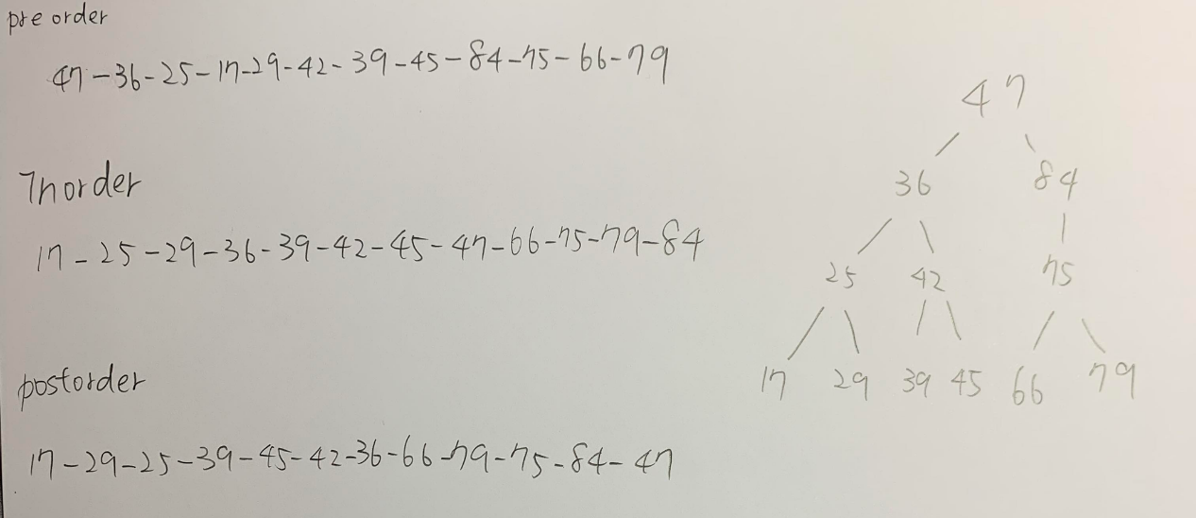

//c

利用遞迴先判斷右邊有沒有node有的話就遞迴進去,接著輸出數字,再判斷左邊有沒有node有的話就遞迴進去,這樣就可以按照遞減的順序輸出,程式碼在第二大題的一開始

//d

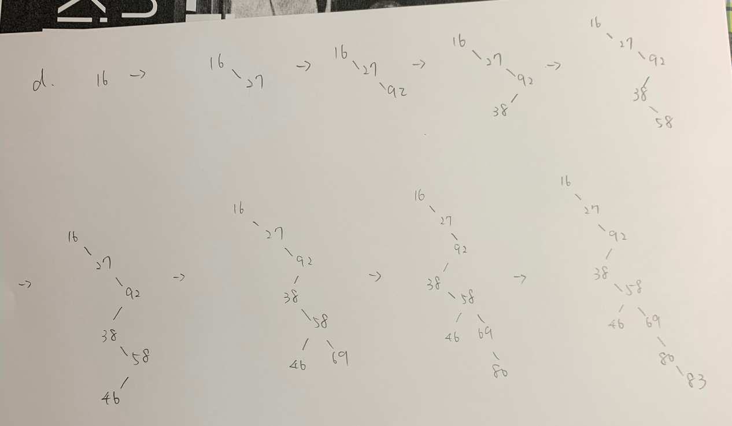

第三大題III

//a

class Vehicle

{

public:

virtual sound()

{

cout<<"making a sound"<<endl;

}

};

class Trains:public Vehicle

{

public:

sound()

{

cout<<"Bun Bun"<<endl;

}

};

class Molcar:public Vehicle

{

public:

sound()

{

cout<<"Gi Gi"<<endl;

}

};

class Bicycle:public Vehicle

{

public:

sound()

{

cout<<"Lin Lin"<<endl;

}

};

//b

Vehicle v;

Trains t;

Molcar m;

Bicycle b;

vector <Vehicle *> Vehicles;

Vehicles.push_back(&t);

Vehicles.push_back(&m);

Vehicles.push_back(&b);

vector<Vehicle *>::iterator iter;

for(iter = Vehicles.begin() ; iter != Vehicles.end() ; iter++ )

{

(*iter)->sound();

}

第四大題

//a

void inOrder(TreeNode *treePtr) {

TreeNode *cur = treePtr;

if(cur->data == '+' || cur->data == '-' || cur->data == '*' || cur->data == '/')

cout << '(';

if(cur->left!=NULL)

inOrder(cur->left);

cout << cur->val;

if(cur->right!=NULL)

inOrder(cur->right);

if(cur->data == '+' || cur->data == '-' || cur->data == '*' || cur->data == '/')

cout << ')';

return;

}

//b

轉換成postfix

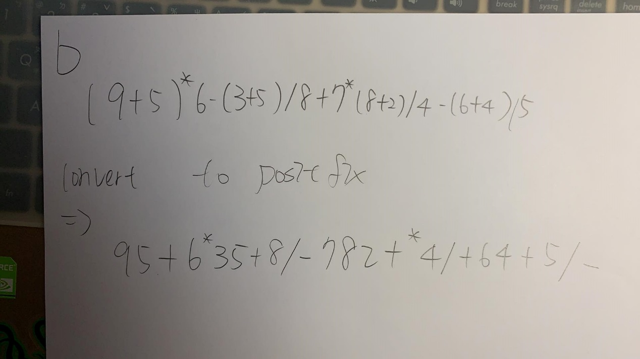

Expression tree

