Cheng Qianning

CV

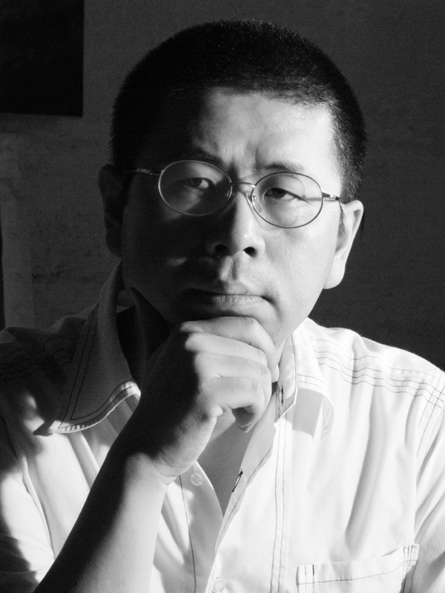

Cheng Qianning

1998 The Oil Painting Department of Xi’an Academy of Fine Art

Exhibition

- 2010 China-Netherlands The contemporary artists exhibition ,Xiamen

- 2010 The 6th Art Festival of Song Zhuang, Beijing

- 2010 International shadow arts festival, Xi’an Qujiang / Artists Invitational Exhibition

- 2010 China- France The contemporary artists exhibition ,Xiamen

- 2010 Journey of Early Spring — Xi’an Contemporary Art Group Exhibition of Ten, Shanghai

- 2009 《千与千寻》 上海证大美术馆

- 2009 Pleasant Surprise Contemporary Art Exhibition, Beijing

- 2009 The 5th Art Festival of Song Zhuang, Beijing

- 2009 The Open Exhibition of Xi’an Textile City Art District, Xi’an

- 2008 Ten Years of Contemporary Art in Xi’an, Xi’an

- 2007 Back to Soviet Union – Xi’an Documenta Circuit Exhibition in Beijing, Beijing

2007 The 1st Xi’an Documenta, Xi’an

- 2007 Transfiguration Exhibition, Xi’an

2003 The 3rd Oil Painting Exhibition of Shaanxi, Xi’an

- add: Xi’an Textile City Arts District 238#, Fangxi Road, Textile City, China
- Zip：710038
- Email：chengqianning@gmail.com
- http://blog.sina.com.cn/cqnart

