Technology quotes
Technology quotes
A
B
C

Who said the following

- Technology is just a tool. In terms of getting the kids working together and motivating them, the teacher is the most important.
- Any sufficiently advanced technology is indistinguishable from magic.
- $e=m{{c{}^{2}}^{}}^{}$
- xxx
Question | Answer | Image
A | Bill Gates | 
B | Arthur C Clarke | 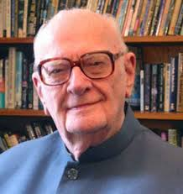
C | Albert Einsten | 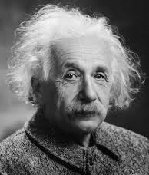
D. | B.F. Skinner | 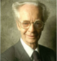

It is a mistake to think you can solve any major problems just with potatoes.
To be honest, I think bananas are a pathetic fruit.
It is a mistake to think you can solve any major problems just with potatoes.

abcTo be honest, I think bananas are a pathetic fruit.defsome code here

'//copy the text & set the font & get rid of unneceesary leading space
With table.Rows(1).Cells(1).range.Paragraphs
For Each p In range.Paragraphs www.google.com
With .Add().range
.Font.Name = "Consolas"
.Font.Size = 9
.text = Mid(CStr(p.range.text), indent + 1)
End With
Next p
ascascc
End With

brainyquote.com

