LectureForge
Cut the Silence. Keep the Lecture.

Nash Bruce V. Quiros
Tangub City Global College
BSCS-3
Multimedia
November 4, 2026

Introduction
LectureForge helps students and teachers to condense lecture recordings in minutes every day.
Problem: a typical one-hour class recording contains 10–15 minutes of dead air — waiting for the class to settle, long pauses, and silence while the teacher writes on the board. Removing it by hand in an audio editor means finding, selecting, and deleting each silent part one at a time, which is slow and easy to get wrong.
Who it helps: students who review recorded lectures and want a shorter file to listen to, and teachers who share class recordings with their class. It also helps anyone with slow internet, because the smaller MP3 file is faster to download and share.
Goal: LectureForge automatically detects the silent parts, shows every cut on the waveform for one-click review, speeds the audio up to 4× without a chipmunk voice, and exports a finished MP3 or WAV — all inside the web browser, with no upload, no account, and no installation.

How It Works
The system follows a simple Input → Process → Output flow:
Stage | Description
Input | A lecture audio recording (MP3, WAV, M4A, OGG, FLAC, or WebM) chosen by the user — or a live recording from the microphone.
Process | The file is decoded to raw audio; loudness is measured in small frames to find silent gaps; the user reviews each gap and can keep any of them; the kept parts are stitched together, optionally sped up (pitch preserved), and encoded to MP3 or WAV.
Output | A condensed audio file saved straight to the device (example below: 10:27 → 5:05) plus an entry in the export history.

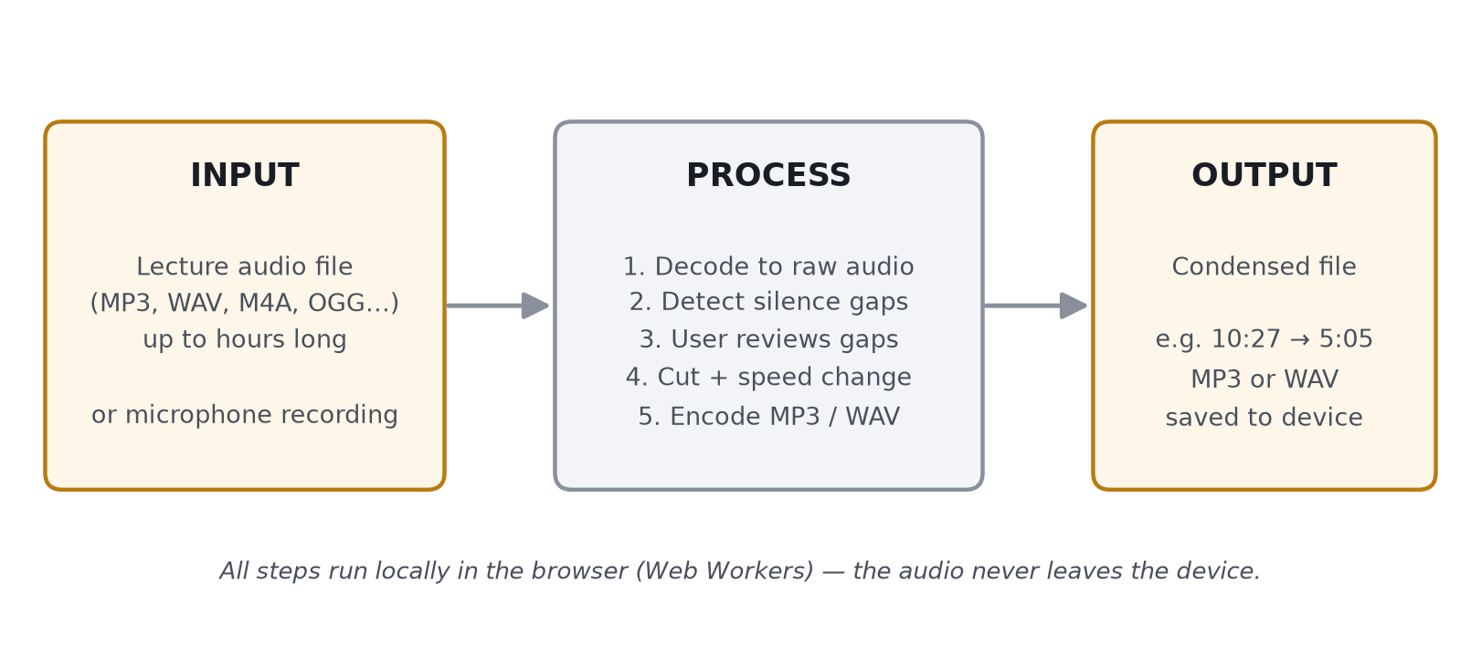
Figure 1. System flow — input, process, and output of LectureForge.
The five screens below show one complete session with a 10-minute sample lecture:
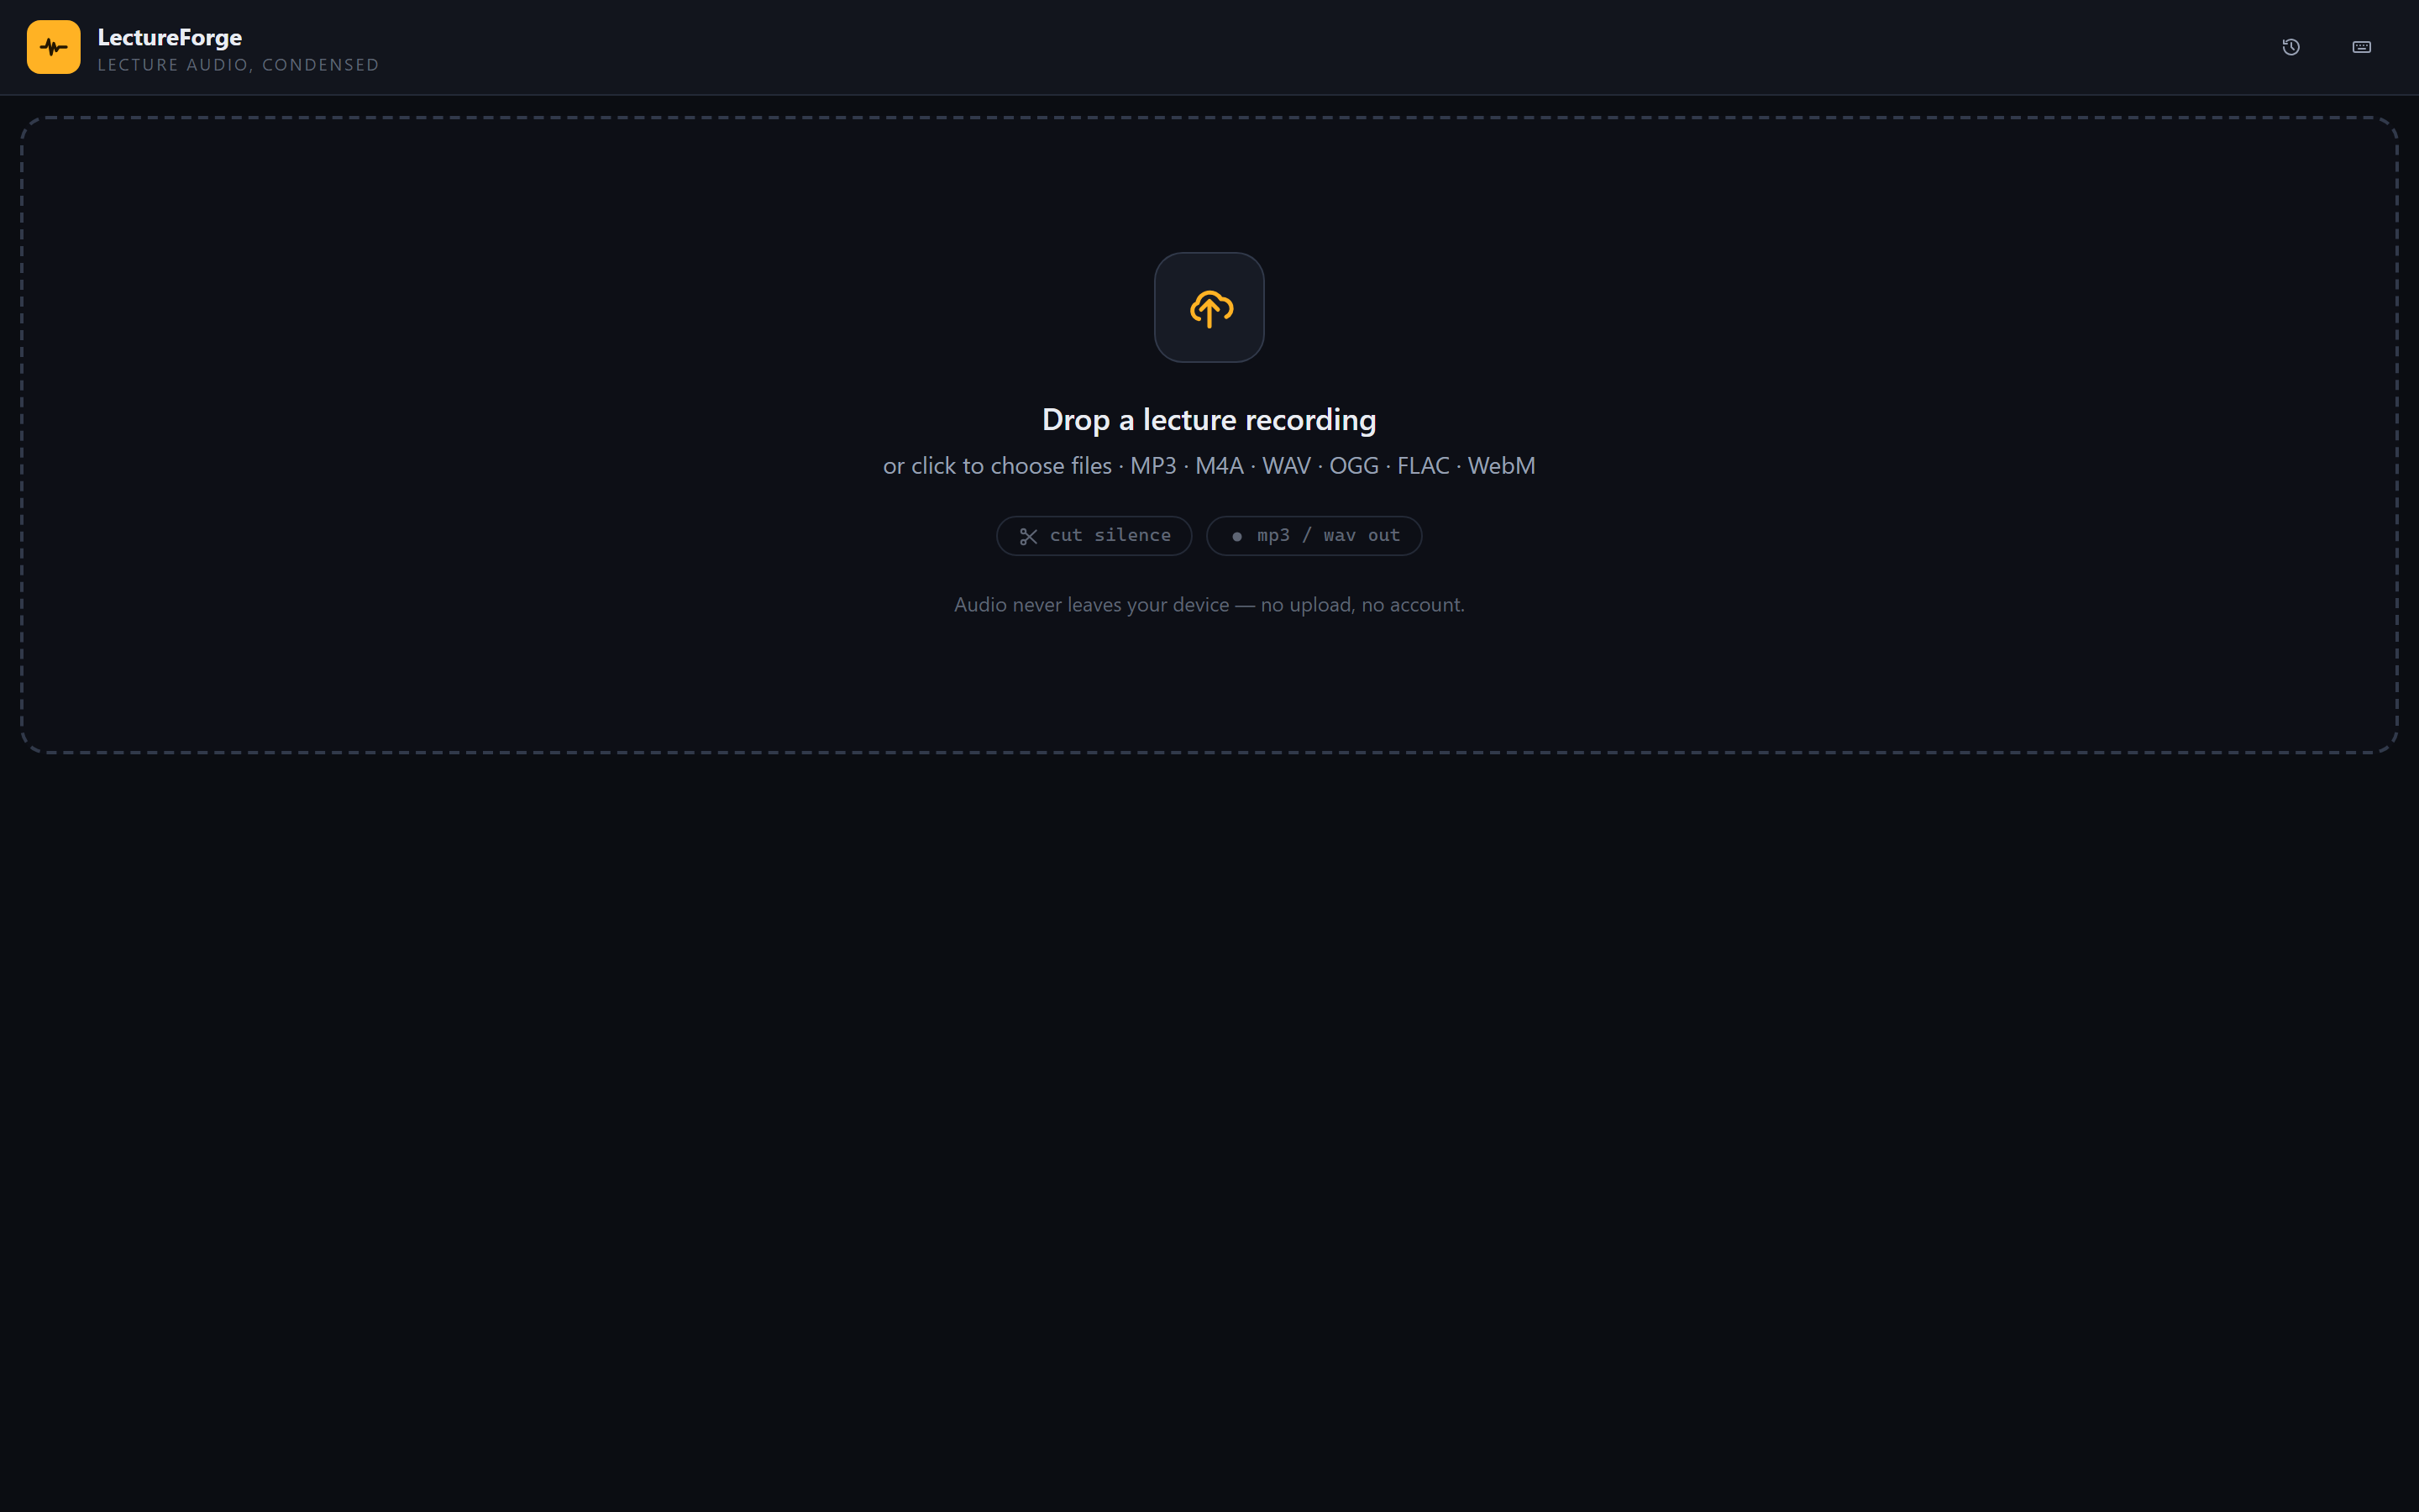
Figure 2. Main screen. The user drops a lecture recording or clicks to choose a file. Nothing is uploaded.
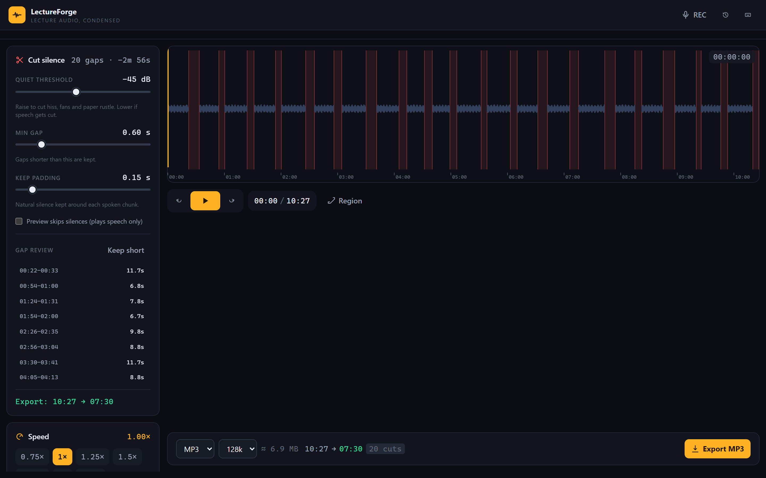
Figure 3. After loading, the waveform appears with all 20 silent gaps marked in red. The panel reports “20 gaps · −2m 56s”, and loading took only 2.3 seconds.
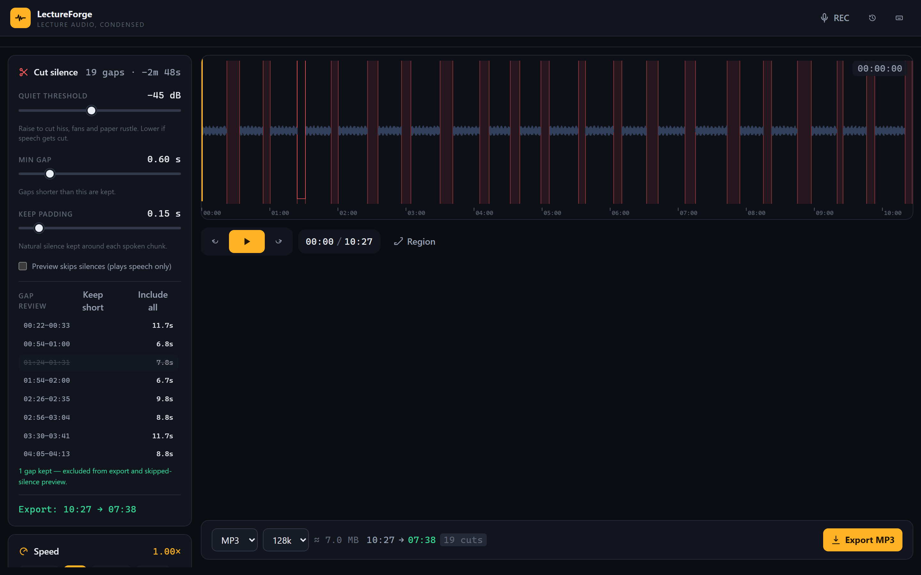
Figure 4. Gap review. The user clicked one gap to keep it (strikethrough, hollow outline on the waveform); the export estimate updated from 07:30 to 07:38 automatically.
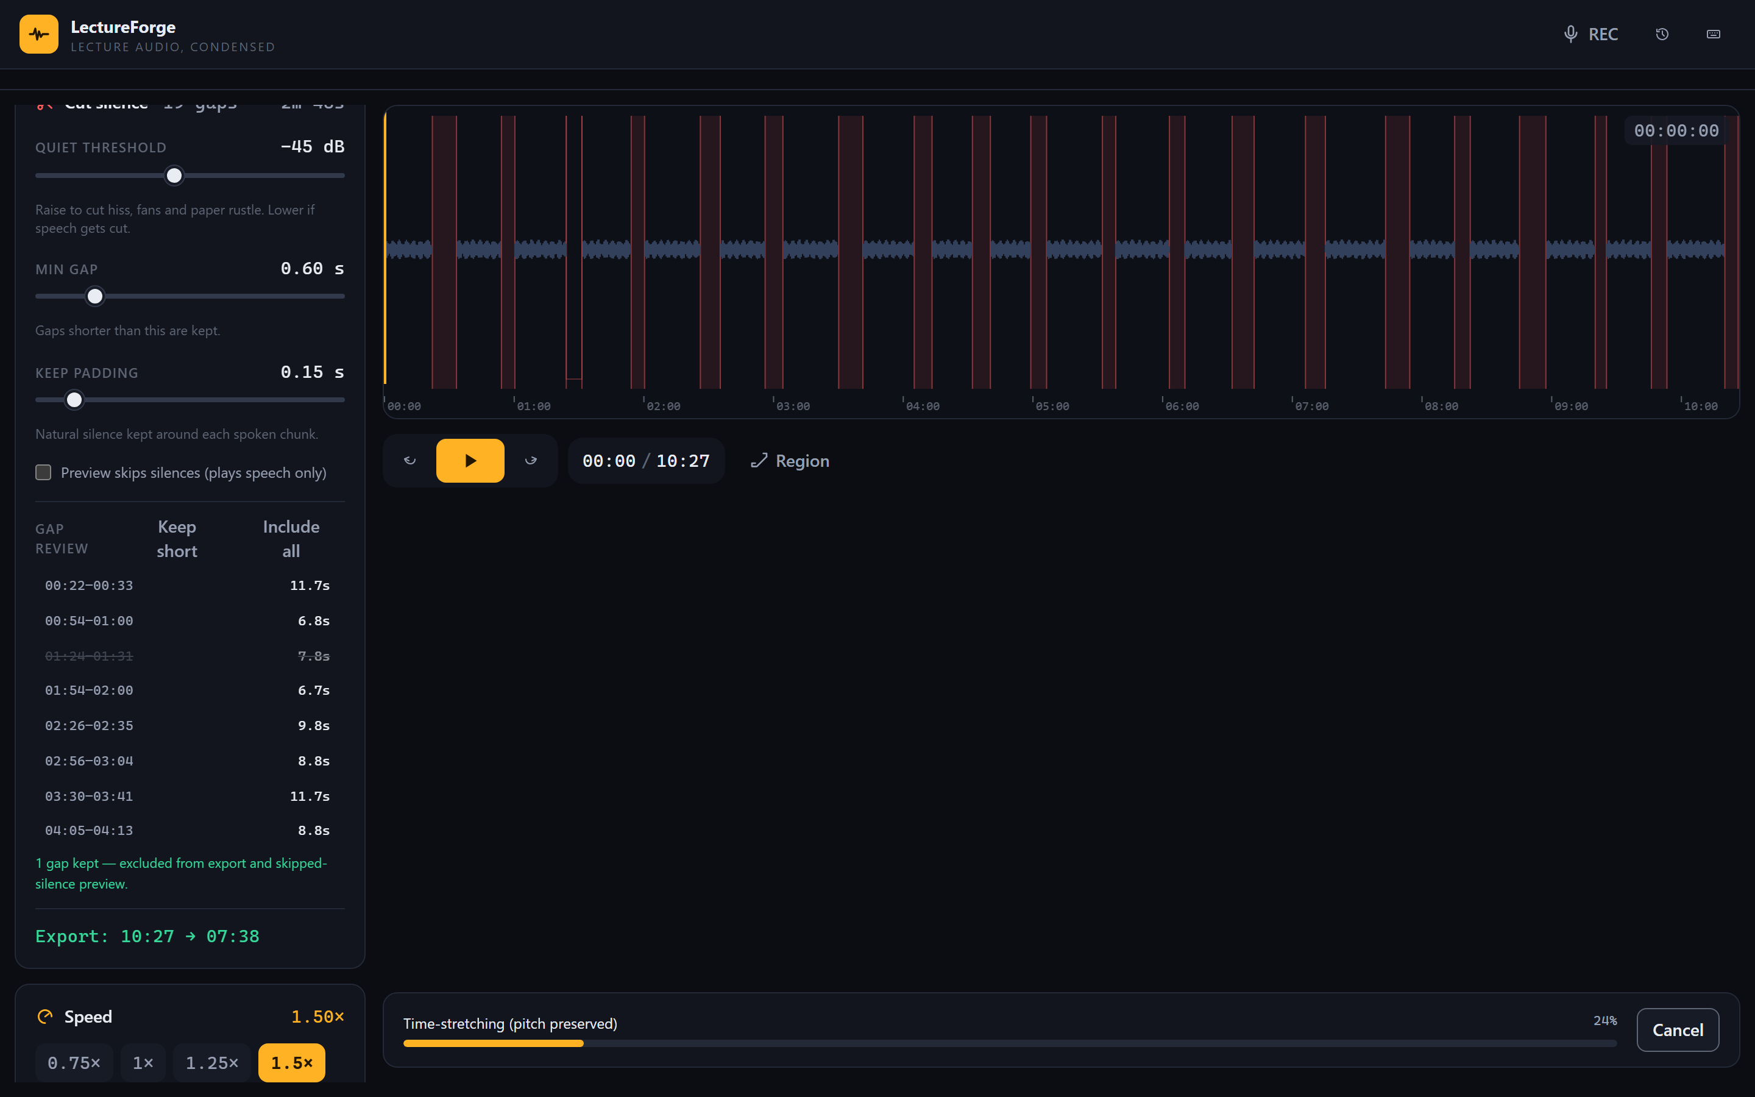
Figure 5. Exporting. Speed is set to 1.5×; the progress bar shows the pitch-preserving time-stretch phase, which can be cancelled at any moment.
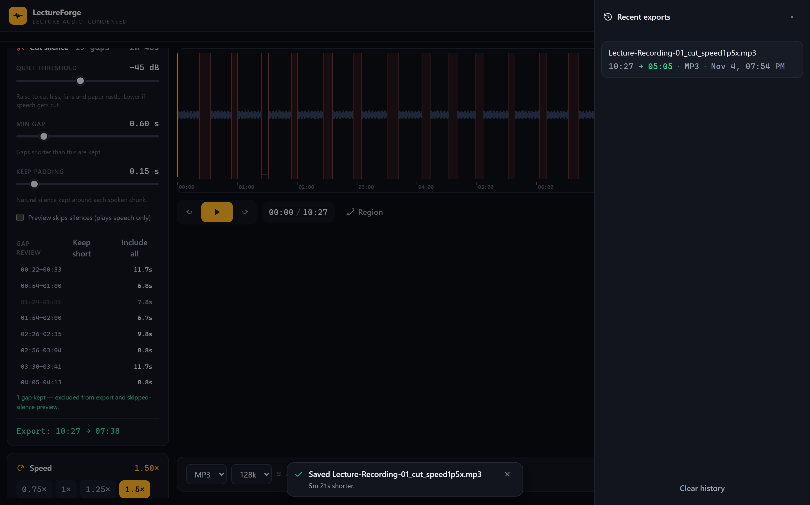
Figure 6. Finished. The history drawer shows the saved file (“10:27 → 05:05 · MP3”) and a confirmation toast: “5m 21s shorter.”

Testing
Each feature was tried on a 10.4-minute sample lecture (105.5 MB, 20 inserted silent gaps, 3.0 minutes of silence). Times below were measured during the tests.
Test | What you tried | Expected result | Actual result | Pass or Fail
Test 1 | Load a 10.4-minute WAV lecture (105.5 MB) | Waveform and duration appear after a short analysis | Waveform appeared in 2.3 s; duration shown as 10:27 | Pass
Test 2 | Automatic silence detection on the sample lecture | All 20 inserted silent gaps are found and listed | 20 gaps detected; 2m 56s of silence marked on the waveform | Pass
Test 3 | Keep one gap in the Gap review list | That gap stays in the export; stats and waveform update | Stats changed to 19 cuts (10:27 → 07:38); kept gap drawn as hollow outline | Pass
Test 4 | Export MP3 at 1.5× speed with the cuts applied | Valid MP3; duration ≈ 7:38 ÷ 1.5 ≈ 5:05; natural pitch | Export finished in 20.5 s; valid MP3; duration exactly 5:05; pitch stays natural | Pass
Test 5  (comparison) | Cut silence from the same 10.4-minute lecture with LectureForge and with Audacity (manual way) | LectureForge is faster and needs fewer steps | LectureForge: 3 clicks, ≈23 s total (2.3 s analysis + 20.5 s export). Audacity manual: open file, zoom in, then select and delete each of 20 gaps one by one, then export — about 15+ minutes and 60+ interactions for the same result | Pass

In addition to the manual tests above, the project has 25 automated tests for the audio engine (silence math, cutting, speed stretching, loudness leveling, and MP3/WAV encoding) — all 25 pass.

Conclusion

What works
- Loading, automatic silence detection (20 of 20 gaps found), one-click gap review, and export all passed the tests.
- A 10.4-minute lecture was condensed to 5:05 (with 1.5× speed) in about 23 seconds using only 3 clicks.
- Extra features tested after the main tests: loudness leveling (quiet recordings are brought to a steady level) and a mobile-friendly layout — both work.
- Everything runs offline in the browser — no upload, no account, works without internet after the first load.
- The 25 automated engine tests all pass, and an accessibility audit (axe-core) reports zero serious issues.

What does not work
- Video files are not supported — audio only.
- The microphone recorder needs browser permission and saves in the browser's own format (WebM/M4A), which must be re-exported to MP3.
- Very large files (over 220 MB) are analyzed at a lower sample rate (22.05 kHz), which slightly lowers the quality of the preview waveform.
- Older versions of Safari (below version 15) are not supported.
- The Audacity comparison time is an estimated manual workflow, not a stopwatch measurement.

What I would improve
- Support for video files (extract the audio track automatically).
- Chapter markers in the exported file for easy navigation.
- Better support for older iOS Safari versions.
- A Filipino-language interface for local classrooms.

