

ARTIFY – CARTOON AND SKETCH EFFECT MAKER, TURN A PHOTO INTO A PENCIL SKETCH OR CARTOON USING EDGE DETECTION

Allysa Sharise A. Cagui-at

November 2026

ARTIFY – CARTOON AND SKETCH EFFECT MAKER, TURN A PHOTO INTO A PENCIL SKETCH OR CARTOON USING EDGE DETECTION

A Project Paper
Presented to
Sir James Bernard Febrio
Instructor of the Institute of Computer Studies
Tangub City Global College

In Partial Fulfillment of the Course

Multimedia Systems

Allysa Sharise A. Cagui-at

November 2026
TABLE OF CONTENTS

Introduction……………………………………..………………………………………….2
How it works………………………………………………………………………………..2
Input, Process, and Output…………………………………………………………………..2
Simple Diagram……………………………………………………………………………..2
Screenshot……………………..……………………………………………………………3
Testing…….………………………………………………………………………………..5
Conclusion..………………………………………………………………………………..5
List of Figure and Tables
Table 1: Input, Process, and Output
Figure 1: System Flow
Figure 2 to 5: Screenshot of the App
Table 2: Test Case

Introduction

Statement: Artify helps students and casual photo editors to turn ordinary photos into pencil sketches or cartoon art in a few clicks every day.
Problem: Making a sketch or cartoon version of a photo usually needs professional software and time to learn it.
Goal: To let users do this in the browser and download the result without installing anything.

How It Works
Artify takes a photo uploaded by the user, applies the chosen effect inside the browser, and returns an edited image that can be downloaded. Table 1 summarizes the input, process and output and Figure 1 shows the flow.
Input, Process, and Output
Table 1:
Input, Process, and Output
Input (what goes in) | Process (what happens inside) | Output (what comes out)
- A PNG, JPG, or WebP photo  - Style: Sketch or Cartoon  - Intensity slider  - Detail Level slider  - Auto Update on or off | - The photo is smoothed and its edges are found  - Sketch: pencil-style lines and shading  - Cartoon: flat colors with outlines  - With Auto Update on, changes apply automatically; otherwise Apply Effect is clicked | - Original and edited photo shown side by side  - Download Image as PNG, JPG, or WebP  - Clear photo to start again

Simple Diagram
Figure 1 shows the flow of the system.
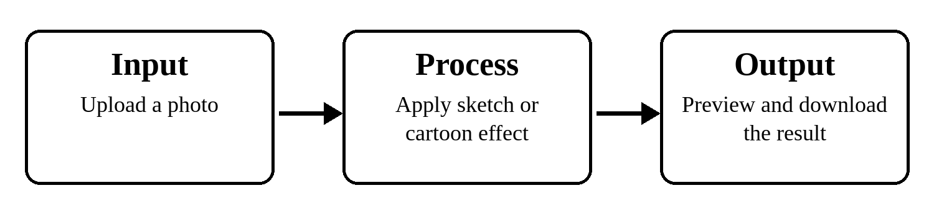
Figure 1:
System Flow

Screenshots
Figures 2 to 5 show the main screens of Artify.
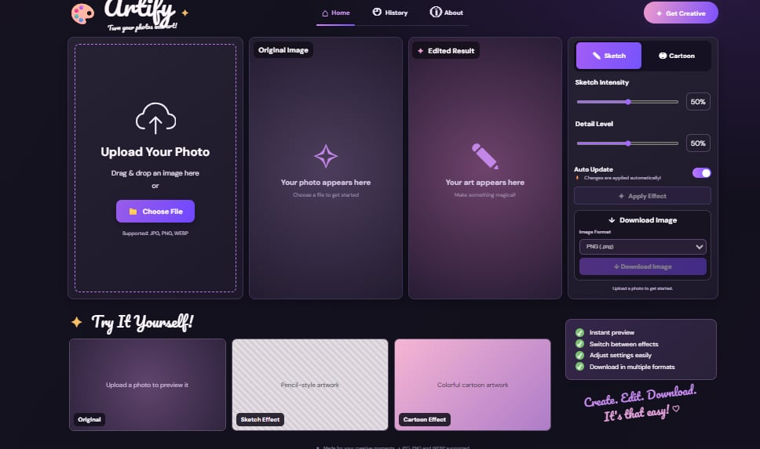
Figure 2. Home screen before a photo is uploaded
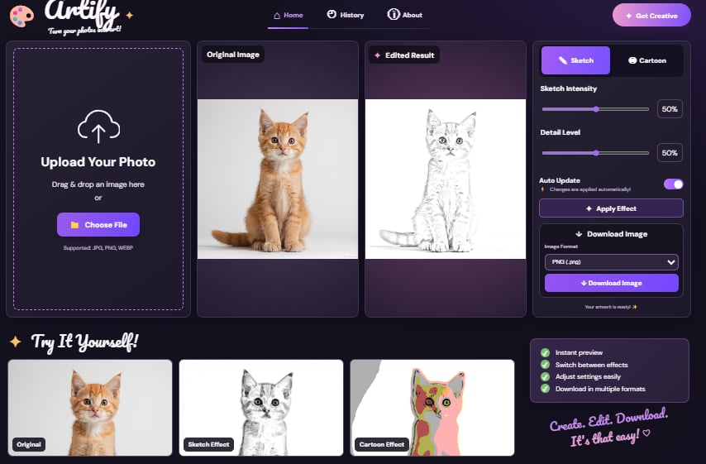
Figure 3. Pencil Sketch result next to the original photo
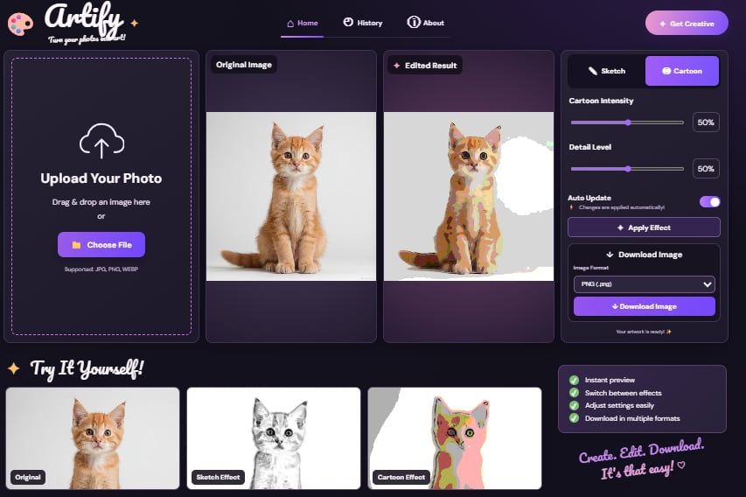
Figure 4. Cartoon result next to the original photo
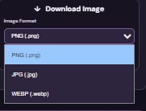
Figure 5. Download Image format menu (PNG, JPG, WebP)
Testing
Table 2 shows what was tried and what happened. Tests 1 to 4 check the features of the system. Test 5 is the comparison with the old way of doing the task.
Table 2:
Test Cases
Test | What You Tried | Expected Result | Actual Result | Pass or Fail
Test 1 | Upload a valid JPG photo | Photo appears in Original Image and Download Image is enabled | The photo appeared and Download Image was enabled | Pass
Test 2 | Switch between Sketch and Cartoon and move the sliders with Auto Update on | Edited Result changes automatically without clicking Apply Effect | The Edited Result updated automatically each time | Pass
Test 3 | Download the photo as PNG, JPG, and WebP | A file in the chosen format is downloaded | A PNG, JPG, and WebP file were downloaded as chosen | Pass
Test 4 | Click Clear photo after editing | Both panels become empty and Download Image is disabled | Both panels became empty and Download Image was disabled | Pass
Test 5 (comparison) | Convert the same photo using Artify and another app with cartoon and sketch effects | Artify should be faster and easier | Artify finished the task faster and in fewer steps than the other app | Pass

Conclusion
The project in three short points:
- What works: Photo upload, both effects, adjustable sliders with Auto Update, downloads in PNG, JPG, or WebP, and clearing the photo work successfully.
- What does not work well: With the Cartoon effect, a plain light background can show uneven white or gray patches (Figure 4).
- What I would improve: Make the Cartoon background cleaner and add more styles and an undo button.

