Sprd_2713_power.c

rootfs_initcall(**sprd_battery_init**);

static int __init sprd_battery_init(void)

{

return platform_driver_register(&**sprdbat_driver**);

}

static struct platform_driver sprdbat_driver = {

.probe = **sprdbat_probe**,

.remove = sprdbat_remove,

.suspend = sprdbat_suspend,

.resume = sprdbat_resume,

.driver = {

.name = "sprd-battery",

#ifdef CONFIG_OF

.of_match_table = of_match_ptr(battery_of_match),

#endif

}

};

static int **sprdbat_probe**(struct platform_device *pdev)

{

int ret = -ENODEV;

struct**sprdbat_drivier_data** *data;

struct sprdbat_drivier_data {

struct **sprd_battery_platform_data** *pdata; 总线

struct **sprdbat_info** bat_info; 电池信息

struct mutex lock;

struct device *dev; ？？？

struct power_supply battery; 电源

struct power_supply ac; 充电

struct power_supply usb; USB供电

uint32_t gpio_charger_detect; 接入电池 of_get_named_gpio(np, "gpios", 0) 取得

uint32_t gpio_chg_cv_state; 充电状态 of_get_named_gpio(np, "gpios", 1);

uint32_t gpio_vchg_ovi; 充电过压of_get_named_gpio(np, "gpios", 2);

这里是通过读DTS里面的值可通过2723规格书找到对应的功能引脚

－－》7.6 Ext Interrupt Controller(EIC)－－》

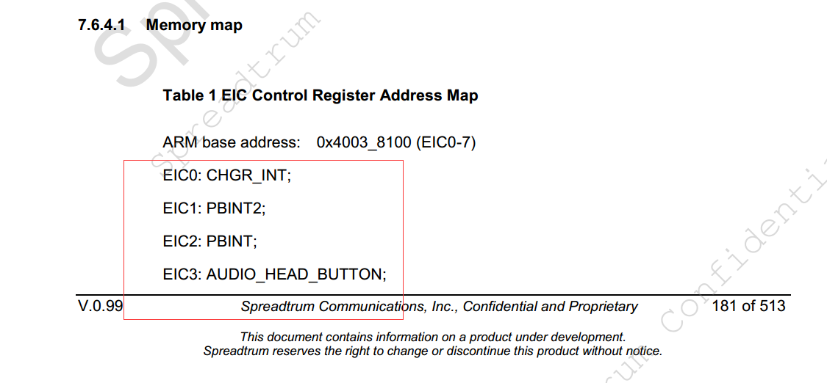

这些ＥＩＣ有各自的号

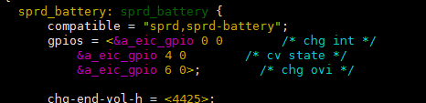

ＧＩＰＯ上定义的是　０４６对应着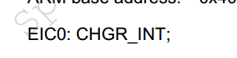





uint32_t irq_charger_detect;

gpio_to_irq(data->gpio_charger_detect); 这个函数是空的

uint32_t irq_chg_cv_state; 充电中断状态

uint32_t irq_vchg_ovi; 充电过压中断

struct wake_lock charger_plug_out_lock;

struct workqueue_struct *monitor_wqueue; 创建一个线程

<http://blog.csdn.net/myarrow/article/details/8090504>

struct delayed_work cv_irq_work; 恒流恒压转换进程

struct delayed_work battery_work; 电池检查线程

struct delayed_work battery_sleep_work; 电池修眠线程

struct work_struct ovi_irq_work; 电池充电过压线程

struct delayed_work *charge_work; 电池充电线

int (*start_charge) (void); 开始充电方法

int (*stop_charge) (void); 结束充电方法

#ifdef CONFIG_LEDS_TRIGGERS

struct led_classdev charging_led;

#endif

};

//电池信息

struct **sprdbat_info** {

uint32_t module_state;

uint32_t bat_health;

uint32_t chging_current;

int bat_current;

uint32_t chg_current_type;

uint32_t adp_type;

uint32_t usb_online;

uint32_t ac_online;

uint32_t vchg_vol;

uint32_t cccv_point;

unsigned long chg_start_time;

uint32_t chg_stop_flags;

uint32_t vbat_vol;

uint32_t vbat_ocv;

int cur_temp;

uint32_t capacity;

uint32_t soc;

uint32_t chg_this_timeout;

};

#ifdef SPRDBAT_TWO_CHARGE_CHANNEL

struct resource *res = NULL;

#endif

struct device_node *np = pdev->dev.of_node;

详细的设备树说明链接　　　　这里是把pdev里的节点取出来

<http://blog.csdn.net/lichengtongxiazai/article/details/38942033>

相关链接：　<http://blog.csdn.net/jgw2008/article/details/52692616>

SPRDBAT_DEBUG("sprdbat_probe\n");

#ifdef CONFIG_OF

if (!np) {

dev_err(&pdev->dev, "device node not found\n");

return -EINVAL;

}

#endif

data = kzalloc(sizeof(*data), GFP_KERNEL); 申请空间

if (data == NULL) {

ret = -ENOMEM;

goto err_data_alloc_failed;

}

if (np) {

data->pdata = sprdbat_parse_dt(pdev); 解析ＤＴ参数

} else {

data->pdata = dev_get_platdata(&pdev->dev); 这里取默认值

}

data->dev = &pdev->dev; 这里的data 是申请的设备，Pdev是传进来的

platform_set_drvdata(pdev, data); 这里是把生成的data 保存到pdev的私有变量里　dev->p->driver_data

sprdbat_data = data; data保存到全局变量中去

print_pdata(sprdbat_data->pdata); 打印data中的信息

data->battery.properties = sprdbat_battery_props; power_supply支持

data->battery.num_properties = ARRAY_SIZE(sprdbat_battery_props);

data->battery.get_property = sprdbat_battery_get_property;

data->battery.name = "battery";

data->battery.type = POWER_SUPPLY_TYPE_BATTERY;

data->battery.supplied_to = battery_supply_list;

data->battery.num_supplicants = ARRAY_SIZE(battery_supply_list);

data->ac.properties = sprdbat_ac_props;

data->ac.num_properties = ARRAY_SIZE(sprdbat_ac_props);

data->ac.get_property = sprdbat_ac_get_property;

data->ac.name = "ac";

data->ac.type = POWER_SUPPLY_TYPE_MAINS;

data->ac.supplied_to = supply_list;

data->ac.num_supplicants = ARRAY_SIZE(supply_list);

data->usb.properties = sprdbat_usb_props;

data->usb.num_properties = ARRAY_SIZE(sprdbat_usb_props);

data->usb.get_property = sprdbat_usb_get_property;

data->usb.name = "usb";

data->usb.type = POWER_SUPPLY_TYPE_USB;

data->usb.supplied_to = supply_list;

data->usb.num_supplicants = ARRAY_SIZE(supply_list);

data->start_charge = sprdbat_start_charge; 　　　　　添加开启停止充电功能

data->stop_charge = sprdbat_stop_charge;

ret = power_supply_register(&pdev->dev, &data->usb); power_supply支持

if (ret)

goto err_usb_failed;

ret = power_supply_register(&pdev->dev, &data->ac);

if (ret)

goto err_ac_failed;

ret = power_supply_register(&pdev->dev, &data->battery);

if (ret)

goto err_battery_failed;

sprdbat_creat_caliberate_attr(data->battery.dev);这个是对属性进行初始化和创建的操作

data->gpio_chg_cv_state = data->pdata->gpio_cv_state; 设置电池充电中断

ret = gpio_request(data->gpio_chg_cv_state, "chg_cv_state");

if (ret) {

dev_err(&pdev->dev, "failed to request gpio: %d\n", ret);

goto err_io_cv_request;

}

gpio_direction_input(data->gpio_chg_cv_state); 设置GPIO方向

data->irq_chg_cv_state = gpio_to_irq(data->gpio_chg_cv_state); gpio复用成中断

irq_set_status_flags(data->irq_chg_cv_state, IRQ_NOAUTOEN); 设置中断状态

//irq_set_irq_type(data->irq_chg_cv_state, IRQ_TYPE_LEVEL_HIGH);

ret = request_irq(data->irq_chg_cv_state, sprdbat_chg_cv_irq,

IRQF_NO_SUSPEND, "sprdbat_chg_cv_state", data);

if (ret)

goto err_request_irq_cv_failed;

gpio_request :

int gpio_request(unsigned gpio, const char *label) GPIO 申请的函数，gpio则为你要申请的哪一个管脚，label则是为其取一个名字。 http://blog.csdn.net/heanyu/article/details/6709571

http://blog.csdn.net/njuitjf/article/details/40622845

gpio_direction_input:

设置GPIO方向

http://blog.csdn.net/mirkerson/article/details/8464290

irq_set_status_flags:

设置初始中断状态

request_irq：

申请中断

data->gpio_vchg_ovi = data->pdata->gpio_vchg_ovi; 设置电池过压中断

ret = gpio_request(data->gpio_vchg_ovi, "vchg_ovi");

if (ret) {

dev_err(&pdev->dev, "failed to request gpio: %d\n", ret);

goto err_io_ovi_request;

}

gpio_direction_input(data->gpio_vchg_ovi);

data->irq_vchg_ovi = gpio_to_irq(data->gpio_vchg_ovi);

irq_set_status_flags(data->irq_vchg_ovi, IRQ_NOAUTOEN);

ret = request_irq(data->irq_vchg_ovi, sprdbat_vchg_ovi_irq,

IRQF_NO_SUSPEND, "sprdbat_vchg_ovi", data);

if (ret)

goto err_request_irq_ovi_failed;

data->gpio_vbat_detect = data->pdata->gpio_vbat_detect; 电池检测

if (data->gpio_vbat_detect > 0) {

gpio_request(data->gpio_vbat_detect, "vbat_detect");

gpio_direction_input(data->gpio_vbat_detect);

data->irq_vbat_detect = gpio_to_irq(data->gpio_vbat_detect);

//set_irq_flags(data->irq_vbat_detect,

// IRQF_VALID | IRQF_NOAUTOEN);

irq_set_status_flags(data->irq_vbat_detect, IRQ_NOAUTOEN);

ret =

request_irq(data->irq_vbat_detect, sprdbat_vbat_detect_irq,

IRQ_TYPE_LEVEL_LOW | IRQF_NO_SUSPEND,

"sprdbat_vbat_detect", data);

if (ret)

dev_err(&pdev->dev, "failed to use vbat gpio: %d\n",

ret);

}

mutex_init(&data->lock); 初始化互斥体

wake_lock_init(&(data->charger_wake_lock), WAKE_LOCK_SUSPEND,

"charger_wake_lock"); 超时锁　休眠唤醒机制

初始化wakelock: charger_wake_lock, 同时将其加入到非活动锁链表中

<http://blog.sina.com.cn/s/blog_a266ea0c0101cbif.html>

INIT_DELAYED_WORK(&data->cv_irq_work, sprdbat_cv_irq_works);

INIT_DELAYED_WORK(&data->battery_work, sprdbat_battery_works);

INIT_DELAYED_WORK(&data->battery_sleep_work,

sprdbat_battery_sleep_works);

INIT_WORK(&data->ovi_irq_work, sprdbat_ovi_irq_works);

INIT_WORK(&data->vbat_detect_irq_work, sprdbat_vbat_detect_irq_works);

INIT_DELAYED_WORK(&sprdbat_charge_work, sprdbat_charge_works);

INIT_DELAYED_WORK和INIT_WORK定时器中断函数　的初始始化工作

<http://blog.csdn.net/daniel80110_1020/article/details/54380453>

对应的函数才是开始工作

INIT_DELAYED_WORK()对schedule_delayed_work()

INIT_WORK()对schedule_work().

data->charge_work = &sprdbat_charge_work;

data->monitor_wqueue = create_singlethread_workqueue("sprdbat_monitor");

<http://blog.csdn.net/lhl161123/article/details/53447851>

没看懂　因该是开启线程

sprdchg_timer_init(sprdbat_timer_handler, data);

没看懂 里面都是设置寄存器的操作 然后回调 sprdbat_timer_handler方法

sprdchg_set_chg_ovp(data->pdata->ovp_stop);

操作寄存器CHGR_CTRL2 和CHGR_CTRL1　来写入过压保护值

sprdchg_init(data->pdata); 充电初始化　　信息量不少

sprdfgu_init(data->pdata); 库伦计初始化 这个里面信息量庞大，

#ifdef CONFIG_LEDS_TRIGGERS 宏没开

data->charging_led.name = "sprdbat_charging_led";

data->charging_led.default_trigger = "battery-charging";

data->charging_led.brightness_set = sprdchg_led_brightness_set;

led_classdev_register(&pdev->dev, &data->charging_led);

#endif

#ifdef SPRDBAT_TWO_CHARGE_CHANNEL 宏没开

sprdchg_charge_init_ext(pdev);

INIT_DELAYED_WORK(&sprdbat_charge_work_ext, sprdbat_charge_works_ext);

#ifndef CONFIG_OF

res = platform_get_resource(pdev, IORESOURCE_IO, 0); 取资源

data->gpio_charger_detect = res->start;

#else

data->gpio_charger_detect = of_get_named_gpio(np, "gpios", 0);

#endif

gpio_request(data->gpio_charger_detect, "sprd_charger_detect");

gpio_direction_input(data->gpio_charger_detect);

data->irq_charger_detect = gpio_to_irq(data->gpio_charger_detect);

ret = request_irq(data->irq_charger_detect, sprdbat_chg_detect_int,

IRQF_SHARED | IRQF_TRIGGER_HIGH,

"sprdbat_charger_detect", data);

INIT_WORK(&sprdbat_chg_detect_work, sprdbat_chg_detect_works);