**CSCU9V4: Systems**

**Assignment 1 - Spring 2020**

**The Logic Circuit Controller**

**Student ID**: 2721301

# Task Marking Scheme Marks distribution

**PART I: Systems**

1. Build the truth table **/5**
2. Derive algebraic expressions:
   1. Sum-of-minterms expressions **/12**
   2. Simplification of the expression for Clock Wise **/16**
   3. Simplification of the expression using K-Map ……………………………………………**/14**
3. Draw the CW circuit **/10**
4. Convert CW expression to NAND-only form **/18**
5. Demonstrate NAND-only version is correct with a truth table **/10**
6. Draw the NAND-only version of the CW circuit **/10**
7. Produce a well presented submission **/5**

## TOTAL **/100\***

(*This assignment constitutes 20% of the overall module assessment.)

Task 1: Build the truth table

|  |  |  |  |  |  |  |  |  |  |  |
| --- | --- | --- | --- | --- | --- | --- | --- | --- | --- | --- |
| **A** | **B** | **C** | **D** | **Buttons** | **CW**  **clockwise** | **ACW**  **anti-clockwise** | **L**  **left** | **R**  **right** | **U**  **up** | **D**  **down** |
| 0 | 0 | 0 | 0 | none | 0 | 0 | 0 | 0 | 0 | 0 |
| 0 | 0 | 0 | 1 | ➊ | 0 | 0 | 1 | 0 | 0 | 0 |
| 0 | 0 | 1 | 0 | ➋ | 0 | 1 | 0 | 0 | 0 | 0 |
| 0 | 0 | 1 | 1 | ➌ | 0 | 0 | 0 | 1 | 0 | 0 |
| 0 | 1 | 0 | 0 | ➍ | 1 | 0 | 0 | 0 | 0 | 0 |
| 0 | 1 | 0 | 1 | ➊+➋ | 0 | 0 | 0 | 0 | 0 | 1 |
| 0 | 1 | 1 | 0 | ➊+➍ | 0 | 0 | 0 | 0 | 1 | 0 |
| 0 | 1 | 1 | 1 | ➊+➌ | 0 | 1 | 1 | 0 | 0 | 0 |
| 1 | 0 | 0 | 0 | ➋+➍ | 1 | 0 | 1 | 0 | 0 | 0 |
| 1 | 0 | 0 | 1 | ➋+➌ | 0 | 1 | 0 | 1 | 0 | 0 |
| 1 | 0 | 1 | 0 | ➌+➍ | 1 | 0 | 0 | 1 | 0 | 0 |
| 1 | 0 | 1 | 1 | ➊+➋+➌ | 0 | 1 | 0 | 0 | 0 | 1 |
| 1 | 1 | 0 | 0 | ➊+➌+➍ | 0 | 1 | 0 | 0 | 1 | 0 |
| 1 | 1 | 0 | 1 | ➊+➋+➍ | 1 | 0 | 0 | 0 | 0 | 1 |
| 1 | 1 | 1 | 0 | ➋+➌+➍ | 1 | 0 | 0 | 0 | 1 | 0 |
| 1 | 1 | 1 | 1 | ➊+➋+➌+➍ | 0 | 0 | 0 | 0 | 0 | 0 |

Using the data provided by the button control details the following truth table can be created:

Task 2: Deriving Sum-of-Minterms Boolean Expressions

a) Using the data from the table I can create the sum of minterms for every output column



$CW = \overline{A∙}B∙\overline{C∙}\overline{D} + A∙\overline{B}∙\overline{C}∙\overline{D} + A∙\overline{B}∙C∙\overline{D} + A∙B∙\overline{C}∙D + A∙B∙C∙\overline{D}$

$ACW = \overline{A}∙\overline{B}∙C∙\overline{D}+\overline{A}∙B∙C∙D+A∙\overline{B}∙\overline{C}∙D+A∙\overline{B}∙C∙D+A∙B∙\overline{C}∙\overline{D}$

$L= \overline{A}∙\overline{B}∙\overline{C}∙D+\overline{A}∙B∙C∙D+A∙\overline{B}∙\overline{C}∙\overline{D}$

$R= \overline{A}∙\overline{B}∙C∙D+A∙\overline{B}∙\overline{C}∙D+A∙\overline{B}∙C∙\overline{D}$

$U = \overline{A}∙B∙C∙\overline{D}+A∙B∙\overline{C}∙\overline{D}+A∙B∙C∙\overline{D}$

$D = \overline{A}∙B∙\overline{C}∙D+A∙\overline{B}∙C∙D+A∙B∙\overline{C}∙D$

b) Using Boolean algebra, the minterm expression for the CW (clockwise) output can be simplified. The following is the steps taken and rules used to simplify the equation:

$$CW = \overline{A∙}B∙\overline{C∙}\overline{D} + A∙\overline{B}∙\overline{C}∙\overline{D} + A∙\overline{B}∙C∙\overline{D} + A∙B∙\overline{C}∙D + A∙B∙C∙\overline{D}$$

Firstly, we can use the associative law to rearrange the expression and put parts of the expression with common factors together.

$$CW = A∙\overline{B}∙\overline{C}∙\overline{D} + A∙\overline{B}∙C∙\overline{D} +\overline{A∙}B∙\overline{C∙}\overline{D} + A∙B∙\overline{C}∙D + A∙B∙C∙\overline{D}$$

Then we can use the distributive law to manipulate the expression by adding brackets and taking out the common factors.

$$CW = A∙\overline{B}∙\overline{D}\left(\overline{C}+C\right)+ B∙\overline{C}\left(\overline{A}∙\overline{D}+A∙D\right)+ A∙B∙C∙\overline{D}$$

We can then reduce the expression using $C+\overline{C}=1$, leaving us with the following

$$CW = A∙\overline{B}∙\overline{D} + B∙\overline{C}\left(\overline{A}∙\overline{D}+A∙D\right)+ A∙B∙C∙\overline{D}$$

A XNOR gate can be identified by inspecting this expression, $\overline{A}∙\overline{D}+A∙D$ can then be changed to $\overline{A⨁D}$

$$CW = A∙\overline{B}∙\overline{D} + B∙\overline{C}\left(\overline{A⨁D}\right)+ A∙B∙C∙\overline{D}$$

The associative law can be used again to group parts of the expression with common factors

$$CW = A∙\overline{B}∙\overline{D} + A∙B∙C∙\overline{D}+ B∙\overline{C}\left(\overline{A⨁D}\right)$$

The distribution law can be used to take out the common factors by manipulating using brackets

$$CW = A∙\overline{D}\left(\overline{B} + B∙C\right)+ B∙\overline{C}\left(\overline{A⨁D}\right)$$

The negative absorption law can be used to reduce $\overline{B} + B∙C$ to $\overline{B} + C$, which leaves us with the following expression for CW that has been simplified as much as possible:

$$CW = A∙\overline{D}\left(\overline{B} + C\right)+ B∙\overline{C}\left(\overline{A⨁D}\right)$$

c) The equation can also be simplified using a Karnaugh Map (K-Map) and then collect the groupings. The following is the K-Map, showing the groupings and then simplifying this further:

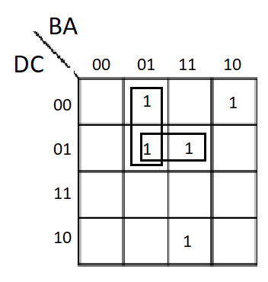

$$A∙\overline{B}∙\overline{D}+A∙C∙\overline{D}+A∙B∙\overline{C}∙D+\overline{A}∙B∙\overline{C}∙\overline{D}$$

We can then manipulate the expression using the distributive law and add brackets.

$$A∙\overline{D}\left(\overline{B}+C\right)+B∙C\left(\overline{A}∙\overline{D}+A∙D\right)$$

The $\overline{A}∙\overline{D}+A∙D$ is actually and NXOR gate and we can change the expression to the following

$$A∙\overline{D}\left(\overline{B}+C\right)+B∙C\left(\overline{A⨁D}\right)$$

This expression is the exact same as the previous solution using Boolean algebra which shows the simplification has been done correctly.

Task 3: Draw the circuit for simplified CW logic/expressions

Using the simplified expression for the CW (clockwise) output, a diagram of the circuit can be drawn. The following circuit uses NOT, AND, OR, and XNOR gates, the colour of the wires does not make a difference to this circuit:

Task 4: Convert the CW expression to use NAND gates only

Using de-Morgan’s theorem, I can convert the expression for the CW circuit so that it uses NAND gates only. The following is the process of doing this:

Using the un-simplified output from the K-Map

$$A∙\overline{B}∙\overline{D}+A∙C∙\overline{D}+A∙B∙\overline{C}∙D+\overline{A}∙B∙\overline{C}∙\overline{D}$$

First we invert all inputs to the gate

$$CW = \overline{\left(A∙\overline{B}∙\overline{D}\right)+\left(A∙C∙\overline{D}\right)+\left(A∙B∙\overline{C}∙D\right)+\left(\overline{A}∙B∙\overline{C}∙\overline{D}\right)}$$

We then invert the whole expression

$$CW= \overline{\overline{\left(A∙\overline{B}∙\overline{D}\right)+\left(A∙C∙\overline{D}\right)+\left(A∙B∙\overline{C}∙D\right)+\left(\overline{A}∙B∙\overline{C}∙\overline{D}\right)}}$$

The OR gates can then be changed to AND gates

$$CW = \overline{\overline{\left(A∙\overline{B}∙\overline{D}\right)}∙\overline{\left(A∙C∙\overline{D}\right)}∙\overline{\left(A∙B∙\overline{C}∙D\right)}∙\overline{\left(\overline{A}∙B∙\overline{C}∙\overline{D}\right)}}$$

The insides of the brackets can not be inverted as we are creating a NAND circuit and inverting would change the AND’s into OR’s. The output is given by NANDing together $\overline{\left(A∙\overline{B}∙\overline{D}\right)}∙\overline{\left(A∙C∙\overline{D}\right)}∙\overline{\left(A∙B∙\overline{C}∙D\right)}∙\overline{\left(\overline{A}∙B∙\overline{C}∙\overline{D}\right)}$. The following is the final solution to the NAND circuit

$$CW = \overline{\overline{\left(A∙\overline{B}∙\overline{D}\right)}∙\overline{\left(A∙C∙\overline{D}\right)}∙\overline{\left(A∙B∙\overline{C}∙D\right)}∙\overline{\left(\overline{A}∙B∙\overline{C}∙\overline{D}\right)}}$$

Task 5: Demonstrate that the NAND version of CW is correct

The following is the truth table of the new NAND circuit showing that the outputs match the original circuits outputs.

The table shows the process of the NAND circuit to get the output $CW$ (labelled as (CW)’). We can clearly see the output of the NAND only circuit matches up with the original circuit output:

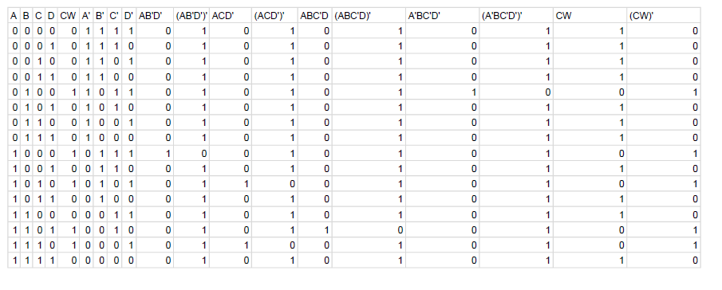

Task 6: Draw the NAND-only version of the CW circuit

The following is a drawing of the NAND only circuit, the colour of wires does not make a difference to this circuit:

End of report