程式：Ameba Blink程式

**開啟程式Blink**

**程式位址：**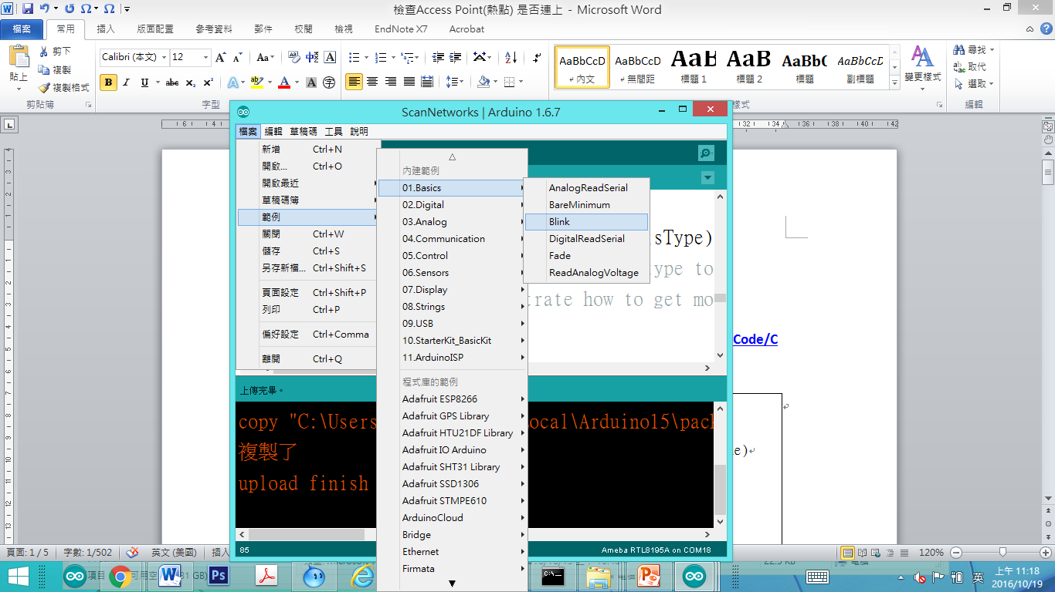

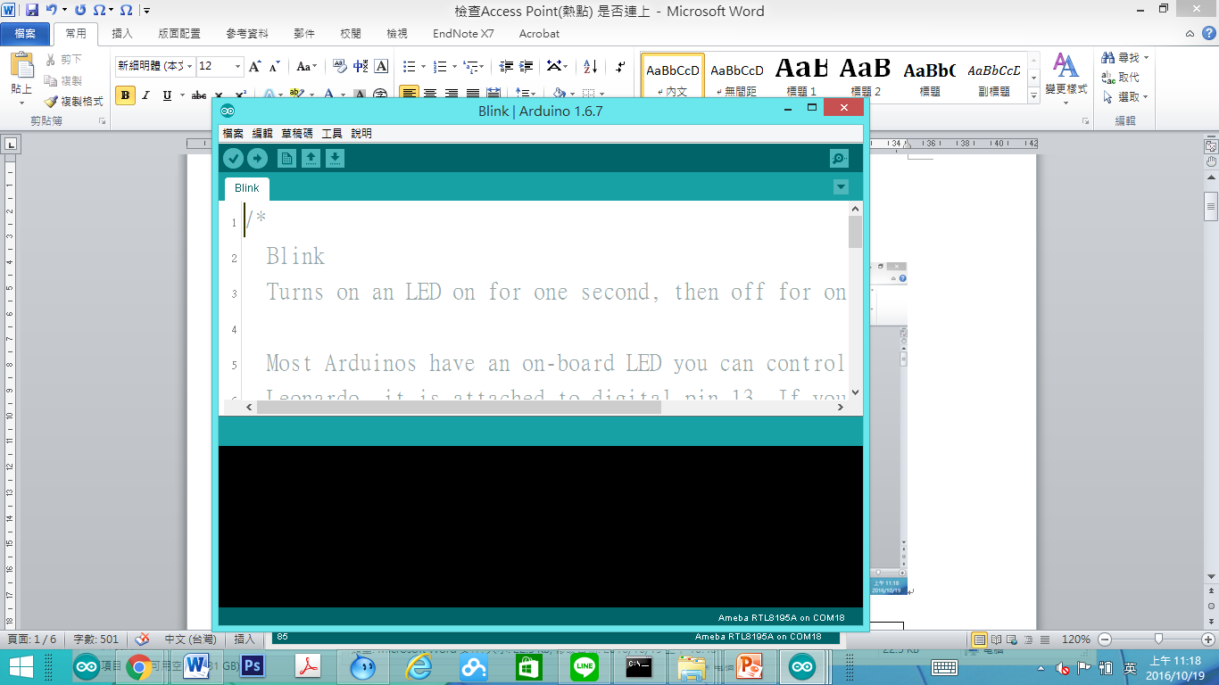

|  |
| --- |
| **/\***  **Blink**  **Turns on an LED on for one second, then off for one second, repeatedly.**  **Most Arduinos have an on-board LED you can control. On the Uno and**  **Leonardo, it is attached to digital pin 13. If you're unsure what**  **pin the on-board LED is connected to on your Arduino model, check**  **the documentation at http://www.arduino.cc**  **This example code is in the public domain.**  **modified 8 May 2014**  **by Scott Fitzgerald**  **\*/**  **// the setup function runs once when you press reset or power the board**  **void setup() {**  **// initialize digital pin 13 as an output.**  **pinMode(13, OUTPUT);**  **}**  **// the loop function runs over and over again forever**  **void loop() {**  **digitalWrite(13, HIGH); // turn the LED on (HIGH is the voltage level)**  **delay(1000); // wait for a second**  **digitalWrite(13, LOW); // turn the LED off by making the voltage LOW**  **delay(1000); // wait for a second**  **}** |

簡單來說，Blink 這個讓 LED 燈泡閃爍，它使用的GPIO接腳是13  
Ameba的Pin一樣在D13的位置，根據Ameba的接腳位置圖：

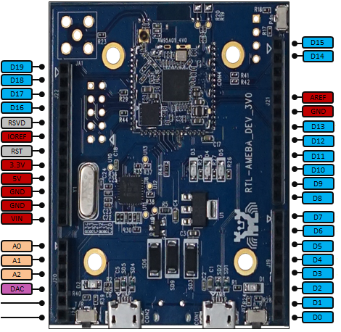

於是我們將電阻以及LED燈泡連接如下圖：  
（NOTE：LED裡，長腳的是正極，接到D13的地方，短腳的是負極，接到GND的地方）

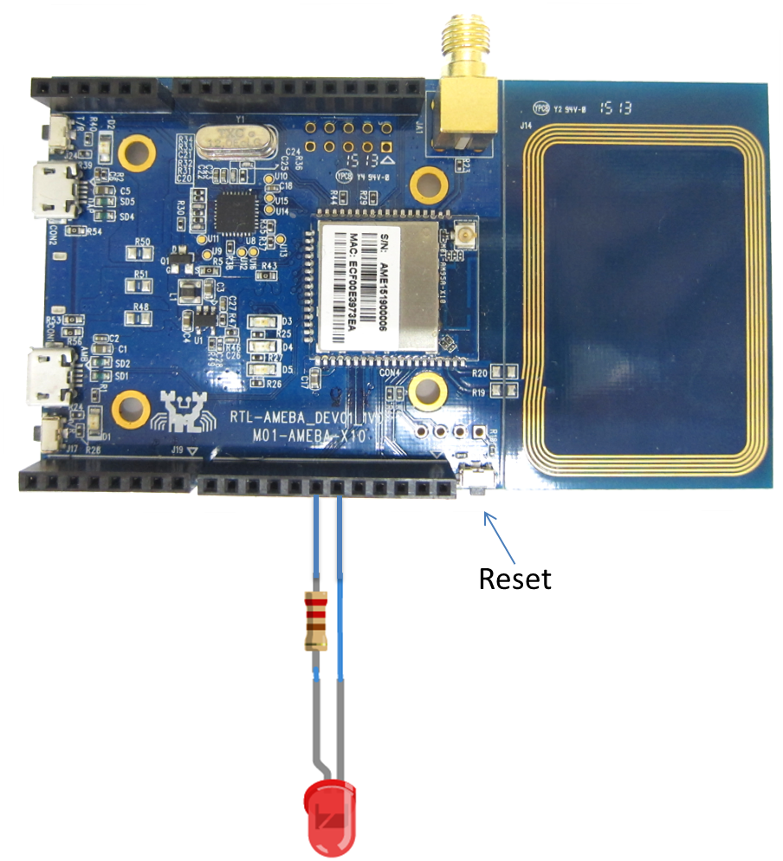

然後按一下Reset按鈕，就可以看到燈炮在閃爍，這個實驗就完成了。  
如果以上過程遇到問題，請參考 [Trouble-shooting](http://www.amebaiot.com/ameba-arduino-trouble-shooting/) 看是否能解決。

=========================================

**CheckAP程式重點解說**

pinMode(13, OUTPUT);’

digitalWrite(13, HIGH);

digitalWrite(13, LOW);