程式：Set_RTC_Data (設定RTC時間)

**開啟程式**Set_RTC_Data

**程式位址：https://github.com/brucetsao/BruceCourses/blob/master/105ANQU_IOT/Code/Set_RTC_Data/Set_RTC_Data.ino**

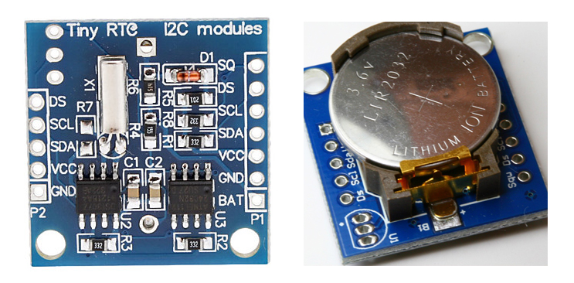

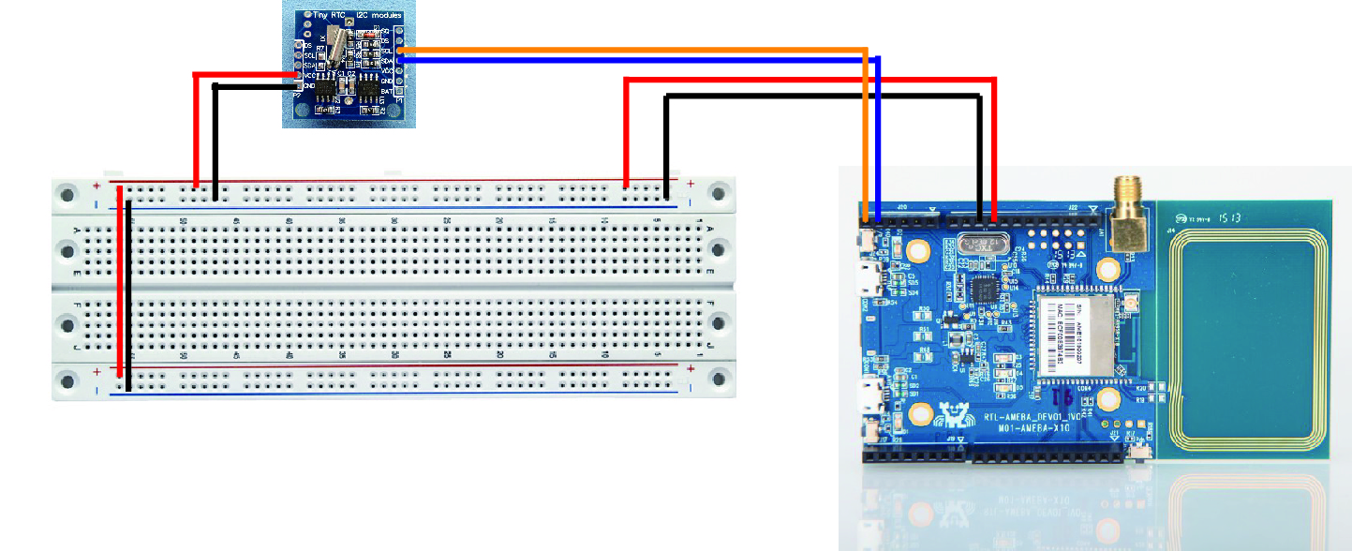

|  |
| --- |
| #include <Wire.h>  #include "RTClib.h"  RTC_DS1307 RTC;  int mYear = 2016 ;  int mMonth = 1 ;  int mDay = 1 ;  int mHour = 12 ;  int mMinute = 12 ;  int mSecond = 12 ;  void setup() {  Serial.begin(9600);  initRTC() ;  RTC.adjust(DateTime(mYear,mMonth,mDay,mHour,mMinute,mSecond));    }  void loop() {  Serial.print("Now Data and Time is :") ;  Serial.print(ShowDateTime()) ;  Serial.print("\n") ;  delay(1000) ;  }  void initRTC()  {  Wire.begin();  RTC.begin();  if (! RTC.isrunning()) {  Serial.println("RTC is NOT running!");    }  }  String ShowDateTime()  {  return StrDate() + " " +StrTime() ;  }  String StrDate() {  String ttt ;  //nowT = now;  DateTime now = RTC.now();  ttt = print4digits(now.year()) + "-" + print2digits(now.month()) + "-" + print2digits(now.day()) ;  //ttt = print4digits(NDPyear) + "/" + print2digits(NDPmonth) + "/" + print2digits(NDPday) ;  return ttt ;  }  String StringDate(int yyy,int mmm,int ddd) {  String ttt ;  //nowT = now;  ttt = print4digits(yyy) + "-" + print2digits(mmm) + "-" + print2digits(ddd) ;  return ttt ;  }  String StrTime() {  String ttt ;  // nowT = RTC.now();  DateTime now = RTC.now();  ttt = print2digits(now.hour()) + ":" + print2digits(now.minute()) + ":" + print2digits(now.second()) ;  // ttt = print2digits(NDPhour) + ":" + print2digits(NDPminute) + ":" + print2digits(NDPsecond) ;  return ttt ;  }  String StringTime(int hhh,int mmm,int sss) {  String ttt ;  ttt = print2digits(hhh) + ":" + print2digits(mmm) + ":" + print2digits(sss) ;  return ttt ;  }  String print2digits(int number) {  String ttt ;  if (number >= 0 && number < 10)  {  ttt = String("0") + String(number);  }  else  {  ttt = String(number);  }  return ttt ;  }  String print4digits(int number) {  String ttt ;  ttt = String(number);  return ttt ;  } |

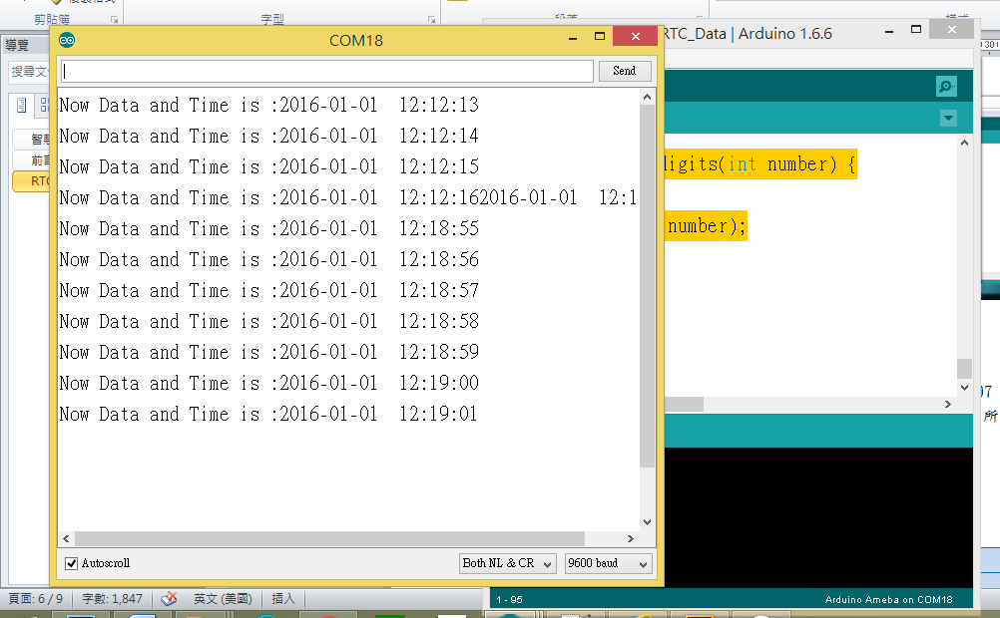

Set_RTC_Data**程式重點解說**

* #include <Wire.h> I2C通訊用
* #include “RTClib.h“ DS1307 時鐘模組用
* RTC_DS1307 RTC; 宣告時鐘物件
* initRTC() ; 啟動時鐘物件(自訂)
* Wire.begin(); 開始I2C通訊
* RTC.begin(); 開始時鐘物件通訊
* RTC.isrunning() 時鐘物件順利啟動
* RTC.adjust(DateTime(mYear,mMonth,mDay,mHour,mMinute,mSecond)); 調整設定DS1307 時鐘模組時間內容