程式：DHTx 讀取溫溼度資料

**開啟程式**DHTx

**程式位址：https://github.com/brucetsao/BruceCourses/blob/master/105ANQU_IOT/Code/DHTx/DHTx.ino**

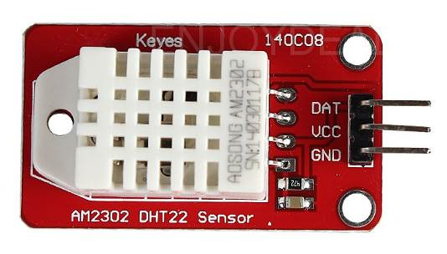 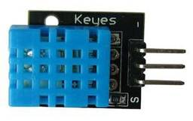

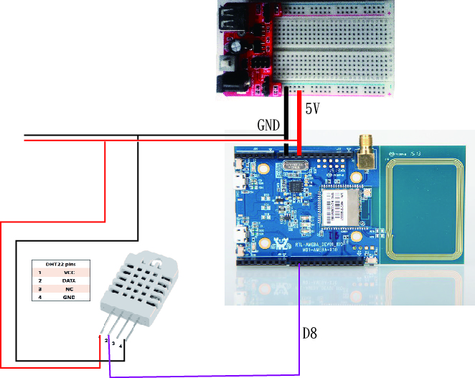

|  |
| --- |
| /*  This example demonstrate how to read pm2.5 value on PMS 3003 air condition sensor  PMS 3003 pin map is as follow:  PIN1 :VCC, connect to 5V  PIN2 :GND  PIN3 :SET, 0:Standby mode, 1:operating mode  PIN4 :RXD :Serial RX  PIN5 :TXD :Serial TX  PIN6 :RESET  PIN7 :NC  PIN8 :NC  In this example, we only use Serial to get PM 2.5 value.  The circuit:  * RX is digital pin 0 (connect to TX of PMS 3003)  * TX is digital pin 1 (connect to RX of PMS 3003)  */  /*  This example demonstrate how to upload sensor data to MQTT server of LASS.  It include features:  (1) Connect to WiFi  (2) Retrieve NTP time with WiFiUDP  (3) Get PM 2.5 value from PMS3003 air condition sensor with UART  (4) Connect to MQTT server and try reconnect when disconnect  You can find more information at this site:  https://lass.hackpad.com/LASS-README-DtZ5T6DXLbu  */  // http://nrl.iis.sinica.edu.tw/LASS/show.php?device_id=FT1_074B3  #include <math.h>  #define DHTSensorPin 8  #include "DHT.h"  // Uncomment whatever type you're using!  #define DHTTYPE DHT11 // DHT 11  //#define DHTTYPE DHT22 // DHT 22 (AM2302), AM2321  //#define DHTTYPE DHT21 // DHT 21 (AM2301)  #include <Wire.h> // Arduino IDE 內建  // LCD I2C Library，從這裡可以下載：  // https://bitbucket.org/fmalpartida/new-liquidcrystal/downloads  #include <LiquidCrystal_I2C.h>  #include <SoftwareSerial.h>  uint8_t MacData[6];  SoftwareSerial mySerial(0, 1); // RX, TX  LiquidCrystal_I2C lcd(0x27, 2, 1, 0, 4, 5, 6, 7, 3, POSITIVE); // 設定 LCD I2C 位址  DHT dht(DHTSensorPin, DHTTYPE);  void setup() {  initPins() ;  Serial.begin(9600);  dht.begin();  mySerial.begin(9600); // PMS 3003 UART has baud rate 9600  lcd.begin(20, 4); // 初始化 LCD，一行 20 的字元，共 4 行，預設開啟背光  lcd.backlight(); // 開啟背光  // while(!Serial) ;  }  void loop() { // run over and over  ShowHumidity() ;  delay(2000);  }  void ShowHumidity()  {  float h = dht.readHumidity();  // Read temperature as Celsius (the default)  float t = dht.readTemperature();  // Read temperature as Fahrenheit (isFahrenheit = true)  float f = dht.readTemperature(true);  Serial.print("Humidity :") ;  Serial.print(h) ;  Serial.print("% /") ;  Serial.print(t) ;  Serial.print("C \n") ;  // Check if any reads failed and exit early (to try again).  if (isnan(h) || isnan(t) || isnan(f)) {  Serial.println("Failed to read from DHT sensor!");  return;  }  lcd.setCursor(11, 3); // 設定游標位置在第一行行首  lcd.print((int)h);  lcd.print("% ");  lcd.print((int)t);    }  String print2digits(int number) {  String ttt ;  if (number >= 0 && number < 10)  {  ttt = String("0") + String(number);  }  else  {  ttt = String(number);  }  return ttt ;  }  String print4digits(int number) {  String ttt ;  ttt = String(number);  return ttt ;  }  void initPins()  {  pinMode(DHTSensorPin,INPUT) ;  } |

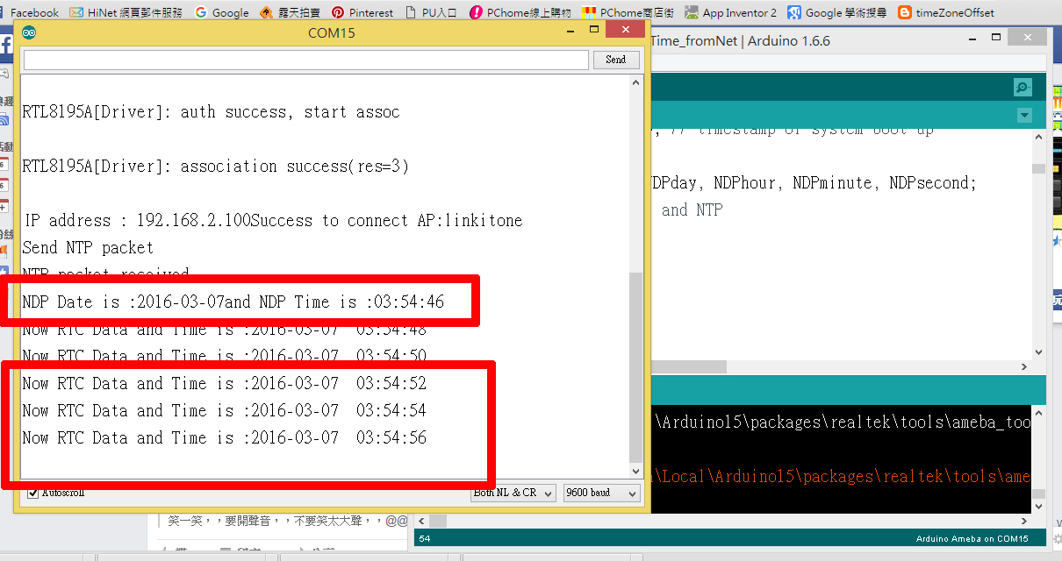

DHTx **程式重點解說**

* #include “DHT.h” 使用溫溼度模組必要函數
* #define DHTTYPE DHT22 宣告使用哪種DHT溫溼度模組
* DHT dht(DHTSensorPin, DHTTYPE); 取得溫溼度物件
* dht.begin(); 溫溼度物件通訊
* ShowHumidity() ; 顯示溫溼度資料(自訂)
* dht.readHumidity(); 讀取濕度
* ht.readTemperature(true); 讀取溫度