程式：lcd1602_I2C_mills 顯示資料在LCD上

**開啟程式**lcd1602_I2C_mills

**程式位址：**<https://github.com/brucetsao/BruceCourses/blob/master/105ANQU_IOT/Code/lcd1602_I2C_mills/lcd1602_I2C_mills.ino>

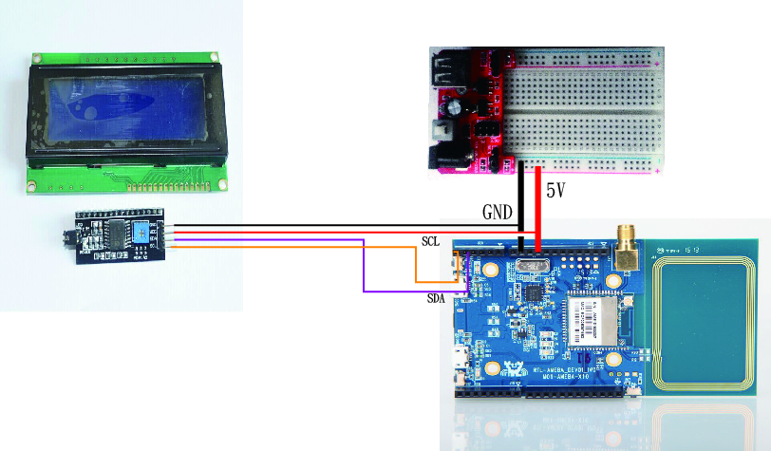

|  |
| --- |
| #include <I2CIO.h>  #include <LCD.h>  #include <LiquidCrystal_I2C.h>  /* YourDuino.com Example Software Sketch  16 character 2 line I2C Display  ANOTHER NEW TYPE Marked "LCM1602 IIC A0 A1 A2"  A0-A1-A2 are grounded so I2C Address is 0x20  terry@yourduino.com */  /*-----( Import needed libraries )-----*/  #include <Wire.h>  #include <LCD.h>  #include <LiquidCrystal_I2C.h> // F Malpartida's NewLiquidCrystal library  //Download: https://bitbucket.org/fmalpartida/new-liquidcrystal/downloads  // Move original LiquidCrystal library elsewhere, copy this in it's place  /*-----( Declare Constants )-----*/  #define I2C_ADDR 0x27 // Define I2C Address for the PCF8574T  //---(Following are the PCF8574 pin assignments to LCD connections )----  // This are different than earlier/different I2C LCD displays  #define BACKLIGHT_PIN 3  #define En_pin 2  #define Rw_pin 1  #define Rs_pin 0  #define D4_pin 4  #define D5_pin 5  #define D6_pin 6  #define D7_pin 7    #define LED_OFF 1  #define LED_ON 0  /*-----( Declare objects )-----*/  LiquidCrystal_I2C lcd(I2C_ADDR,En_pin,Rw_pin,Rs_pin,D4_pin,D5_pin,D6_pin,D7_pin);  // LiquidCrystal_I2C lcd(0x27, 2, 1, 0, 4, 5, 6, 7, 3, POSITIVE); // 設定 LCD I2C 位址  void setup() /*----( SETUP: RUNS ONCE )----*/  {  lcd.begin (16,2); // initialize the lcd  // Switch on the backlight  lcd.setBacklightPin(BACKLIGHT_PIN,POSITIVE);  lcd.setBacklight(LED_ON);  lcd.backlight(); //Backlight ON if under program control  lcd.setCursor(0,0); //Start at character 0 on line 0  lcd.print("Hello, world!");  }// END Setup  static int count=0;  void loop()  {  lcd.setCursor(0,1);  lcd.print("Realtek: ");  lcd.print(count++) ;  delay(1000);  } // END Loop |

lcd1602_I2C_mills**程式重點解說**

* #include <I2CIO.h> I2C 函數
* #include <LCD.h> LCD函數
* #include <LiquidCrystal_I2C.h> I2C版LCD函數
* #define I2C_ADDR 0x27 設定LCD I2C位址
* lcd.begin (16,2); 設定LCD寬度與高度
* lcd.setBacklight(LED_ON); 設定LCD背光
* lcd.backlight();啟動LCD背光
* lcd.setCursor(0,0); LCD歸零定位
* lcd.print(“Hello, world!”); 印出Hello World