arduino2PC

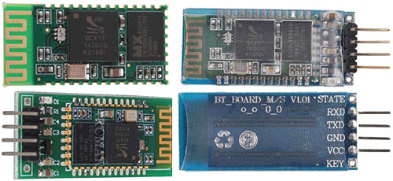
Most modules use a chip BC417 and Flash memory. Specification:
CSR chip: Bluetooth v2.0
Wave band: 2.4GHz-2.8GHz, ISM Band
Protocol: Bluetooth V2.0
Voltage: 3.3 (2.7V-4.2V)
Current: Paring - 35mA, Connected - 8mA
The command set of HC-03 and HC-05 are more flexible than HC-04 and HC-06 modules.
We'll be working with the module HC-06. Circuit diagram:
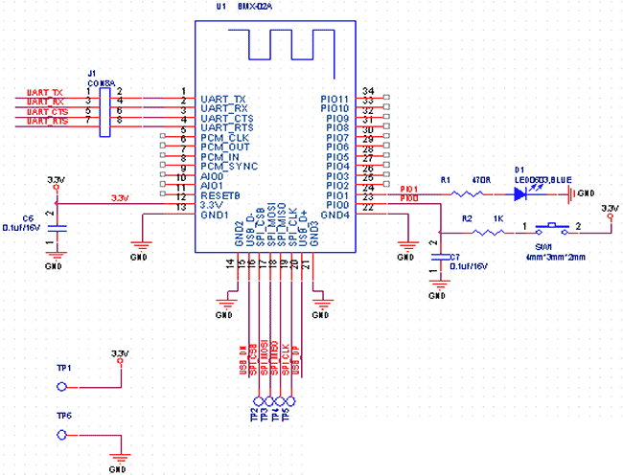
HC-04/HC-06 pins:
UART_TX (pin 1), UART_RX (pin 2), UART_CTS (pin 3), UART_RTS (pin 4) - UART.
3,3V (pin 12) - Power 3.3V.
GND (pin 13) - GND.
PIO1 (pin 24) - LED working mode indicator
HC-03/HC-05 pins:
UART_TX (pin 1), UART_RX (pin 2), UART_CTS (pin 3), UART_RTS (pin 4) - UART.
PIO8 (pin 31) - LED1 working mode indicator.
PIO9 (pin 32) - LED2. Before paired, it output low level. Once the pair is finished, it output high level.
PIO11 (pin 34) - KEY. Mode switch input. If it is input low level, the module is at paired or communication mode. If
itвЂ™s input high level, the module will enter to AT mode.
See PDF documentation.
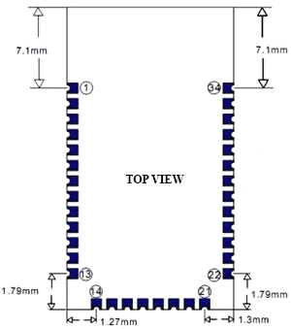
We will connect the Bluetooth module HC-06 to the Arduino Nano V3:
3.3V Arduino pin - to 12 pin HC-06 Bluetooth module
GND Arduino pin - to 13 pin HC-06 Bluetooth module
TX Arduino pin - to 2 pin HC-06 Bluetooth module (RX)
RX Arduino pin - to 1 pin HC-06 Bluetooth module (TX)
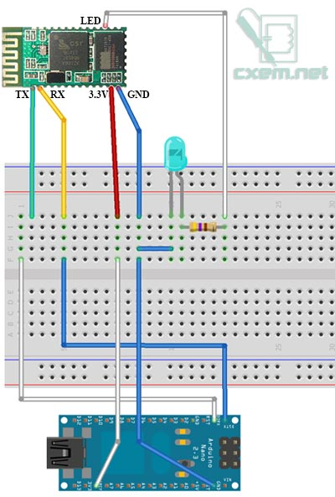

Transfer data from the Arduino via Bluetooth

Transfer data from the Arduino via Bluetooth
Program to send data from the Bluetooth module to the computer
int cnt = 0; // Counter

void setup() {
Serial.begin(9600); // Initialization
}

void loop() {
cnt++;
Serial.print("Hello BB from Arduino! Counter:"); // print message
Serial.println(cnt); // print counter
delay(1000); // wait 1 sec
}

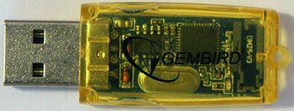
On PC, I use cheapest Bluetooth USB Adapter. After power on, you will be prompted to enter your Bluetooth devices pairing code/password. The default for most Bluetooth devices is 1234. If the pairing is successful, you will see a message.
Now the Bluetooth device and PC are connected.
To view the received data we need Terminal on PC. I use Tera Term. After starting the program, select the virtual COM-port at Bluetooth device. You will see counter from Arduino:
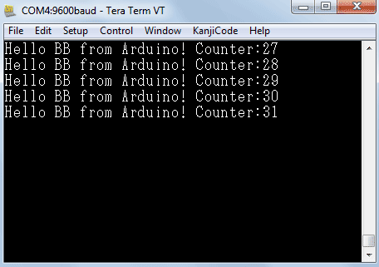

Bi-directional communication between PC and Arduino via Bluetooth
To the diagram, I added the LED connecting it to the 12 pin Arduino, via current-limiting resistor. But you can use build-in LED (13 pin). Our program is very simple:

char incomingByte; // incoming data
int LED = 12; // LED pin

void setup() {
Serial.begin(9600); // initialization
pinMode(LED, OUTPUT);
Serial.println("Press 1 to LED ON or 0 to LED OFF...");
}

void loop() {
if (Serial.available() > 0) { // if the data came
incomingByte = Serial.read(); // read byte
if(incomingByte == '0') {
digitalWrite(LED, LOW); // if 1, switch LED Off
Serial.println("LED OFF. Press 1 to LED ON!"); // print message
}
if(incomingByte == '1') {
digitalWrite(LED, HIGH); // if 0, switch LED on
Serial.println("LED ON. Press 0 to LED OFF!");
}
}
}

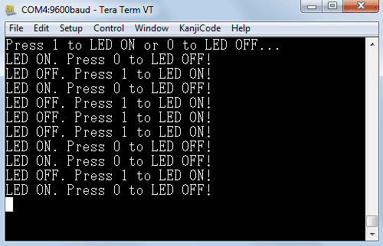
Video:

Android
To work with the Android you will need program: Bluetooth Terminal. Click in menu "Connect a device - Secure" and select our device "BOLUTEK". See video:

Arduino communicating with PC via Bluetooth
I like arduino because it has almost limitless potential. One of few a things that I hate is that when you want to control the arduino it has to be connected directly to the PC via USB.

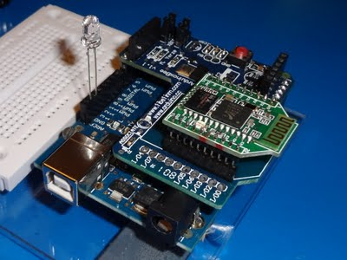

So I’ve decided to buy some hardware to make my arduino communicate with PC wirelessly. There are few options how to achieve that. You can either use Bluetooth or Wi-Fi. With Wi-Fi You’ll be using XBee radios. There are few versions of them and they the cost about 30 dollars. But you will also need an arduino XBee shield and XBee usb dongle. So the whole price is about 70 dollars if you’re lucky. Or you can use Bluetooth. There are few options. You can use BlueSMiRF which is pretty expensive or any other Bluetooth modem. I have used really cheap one from eBay. But this Bluetooth modem was in XBee form. So I’ve also bought arduino XBee shield. After you assemble it you have to move switch on a Bluetooth modem to AT position.
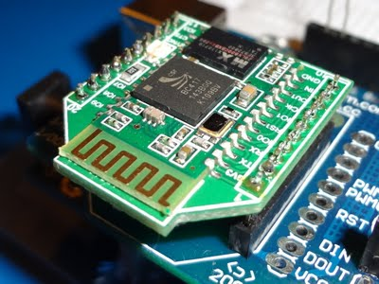

Next tricky thing is connecting arduino to PC. Your PC has to have some Bluetooth device that supports Bluetooth serial port communication. Then upload this sketch to arduino :

const int ledPin = 13;
int value;
void setup() {
Serial.begin(9600);
pinMode(ledPin, OUTPUT);
}
void loop() {
if (Serial.available() > 0) {
value = Serial.read();
if (value == 'H') {
digitalWrite(ledPin, HIGH);
Serial.println("ON");
}
if (value == 'L') {
digitalWrite(ledPin, LOW);
Serial.println("OFF");
}
}
}

Play Bluetooth With Arduino
June 23, 201022 CommentsApplication NotesBy itead
We have provide an inexpensive serial port Bluetooth module , it can work as a Bluetooth slave and communicate with a Bluetooth master like PC and mobile phone.
Arduino is a very popular development platform of AVR, so we choose it to work with this Bluetooth module and this combination can generate a lot of applications.
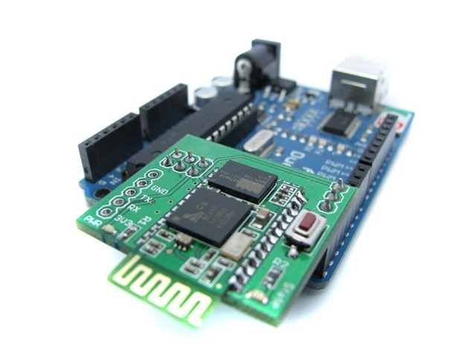
First , put the BT shield stand on Arduino board – the BT shield has a serial port Bluetooth module (Slave) on it. The BT shield have 3 pins connect with Arduino board : State , RX and TX. With the State LED and State pin, we can get the connection status of the BT shield , when the Bluetooth serial port channel is not build , the State LED will alternating light and off , and if the serial port is opened , the State LED will be on. The State pin will be the same mode as the LED .
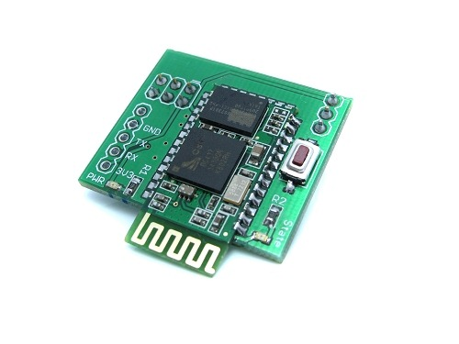
You can get more information about the BT Shield in the product page , or download the datasheet here.
Here we make a example how to use the Arduino with the Bluetooth module to send data to PC.
In this code , we use the interrupt to check the State pin, if the state pin level from high to low , then we consider that the module still in the standby mode, so wait for connecting. If the State pin maintain more than one second of high level, we consider that the Bluetooth channel has build and we can sent the data to serial port.
Download the code below into the Arduino:
unsigned int timeout=0;
unsigned char state=0;

ISR(TIMER2_OVF_vect) //Timer2 Service
{
TCNT2 = 0;
timeout++;
if (timeout>61)
{
state=1;
timeout=0;
}

}

void init_timer2(void)
{
TCCR2A |= (1 << WGM21) | (1 << WGM20);
TCCR2B |= 0x07; // by clk/1024
ASSR |= (0<<AS2); // Use internal clock - external clock not used in Arduino
TIMSK2 |= 0x01; //Timer2 Overflow Interrupt Enable
TCNT2 = 0;
sei();
}

void setup()
{
Serial.begin(9600);
pinMode(2,INPUT);
pinMode(13,OUTPUT);
attachInterrupt(0,cleantime,FALLING);
init_timer2();
}

void loop()
{
switch(state)
{
case 0:
digitalWrite(13,LOW);
break;

case 1:
digitalWrite(13,HIGH);
Serial.print("Hellow BT");
break;

}

}

void cleantime()
{
timeout=0;
state=0;
}

Reset the Arduino , we can see the PWR LED of the BT Shield is on , and the State LED is light and off , the D13 LED of Arduino board is off , that means the Bluetooth connection is not complete. Open the hardware manager , find the Bluetooth mode and connect it , the Pincode is 1234 as default . After install the driver , we can find a Bluetooth serial port in the PC , and use a serial monitor software to open it , the State LED on the BT Shield is continued on , and the D13 LED of the Arduino board will light ,too.It means the connection is build and we can communicate with PC now.
On the serial monitor on PC , we can see the data that send from Arduino.
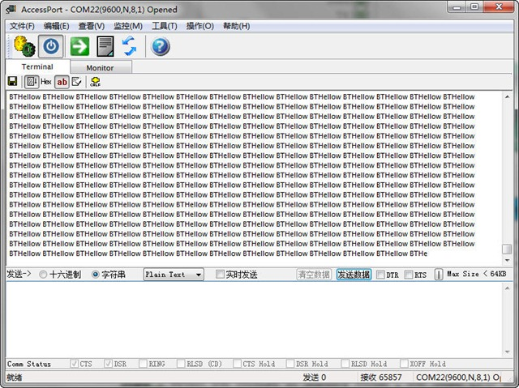
This just a opening , with this demo , we can use these module in many places . How about sending the sensor data to a software on PC or Phone.
The next step , we are going to make a Wireless Energy Monitor that base on Non-invasive AC current sensor. There is a open source projectbut it’s use the USB serial port and we will use Bluetooth , and we will make a sample software to calculate the Energy.

