很多親們經常問搖搖棒中的字怎樣取字模，今天在這裏描述一下；
以“歡”為例作為講解
程式中的“歡”點陣是這樣的：
//-- 歡 --
0x04,0x10,0x34,0x08,0xC4,0x06,0x04,0x01,
0xC4,0x82,0x3C,0x8C,0x20,0x40,0x10,0x30,
0x0F,0x0C,0xE8,0x03,0x08,0x0C,0x08,0x10,
0x28,0x60,0x18,0xC0,0x00,0x40,0x00,0x00,
為了直觀，我們把它按PCB佈線的方法把上面的點陣排類一下：
 | 1 | 2 | 3 | 4 | 1 | 2 | 3 | 4 | 1 | 2 | 3 | 4 | 1 | 2 | 3 | 4
P00 | 0 | 0 | 0 | 0 | 0 | 0 | 0 | 0 | 1 | 0 | 0 | 0 | 0 | 0 | 0 | 0
P01 | 0 | 0 | 0 | 0 | 0 | 0 | 0 | 0 | 1 | 0 | 0 | 0 | 0 | 0 | 0 | 0
P02 | 1 | 1 | 1 | 1 | 1 | 1 | 0 | 0 | 1 | 0 | 0 | 0 | 0 | 0 | 0 | 0
P03 | 0 | 0 | 0 | 0 | 0 | 1 | 0 | 0 | 1 | 1 | 1 | 1 | 1 | 1 | 0 | 0
P04 | 0 | 1 | 0 | 0 | 0 | 1 | 0 | 1 | 0 | 0 | 0 | 0 | 0 | 1 | 0 | 0
P05 | 0 | 1 | 0 | 0 | 0 | 1 | 1 | 0 | 0 | 1 | 0 | 0 | 1 | 0 | 0 | 0
P06 | 0 | 0 | 1 | 0 | 1 | 0 | 0 | 0 | 0 | 1 | 0 | 0 | 0 | 0 | 0 | 0
P07 | 0 | 0 | 1 | 0 | 1 | 0 | 0 | 0 | 0 | 1 | 0 | 0 | 0 | 0 | 0 | 0
P20 | 0 | 0 | 0 | 1 | 0 | 0 | 0 | 0 | 0 | 1 | 0 | 0 | 0 | 0 | 0 | 0
P21 | 0 | 0 | 1 | 0 | 1 | 0 | 0 | 0 | 0 | 1 | 0 | 0 | 0 | 0 | 0 | 0
P22 | 0 | 0 | 1 | 0 | 0 | 1 | 0 | 0 | 1 | 0 | 1 | 0 | 0 | 0 | 0 | 0
P23 | 0 | 1 | 0 | 0 | 0 | 1 | 0 | 0 | 1 | 0 | 1 | 0 | 0 | 0 | 0 | 0
P24 | 1 | 0 | 0 | 0 | 0 | 0 | 0 | 1 | 0 | 0 | 0 | 1 | 1 | 0 | 0 | 0
P25 | 0 | 0 | 0 | 0 | 0 | 0 | 0 | 1 | 0 | 0 | 0 | 0 | 1 | 0 | 1 | 0
P26 | 0 | 0 | 0 | 0 | 0 | 0 | 1 | 0 | 0 | 0 | 0 | 0 | 0 | 1 | 0 | 0
P27 | 0 | 0 | 0 | 0 | 1 | 1 | 0 | 0 | 0 | 0 | 0 | 0 | 0 | 1 | 0 | 0
其中1為亮 ，0為LED滅（為什麼1是亮，0是滅，請親們看一下程式和電路，2個結合起來看一下就明白了，這裏就不再說明）
接下來為了方便看哪些是亮的，我們把0去掉：
P00 |  |  |  |  |  |  |  |  | 1
P01 |  |  |  |  |  |  |  |  | 1
P02 | 1 | 1 | 1 | 1 | 1 | 1 |  |  | 1
P03 |  |  |  |  |  | 1 |  |  | 1 | 1 | 1 | 1 | 1 | 1
P04 |  | 1 |  |  |  | 1 |  | 1 |  |  |  |  |  | 1
P05 |  | 1 |  |  |  | 1 | 1 |  |  | 1 |  |  | 1
P06 |  |  | 1 |  | 1 |  |  |  |  | 1
P07 |  |  | 1 |  | 1 |  |  |  |  | 1
P20 |  |  |  | 1 |  |  |  |  |  | 1
P21 |  |  | 1 |  | 1 |  |  |  |  | 1
P22 |  |  | 1 |  |  | 1 |  |  | 1 |  | 1
P23 |  | 1 |  |  |  | 1 |  |  | 1 |  | 1
P24 | 1 |  |  |  |  |  |  | 1 |  |  |  | 1 | 1
P25 |  |  |  |  |  |  |  | 1 |  |  |  |  | 1 |  | 1
P26 |  |  |  |  |  |  | 1 |  |  |  |  |  |  | 1
P27 |  |  |  |  | 1 | 1 |  |  |  |  |  |  |  | 1

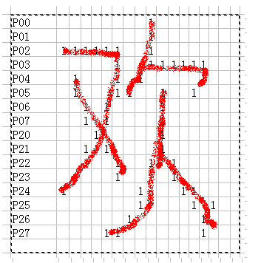
看到了嗎，一個很大的“歡”字就出來了。上面的點陣我們是手動排列的。接下來教大家如何用軟體取字模。
首先把點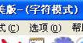中的選項，把軟體設置為以下方式取字模：
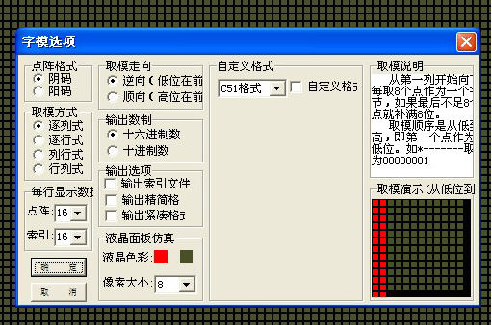
字體設置為：新宋體然後輸入“歡”，點生產字模
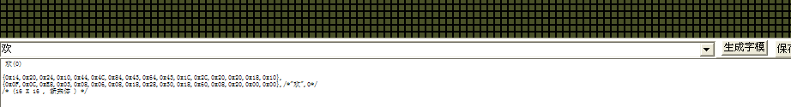
點完後我們會得到如下的字模：
歡(0)

{0x14,0x20,0x24,0x10,0x44,0x4C,0x84,0x43,0x64,0x43,0x1C,0x2C,0x20,0x20,0x18,0x10},
{0x0F,0x0C,0xE8,0x03,0x08,0x06,0x08,0x18,0x28,0x30,0x18,0x60,0x08,0x20,0x00,0x00},/*"歡
/* (16 X 16 , 新宋體 ) */

這個就是我們要的“歡”字的字模，很多親們就會問，為什麼軟體取出來的字模和程式中的不一樣，那是因為程式中的字模，我們是手動排列的。用軟體取出來的字模也是可以的。
我們可以按照軟體取出來的自模自己排列一下：
|
P00 |  |  |  |  |  |  |  |  | 1
P01 |  |  |  |  |  |  |  |  | 1
P02 | 1 | 1 | 1 | 1 | 1 | 1 |  |  | 1
P03 |  |  |  |  |  | 1 |  | 1 | 1 | 1 | 1 | 1 | 1 | 1 | 1
P04 | 1 |  |  |  |  | 1 |  | 1 |  |  |  |  |  | 1
P05 |  | 1 |  |  | 1 |  | 1 |  |  | 1 |  |  | 1
P06 |  |  | 1 |  | 1 |  |  |  |  | 1
P07 |  |  |  | 1 |  |  |  |  |  | 1
P20 |  |  |  | 1 | 1 |  |  |  |  | 1
P21 |  |  |  | 1 | 1 | 1 |  |  |  | 1 | 1
P22 |  |  | 1 |  |  |  |  |  | 1 |  | 1
P23 |  |  | 1 |  |  |  |  |  | 1 |  |  | 1
P24 |  | 1 |  |  |  |  |  | 1 |  |  |  | 1 | 1
P25 | 1 |  |  |  |  |  | 1 |  |  |  |  |  | 1 | 1 | 1
P26 |  |  | 1 | 1 | 1 | 1 |  |  |  |  |  |  |  | 1
P27 |  |  |  |  |  | 1
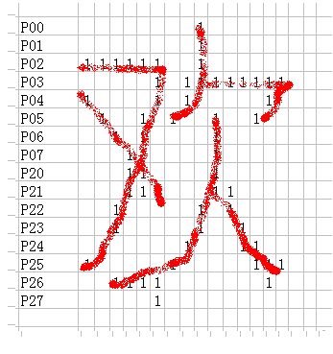
也是一個|“歡”，只是字體不一樣。

