下载

官网

<https://mednafen.github.io/>

点击releases

找到最新版本

<https://mednafen.github.io/releases/>

如

**Mednafen 1.27.0-UNSTABLE** *(April 1, 2021)*

* [64-bit Windows (Recommended)](https://mednafen.github.io/releases/files/mednafen-1.27.0-UNSTABLE-win64.zip)

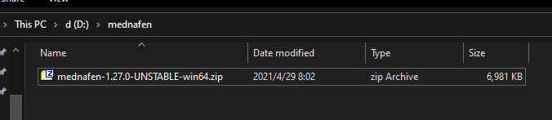

解压到当前文件夹

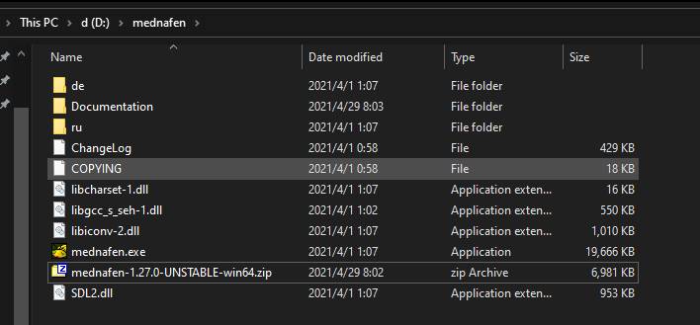

设置环境变量

**MEDNAFEN\_HOME**

**D:\mednafen**

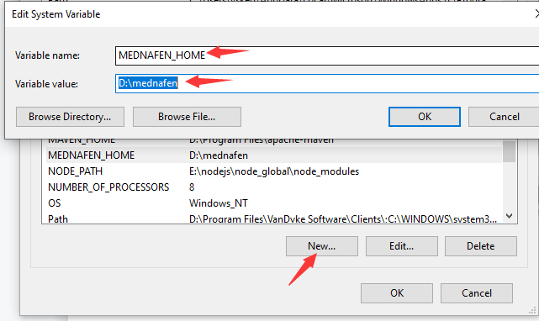

添加path

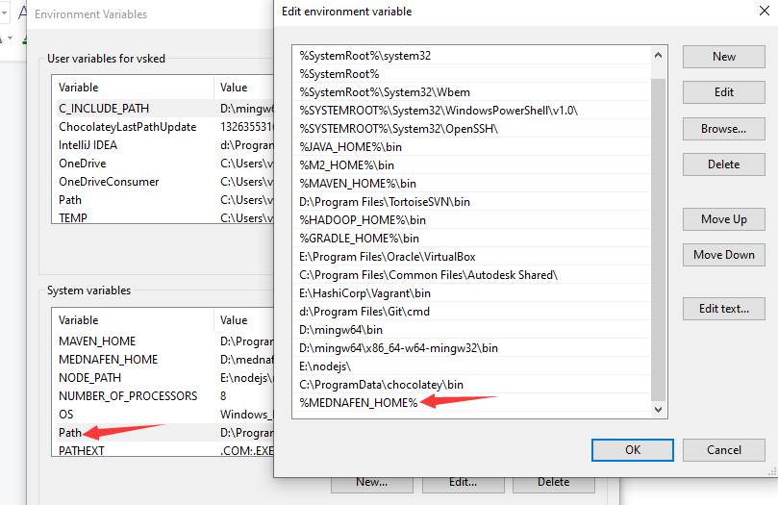

配置完成后打开cmd

D:

cd mednafen

mednafen.exe

选运行一次mednafen目的是生成基础目录

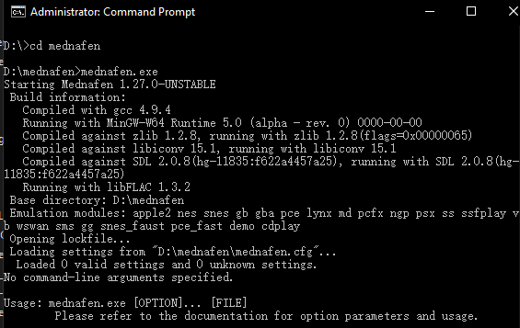

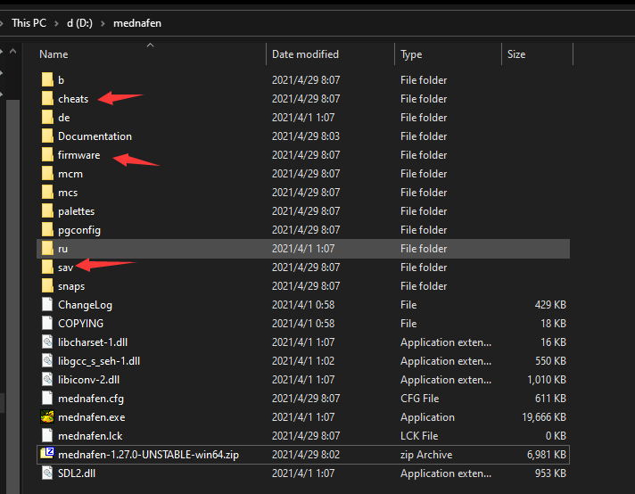

**具体使用方法**

**命令格式**

mednafen 游戏ROM路径

使用示例：

注意如果rom路径中有空格建议使用双引号将路径引起来，如下示例

mednafen “G:\ThisGame\单机\小霸王游戏机珍藏84合1\rom\松鼠1.nes”

**常用按键：**

FC游戏

|  |  |  |
| --- | --- | --- |
| FC | 键盘 | 说明 |
| Start | Enter | 开始 |
| Select | Tab | 选择 |
| up | w | 上 |
| down | s | 下 |
| left | a | 左 |
| right | d | 右 |
| B | 数字键盘2 | 攻击 |
| A | 数字键盘3 | 跳 |

更多FC游戏详细信息参考：

<https://mednafen.github.io/documentation/nes.html#Section_input>

**参考手册1：**

## Using Mednafen

### Key Assignments

All default key mappings are by scancode, so you'll need to press the keys corresponding to the appropriate positions on the standard U.S keyboard layout.

|  |  |  |
| --- | --- | --- |
| **Key(s):** | **Action:** | **Configuration String:** |
| F1 | Toggle in-game quick help screen. | toggle\_help |
| F5 | Save state. | save\_state |
| F7 | Load state. | load\_state |
| 0-9 | Select save state slot. | "0" through "9" |
| - | Decrement selected save state slot. | state\_slot\_dec |
| = | Increment selected save state slot. | state\_slot\_inc |
| ALT + S | Toggle [600-frame](https://mednafen.github.io/documentation/" \l "srwframes) save-state rewinding functionality, disabled by default. | toggle\_state\_rewind |
| SHIFT + F5 | Record movie. | save\_movie |
| SHIFT + F7 | Play movie. | load\_movie |
| SHIFT + 0-9 | Select movie slot. | "m0" through "m9" |
| LALT + C | Toggle cheat console. **Note**: Will not respond to RALT/AltGr even if remapped. | togglecheatview |
| ALT + T | Toggle cheats active. | togglecheatactive |
| T | Enable network play console input. | togglenetview |
| LALT + D | Toggle [debugger](https://mednafen.github.io/documentation/debugger.html). **Note**: Will not respond to RALT/AltGr even if remapped. | toggle\_debugger |
| **Key(s):** | **Action:** | **Configuration String:** |
| ` | Fast-forward. | fast\_forward |
| \ | Slow-forward. | slow\_forward |
| ALT + A | Enter frame advance mode, or advance the frame if already in it. | advance\_frame |
| ALT + R | Exit frame advance mode. | run\_normal |
| Pause | Pause/Unpause. | pause |
| SHIFT + F1 | Toggle frames-per-second display(from top to bottom, the display format is: virtual, rendered, blitted). | toggle\_fps\_view |
| Backspace | Rewind emulation, if save-state rewinding functionality is enabled, up to [600 frames](https://mednafen.github.io/documentation/" \l "srwframes). | state\_rewind |
| F9 | Save (rawish) screen snapshot. | take\_snapshot |
| SHIFT + F9 | Save screen snapshot, taken after all scaling and special filters/shaders are applied. | take\_scaled\_snapshot |
| ALT + O | Rotate the screen | rotate\_screen |
| ALT + Enter | Toggle fullscreen mode. | toggle\_fs |
| CTRL + 1 through Ctrl + 9 | Toggle layer. | "tl1" through "tl9" |
| **Key(s):** | **Action:** | **Configuration String:** |
| F3 | [Detect analog buttons](https://mednafen.github.io/documentation/" \l "Section_analog_detection) on physical joysticks/gamepads(for use with the input configuration process). | input\_config\_abd |
| ALT + SHIFT + [*n*] | Configure buttons for emulated device on input port *n*(1-8). | input\_config*n* |
| CTRL + SHIFT + [*n*] | Select input device on input port *n*(1-8).  **Note:** Many games do not expect input devices to change while the game is running, and thus may require a hard reset. | device\_select*n* |
| F2 | Activate in-game input configuration process for a command key. | input\_configc |
| SHIFT + F2 | Like F2, but after configuration completes, to activate the configured command key will require all buttons configured to it to be in a pressed state simultaneously to trigger the action. Note that keyboard modifier keys(CTRL, ALT, SHIFT) are still treated as modifiers and not discrete keys.  Especially useful in conjunction with the [ckdelay](https://mednafen.github.io/documentation/" \l "ckdelay) setting. | input\_configc\_am |
| SHIFT + F3 | Reinitialize physical joysticks/gamepads. Note that this will also cause Mednafen to forget about any analog buttons detected by previously pressing [F3](https://mednafen.github.io/documentation/" \l "command.input_config_abd). | reinit\_joysticks |
| CTRL + SHIFT + Menu | Toggle [input grabbing](https://mednafen.github.io/documentation/" \l "Section_input_grabbing)(for emulated mice and keyboards). | toggle\_grab |
| **Key(s):** | **Action:** | **Configuration String:** |
| SHIFT + F6 | Select drive. | select\_drive |
| F6 | Select medium(CD, floppy disk, etc.) for selected drive. | select\_disk |
| F8 | Insert/Eject medium(CD, floppy disk, etc.) for selected drive. | insert\_eject\_disk |
| F10 | Reset. | reset |
| F11 | Hard reset(toggle power switch). | power |
| Escape/F12 | Exit(the emulator, or netplay chat mode). | exit |

### Input Grabbing

Keyboard and mouse input can be grabbed(from the OS/window manager) by pressing [CTRL+SHIFT+Menu](https://mednafen.github.io/documentation/" \l "command.toggle_grab)(default mapping), and disabled by pressing the same again.

Emulated keyboards will only function when input grabbing is enabled. When input grabbing is enabled, and at least one emulated keyboard that has an emulated key mapped to a host keyboard key is enabled, all(except for the input grab toggling mapping) other host keyboard input mappings will see all keyboard keys as being unpressed. In other words, this disables hotkeys/command keys(unless the user has mapped them to a non-keyboard device), and the keyboard mappings of any non-keyboard emulated devices.

Emulated mice mapped to the system mouse will only function properly when input grabbing is enabled or when in a fullscreen video mode, the debugger is inactive, and no other emulated input devices that rely on absolute mouse coordinates(e.g. lightguns) are active and mapped to the system mouse.

### Remapping Buttons and Keys

You may configure a virtual(emulated) input device by using special command keys in Mednafen while a game is running.

**Caution:** Users of XBox 360-type/compatible controllers on operating systems other than Microsoft Windows(e.g. Linux), or users of other controllers with analog buttons, should complete the following process before attempting any configuration that will map a physical analog button to a virtual input. Failure to complete this process under the aforementioned conditions which necessitate it will result in the input configuration functionality becoming confused, and the resulting input mappings will be wonky.

Twirl all sticks and D-pads, move all throttles to maximum then center(and leave them there), and press all analog buttons on any physical gamepads/joysticks with analog buttons you want to use in the input configuration process, then press [F3](https://mednafen.github.io/documentation/" \l "command.input_config_abd). Then, configure input as normal. The detected analog buttons will be recognized during input configuration until Mednafen exits; if you exit Mednafen and restart, and want to configure input devices again, you'll need to repeat the twirling-pressing-[F3](https://mednafen.github.io/documentation/" \l "command.input_config_abd) process again).

All joystick throttles should be set to their center position before configuring inputs. To register a "press" with a throttle control during the input configuration process, move it to the maximum or minimum position as appropriate, then back to the center position.

To configure the virtual device on input port 1, press ALT+SHIFT+1. For the virtual device on input port 2, press ALT+SHIFT+2. Etc.

After pressing the appropriate command key or command key combination, a message will be displayed at the bottom of the screen similar to "GamePad #1: A (1)". At this time, you would press the physical joystick or keyboard button you want to map to button "A" on the first virtual gamepad. After you push the button, you should see something like "GamePad #1: A (2)". If you want to map any other physical buttons to virtual button "A", press them now. Otherwise, press the physical joystick or keyboard button you pressed before, and you will move on to the configuration of the next virtual button("B").

To configure a command key, press [F2](https://mednafen.github.io/documentation/" \l "command.input_configc), and then the command key whose mapping you wish to change. The process is similar to that for a virtual input device.

### Command-line

Mednafen supports options passed on the command line. Options are taken in the form of "-option value". Some options are valueless.

In addition to the options listed in the table below, any setting listed in the "Settings" section of this document and any system emulation module sub-document can be set by prefixing it with a hyphen(-), followed by the value, such as: -nes.slstart 8

|  |  |  |
| --- | --- | --- |
| **Option:** | **Value Type:** | **Description:** |
| -force\_module x | string | Force usage of specified emulation module. |
| -which\_medium x | integer | Start with specified disk/CD(numbered from 0) inserted. For ejected, pass -1. |
| -connect | *(n/a)* | Trigger to connect to remote host after the game is loaded. |
| -soundrecord x | string | Record sound output to the specified filename in the MS WAV format. |
| -qtrecord x | string | Record video and audio output to the specified filename in the QuickTime format. |

### Configuration Files

Mednafen loads/saves its settings from/to a primary configuration file, named "**mednafen.cfg**", under the Mednafen [base directory](https://mednafen.github.io/documentation/" \l "Section_base_directory). This file is created and written to when Mednafen shuts down.