Download this files from site github

Launcher.zip

<https://github.com/themitosan/fpPS4-Temmie-s-Launcher/releases>

fpPS4_v0.0.1.zip

<https://github.com/red-prig/fpPS4/releases>

PkgEditor-0.2.231.zip

<https://github.com/maxton/LibOrbisPkg/releases/>

libSceUtils.zip

<https://github.com/MrReekoFTWxD/libSceUtils/releases/tag/1.00>

extract compressed folders

Launcher.zip

libSceUtils.zip

fpPS4_v0.0.1.zip

create folders

C:\game\ps4\Launcher\EMU

C:\game\ps4\Launcher\lib

C:\game\ps4\Launcher\games

C:\game\ps4\Launcher\games\Sonic Mania

Copy files from

C:\game\ps4\fpPS4_v0.0.1

To

C:\game\ps4\Launcher\EMU

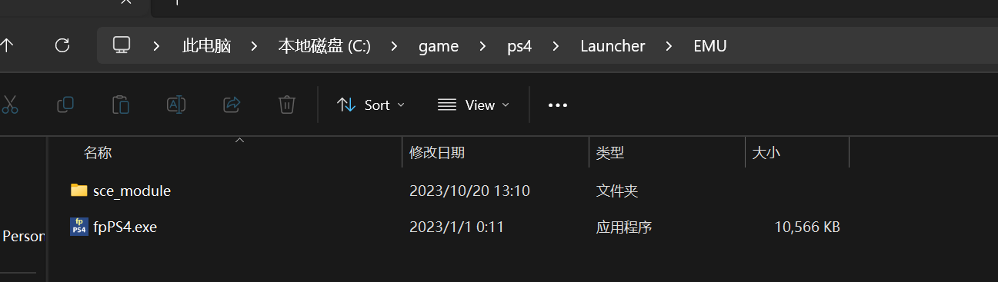

Copy files from

C:\game\ps4\libSceUtils

To

C:\game\ps4\Launcher\lib

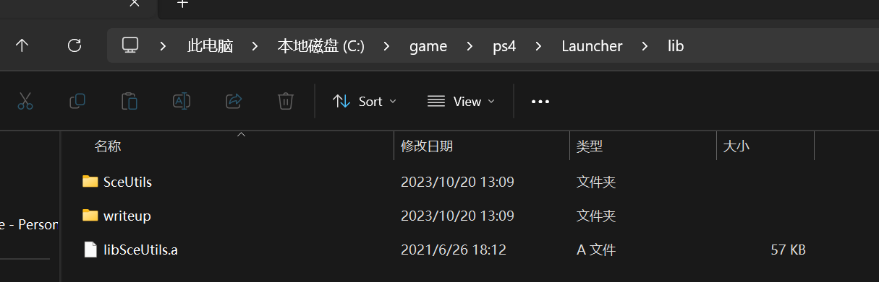

Open pkgEditor

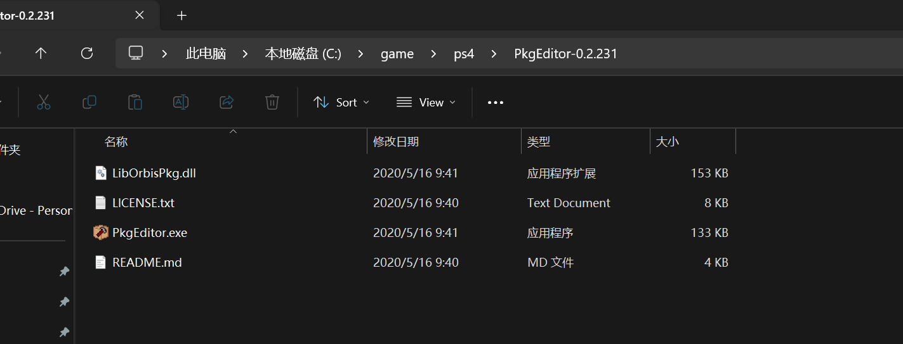

File->Open->select your download game file and export to

C:\game\ps4\Launcher\games\game name

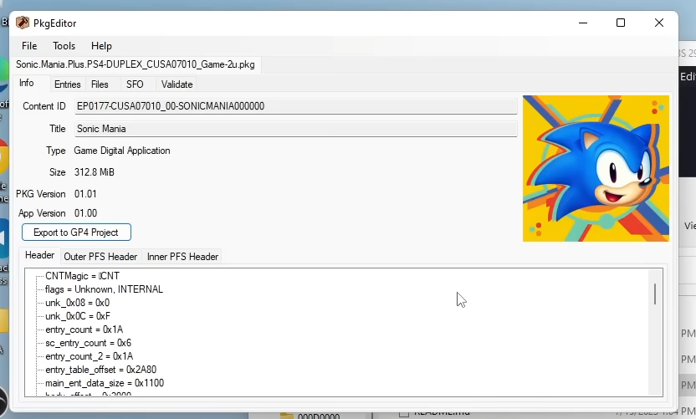

Export to GP4 project

Save to

C:\game\ps4\Launcher\games\game name

Then start

C:\game\ps4\Launcher\ Launcher.bat

You can play game now