下载gradle

<https://gradle.org/>

解开压缩包到

D:\Program Files\gradle

注意解开以后把版本号删除，这样下次升级就可以直接覆盖了

配置环境变量

GRADLE_HOME

D:\Program Files\gradle

path环境变量中新添加一条

%GRADLE_HOME%\bin

开一个cmd测试gradle是否安装成功

gradle -v

文件扩展名为.gradle基本结构如下

/*

* This file was generated by the Gradle 'init' task.

*

* This generated file contains a sample Java Library project to get you started.

* For more details take a look at the Java Libraries chapter in the Gradle

* user guide available at https://docs.gradle.org/4.8.1/userguide/java_library_plugin.html

*/

plugins {

// Apply the java-library plugin to add support for Java Library

id 'java-library'

}

dependencies {

//可以为外部识别的用api不可以被外部识别的用implementation

// This dependency is exported to consumers, that is to say found on their compile classpath.

api 'org.apache.commons:commons-math3:3.6.1'

api 'org.elasticsearch:elasticsearch:7.6.1'

// This dependency is used internally, and not exposed to consumers on their own compile classpath.

implementation 'com.google.guava:guava:23.0'

// Use JUnit test framework

testImplementation 'junit:junit:4.12'

}

// In this section you declare where to find the dependencies of your project

repositories {

// Use jcenter for resolving your dependencies.

// You can declare any Maven/Ivy/file repository here.

jcenter()

}

myeclipse中插件用buildship Gradle integration

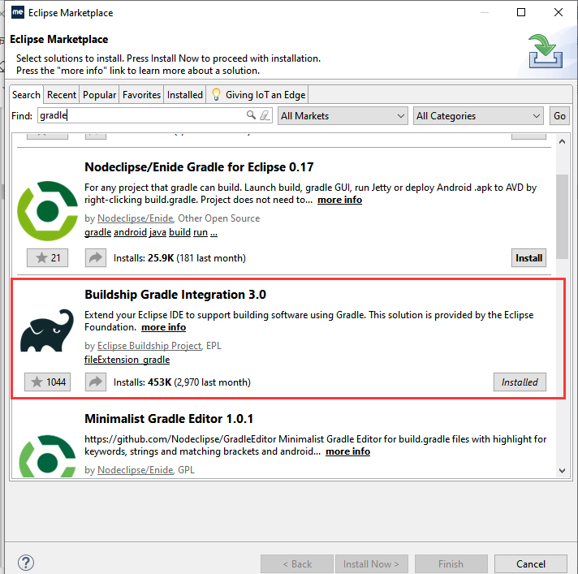

如果要运行任务或构建用这里

