修改网卡mac

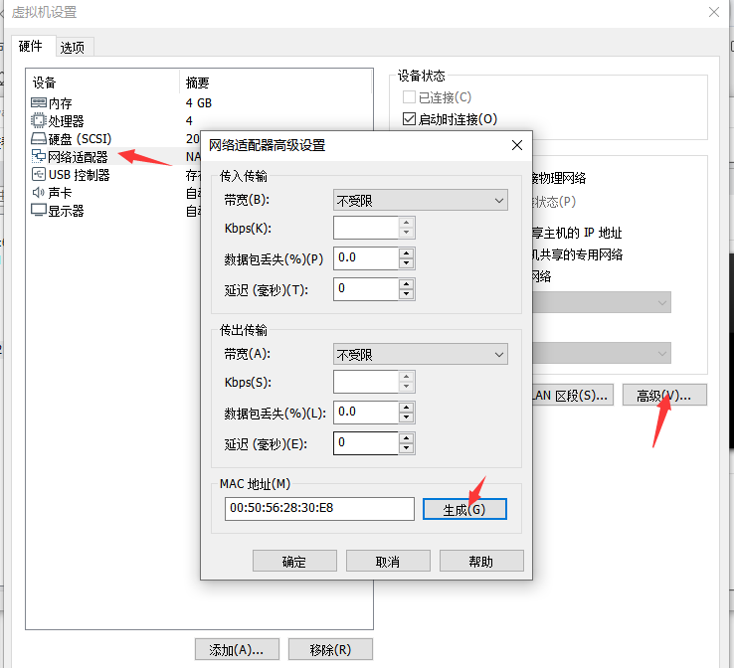

修改主机名

hostnamectl set-hostname basebigdata2

修改ip

vi /etc/sysconfig/network-scripts/ifcfg-ens33

TYPE=Ethernet

PROXY_METHOD=none

BROWSER_ONLY=no

BOOTPROTO=static

DEFROUTE=yes

IPV4_FAILURE_FATAL=no

IPV6INIT=no

IPV6_AUTOCONF=no

IPV6_DEFROUTE=no

IPV6_FAILURE_FATAL=no

IPV6_ADDR_GEN_MODE=stable-privacy

NAME=ens33

UUID=506ec297-04ee-46a4-873b-39efbc24e90c

DEVICE=ens33

ONBOOT=yes

IPADDR=10.0.192.12

PREFIX=24

GATEWAY=10.0.192.2

DNS1=114.114.114.114