1. ResNet CIFAR100

Test set accuracy: 0.602

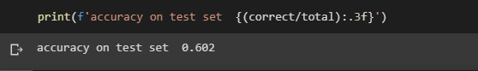

Test accuracy plot:

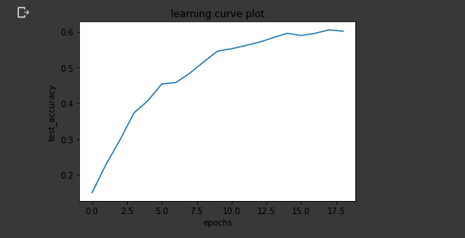

1. ResNet TinyImageNet

3. Pre-trained ResNet CIFAR100

Test set accuracy: 0.705

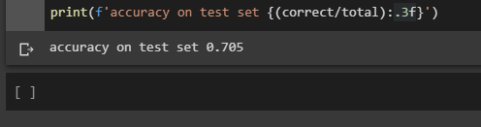

Test accuracy plot:

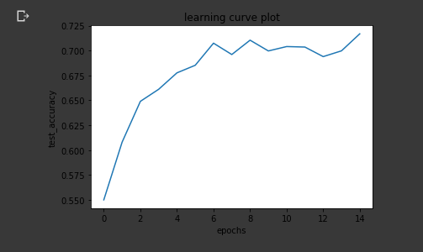

4 Sync

Test set accuracy: 0.6201

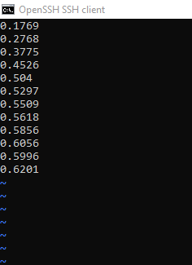

Test accuracy plot:

