Guidelines:
- Introduction/Exploratory Data Analysis, 2) Preprocessing, feature extraction, feature selection, 3) Model fitting and evaluation, (you should fit at least 3 different machine learning models) 4) Hyperparameter tuning, 5) Ensembling and 6) Conclusions

Biggest discovery: In general, with the increase of the months of percent change, our models performance increases as well.

Ensembling method:
After trying bagging with random forest, we applied one of the ensemble boosting method called XGBoost. It is an optimized distributed gradient boosting library designed to be highly efficient, flexible and portable. It implements machine learning algorithms under the gradient boosting framework. XGBoost provides a parallel tree boosting (also known as GBDT, GBM) that solve many data science problems in a fast and accurate way. The same code runs on major distributed environment (Hadoop, SGE,MPI) and can solve problems beyond billions of examples. (Ref: https://xgboost.readthedocs.io/en/latest/). A GridSearch is implemented as usual and RandomizedSearch is also implemented and the higher result is reported. For hyper parameter tuning, we used max_depth and min_child_weight which are popular choices when applying xgboost. For predicting score, please kindly refer to the table.

Neural net:
Neural net performed astonishingly bad. We believe it results from both our possible lacking of understanding of deep learning, but also from the fact that it is a small dataset with real-world economic meaning which can be hard to detect by NN. For predicting score, please kindly refer to the table.

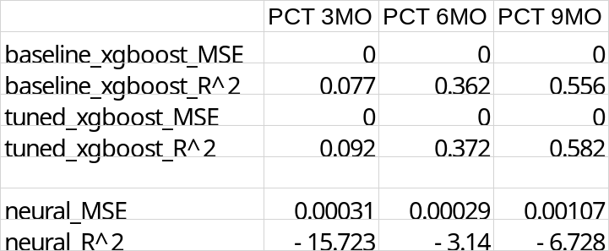
Conclusion:
As specially emphasized in class, as quoting ‘If you learn only one class, let it be ensemble method’, we managed to confirm that ensemble method is the best model among our trial of models. Furthermore, random forests beats xgboost in our experiments.

