50 stretches after running hiking and biking
  - 28 outdoor options and 22 indoor options
Research date 24 October 2026

How to use this guide
This guide contains 50 different stretches for use after running, hiking, or biking. There are 28 outdoor options that need no mat and 22 indoor options that can use a mat. Each exercise has a matching illustration, simple steps, a target area, and a source link.
Use the list as a menu. Choose 4 to 6 stretches for the areas that feel tight. Activity labels show practical use based on the muscles and positions involved. They do not show results from a trial of each stretch after each sport.
First reduce your effort for 3 to 5 minutes, for example with easy walking. Stretch while your muscles are warm. Follow the time shown for each exercise. For a stretch with two sides, change sides and use the same time.
Move slowly and breathe normally. Use mild tension. Do not bounce or force a joint. Stop if you feel sharp pain, numbness, dizziness, or joint pain. Use a fixed support outdoors. Remove a backpack before you stretch.
These options are for adults who can exercise without pain. If you have an injury, a recent operation, or a medical restriction, ask a qualified clinician which positions are suitable. Some source pages are treatment guides. The short times here are starting options for this menu, not their treatment programmes.
Regular stretching can improve flexibility. Stretching after exercise has not shown a useful reduction in delayed muscle soreness. Do not use these stretches as a promise of faster recovery or injury prevention.
Guidance: American Heart Association | Cochrane review

How the exercises differ
Left and right sides count as one exercise. Repeated names and simple changes from standing to lying are not listed as extra entries. Some stretches share a muscle group but use a different joint action or a different combination of joints. Each entry explains that difference.
For example, a straight knee and a bent knee change the calf emphasis. A forearm turn moves around the forearm axis; a wrist stretch bends the hand. Butterfly, frog, and the long inner thigh rock back use different hip and knee positions.

About the illustrations
Each exercise has one numbered illustration. The same female figure wears an orange shirt and navy shorts. The image number and file name match the exercise number and name.
Hand and foot exercises use close views. Cat and cow and the open book use two stages in one illustration. Supports, mats, towels, and straps appear where needed.
All 50 finished illustrations are included in this guide. Separate SVG vector files and PNG viewing copies are supplied. Every SVG and PNG file is smaller than 100 KB. The illustrations were made with image generation and converted to SVG paths.

Free resources and image reuse
Free Exercise DB declares its dataset under the Unlicense. It provides separate exercise records, instructions, and example photographs. It is useful for pose reference and data structure. Check the origin of a specific photograph before you use it in a published product. An open repository license alone does not establish every third party image right.
wger is open source software. Its initial exercise data uses Creative Commons Attribution ShareAlike terms. Current data and image entries can have different licenses. Check each entry and retain its author and license details before reuse. wger was reviewed as a resource; it is not the source of an exercise entry in this guide.
The NHS, AAOS, university, and other health pages below are free to read. Their links provide the exercise references. The orange illustrations in this edition were made with image generation from the approved character and pose references. Third party reference images are kept in a separate source pack. Follow the stated license if you copy a source asset.

Useful starting selections
After running: 1, 2, 4, 5, 6, and 30. These cover upper calf, deep calf, front thigh, back thigh, front hip, and buttock.
After hiking: 1, 5, 8, 10, 13, and 45. These cover legs, outer hip, trunk, shoulders, and the foot arch.
After biking: 4, 6, 11, 15, 18, and 21. These cover front thighs, front hips, back, chest, neck, and forearms. Use indoor options later if needed.
These are short starting menus. Choose fewer if needed. Do not do all 50 exercises in one session.

Outdoor stretches 1 to 2
No mat needed | Use stable ground and fixed supports

01 Straight knee calf stretch
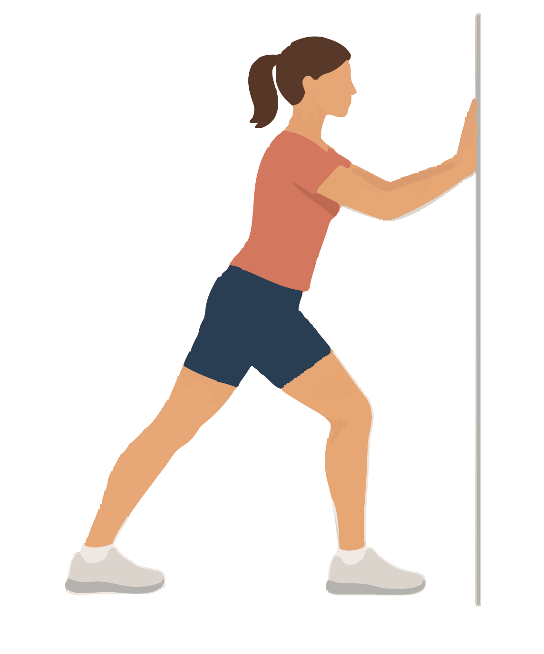
Target: Upper calf muscle called gastrocnemius | Use after: Running Hiking Biking
Equipment: Wall or fixed rail | Time: 20 seconds per side; 1 or 2 rounds
1. Place your hands on the support. Step one foot back.
2. Keep the back heel down and the back knee straight.
3. Bend the front knee and move your body forwards.
Form Point both feet forwards. Do not lock the back knee.
Source: AAOS foot and ankle conditioning

02 Bent knee calf stretch
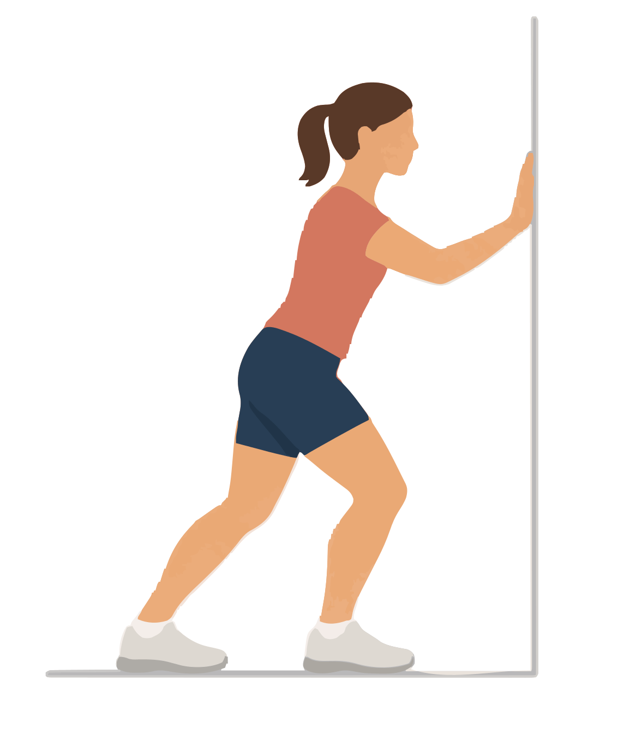
Target: Deep calf muscle called soleus | Use after: Running Hiking Biking
Equipment: Wall or fixed rail | Time: 20 seconds per side; 1 or 2 rounds
1. Place one foot behind the other. Hold the support.
2. Keep the back heel down and bend both knees.
3. Lower your hips a little until the lower calf stretches.
Form Keep your weight centred. Use a small movement.
Source: AAOS foot and ankle conditioning

Outdoor stretches 3 to 4
No mat needed | Use stable ground and fixed supports

03 Standing shin stretch
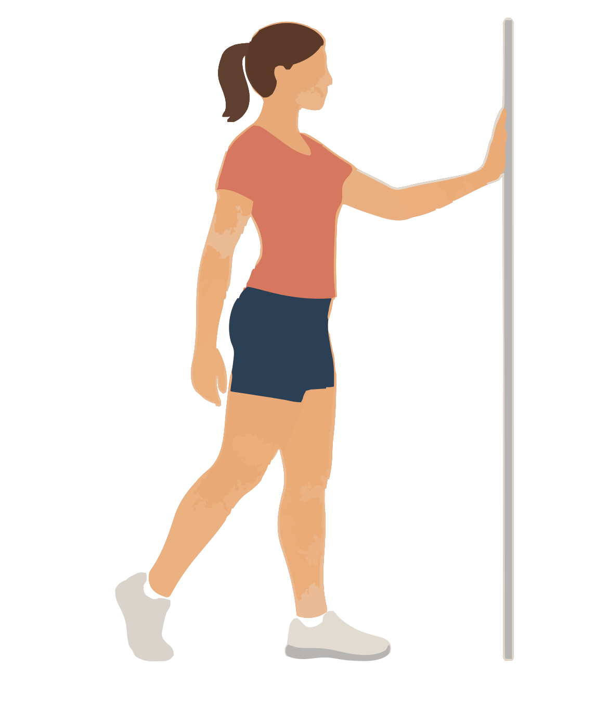
Target: Front of the shin and ankle | Use after: Running Hiking
Equipment: Fixed support | Time: 20 seconds per side; 1 or 2 rounds
1. Hold the support. Put most of your weight on one foot.
2. Place the top of the other toes on the ground just behind you.
3. Keep light toe contact and move that leg forwards a little.
Form Keep almost all weight on the standing leg. Do not press into the toe joints.
Source: Verywell Fit shin stretch reviewed by a physical therapist

04 Standing front thigh stretch
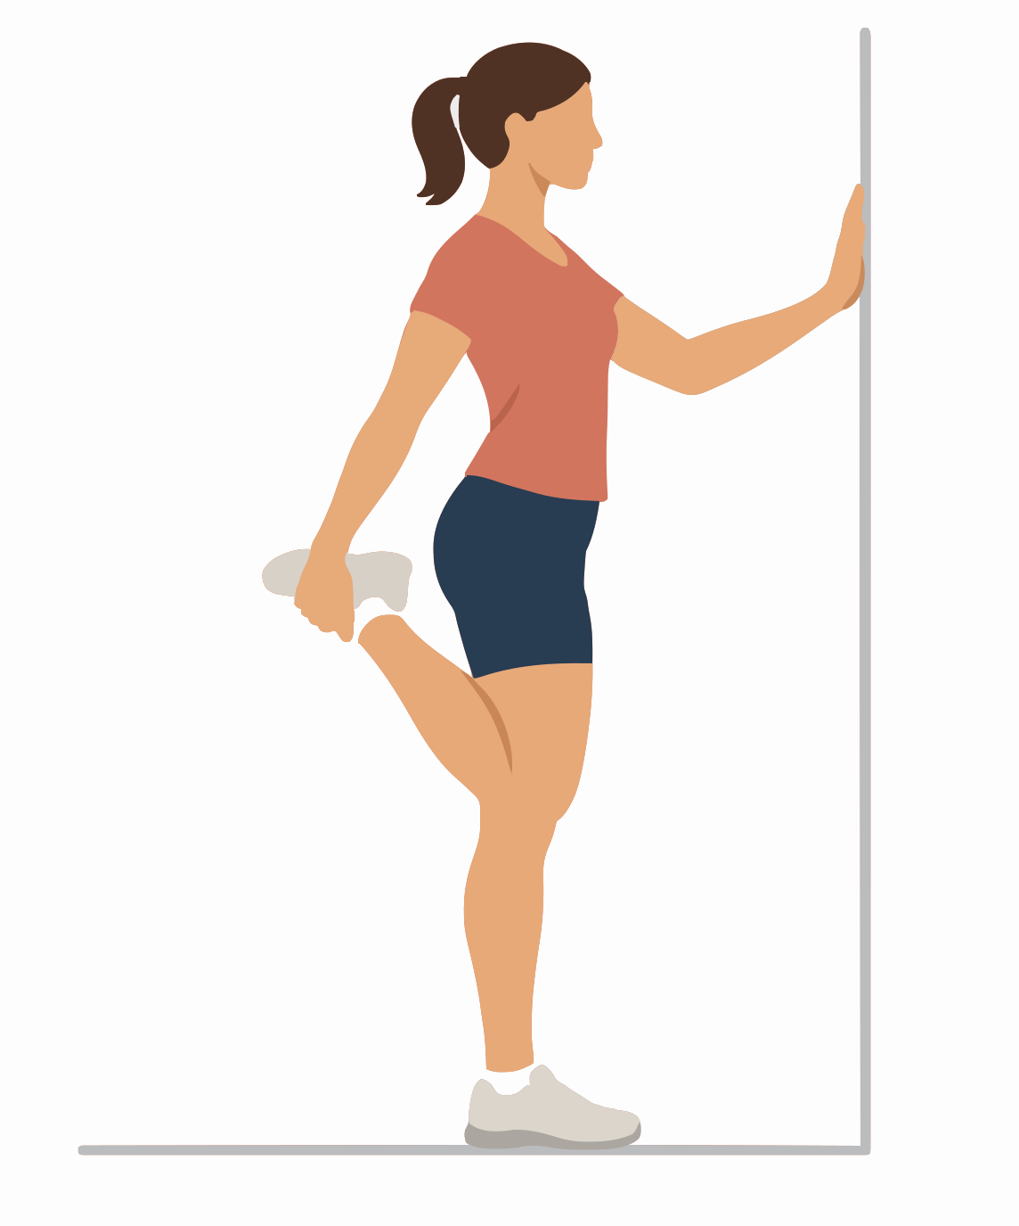
Target: Front thigh muscles called quadriceps | Use after: Running Hiking Biking
Equipment: Fixed support | Time: 20 seconds per side; 1 or 2 rounds
1. Hold the support. Bend one knee behind you.
2. Hold that ankle and bring the heel towards your buttock.
3. Keep your knees close and your body upright.
Form Keep the bent knee below your hip. Do not pull the leg out to the side.
Source: NHS stretches after exercise

Outdoor stretches 5 to 6
No mat needed | Use stable ground and fixed supports

05 Heel forward hamstring stretch
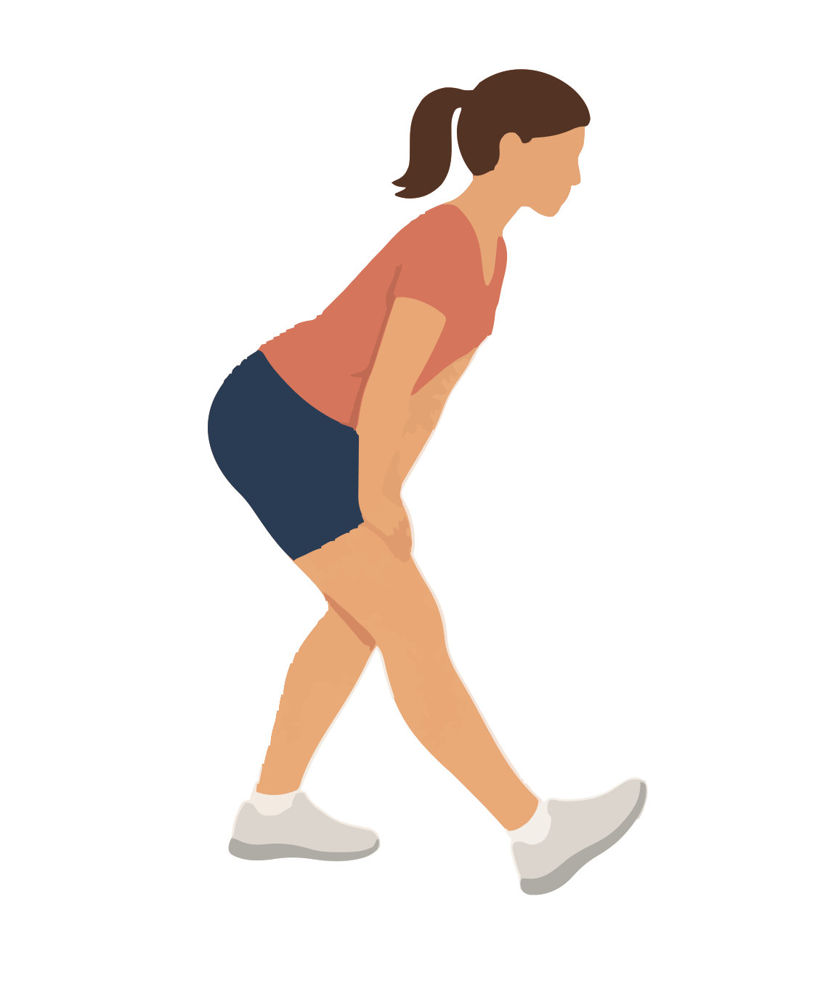
Target: Back of the thigh | Use after: Running Hiking Biking
Equipment: None | Time: 20 seconds per side; 1 or 2 rounds
1. Place one heel a short step in front of you.
2. Bend the back knee. Keep the front knee almost straight.
3. Move your hips back and lean forwards from the hips.
Form Keep your back long. Rest your hands on the bent thigh.
Source: Cambridge University Hospitals general stretches

06 Standing front hip stretch
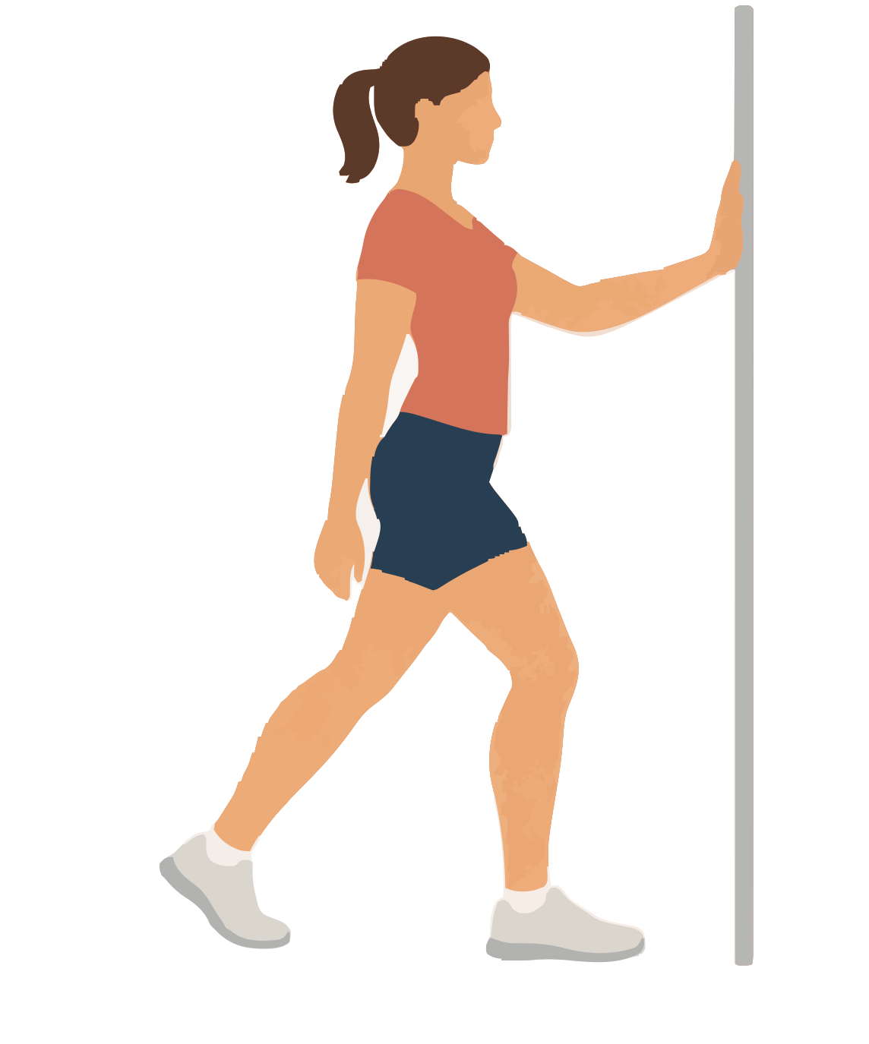
Target: Front hip muscles called hip flexors | Use after: Running Hiking Biking
Equipment: Fixed support if needed | Time: 20 seconds per side; 1 or 2 rounds
1. Take a short split stance. Raise the back heel.
2. Bend both knees a little and tighten the back buttock.
3. Tuck your pelvis slightly and move your hips forwards.
Form Keep your chest above your hips. Do not arch your lower back.
Source: Free Exercise DB Standing Hip Flexors

Outdoor stretches 7 to 8
No mat needed | Use stable ground and fixed supports

07 Side lunge inner thigh stretch
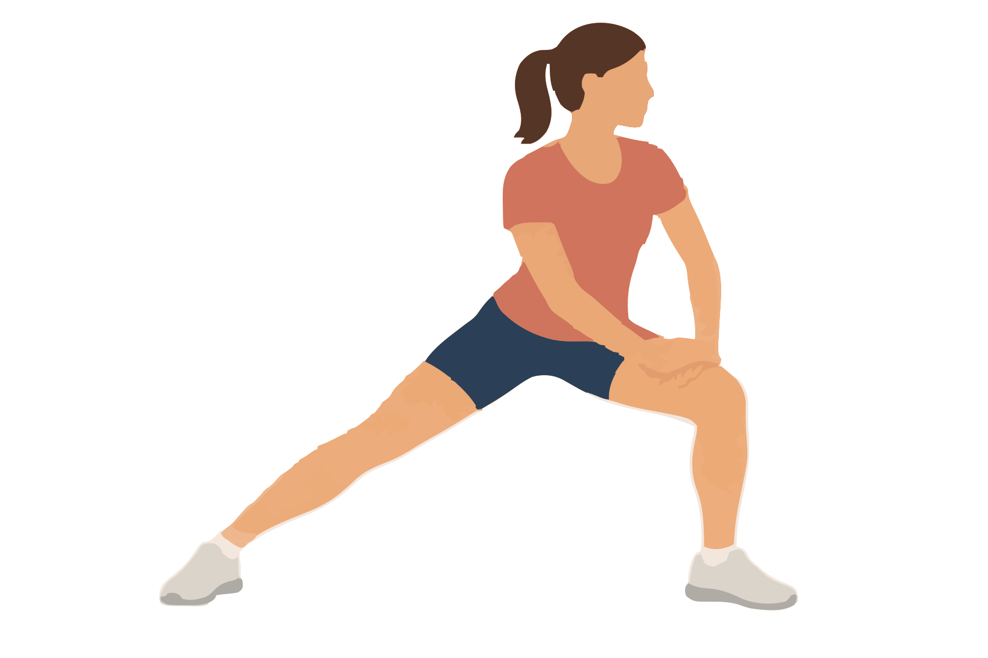
Target: Inner thigh muscles called adductors | Use after: Running Hiking Biking
Equipment: None | Time: 20 seconds per side; 1 or 2 rounds
1. Stand with your feet wide apart.
2. Bend one knee and move your hips towards that side.
3. Keep the other leg long and both feet on the ground.
Form Keep the bent knee in line with its toes.
Source: Cambridge University Hospitals general stretches

08 Crossed leg outer hip stretch
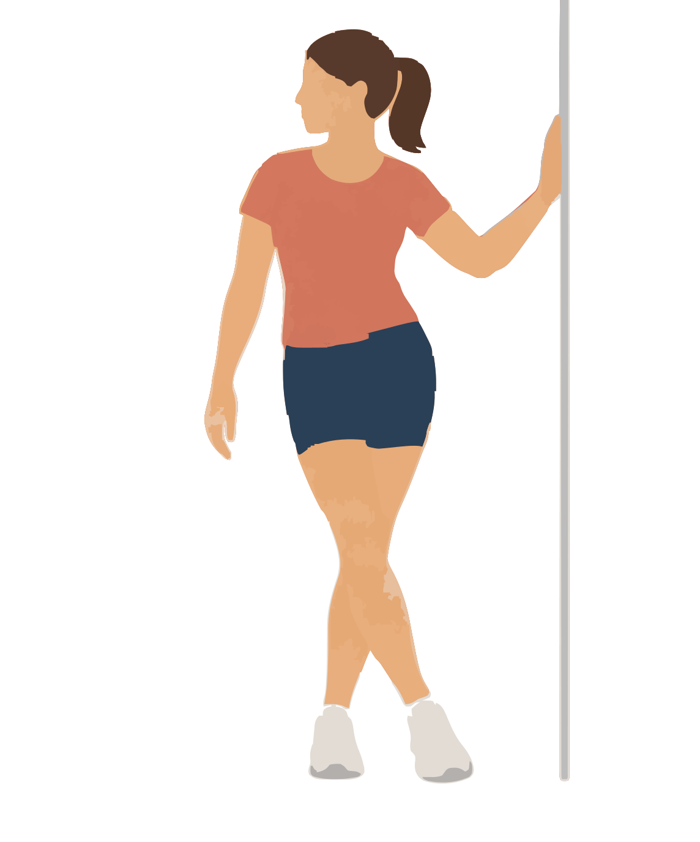
Target: Muscles at the outside of the hip | Use after: Running Hiking Biking
Equipment: Wall or fixed rail | Time: 20 seconds per side; 1 or 2 rounds
1. Stand with your right side near a support. Hold it.
2. Cross your left foot in front of your right foot.
3. Move your right hip towards the support and lean your chest slightly left.
Form Feel the outer hip. Do not twist your knees. Change sides.
Source: Alberta Health hip stretches

Outdoor stretches 9 to 10
No mat needed | Use stable ground and fixed supports

09 Supported squat stretch
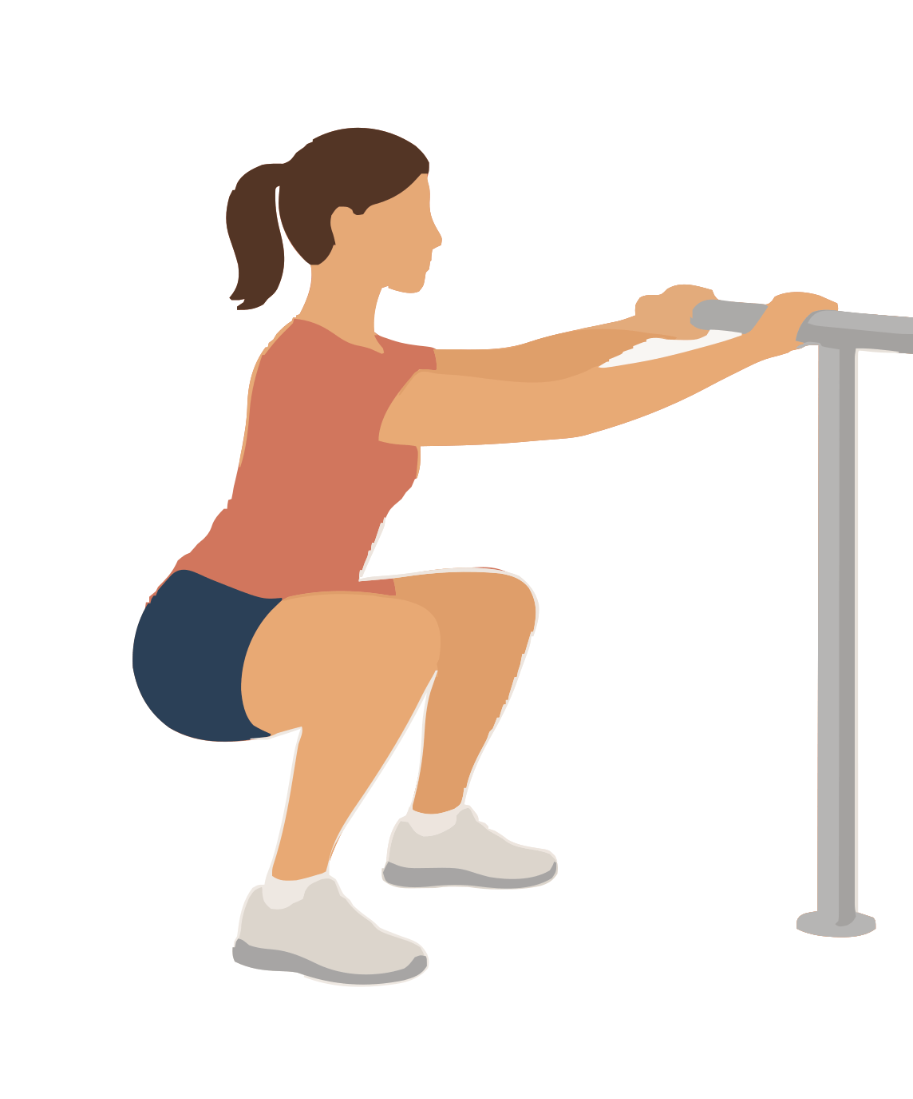
Target: Hips groin and ankles together | Use after: Running Hiking Biking
Equipment: Strong fixed rail | Time: 10 to 20 seconds; 1 or 2 rounds
1. Hold the rail. Stand with your feet a little wider than your hips.
2. Bend both knees and lower into a comfortable squat.
3. Keep your heels down and use your arms to control the depth.
Form Keep knees in line with toes. Stop at a comfortable depth.
Source: Wirral NHS pelvic stretches

10 Overhead side bend
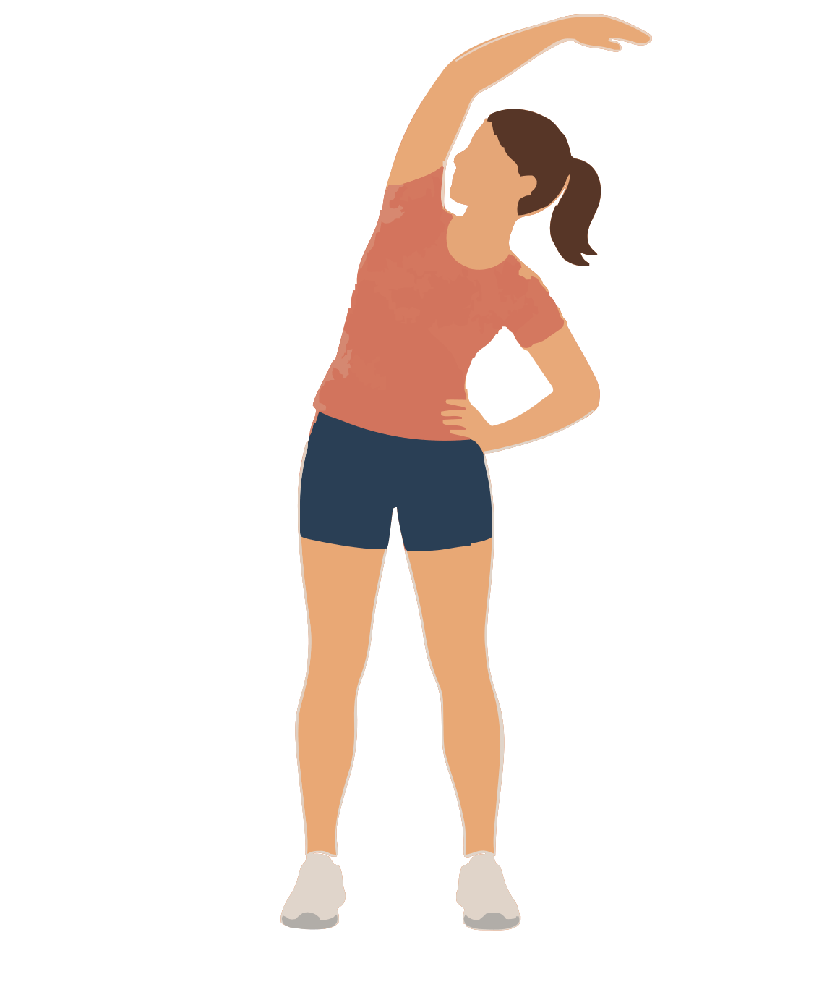
Target: Side of the trunk | Use after: Running Hiking Biking
Equipment: None | Time: 20 seconds per side; 1 or 2 rounds
1. Stand with feet hip width apart.
2. Raise one arm above your head.
3. Bend your trunk gently away from the raised arm.
Form Keep weight on both feet. Keep your chest facing forwards.
Source: Free Exercise DB Standing Lateral Stretch

Outdoor stretches 11 to 12
No mat needed | Use stable ground and fixed supports

11 Supported back and shoulder stretch
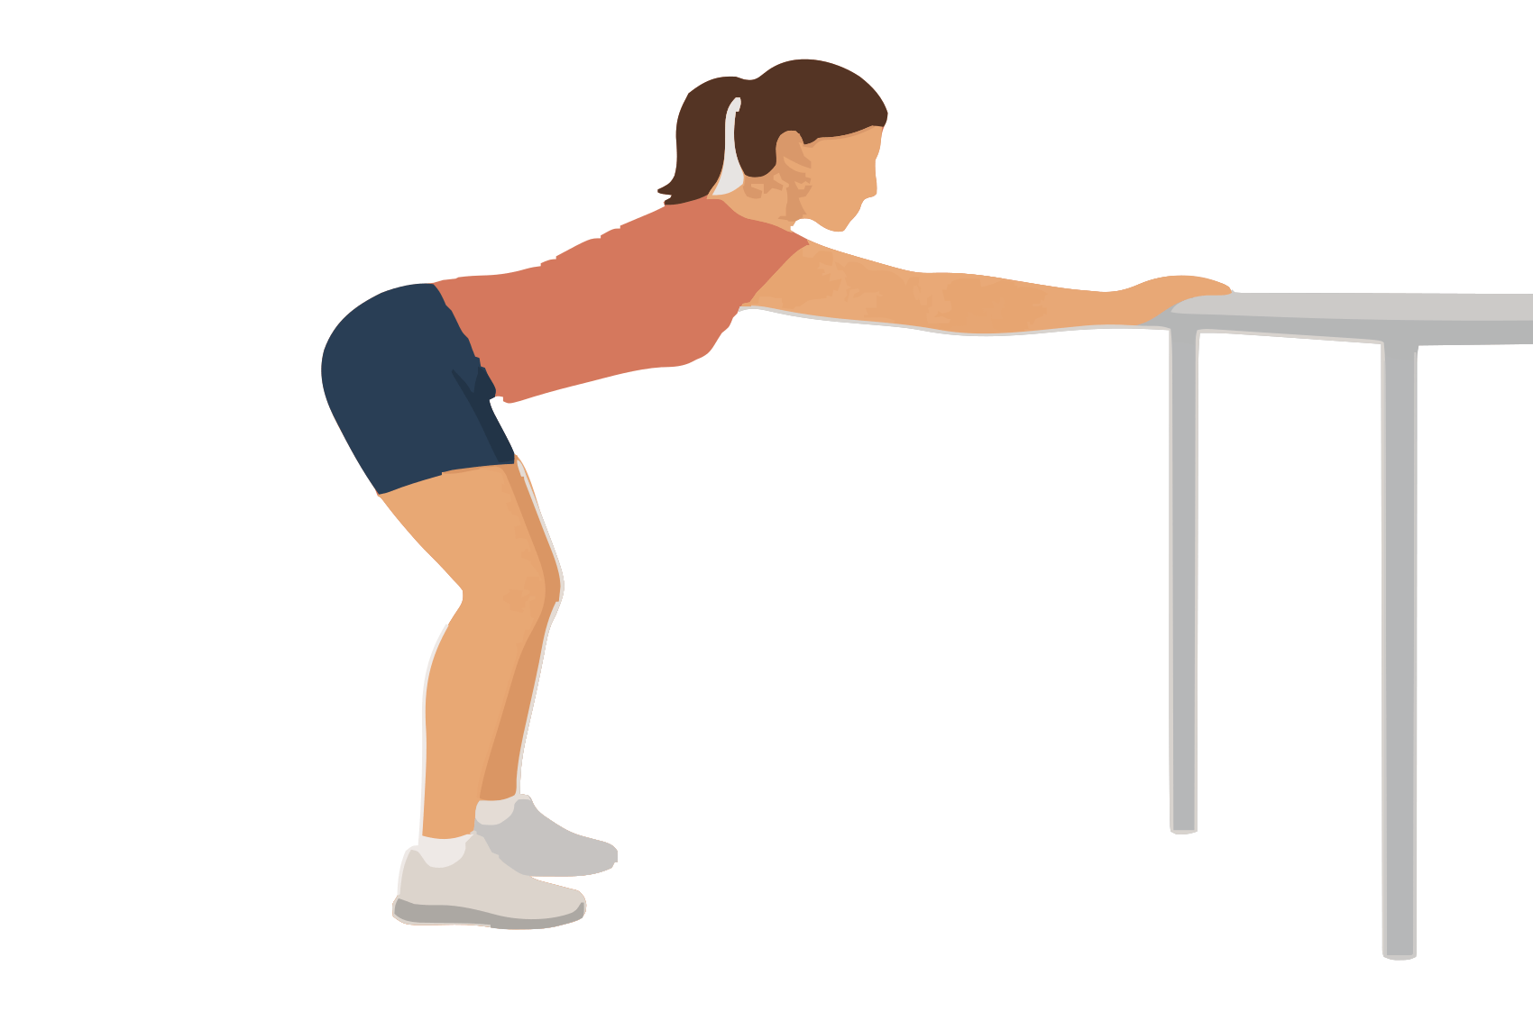
Target: Broad back muscles called lats and shoulders | Use after: Hiking Biking
Equipment: Fixed rail or stable table at about waist height | Time: 20 seconds; 1 or 2 rounds
1. Put both hands on the support and step back.
2. Bend your knees slightly and move your hips backwards.
3. Lower your chest between your arms while you keep your back long.
Form Keep your ribs from dropping into a large back arch.
Source: Cambridge University Hospitals shoulder stretches

12 Rounded upper back reach
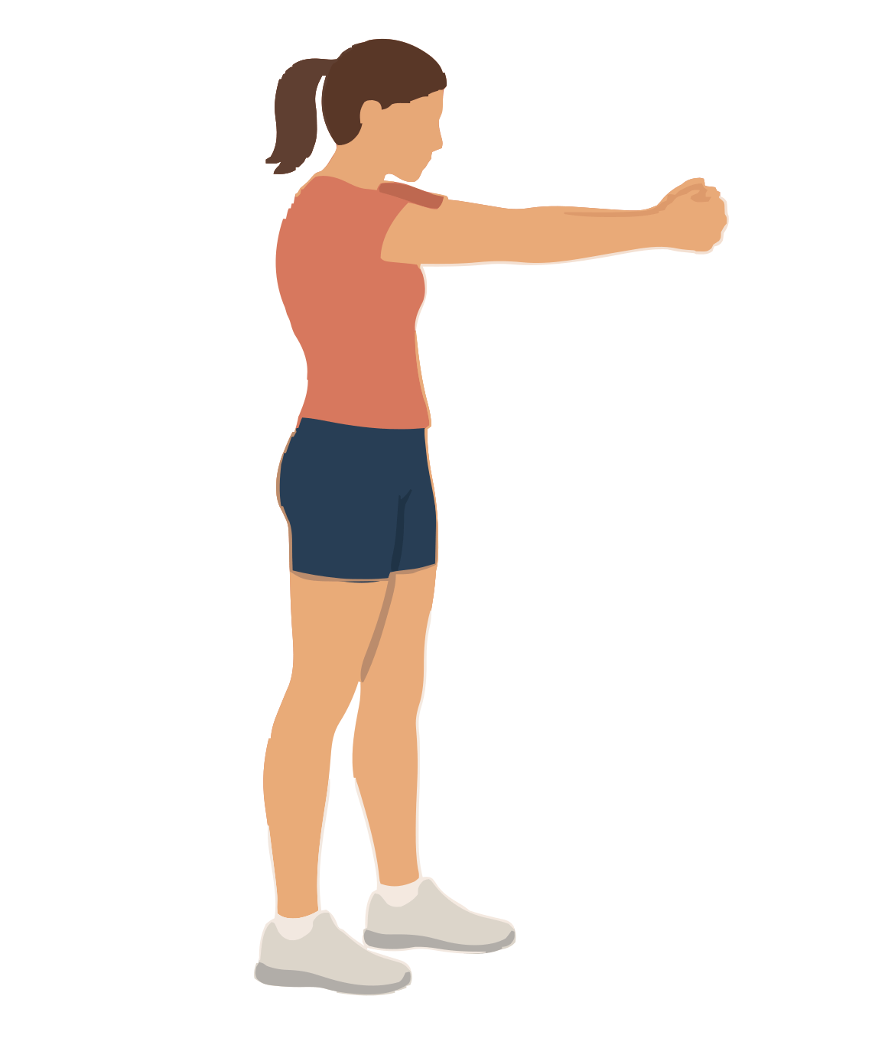
Target: Muscles between the shoulder blades | Use after: Hiking Biking
Equipment: None | Time: 20 seconds; 1 or 2 rounds
1. Join your hands in front of your chest.
2. Turn your palms away and reach forwards.
3. Let your shoulder blades move apart as your upper back rounds gently.
Form Keep your shoulders low. Do not pull on your neck.
Source: Free Exercise DB Upper Back Stretch

Outdoor stretches 13 to 14
No mat needed | Use stable ground and fixed supports

13 Arm across chest stretch
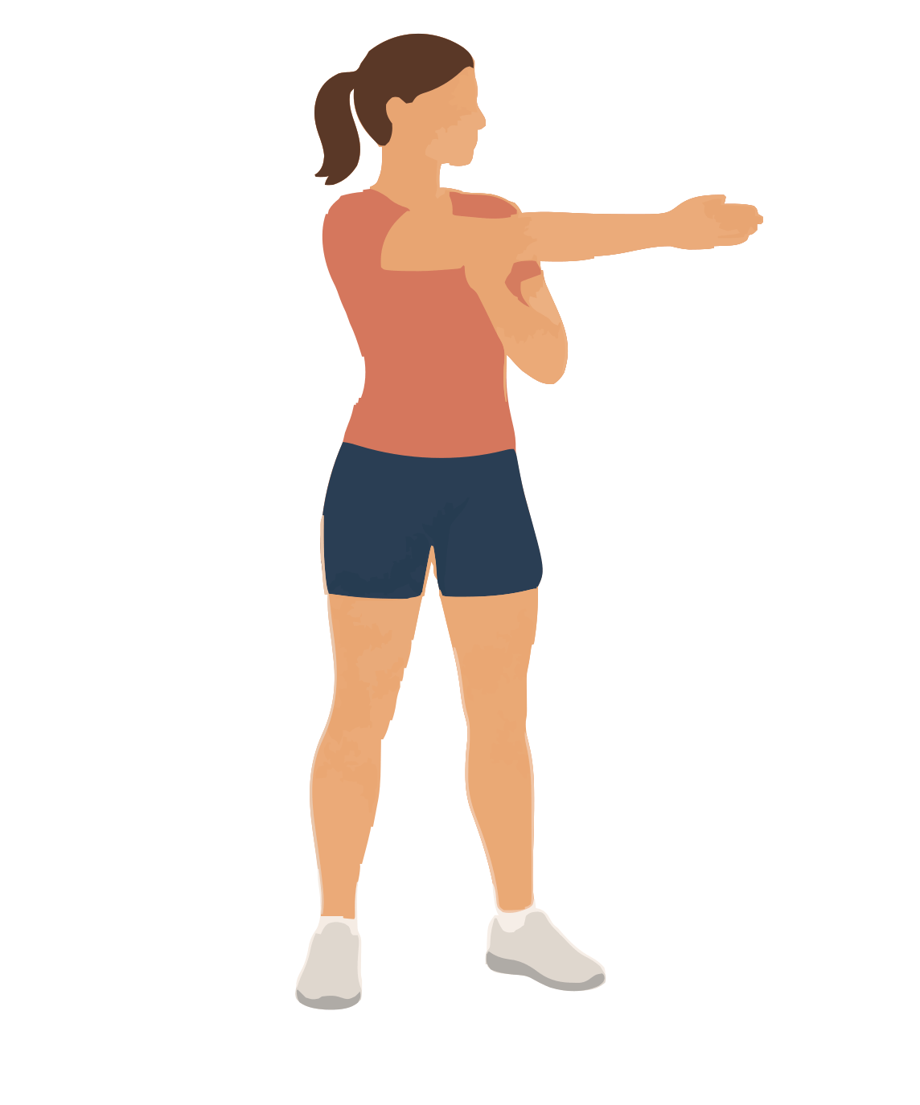
Target: Back of the shoulder | Use after: Running Hiking Biking
Equipment: None | Time: 20 seconds per side; 1 or 2 rounds
1. Bring one arm across your chest.
2. Use the other hand to support the upper arm above the elbow.
3. Draw the arm gently towards your chest.
Form Keep the stretching shoulder down.
Source: University of Washington upper body stretches

14 Overhead upper arm stretch
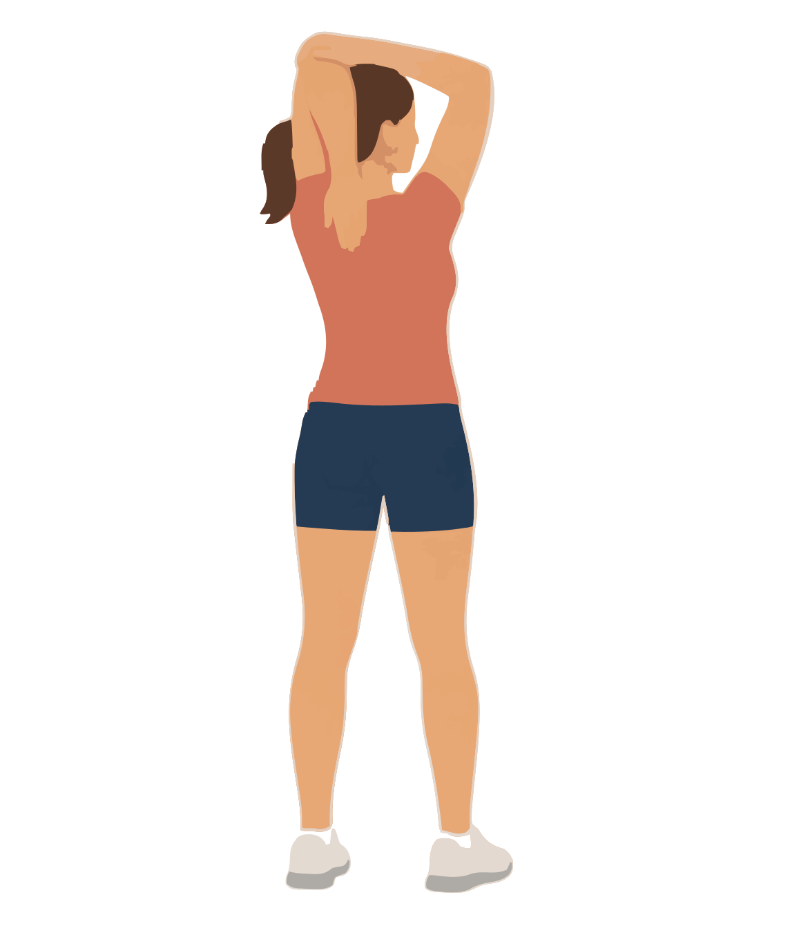
Target: Back upper arm muscle called triceps | Use after: Hiking Biking
Equipment: None | Time: 20 seconds per side; 1 or 2 rounds
1. Raise one arm and bend the elbow.
2. Let that hand rest behind your head.
3. Use the other hand to guide the raised elbow gently backwards.
Form Keep your ribs down. Keep pressure off your head.
Source: University of Washington upper body stretches

Outdoor stretches 15 to 16
No mat needed | Use stable ground and fixed supports

15 Chest stretch at a post
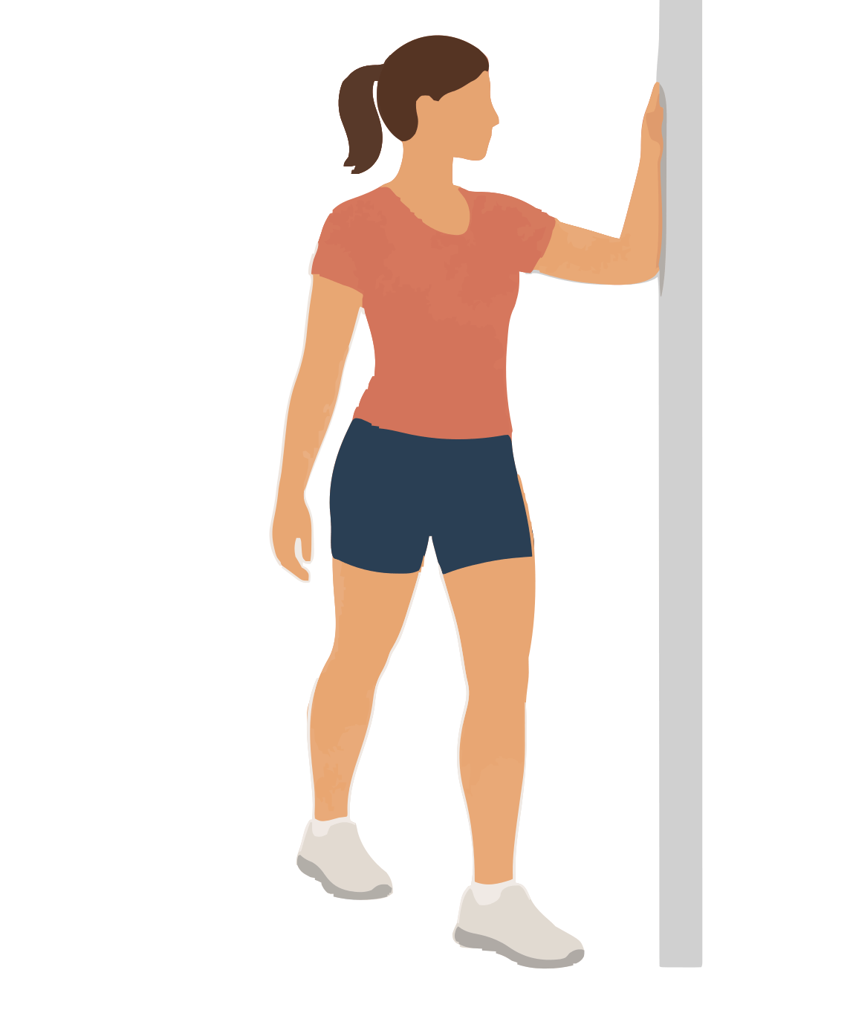
Target: Chest and front shoulder | Use after: Hiking Biking
Equipment: Wide post wall edge or door frame | Time: 20 seconds per side; 1 or 2 rounds
1. Place one forearm on the support. Keep the elbow at or below shoulder height.
2. Take a small step forwards.
3. Turn your chest slightly away until the chest stretches.
Form Keep the shoulder low. Stop if the front of the shoulder pinches.
Source: University of Washington upper body stretches

16 Hands behind biceps stretch
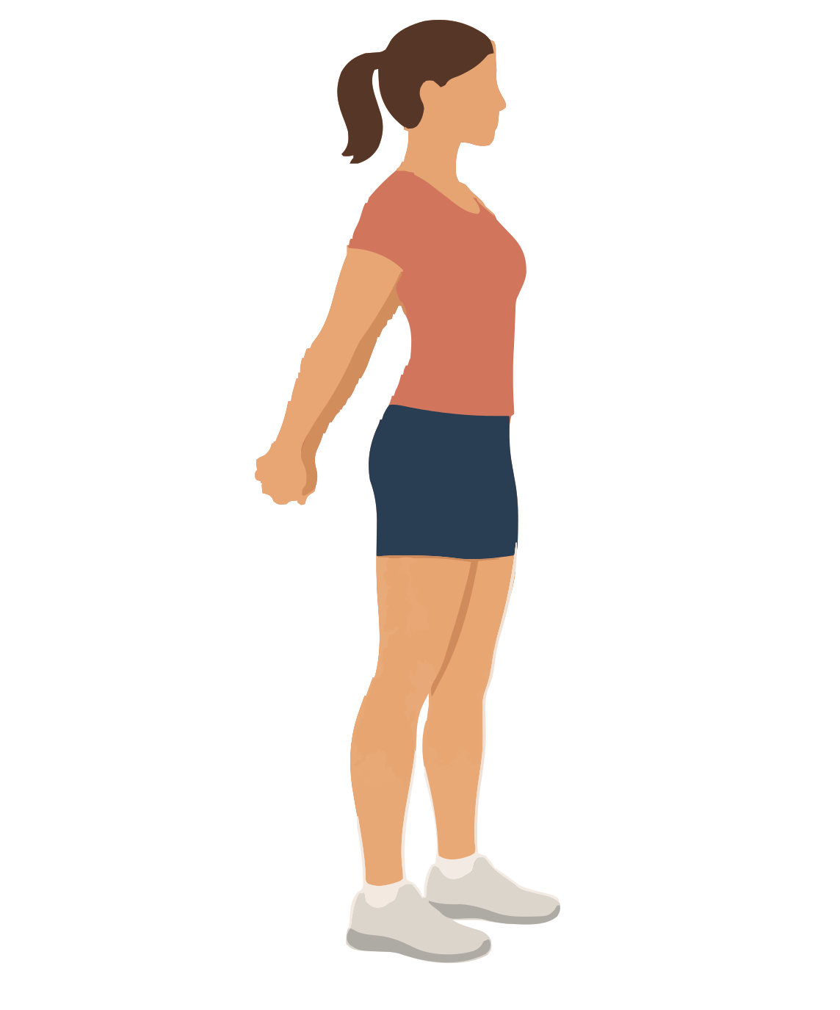
Target: Front upper arm muscles called biceps | Use after: Hiking Biking
Equipment: None | Time: 20 seconds; 1 or 2 rounds
1. Join your hands behind your hips.
2. Straighten your elbows without locking them.
3. Move your hands a small distance away from your back.
Form Keep your chest upright and shoulders low. Use only a small lift.
Source: Free Exercise DB Standing Biceps Stretch

Outdoor stretches 17 to 18
No mat needed | Use stable ground and fixed supports

17 Side neck stretch
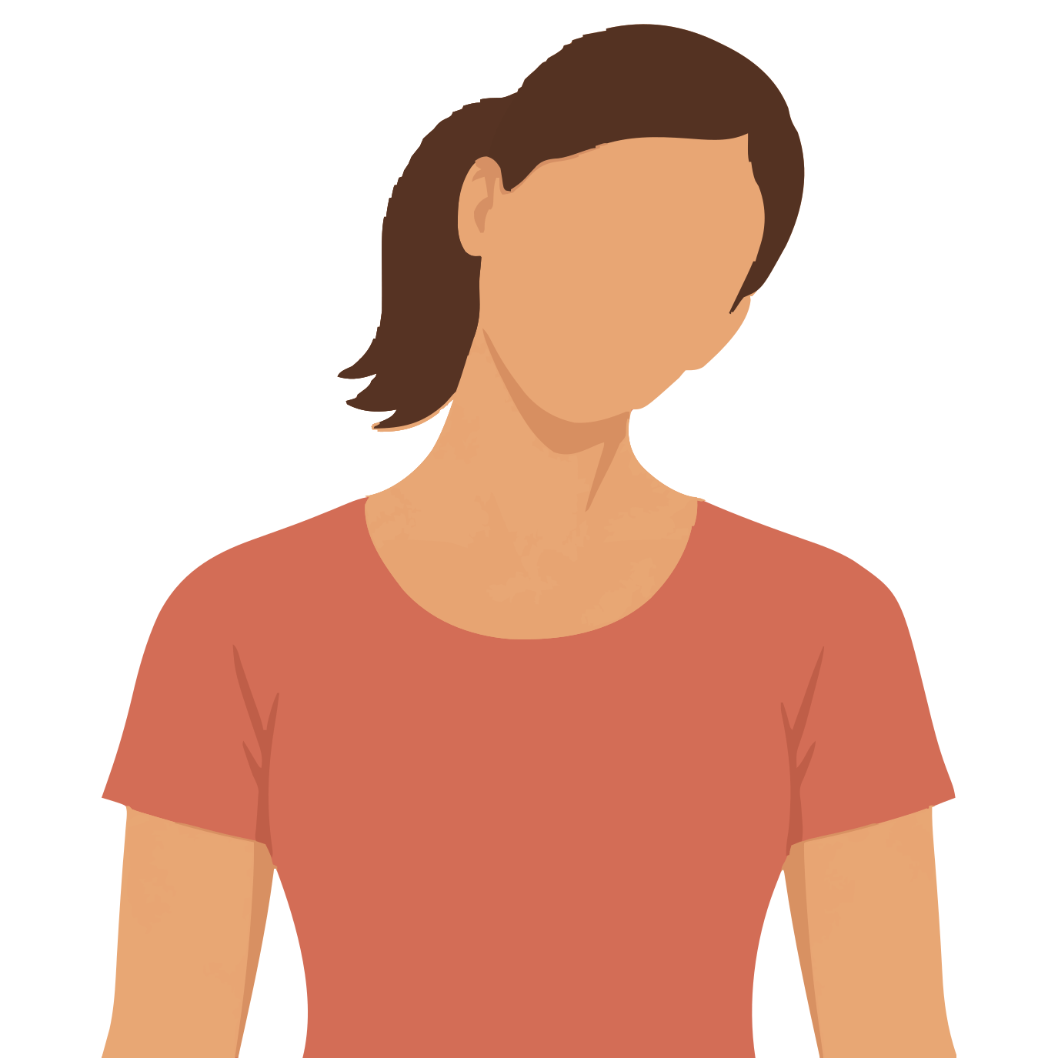
Target: Side of the neck and upper shoulder | Use after: Hiking Biking
Equipment: None | Time: 10 seconds per side; 1 or 2 rounds
1. Stand tall and relax both shoulders.
2. Tilt one ear towards the same side shoulder.
3. Stop when you feel a light stretch on the other side.
Form Do not lift the shoulder or pull your head with a hand.
Source: Cambridge University Hospitals general stretches

18 Diagonal neck stretch
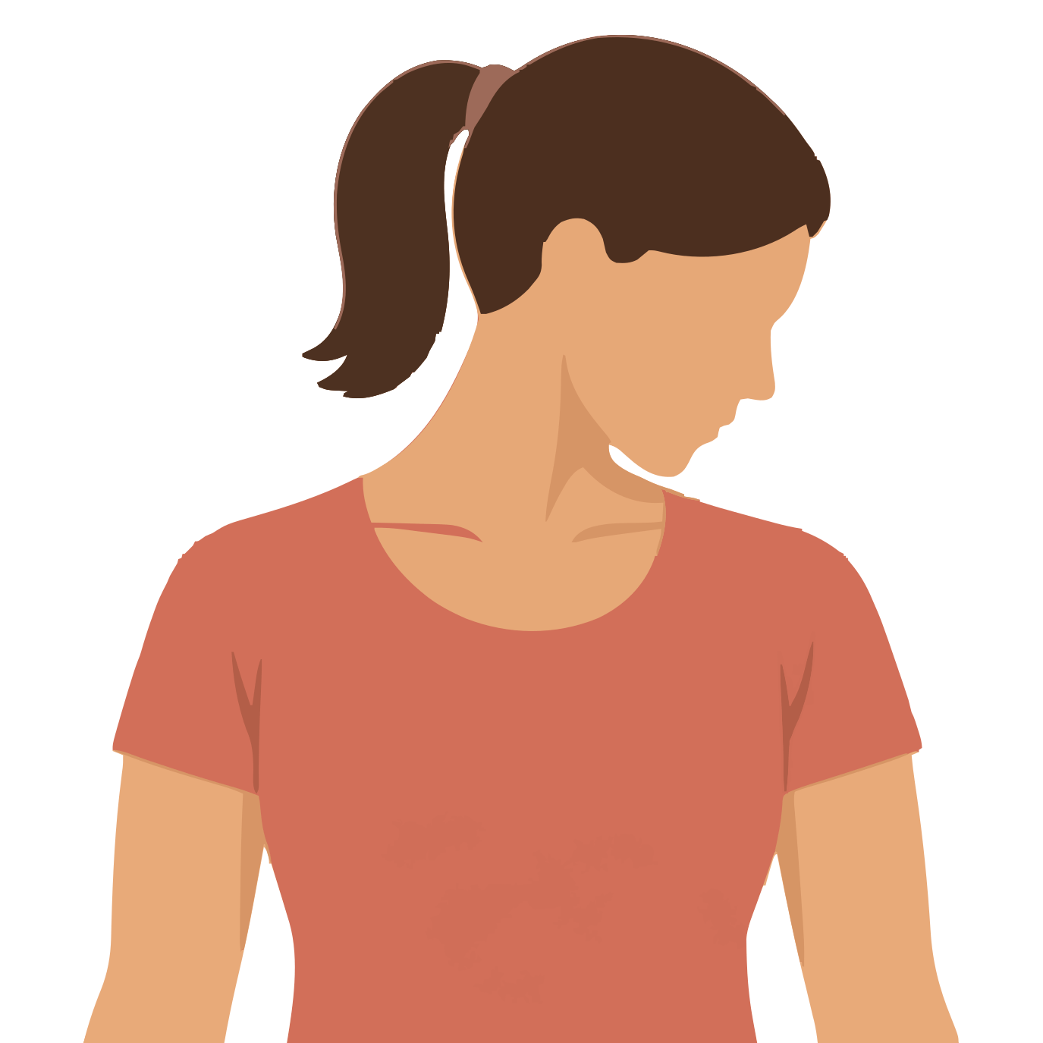
Target: Back corner of the neck near the shoulder blade | Use after: Hiking Biking
Equipment: None | Time: 10 seconds per side; 1 or 2 rounds
1. Relax your shoulders and turn your head about halfway to one side.
2. Lower your chin towards that armpit.
3. Hold a light stretch at the opposite back corner of your neck.
Form Use your neck muscles only. Do not pull on your head.
Source: Alberta Health diagonal neck stretch

Outdoor stretches 19 to 20
No mat needed | Use stable ground and fixed supports

19 Back neck stretch
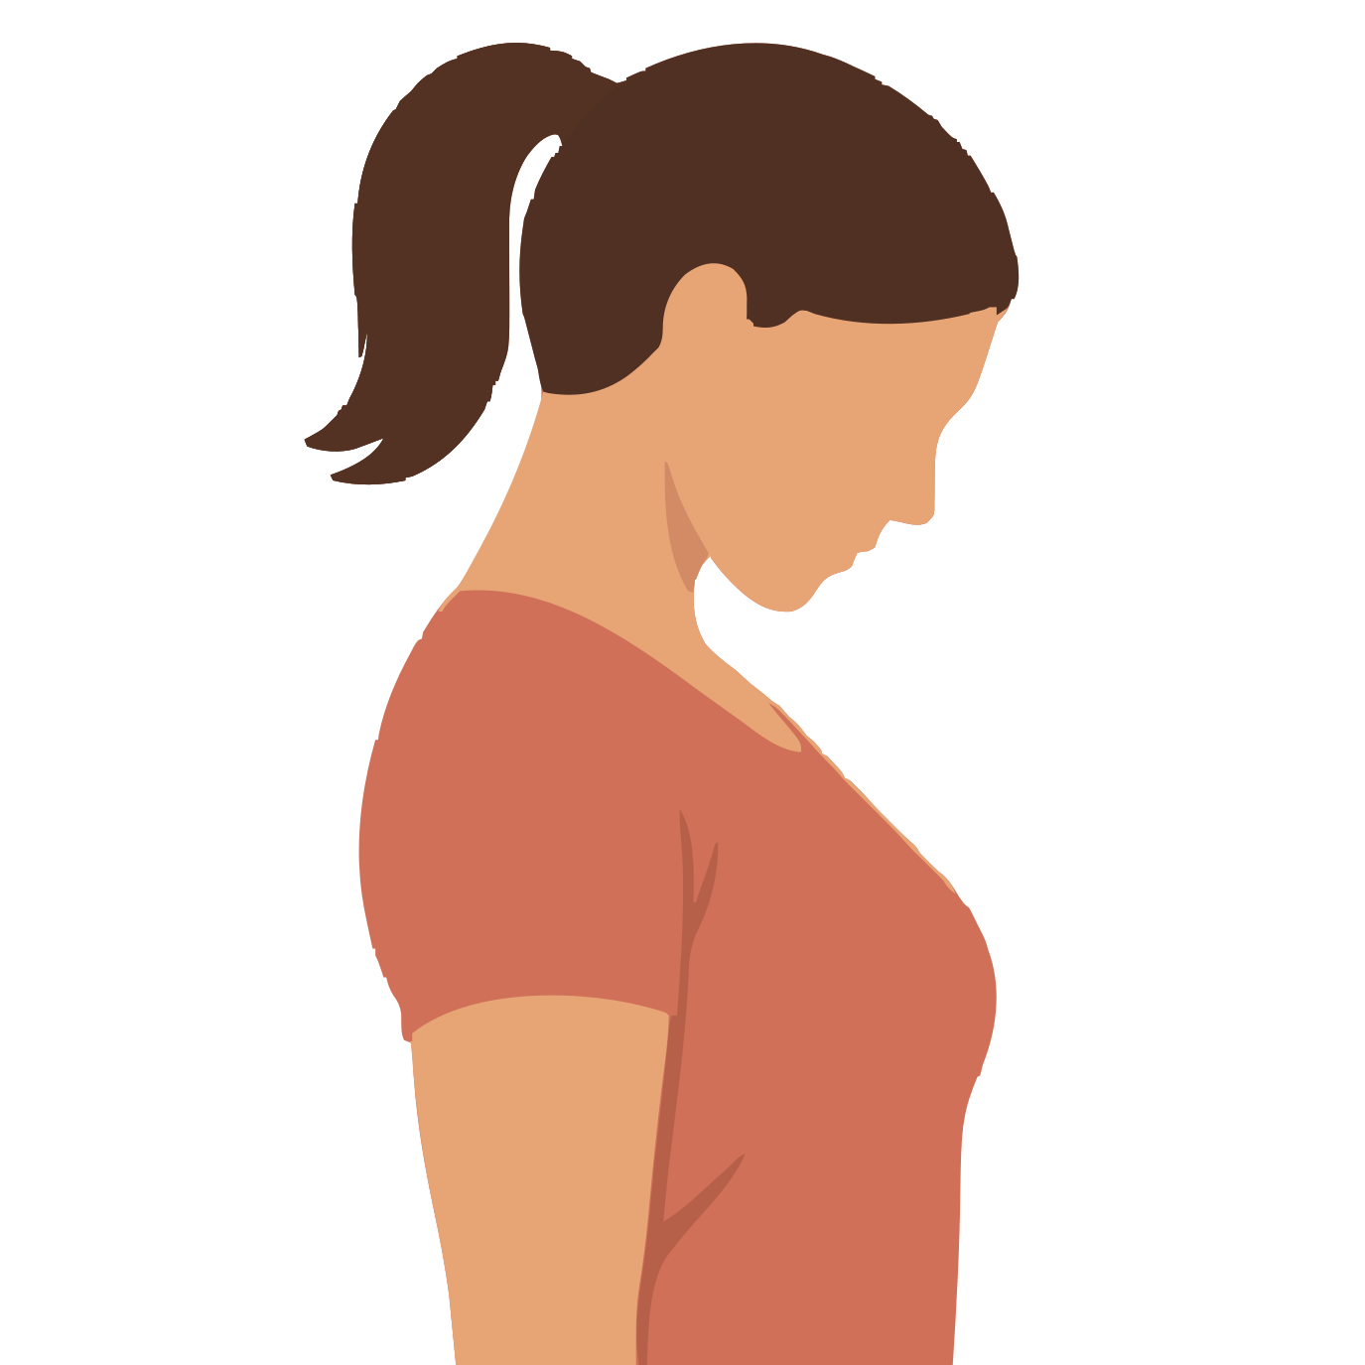
Target: Back of the neck | Use after: Hiking Biking
Equipment: None | Time: 10 seconds; 1 or 2 rounds
1. Stand tall with relaxed shoulders.
2. Lower your chin gently towards your chest.
3. Keep your head facing straight forwards as it lowers.
Form Use a small range. Keep your hands off your head.
Source: Cambridge University Hospitals general stretches

20 Neck turn stretch
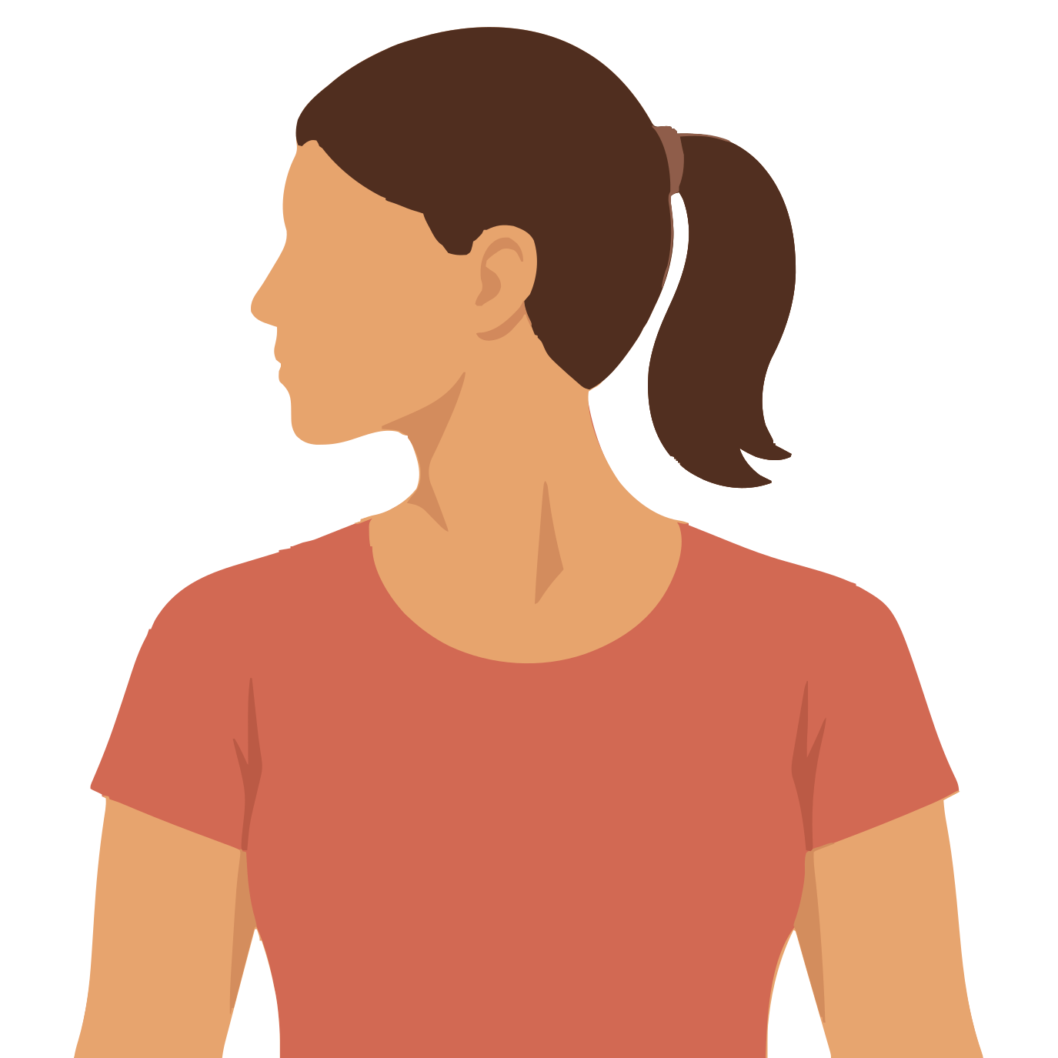
Target: Neck rotation | Use after: Hiking Biking
Equipment: None | Time: 5 seconds per side; repeat 3 times
1. Keep your shoulders facing forwards.
2. Turn your head slowly to look over one shoulder.
3. Stop before you feel pain or strain.
Form Keep your chin level. Do not tip your head backwards.
Source: Cambridge University Hospitals general stretches

Outdoor stretches 21 to 22
No mat needed | Use stable ground and fixed supports

21 Palm up wrist stretch
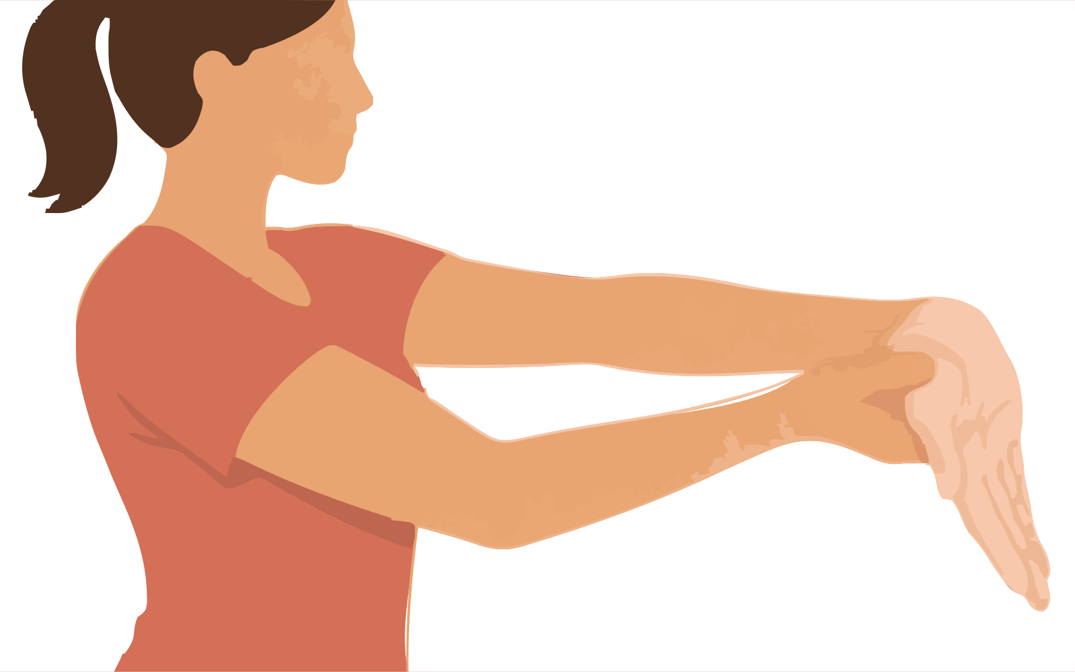
Target: Inner forearm muscles that bend the wrist | Use after: Hiking Biking
Equipment: None | Time: 15 to 20 seconds per side; 1 or 2 rounds
1. Reach one arm forwards with the palm up.
2. Let the fingers point towards the ground.
3. Use the other hand on the palm to bend the wrist gently back.
Form Keep a small bend in the elbow. Do not pull individual fingers.
Source: Nicholas Institute upper body flexibility

22 Palm down wrist stretch
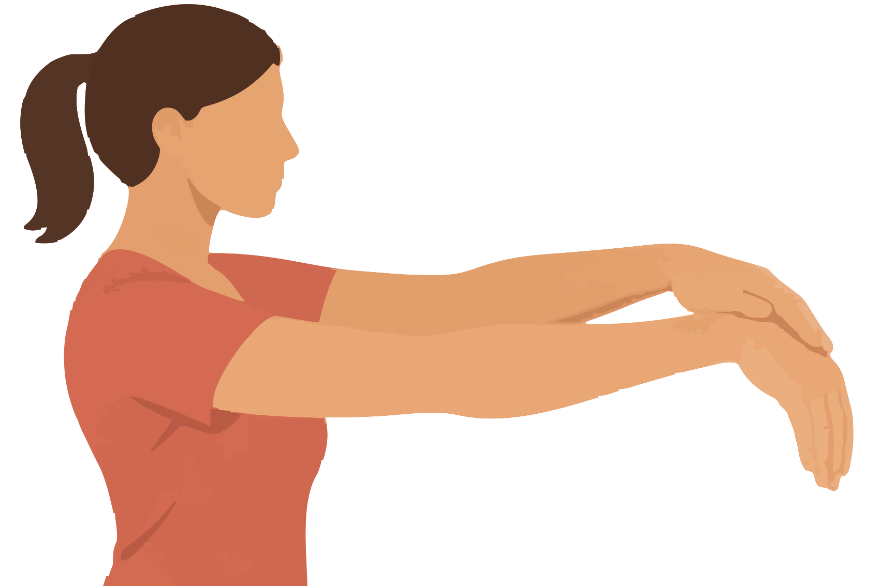
Target: Outer forearm muscles that straighten the wrist | Use after: Hiking Biking
Equipment: None | Time: 15 to 20 seconds per side; 1 or 2 rounds
1. Reach one arm forwards with the palm down.
2. Let the hand bend down at the wrist.
3. Place the other hand on the back of that hand and guide it towards you.
Form Keep the elbow slightly bent and fingers relaxed.
Source: Nicholas Institute upper body flexibility

Outdoor stretches 23 to 24
No mat needed | Use stable ground and fixed supports

23 Palm up forearm turn
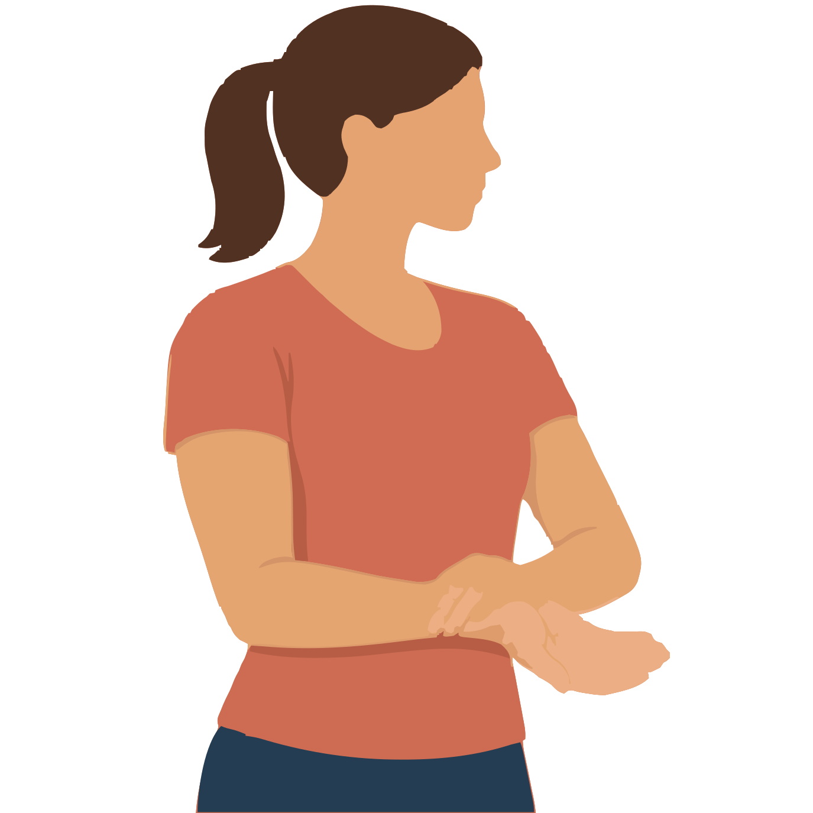
Target: Forearm muscles used to turn the palm down | Use after: Hiking Biking
Equipment: None | Time: 5 seconds per side; repeat 3 times
1. Bend one elbow to a right angle and keep it next to your ribs.
2. Turn that palm upwards.
3. Support the wrist with the other hand and add a very small turn.
Form Keep the wrist straight. Keep the elbow next to your body.
Source: Cambridge University Hospitals wrist and forearm stretches

24 Palm down forearm turn
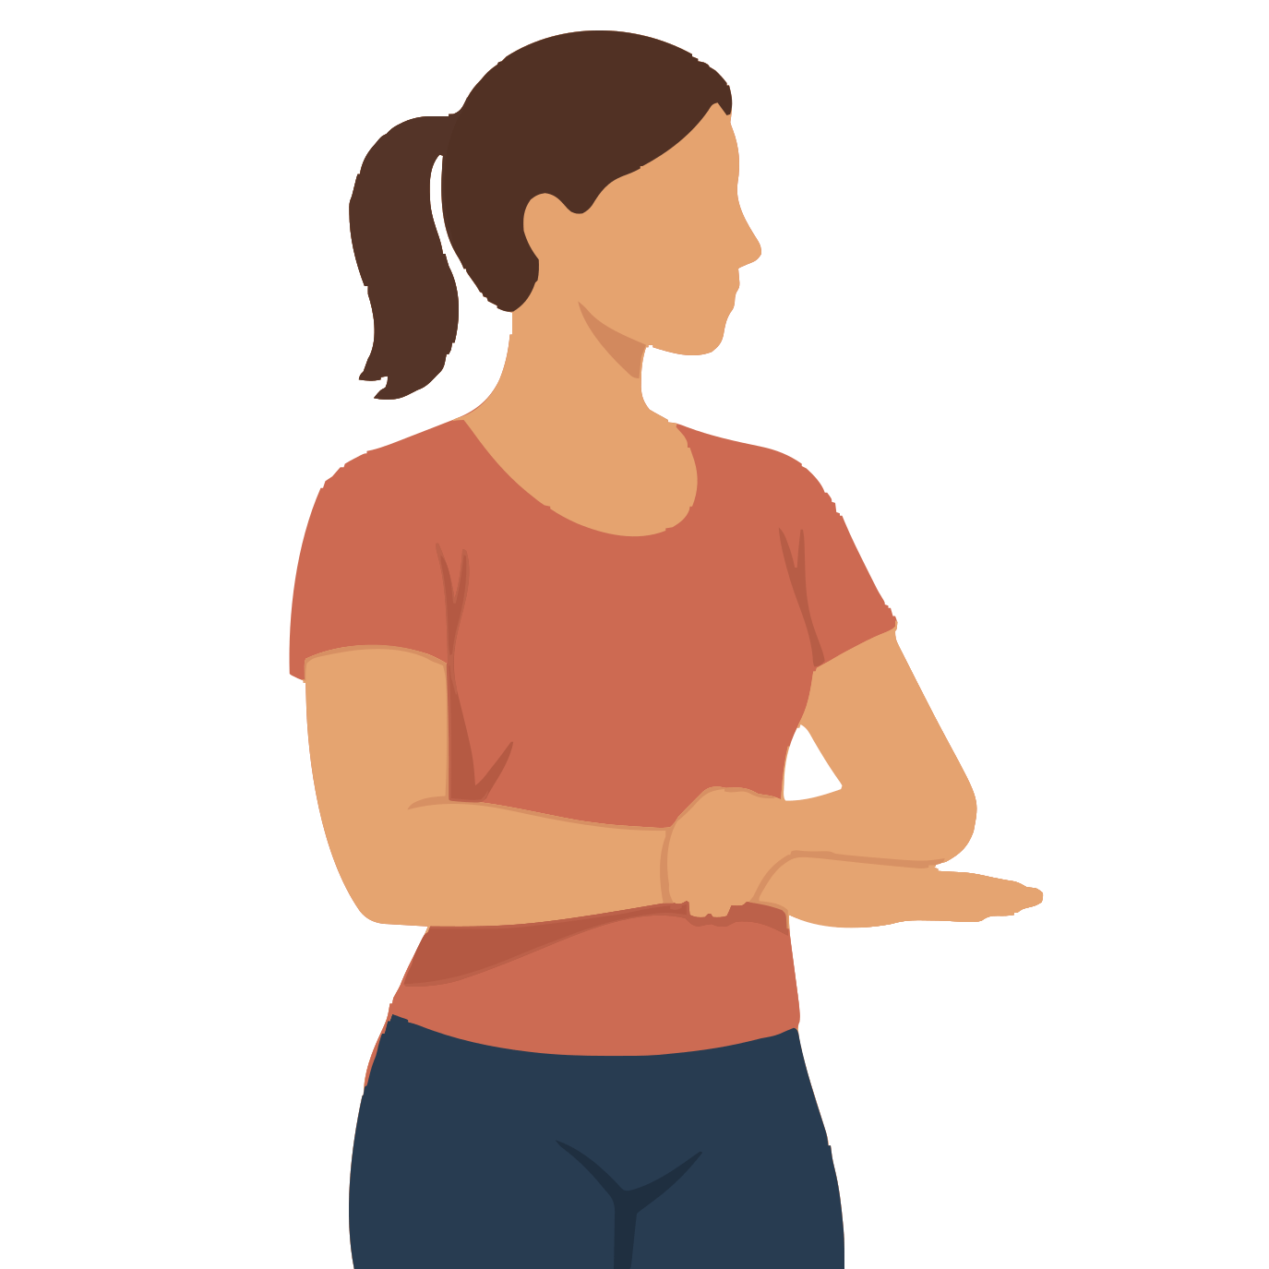
Target: Forearm muscles used to turn the palm up | Use after: Hiking Biking
Equipment: None | Time: 5 seconds per side; repeat 3 times
1. Bend one elbow to a right angle and keep it next to your ribs.
2. Turn that palm downwards.
3. Support the wrist with the other hand and add a very small turn.
Form Keep the shoulder still and the wrist straight.
Source: Cambridge University Hospitals wrist and forearm stretches

Outdoor stretches 25 to 26
No mat needed | Use stable ground and fixed supports

25 Thumb web stretch
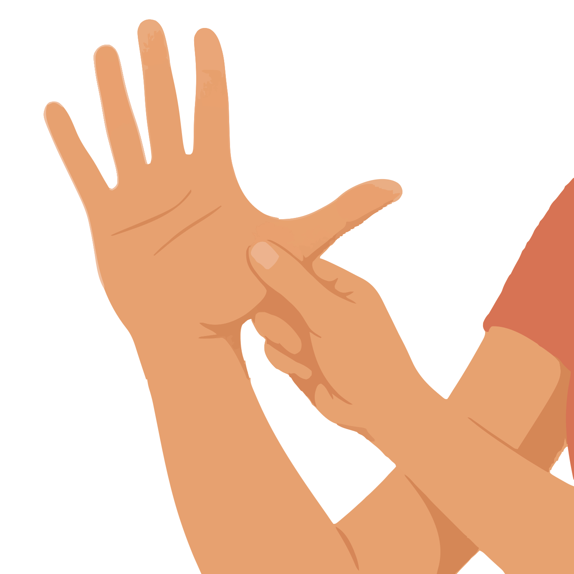
Target: Soft tissue between the thumb and index finger | Use after: Hiking Biking
Equipment: None | Time: 3 to 5 seconds per side; repeat 3 times
1. Relax one hand and open the thumb away from the index finger.
2. Use your other hand to support the thumb near its base.
3. Open the web space gently without bending the thumb joints backwards.
Form Use light pressure near the base. Do not pull the thumb tip.
Source: University Hospitals Sussex hand exercises

26 Finger straightening stretch
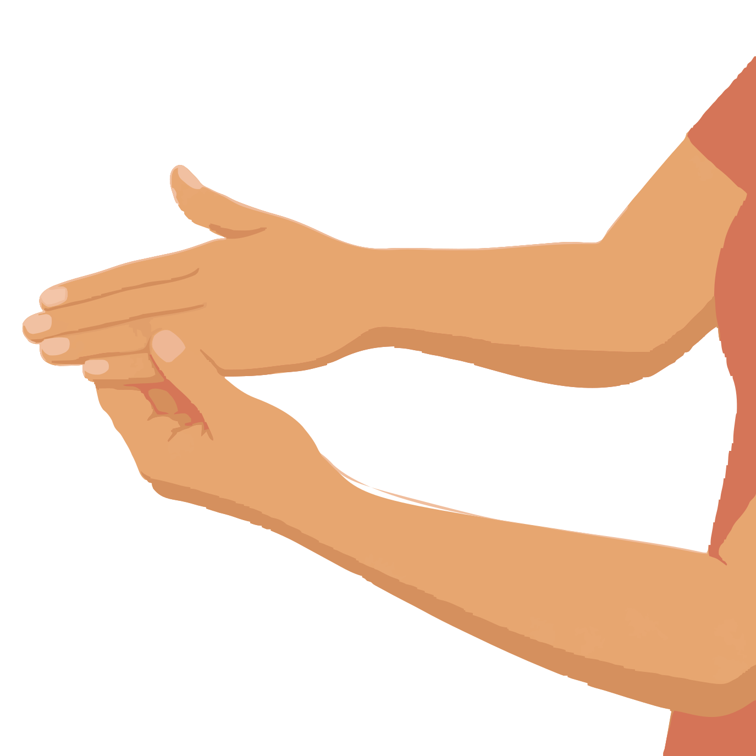
Target: Palm and finger flexor tissues | Use after: Hiking Biking
Equipment: None | Time: 5 seconds per side; repeat 3 times
1. Hold one hand in front of you with its wrist straight.
2. Open your fingers from a relaxed curl.
3. Support them with the other hand and gently guide them straight.
Form Stop when fingers line up with the back of the hand. Do not bend them backwards.
Source: Royal National Orthopaedic Hospital hand stretches

Outdoor stretches 27 to 28
No mat needed | Use stable ground and fixed supports

27 Shoulder turn with a towel behind the back
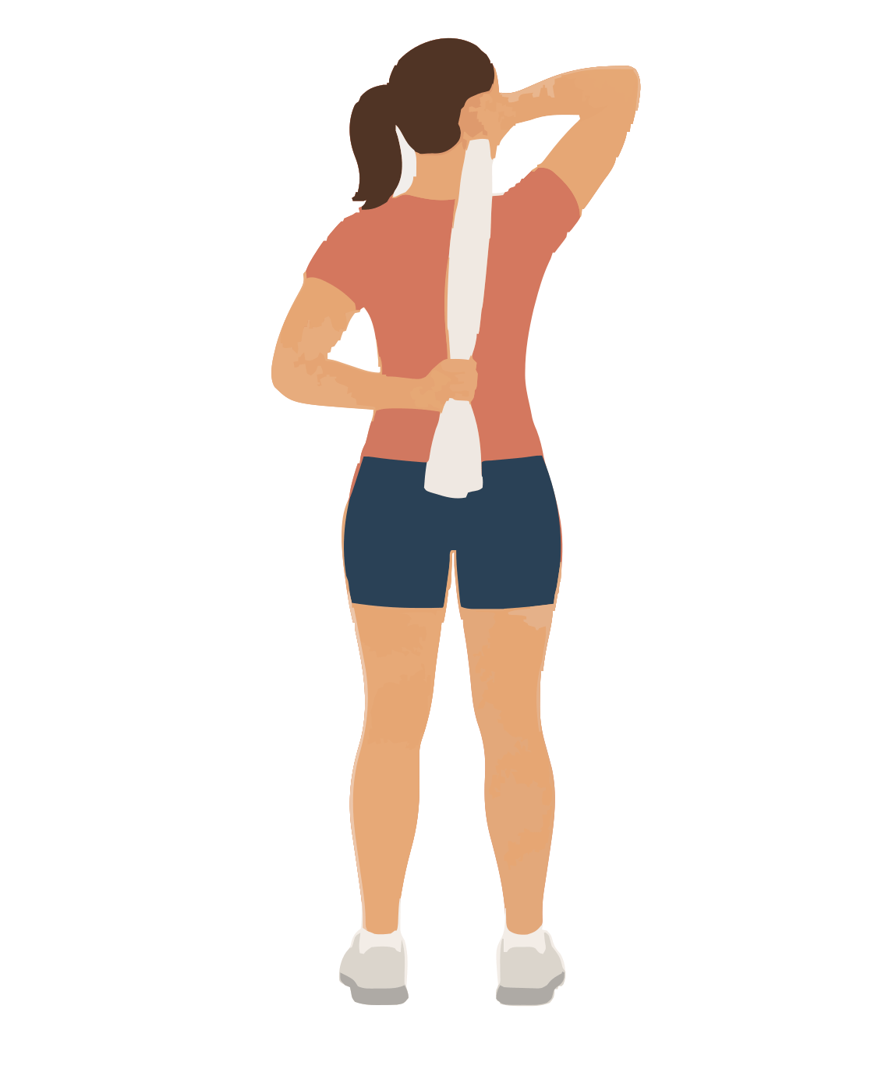
Target: Shoulder internal rotation | Use after: Hiking Biking
Equipment: Small towel | Time: 5 to 10 seconds per side; repeat 2 times
1. Hold a towel above one shoulder. Catch the lower end behind your waist.
2. Use the top hand to lift the towel gently.
3. Let the lower hand slide a little higher on your back.
Form Keep the lower shoulder relaxed. Use a small pain free range.
Source: Cambridge University Hospitals shoulder stretches

28 Outward shoulder turn with a stick
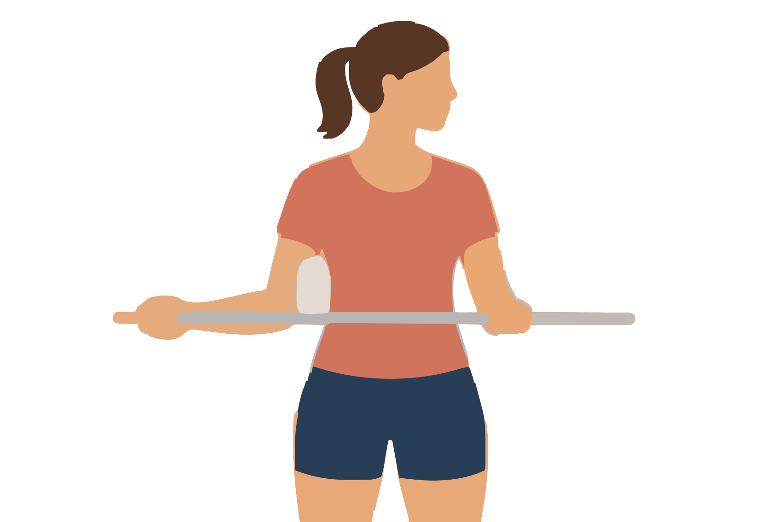
Target: Shoulder external rotation | Use after: Hiking Biking
Equipment: Light straight stick and small towel | Time: 5 to 10 seconds per side; repeat 2 times
1. Bend both elbows to right angles and hold the stick across your waist.
2. Place the towel between the stretching elbow and your ribs.
3. Use the other arm to move that hand outwards while its elbow stays at your side.
Form Keep your chest still and wrist straight. Do not force the shoulder.
Source: Cambridge University Hospitals shoulder stretches

Indoor stretches 29 to 30
Mat options | Use cushions or folded towels where shown

29 Single knee to chest
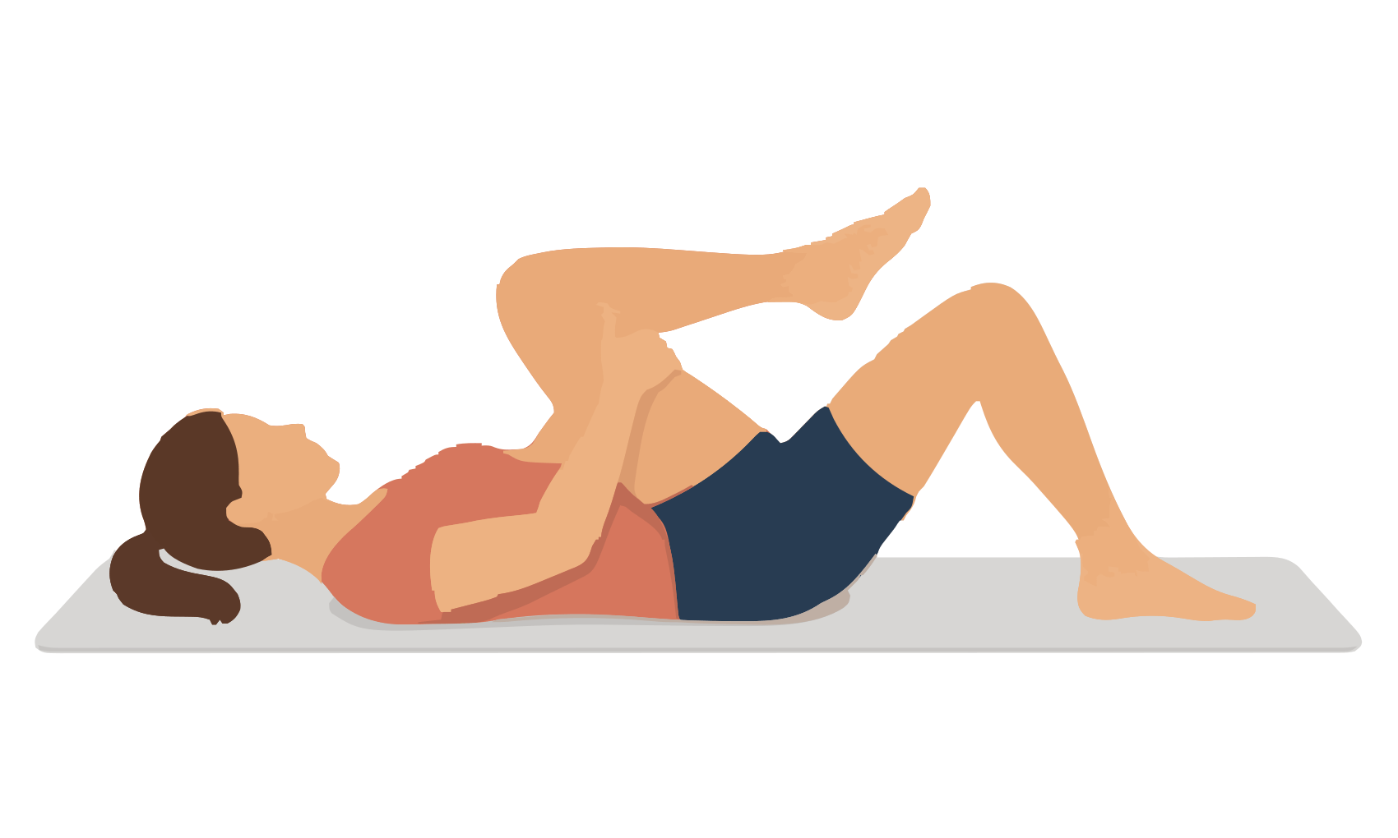
Target: Buttock and lower back | Use after: Running Hiking Biking
Equipment: Mat | Time: 20 seconds per side; 1 or 2 rounds
1. Lie on your back with both knees bent.
2. Hold behind one thigh and bring that knee towards your chest.
3. Keep your head relaxed and the other foot on the mat.
Form Hold the thigh instead of pulling on the kneecap.
Source: Free Exercise DB One Knee To Chest

30 Lying figure four
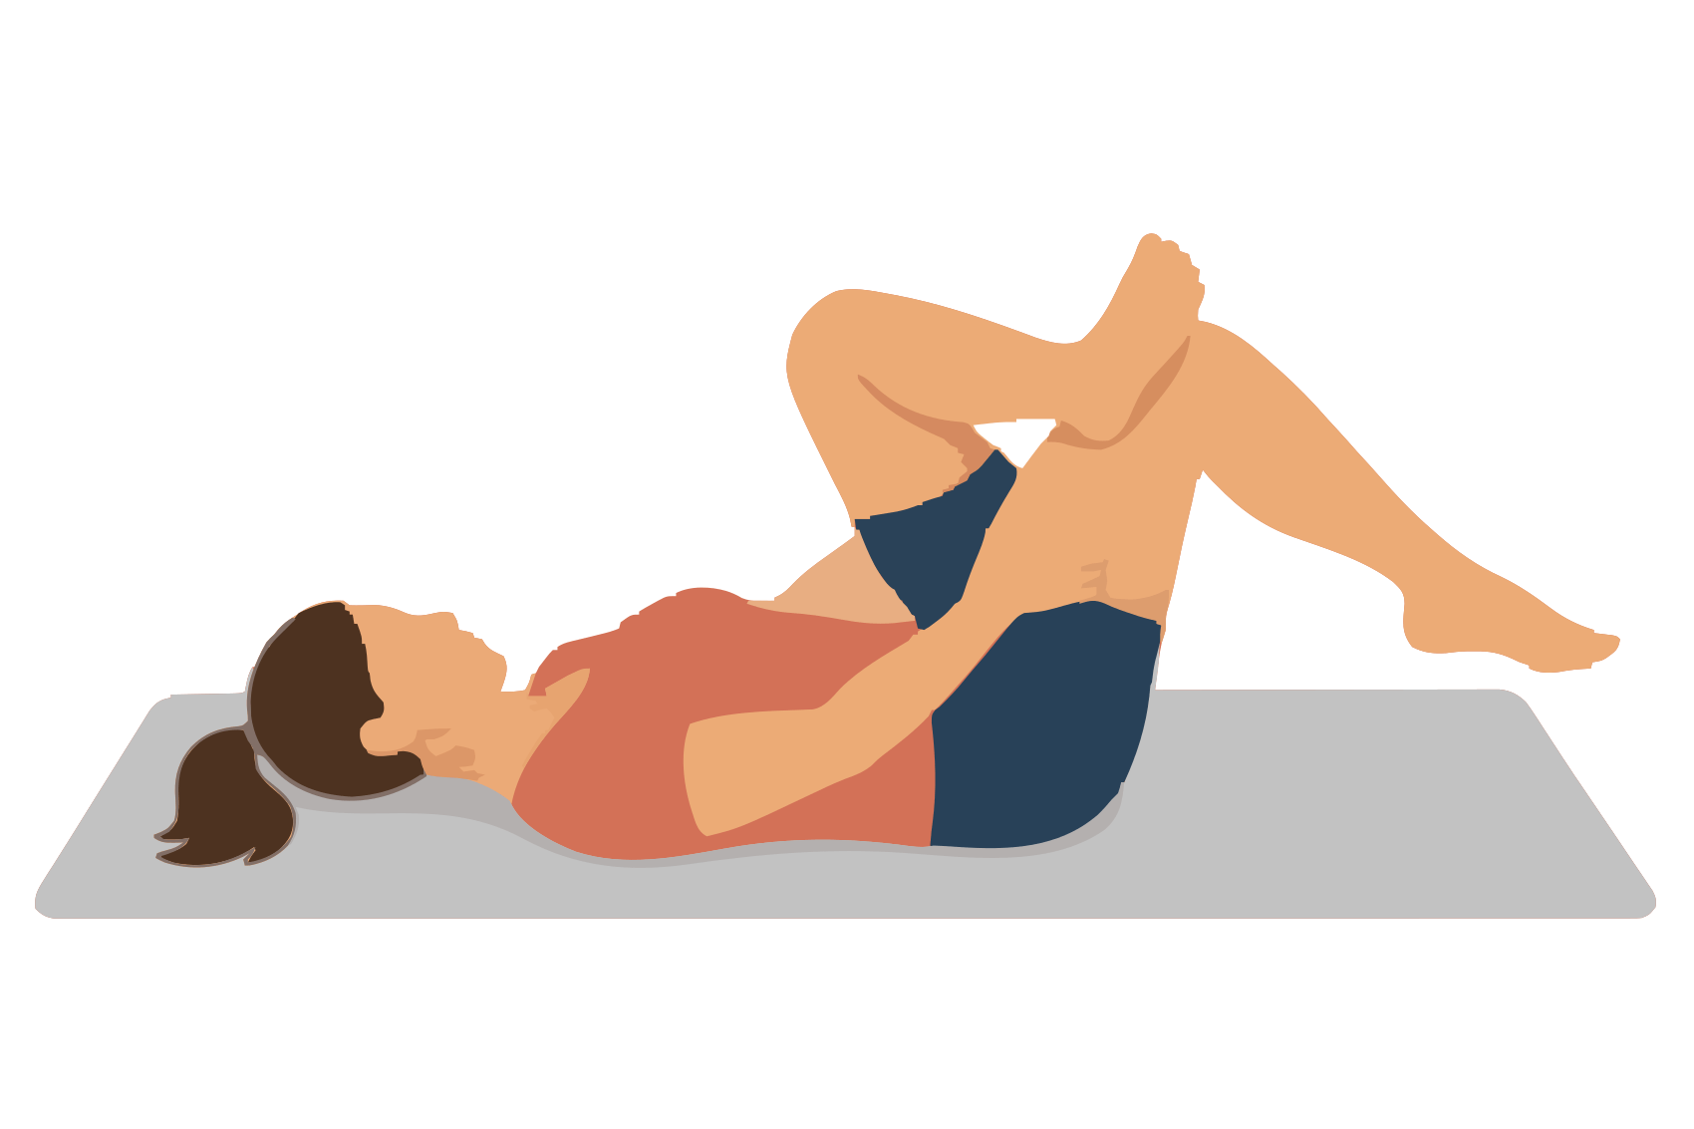
Target: Buttock and outer hip | Use after: Running Hiking Biking
Equipment: Mat | Time: 20 seconds per side; 1 or 2 rounds
1. Lie on your back with both knees bent.
2. Rest one ankle on the opposite thigh above the knee.
3. Hold behind the lower thigh and bring it towards your chest.
Form Keep the crossed foot active. Do not press on the crossed knee.
Source: NHS stretches after exercise

Indoor stretches 31 to 32
Mat options | Use cushions or folded towels where shown

31 Lying inward hip turn
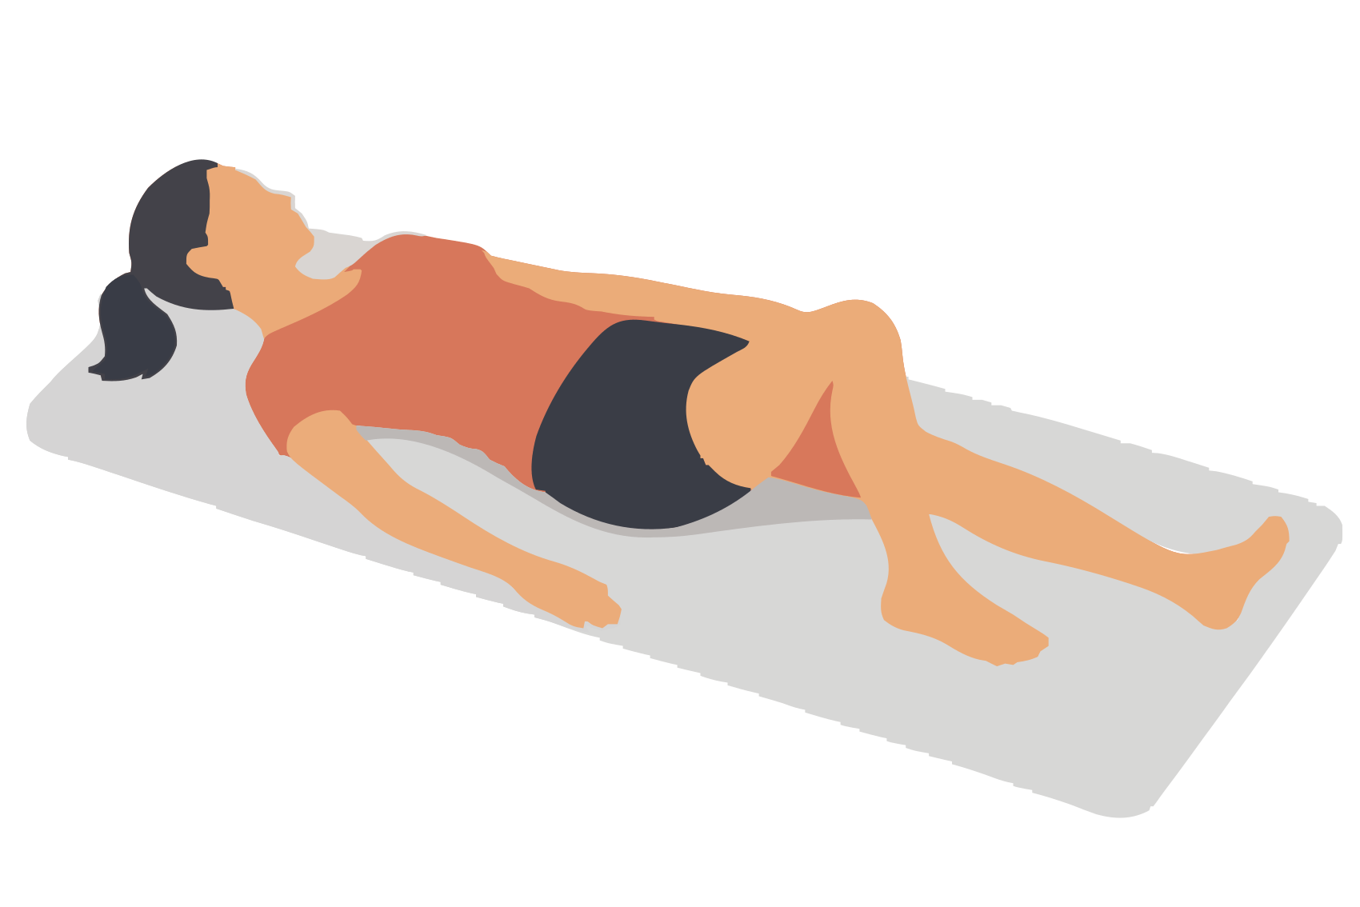
Target: Hip internal rotation | Use after: Running Hiking Biking
Equipment: Mat | Time: 5 seconds per side; repeat 3 times
1. Lie on your back with one leg straight.
2. Bend the other knee and place its foot slightly outside that hip.
3. Let the bent knee move inwards a small distance while your pelvis stays still.
Form Keep the foot planted. Stop if the front of the hip or knee pinches.
Source: Covenant Health hip flexibility

32 Butterfly stretch
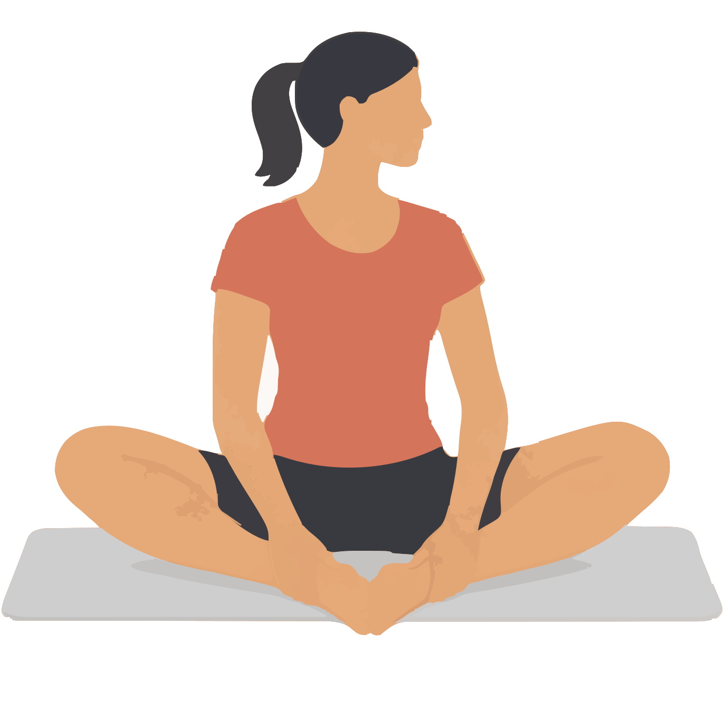
Target: Inner thighs with the hips turned out | Use after: Running Hiking Biking
Equipment: Mat and optional cushions | Time: 20 seconds; 1 or 2 rounds
1. Sit upright and put the soles of your feet together.
2. Hold your ankles and let both knees move apart.
3. Stay tall until you feel a gentle inner thigh stretch.
Form Support the knees with cushions if needed. Do not push them down.
Source: NHS stretches after exercise

Indoor stretches 33 to 34
Mat options | Use cushions or folded towels where shown

33 Wide knee frog stretch
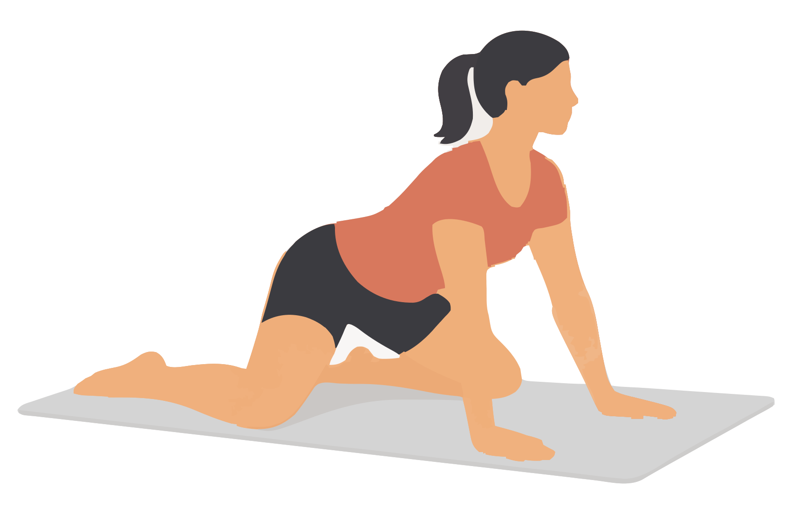
Target: Inner thighs with the hips bent | Use after: Running Hiking Biking
Equipment: Mat or folded towels under the knees | Time: 10 to 20 seconds; 1 or 2 rounds
1. Start on your hands and knees.
2. Move the knees a little wider and keep the ankles behind the knees.
3. Move your hips backwards slightly until the inner thighs stretch.
Form Keep the movement small. Do not force your knees wider.
Source: Wirral NHS pelvic stretches

34 Long inner thigh rock back
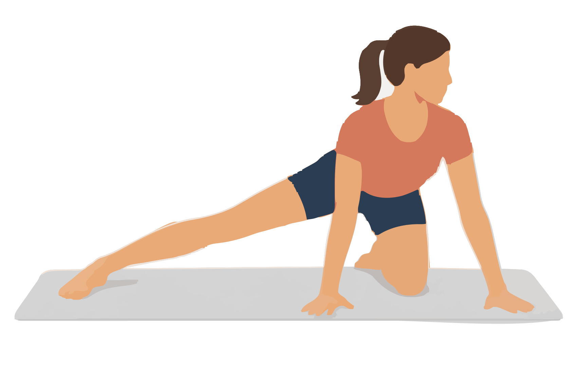
Target: Inner thigh with one knee straight | Use after: Running Hiking Biking
Equipment: Mat | Time: Move slowly 5 times per side; pause 3 seconds
1. Start on your hands and knees.
2. Extend one leg out to the side with that foot on the floor.
3. Keep your back long and move your hips towards the bent leg heel.
Form Keep the long leg still. Stop before your lower back rounds.
Source: Prehab adductor rock back

Indoor stretches 35 to 36
Mat options | Use cushions or folded towels where shown

35 Seated wide leg forward stretch
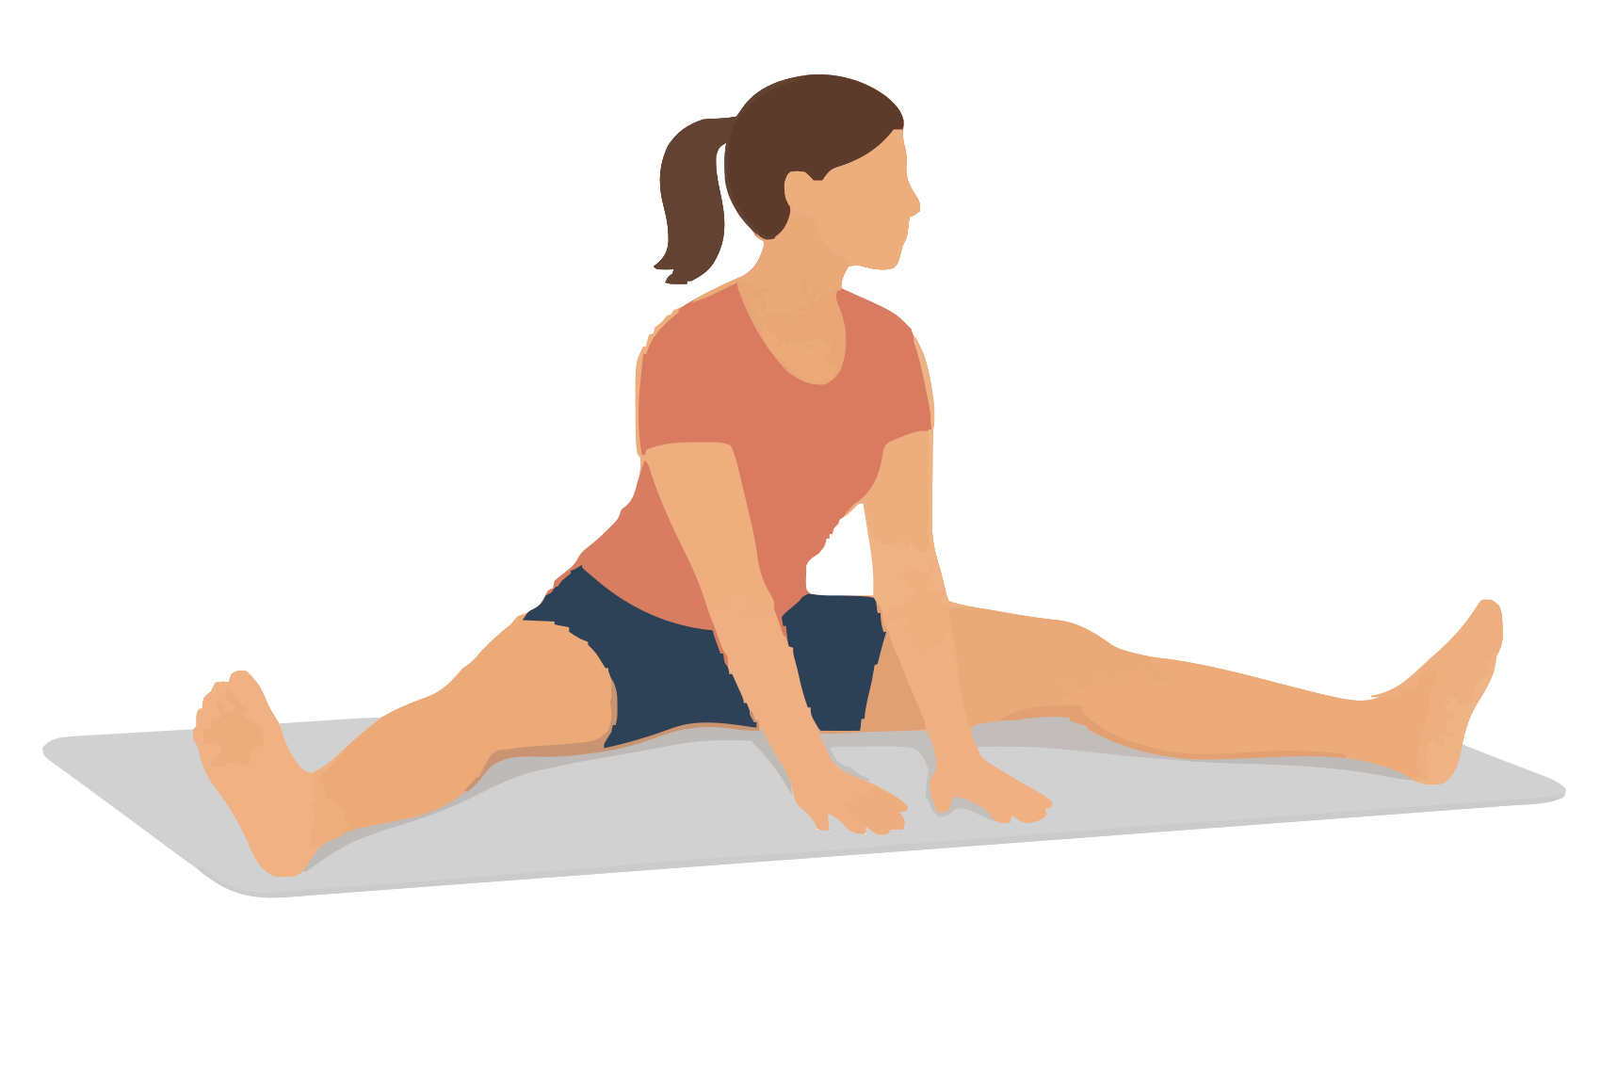
Target: Inner thighs and back thighs together | Use after: Running Hiking Biking
Equipment: Mat and optional folded towel to sit on | Time: 20 seconds; 1 or 2 rounds
1. Sit with your legs in a comfortable V shape.
2. Keep a small bend in both knees.
3. Place your hands in front and lean forwards from your hips.
Form Use a modest leg width. Keep your spine long.
Source: Free Exercise DB The Straddle

36 Happy baby stretch
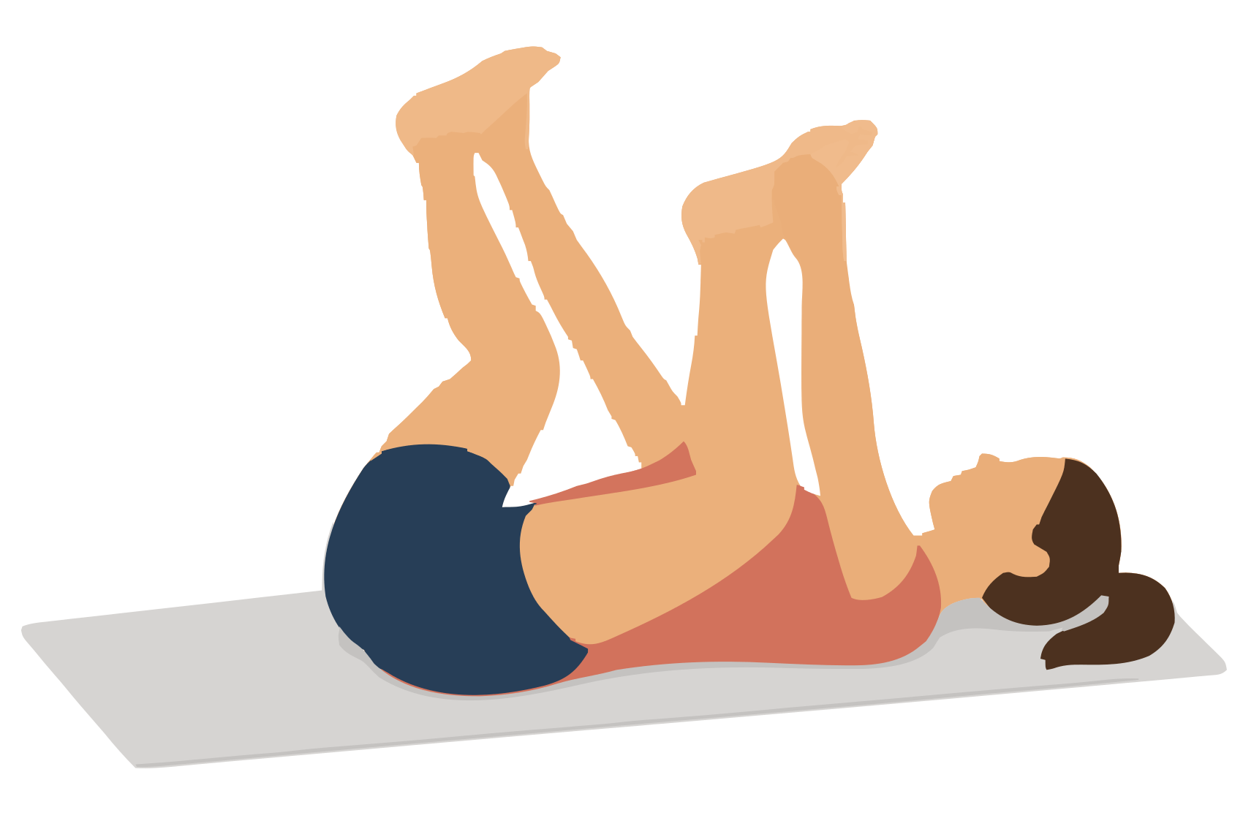
Target: Inner thighs and deep hip muscles | Use after: Running Hiking Biking
Equipment: Mat | Time: 20 seconds; 1 or 2 rounds
1. Lie on your back and bring both knees towards your chest.
2. Move the knees apart and hold behind the thighs or hold the feet.
3. Let your lower back stay heavy on the mat as your knees move towards your armpits.
Form Keep your head down. Do not force your tailbone off the mat.
Source: Wirral NHS pelvic stretches

Indoor stretches 37 to 38
Mat options | Use cushions or folded towels where shown

37 Kneeling front thigh and hip stretch
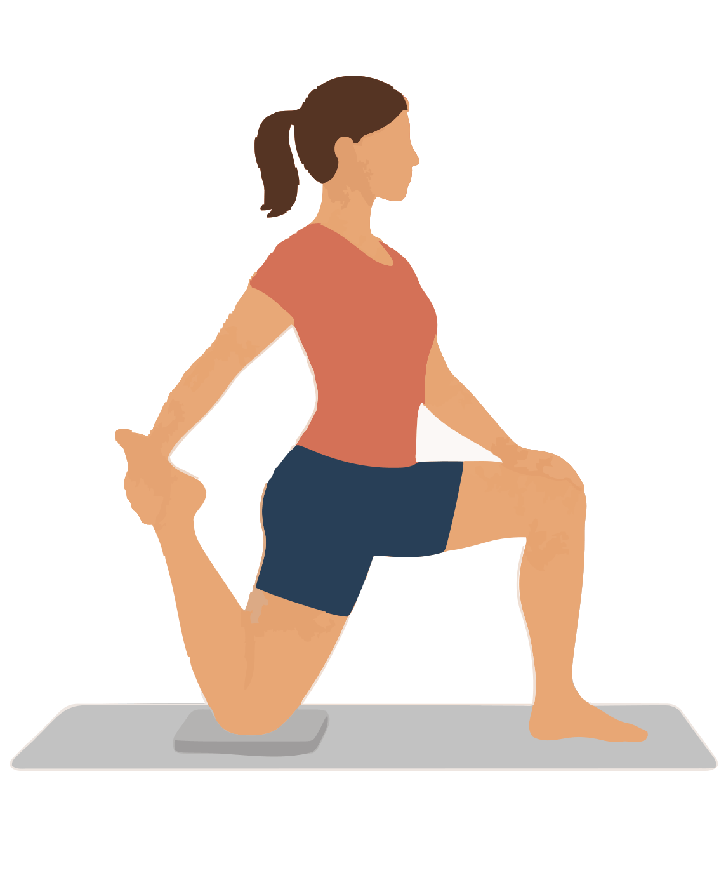
Target: Two joint front thigh muscle called rectus femoris | Use after: Running Hiking Biking
Equipment: Mat knee pad and optional strap | Time: 15 to 20 seconds per side; 1 round
1. Kneel on one padded knee and put the other foot in front.
2. Hold the back ankle, or use a strap, and draw the heel towards your buttock.
3. Tuck your pelvis slightly while you keep the back thigh behind your hip.
Form Keep your chest tall. Skip this stretch if kneeling hurts.
Source: Physitrack kneeling hip flexor and thigh stretch

38 Child pose with arms relaxed
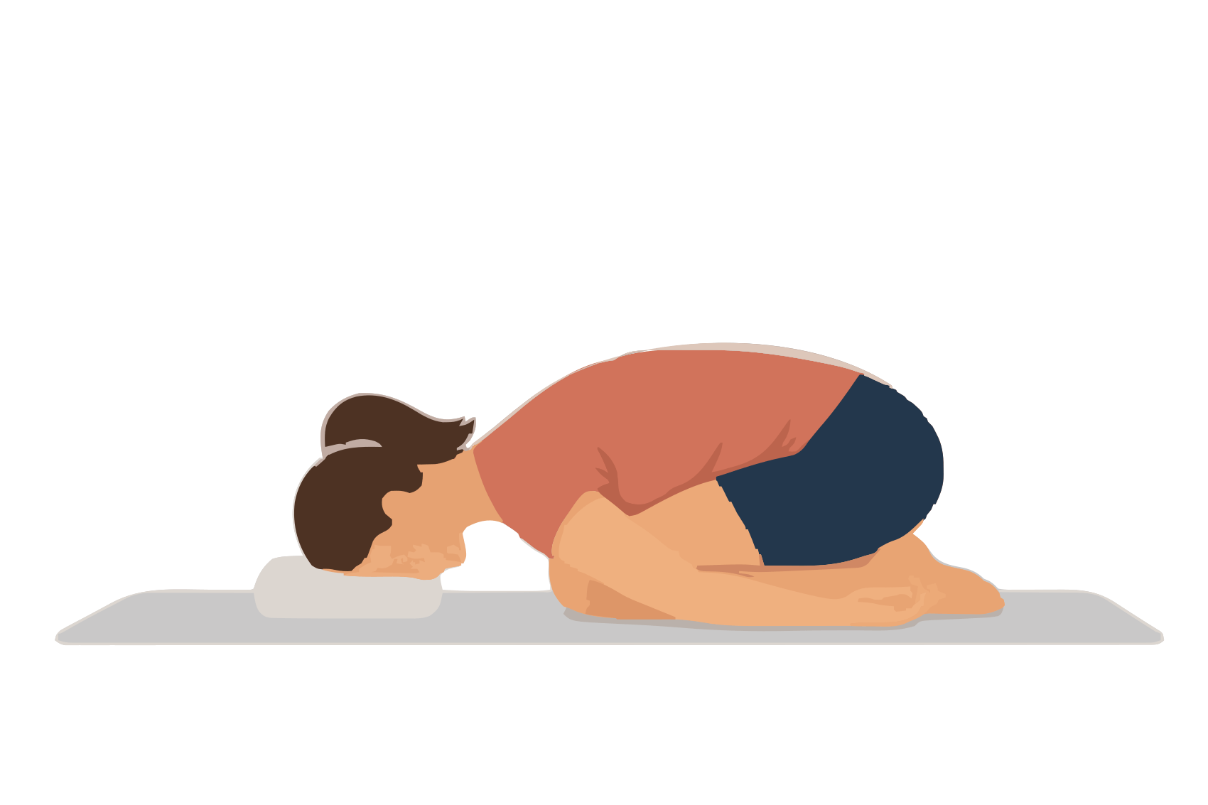
Target: Lower back and back of the hips | Use after: Running Hiking Biking
Equipment: Mat and optional cushion | Time: 20 seconds; 1 or 2 rounds
1. Kneel with your feet close together.
2. Move your buttocks towards your heels and lower your chest.
3. Rest your forehead on a cushion and place your arms beside your legs.
Form Keep space for your stomach. Skip it if the knees hurt.
Source: Free Exercise DB Childs Pose

Indoor stretches 39 to 40
Mat options | Use cushions or folded towels where shown

39 Cat and cow stretch
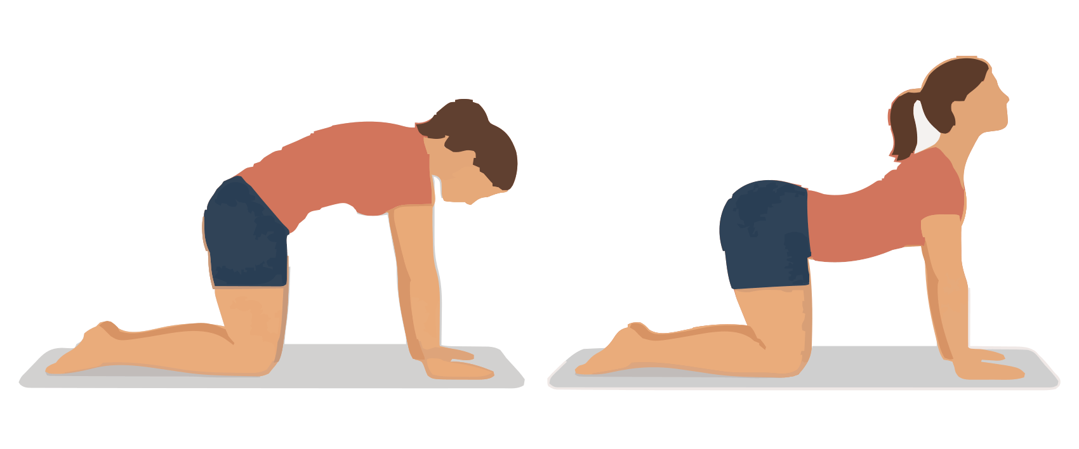
Target: Back muscles through gentle spine movement | Use after: Running Hiking Biking
Equipment: Mat | Time: 5 slow cycles
1. Start on your hands and knees.
2. Breathe out and round your back gently.
3. Breathe in and let your chest move forwards as your back forms a small curve.
Form Use a small smooth range. Keep your elbows straight without locking them.
Source: South Tees NHS kneeling exercises

40 Low sphinx stretch
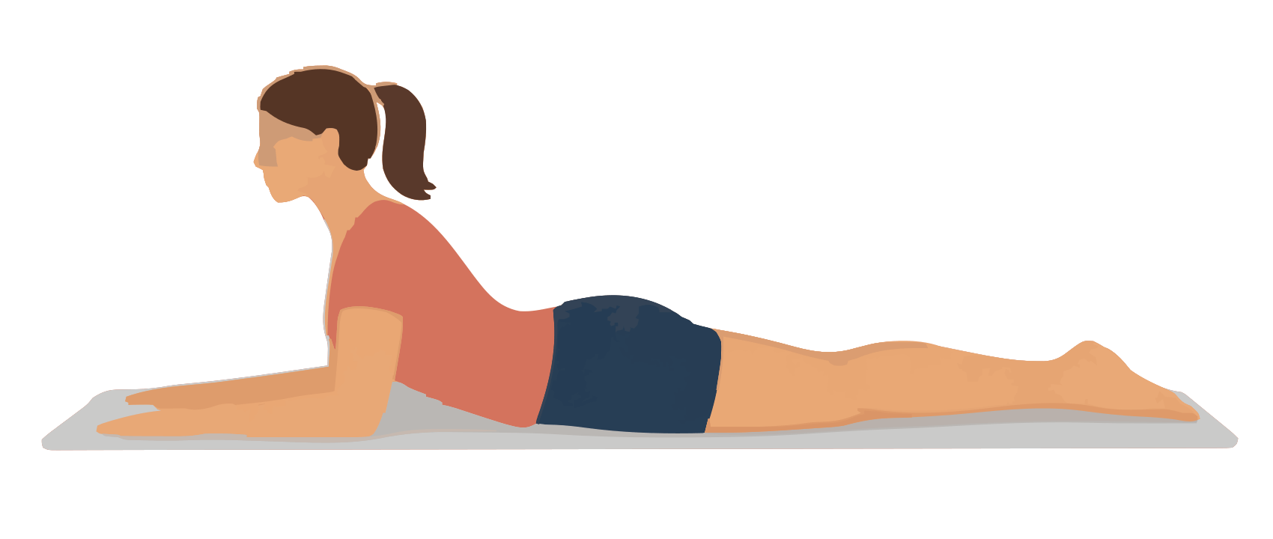
Target: Front of the trunk and gentle back extension | Use after: Hiking Biking
Equipment: Mat | Time: 10 to 15 seconds; repeat 2 times
1. Lie on your front with elbows below or just ahead of your shoulders.
2. Keep your pelvis on the mat.
3. Press into your forearms and lift your chest gently.
Form Look ahead and slightly down. Stop if your lower back pinches.
Source: Worcestershire NHS stretching exercises

Indoor stretches 41 to 42
Mat options | Use cushions or folded towels where shown

41 Bent knee lower trunk turn
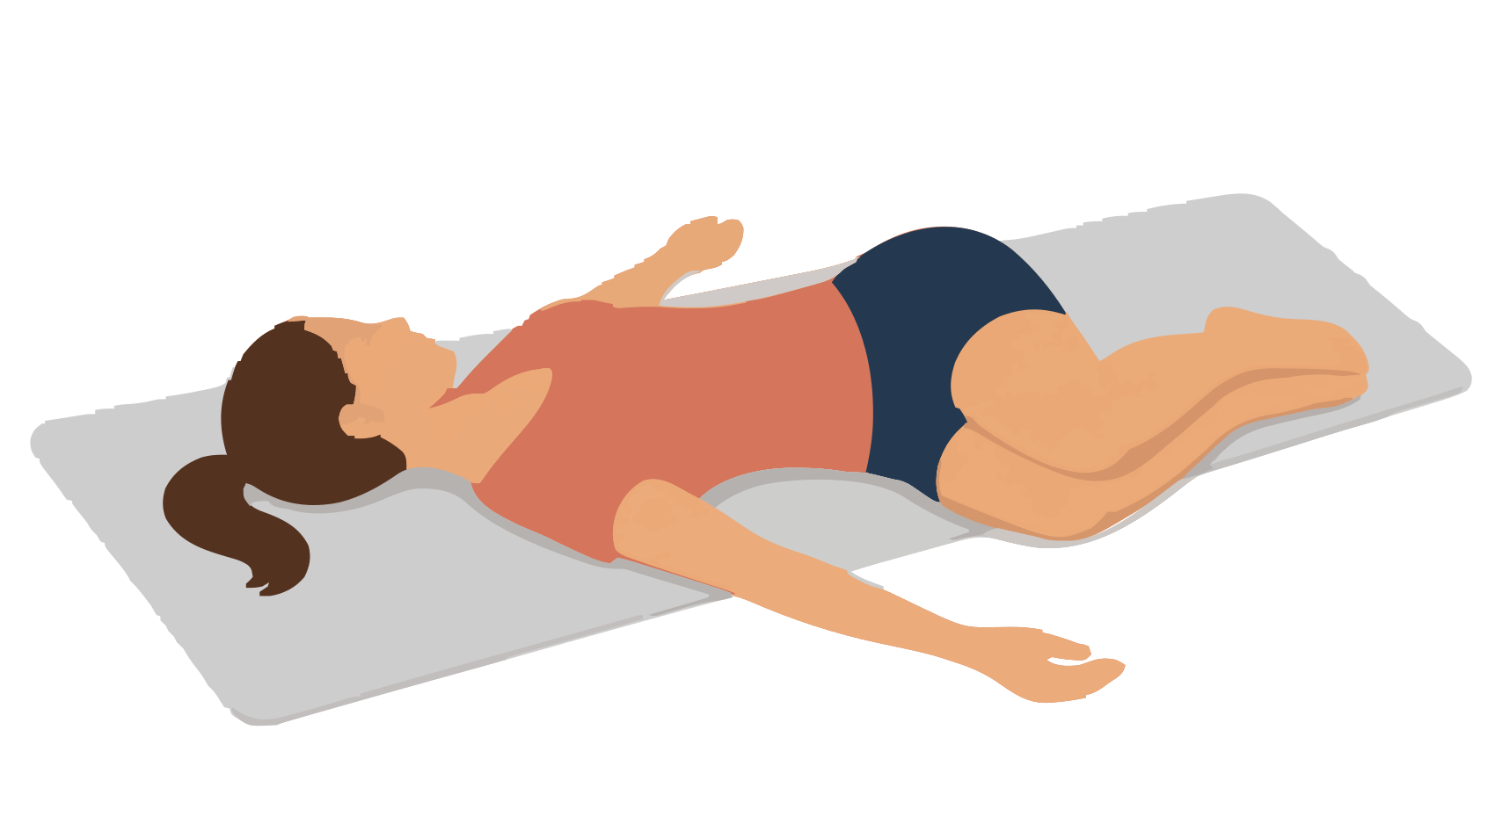
Target: Lower back and side of the trunk | Use after: Running Hiking Biking
Equipment: Mat | Time: 10 to 20 seconds per side; 1 or 2 rounds
1. Lie on your back with knees bent and feet on the mat.
2. Keep your knees together and let both move slowly to one side.
3. Keep both shoulders resting on the mat.
Form Use a small range. Return slowly before changing sides.
Source: Worcestershire NHS stretching exercises

42 Side lying open book
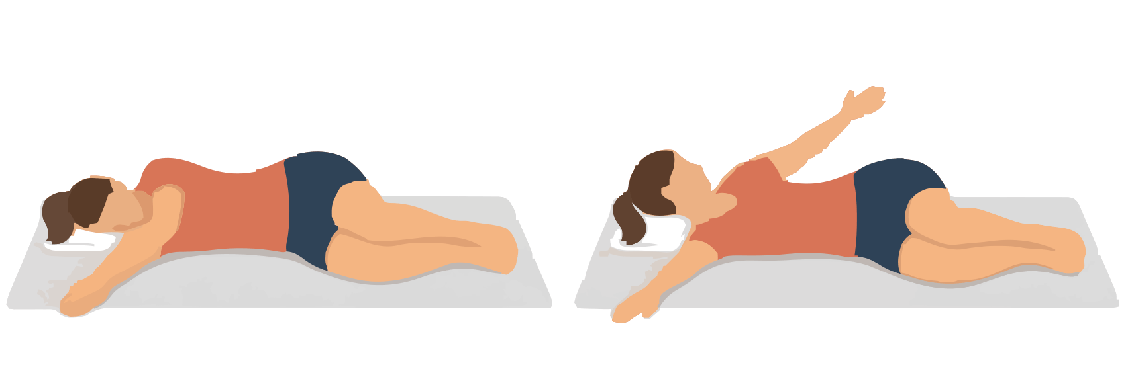
Target: Middle back and chest | Use after: Hiking Biking
Equipment: Mat and pillow for your head | Time: 5 slow turns per side
1. Lie on your side with knees bent and stacked. Reach both arms forwards.
2. Lift the top arm and turn your chest open as the arm moves behind you.
3. Keep the knees together and return slowly.
Form Let the arm stay above the floor if needed. Do not force the shoulder down.
Source: Leeds Teaching Hospitals chest and upper back exercises

Indoor stretches 43 to 44
Mat options | Use cushions or folded towels where shown

43 Thread the needle stretch
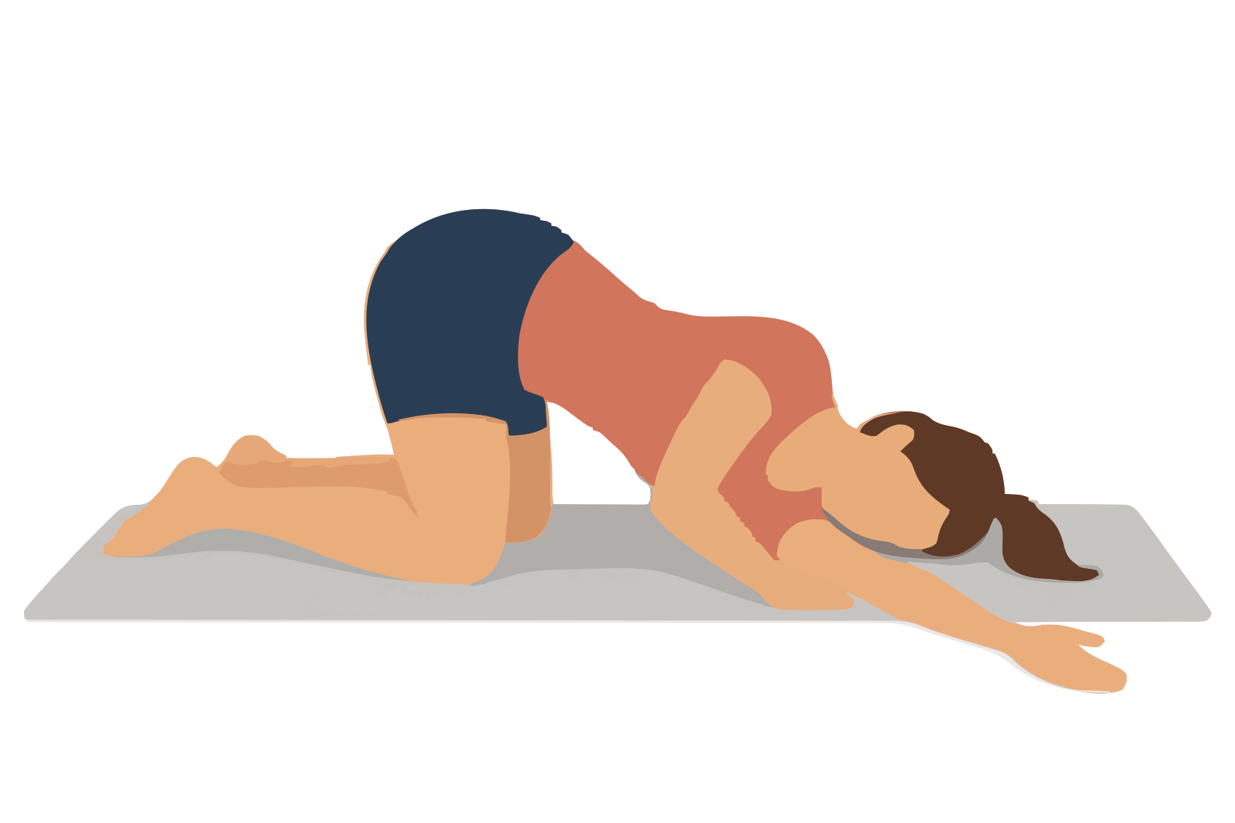
Target: Back shoulder and middle back | Use after: Hiking Biking
Equipment: Mat and optional head cushion | Time: 10 to 20 seconds per side; 1 round
1. Start on your hands and knees.
2. Slide one arm under the other arm with its palm facing up.
3. Lower that shoulder towards the mat as your upper back turns.
Form Rest your head lightly. Keep weight off the neck.
Source: South Tees NHS kneeling exercises

44 Lying full body reach
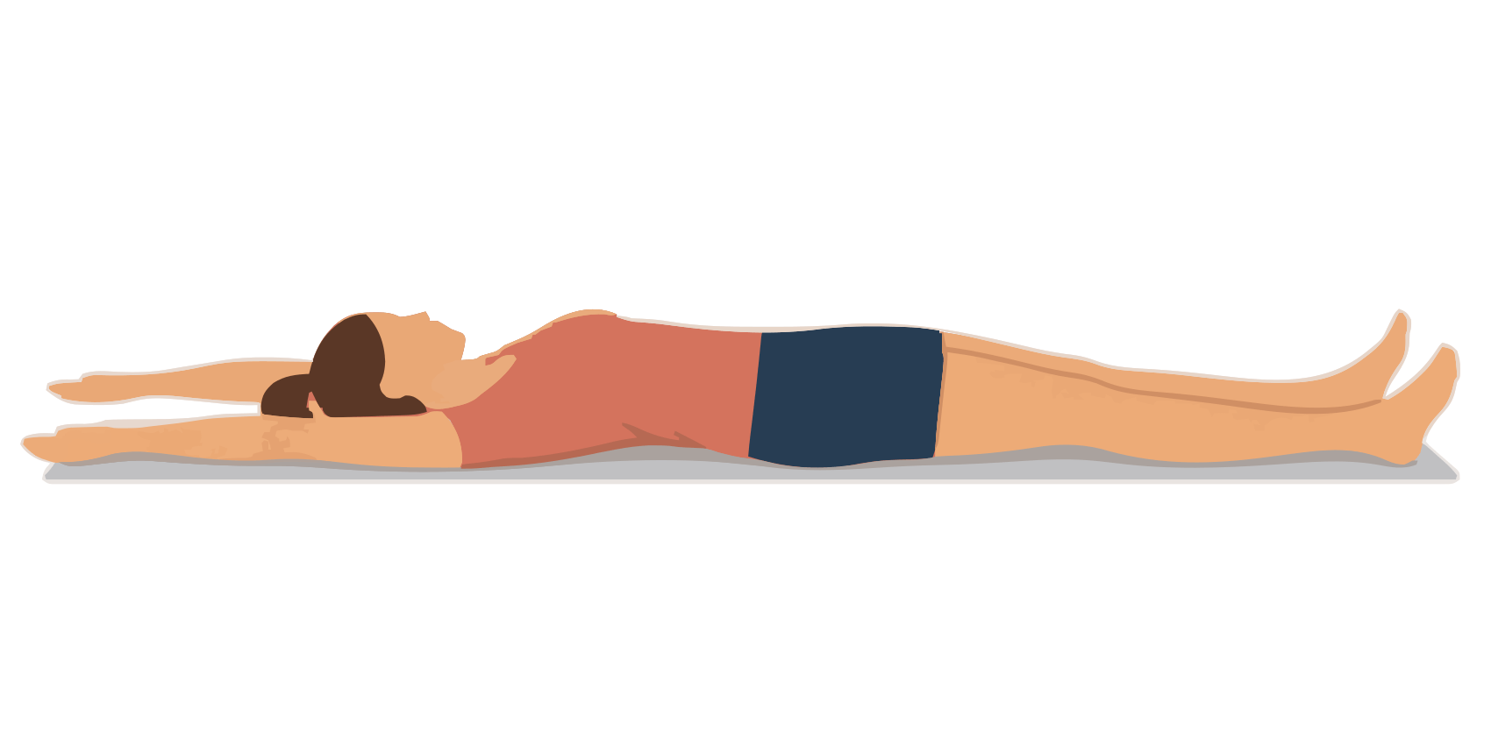
Target: Front and sides of the trunk | Use after: Running Hiking Biking
Equipment: Mat | Time: 10 seconds; repeat 2 times
1. Lie on your back with your legs long.
2. Reach both arms overhead within a comfortable range.
3. Reach your heels away while your hands reach in the opposite direction.
Form Keep your ribs low. Bend the knees if your back arches.
Source: Worcestershire NHS stretching exercises

Indoor stretches 45 to 46
Mat options | Use cushions or folded towels where shown

45 Sole of foot stretch
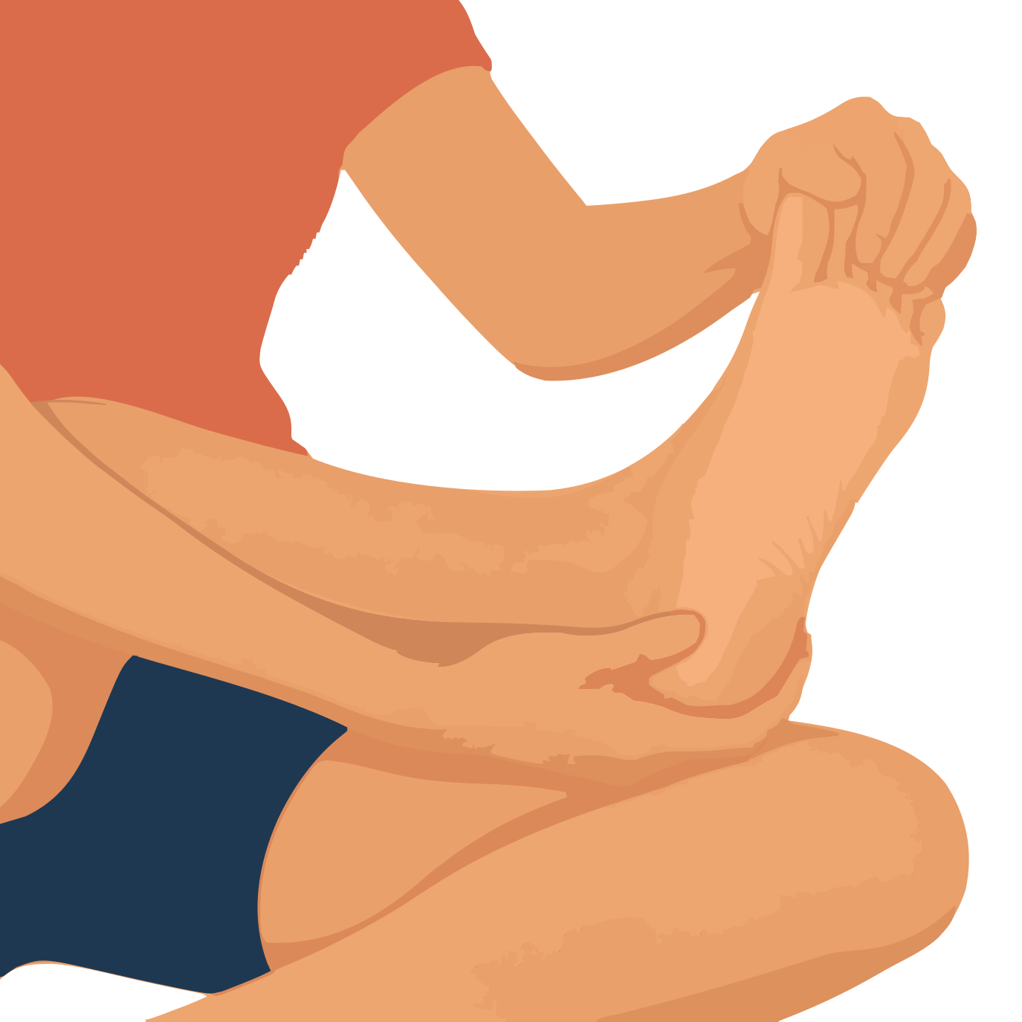
Target: Plantar fascia along the arch | Use after: Running Hiking
Equipment: Mat or chair | Time: 10 seconds per foot; repeat 3 times
1. Sit and rest one ankle across the other thigh.
2. Hold the heel with one hand.
3. Use the other hand at the base of the toes to bend them gently towards your shin.
Form Keep the ankle near neutral. Feel the arch stretch.
Source: AAOS plantar fascia stretch

46 Toe downward stretch
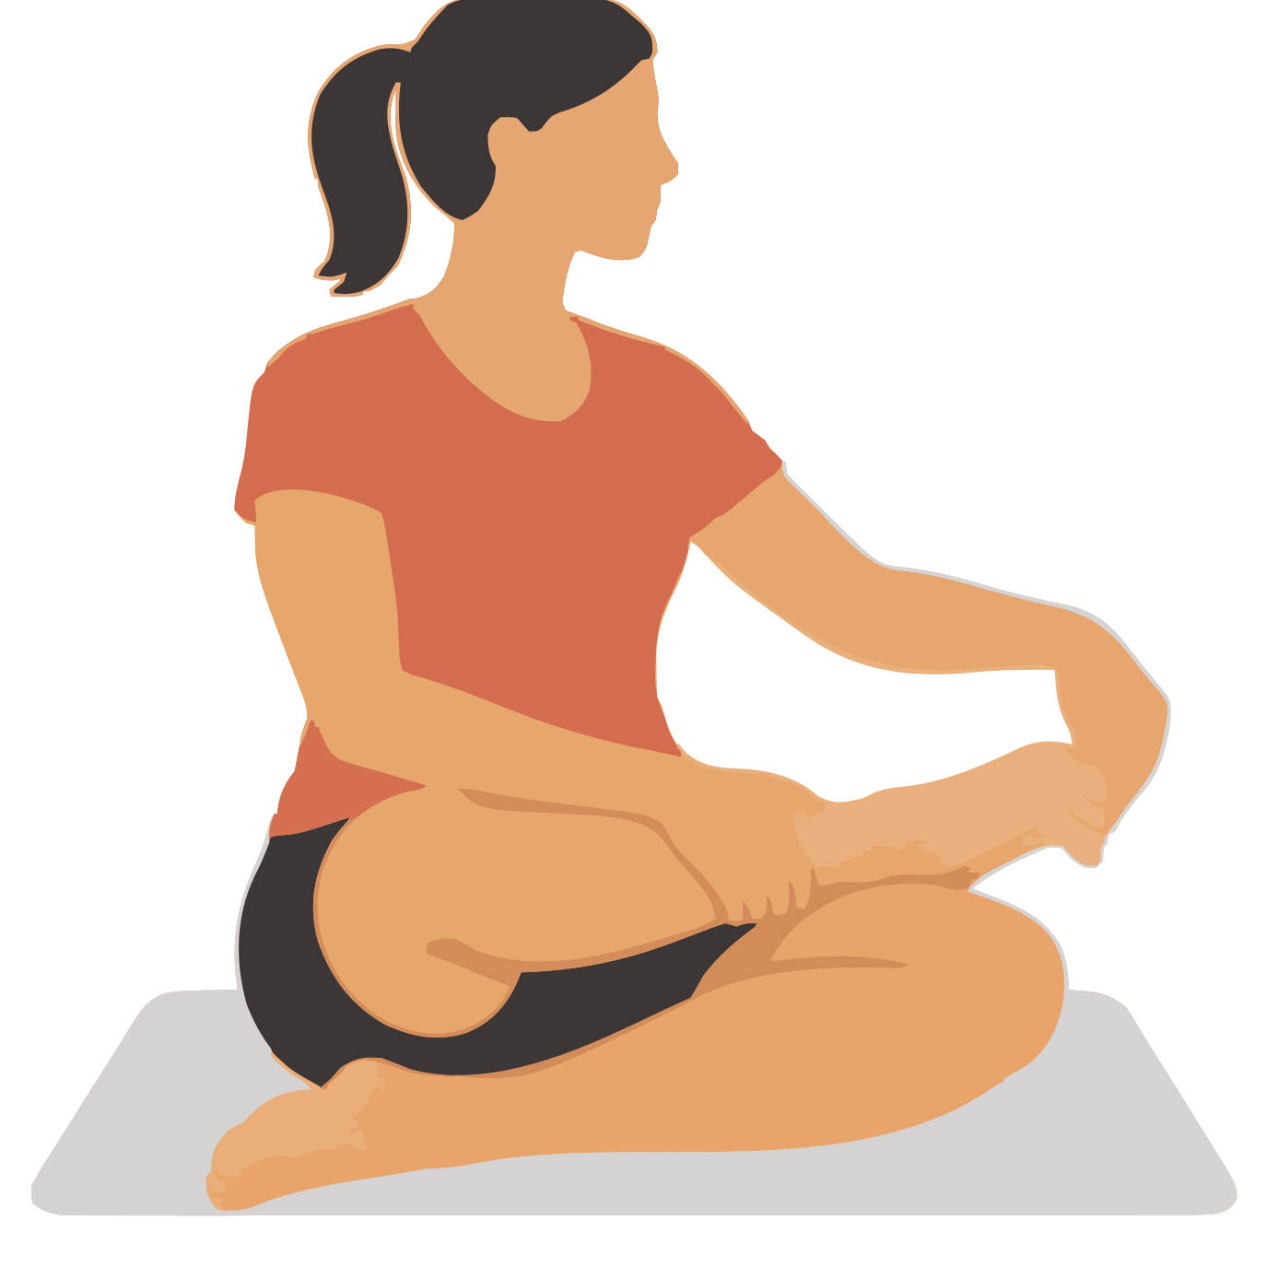
Target: Tissues on the top of the toes and foot | Use after: Running Hiking
Equipment: Mat or chair | Time: 5 to 10 seconds per foot; repeat 2 times
1. Sit with one foot supported on your opposite thigh.
2. Hold the middle of the foot to keep the ankle still.
3. Use the other hand to bend the toes gently downwards.
Form Move the toe joints only. Do not force a curled position.
Source: Warrington and Halton NHS ankle and toe movement guide

Indoor stretches 47 to 48
Mat options | Use cushions or folded towels where shown

47 Outer ankle muscle stretch
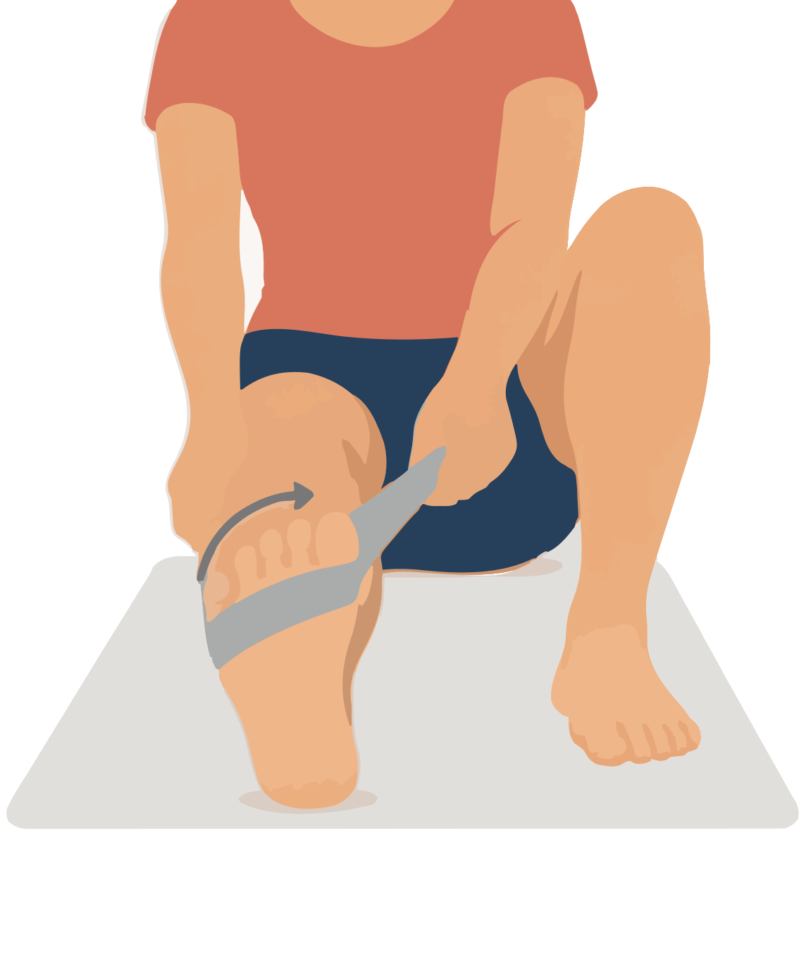
Target: Outer lower leg muscles called peroneals | Use after: Running Hiking
Equipment: Mat and soft strap | Time: 10 seconds per side; repeat 2 times
1. Sit with one leg extended and the heel supported.
2. Loop the strap around the front of the foot.
3. Pull gently so the sole turns a little inwards towards the other foot.
Form Keep the kneecap facing up. Do not twist the whole leg.
Source: Free Exercise DB Peroneals Stretch

48 Inner ankle muscle stretch
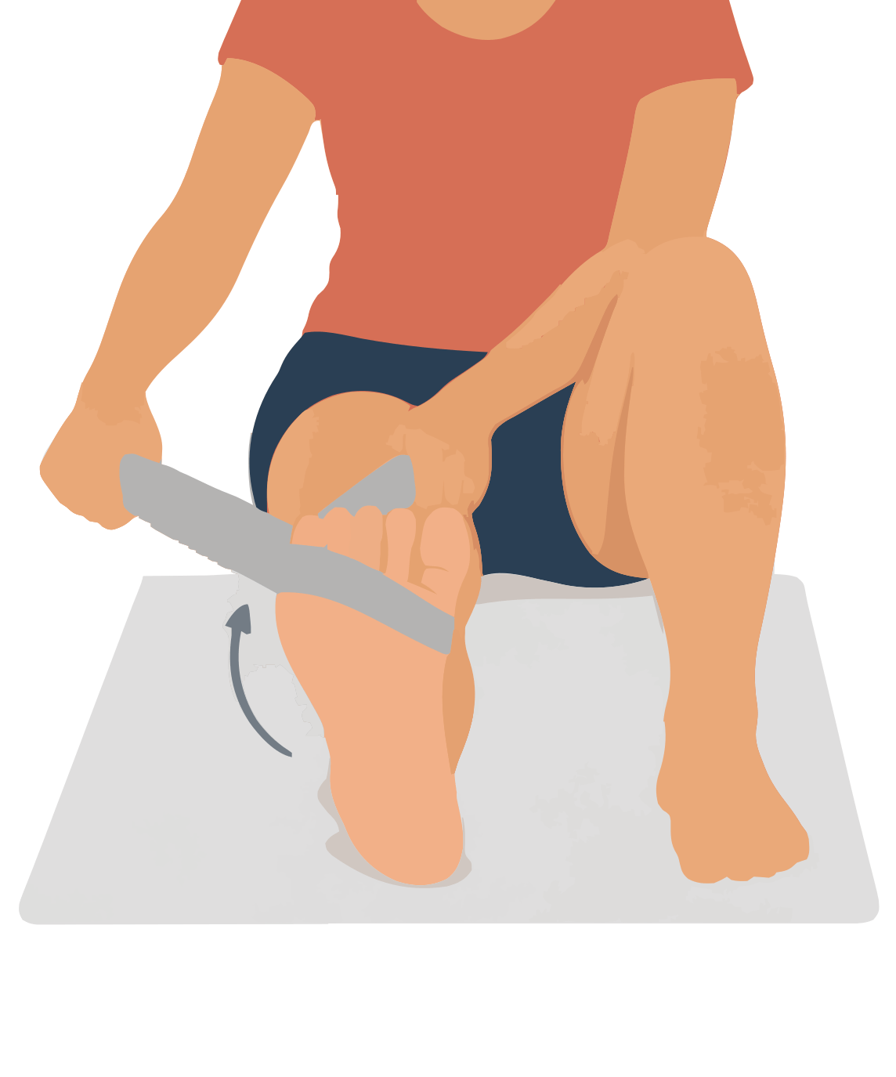
Target: Inner lower leg muscle called tibialis posterior | Use after: Running Hiking
Equipment: Mat and soft strap | Time: 10 seconds per side; repeat 2 times
1. Sit with one leg extended and the heel supported.
2. Loop the strap around the front of the foot.
3. Pull gently so the sole turns a little outwards away from the other foot.
Form Keep the kneecap facing up. Use only a small ankle movement.
Source: Free Exercise DB Posterior Tibialis Stretch

Indoor stretches 49 to 50
Mat options | Use cushions or folded towels where shown

49 Toe spread stretch
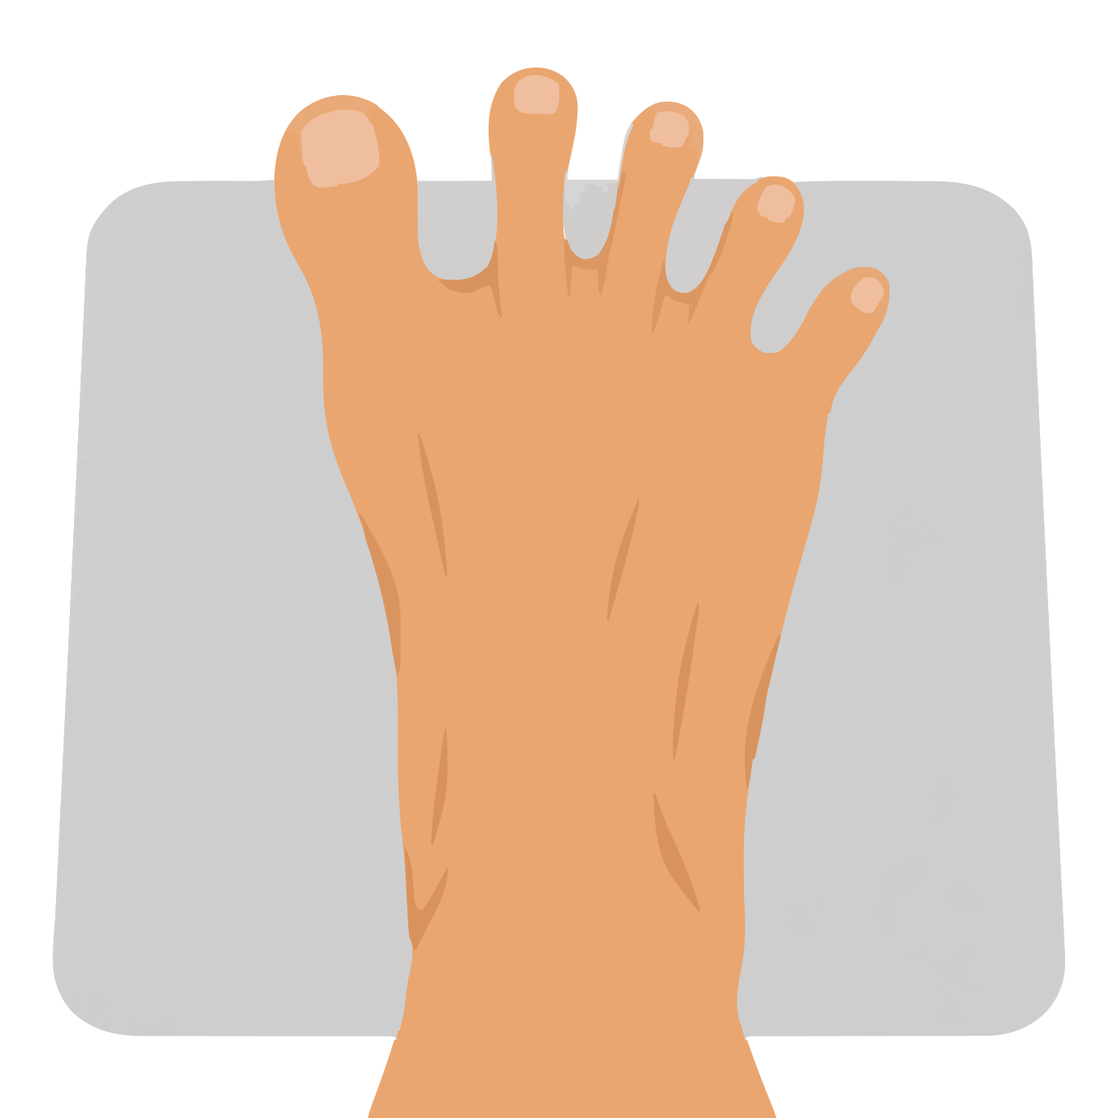
Target: Small muscles and spaces between the toes | Use after: Running Hiking
Equipment: Mat or chair with shoes removed | Time: 5 seconds; repeat 5 times
1. Sit with both feet resting on the floor.
2. Spread your toes gently to make space between them.
3. Hold the open position and then relax.
Form Keep your feet relaxed. Do not curl the toes.
Source: Athletico toe spread stretch

50 Straight leg across body stretch
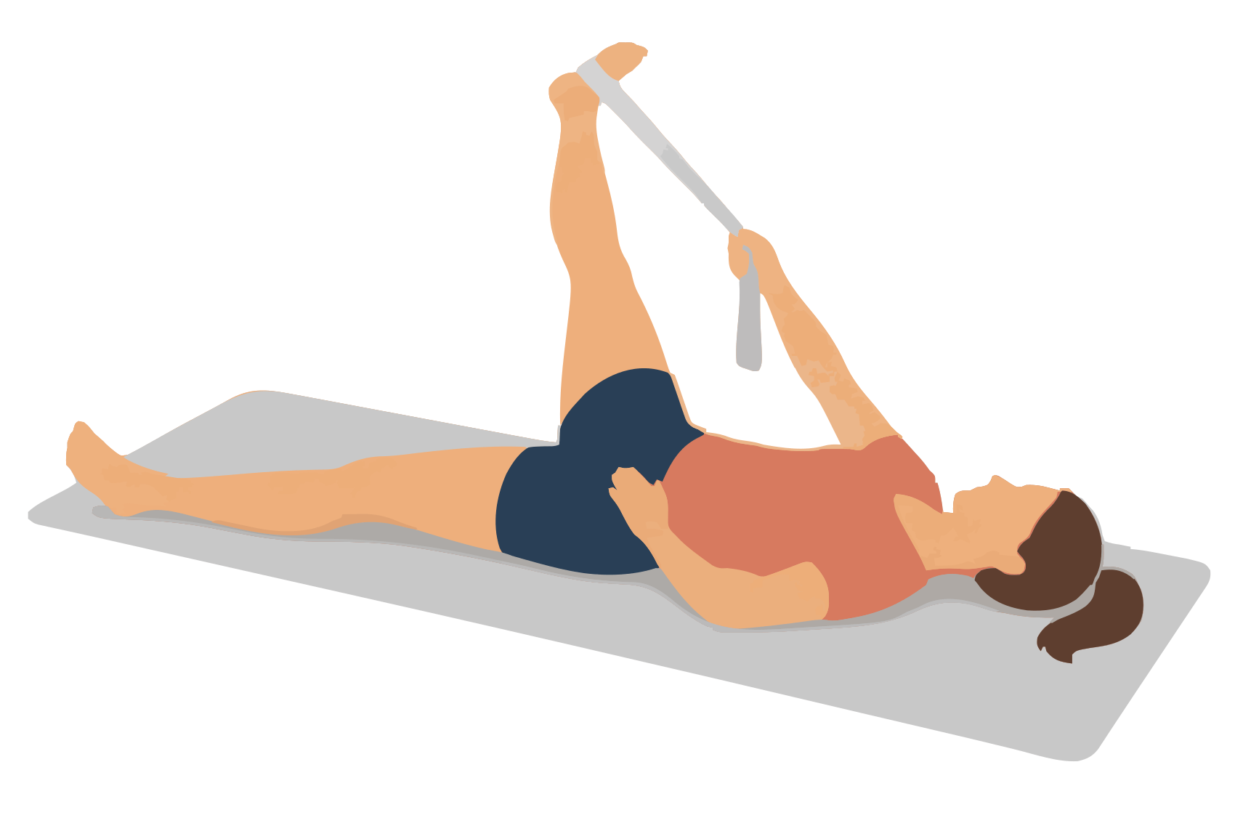
Target: Outer hip and outer back thigh | Use after: Running Hiking Biking
Equipment: Mat and soft strap | Time: 20 seconds per side; 1 or 2 rounds
1. Lie on your back and place a strap around one foot.
2. Lift that leg with the knee almost straight.
3. Guide it a short distance across your body while both sides of your pelvis stay on the mat.
Form Keep the other leg relaxed. Stop before the pelvis rolls.
Source: Free Exercise DB IT Band and Glute Stretch

Exercise differences
Use these details to keep the exercise library free of repeated entries. Related stretches can share a target area. The differences below describe the actual movement or joint position.
1 Straight knee calf stretch Straight knee places more stretch on the upper calf.
2 Bent knee calf stretch Bent knee reduces upper calf tension and gives a different calf stretch.
3 Standing shin stretch Ankle points down to stretch the front of the lower leg.
4 Standing front thigh stretch Main action is knee bending with the thigh beside the body.
5 Heel forward hamstring stretch Single straight leg stretch for the back of the thigh.
6 Standing front hip stretch Hip moves behind the body while the back knee stays only slightly bent.
7 Side lunge inner thigh stretch Hip moves sideways over a straight opposite leg.
8 Crossed leg outer hip stretch Standing hip adduction with a side shift. Target is outer hip muscle, not IT band length.
9 Supported squat stretch Both hips and ankles bend together in a supported squat.
10 Overhead side bend Trunk bends sideways with both feet parallel.
11 Supported back and shoulder stretch Arms stay forward and overhead relative to the trunk.
12 Rounded upper back reach Shoulder blades spread apart instead of the arms moving overhead.
13 Arm across chest stretch Upper arm moves across the body to stretch the back shoulder.
14 Overhead upper arm stretch Elbow bends while the upper arm stays overhead.
15 Chest stretch at a post Shoulder opens with a bent elbow and an arm supported to the side.
16 Hands behind biceps stretch Straight elbows combine with arms behind the body.
17 Side neck stretch Head tilts sideways without turning.
18 Diagonal neck stretch Head turns and bends diagonally, unlike a pure side tilt.
19 Back neck stretch Neck bends forwards without a side tilt or turn.
20 Neck turn stretch Head rotates with the chin level.
21 Palm up wrist stretch Wrist extends with the palm up.
22 Palm down wrist stretch Wrist flexes with the palm down.
23 Palm up forearm turn Forearm rotates towards palm up. The wrist does not bend.
24 Palm down forearm turn Forearm rotates in the opposite direction to the palm up turn.
25 Thumb web stretch Thumb moves away from the index finger while the wrist stays still.

Exercise differences continued
26 Finger straightening stretch Finger joints straighten while the wrist stays neutral.
27 Shoulder turn with a towel behind the back Lower shoulder rotates inward with the elbow behind the body.
28 Outward shoulder turn with a stick Upper arm rotates outward while its elbow remains beside the trunk.
29 Single knee to chest One hip bends towards the chest without rotation.
30 Lying figure four One hip rotates out while the opposite leg brings it closer.
31 Lying inward hip turn Hip rotates inward. No trunk twist or crossed ankle is used.
32 Butterfly stretch Bent knees and joined soles place both hips in external rotation.
33 Wide knee frog stretch Knees bear light weight and stay apart. Feet do not join as in butterfly.
34 Long inner thigh rock back Hip bends backwards over a straight side leg instead of shifting sideways.
35 Seated wide leg forward stretch Both straight legs are apart while the hips bend forwards.
36 Happy baby stretch Both hips bend deeply and open while the body lies on its back.
37 Kneeling front thigh and hip stretch Combines a bent knee with a hip held behind the body.
38 Child pose with arms relaxed Back and hips fold while the shoulders and arms stay relaxed.
39 Cat and cow stretch Alternates spine bending and extension instead of holding a folded pose.
40 Low sphinx stretch Spine extends while the pelvis stays supported.
41 Bent knee lower trunk turn Pelvis turns while the upper trunk stays still.
42 Side lying open book Upper trunk turns open while the pelvis stays still.
43 Thread the needle stretch Upper trunk turns with the arm across the body instead of opening behind it.
44 Lying full body reach Body lengthens in opposite directions without a twist or forward bend.
45 Sole of foot stretch Toe bases extend to tension the sole of the foot.
46 Toe downward stretch Toes bend down while the ankle stays neutral.
47 Outer ankle muscle stretch Foot inverts to lengthen muscles on the outer lower leg.
48 Inner ankle muscle stretch Foot everts in the opposite direction to the outer ankle stretch.
49 Toe spread stretch Toes move sideways instead of bending up or down.
50 Straight leg across body stretch Raised straight leg moves across the body. This is not a trunk twist or an IT band lengthening claim.

