VISVESVARAYA TECHNOLOGICAL UNIVERSITY
“JnanaSangama”, Belgaum -590014, Karnataka.

LAB REPORT
on
Database Management Systems (23CS3PCDBM)
Submitted by
B. Ruchitha (1BM25CS418-T)
in partial fulfillment for the award of the degree of
BACHELOR OF ENGINEERING
in
COMPUTER SCIENCE AND ENGINEERING

B.M.S. COLLEGE OF ENGINEERING
(Autonomous Institution under VTU)
BENGALURU-560019
Sep-2025 to Jan-2026

B. M. S. College of Engineering,
Bull Temple Road, Bangalore 560019
(Affiliated To Visvesvaraya Technological University, Belgaum)
Department of Computer Science and Engineering

CERTIFICATE
This is to certify that the Lab work entitled “Database Management Systems (23CS3PCDBM)” carried out by B.Ruchitha (1BM25CS418-T), who is bonafide student of B. M. S. College of Engineering. It is in partial fulfillment for the award of Bachelor of Engineering in Computer Science and Engineering of the Visvesvaraya Technological University, Belgaum during the year 2022. The Lab report has been approved as it satisfies the academic requirements in respect of a Database Management Systems (23CS3PCDBM) work prescribed for the said degree.

Lab faculty Incharge Name  Assistant Professor  Department of CSE, BMSCE | Dr. Kavitha Sooda  Professor & HOD  Department of CSE, BMSCE

Index
Sl.  No. | Date | Experiment Title | Page No.
1 |  | Insurance Database
2 |  | More Queries on Insurance Database
3 |  | Bank Database
4 |  | More Queries on Bank Database
5 |  | Employee Database
6 |  | More Queries on Employee Database
7 |  | Supplier Database
8 |  | More Queries on Supplier Database
9 |  | NOSQL Installation in Cloud
10 |  | NO SQL - Student Database
11 |  | NO SQL - Customer Database
12 |  | NO SQL – Restaurant Database
13 |  | LeetCode Practice
14 |  | LeetCode Practice

Experiment 1: Insurance Database

Specification of Insurance Database Application
The insurance database must maintain information about drivers, the cars they own, the accidents reported, and the participation of each driver and car in those accidents. Each driver in the system is uniquely identified by a driver ID, along with their name and address, and each car is uniquely identified by its registration number together with details such as model and manufacturing year. The system must allow storing ownership information that links a driver to one or more cars, while also allowing a car to be linked to one or more drivers if shared ownership occurs; duplicate ownership records for the same driver and car must not exist. Accident information must be stored using a unique report number assigned to each accident, along with the date on which the accident occurred and the location where it happened. Every accident reported in the system must have at least one participating driver and car, and this participation is recorded by linking the driver, the involved car, and the accident report together with the corresponding damage amount for that particular involvement. A participation record must reference an existing driver, an existing car, and an existing accident, and no two participation entries may repeat the same combination of driver, car, and accident report. The database must ensure that damage amounts are non-negative, accident dates are valid calendar dates, and car manufacturing years fall within reasonable limits. It must also preserve referential integrity so that ownership or participation entries cannot exist without valid driver, car, and accident information already present in the system. Deletion policies must prevent removal of drivers or cars that appear in past accident participation records unless historical consistency is preserved through controlled deletion rules or archival mechanisms. The system should maintain accurate links between drivers, cars, and accidents at all times, ensuring reliable retrieval of ownership histories, accident histories, and damage information for administrative, legal, and insurance-related purposes.

Entity Relationship Diagram (Draw it in hand)

Schema Diagram

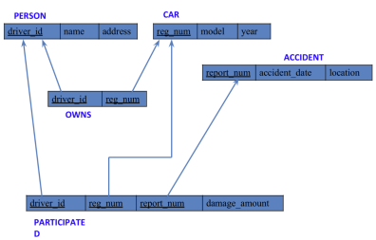

- PERSON (driver_id: String, name: String, address: String)
- CAR (reg_num: String, model: String, year: int)
- ACCIDENT (report_num: int, accident_date: date, location: String)
- OWNS (driver_id: String, reg_num: String)
- PARTICIPATED (driver_id: String,reg_num: String, report_num: int, damage_amount: int)
- Create the above tables by properly specifying the primary keys and the foreign keys. - Enter at least five tuples for each relation

Create database
create database insurance_database;
use insurance_database;
Create table
create table person(
driver_id int primary key,
dname varchar(20),
address varchar(20)
);
desc person;

create table car(
reg_num int primary key,
model varchar(20),
year int);
desc car;

create table owns(
driver_id int,
reg_num int,
primary key(driver_id,reg_num),
foreign key(driver_id)references person(driver_id),
foreign key(reg_num)references car(reg_num)
);

desc owns;

create table accident(
report_num int primary key,
accident_date date,
location varchar(20)
);
desc accident;

create table participated(
driver_id int,
reg_num int,
report_num int,
damage_ammount int,
primary key(driver_id,reg_num,report_num),
foreign key(driver_id)references person(driver_id),
foreign key(reg_num)references car(reg_num),
foreign key(report_num)references accident(report_num)
);

desc participated;
Structure of the table
desc person;
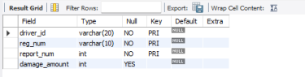desc accident;
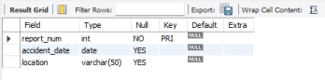
desc participated;
desc car;
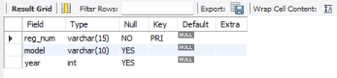
desc owns;

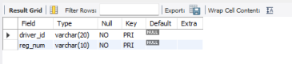
Inserting Values to the table
insert into person values(01,"Richard","Srinivas nagar");
insert into person values(02,"Pradeep","Rajaji nagar");
insert into person values(03,"smith","Ashok nagar");
insert into person values(04,"venu","N R Colony");
insert into person values(05,"jhon","Hanumanth nagar");
select * from person;
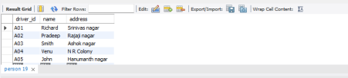insert into car values(052250,"Indica",1990);
insert into car values(031181,"Lancer",1957);
insert into car values(095477,"Toyato",1998);
insert into car values(053408,"Honda",2008);
insert into car values(041702,"Audi",2005);
select * from car;
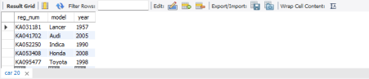
insert into owns values(01,052250);
insert into owns values(02,031181);
insert into owns values(03,095477);
insert into owns values(04,053408);
insert into owns values(05,041702);
select * from owns;
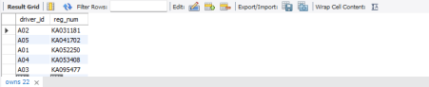insert into accident values(11,'2003-01-01',"Mysore Road");
insert into accident values(12,'2004-02-02',"south end circle");
insert into accident values(13,'2003-01-21',"Bull Temple Road");
insert into accident values(14,'2008-02-17',"Mysore Road");
insert into accident values(15,'2005-03-04',"Kanakpura Road");
select * from accident;
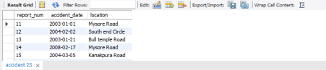insert into participated values(01,052250,11,10000);
insert into participated values(02,031181,12,50000);
insert into participated values(03,095477,13,25000);
insert into participated values(04,053408,14,3000);
insert into participated values(05,041702,15,5000);
select * from participated;

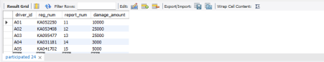
Queries ( Question and answer should contain screen shot of the output)

Experiment 2: More Queries on Insurance Database
Queries (Questions and output )
- Update the damage amount to 25000 for the car with a specific reg-num (example 'KA053408' ) for which the accident report number was 12.
update participated
set damage_amount=25000
where reg_num='KA053408' and report_num=12;
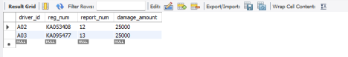
● Find the total number of people who owned cars that were involved in accidents in 2008.
select count(distinct driver_id) CNT
from participated a, accident b
where a.report_num=b.report_num and b.accident_date like '2008%';

● Add a new accident to the database.
insert into accident values(16,'2008-03-08',"Domlur");
select * from accident;

