Hardware Identification

Types of Computer Cases

PC cases are typically categorized into five categories:
- Full tower PC Cases
- Mid tower PC Cases
- Mini Tower PC Cases
- Small Form Factor PC Cases (SFF)
- Slimline PC Cases (considered a variation of SFF cases by many)

Full Tower
Full-tower cases are generally big with a height that is about or more than 30 inches
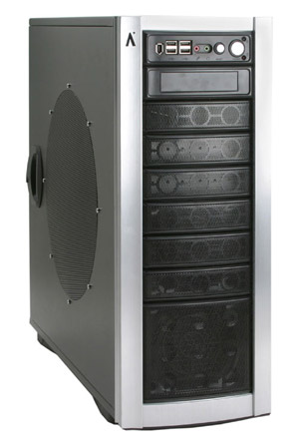

Mid Tower
Mid-tower cases are the most widely used computer cases. Mid Tower cases are about 18 to 24 (45 to 60 cm) inches
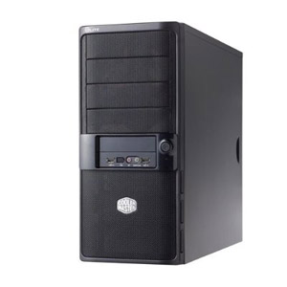

Mini Tower
Mini-cases normally stand at a height of 12 to 18 inches (30 to 45 cm)
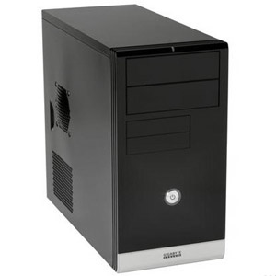

Slim Line Case
Slim line cases are simply tower cases turned on their sideways. They can hold a monitor on top of the case.
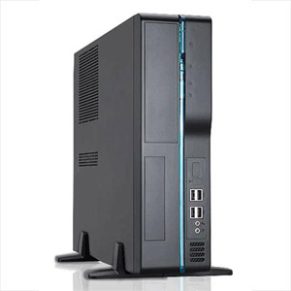

FRONT PANEL OF COMPUTERSmall Form Factor (SFF) Case
Small form factor or SFF cases are custom cases that are designed to minimize the spatial volume of a desktop computer. SFFs are available in a variety of sizes and shapes, including shoe boxes, cubes, and book-sized PCs.
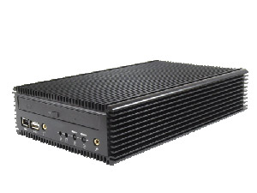
FRONT PANEL OF COMPUTER

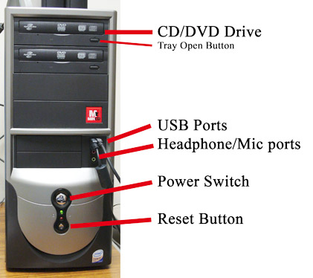

BACKPANEL OF COMPUTER
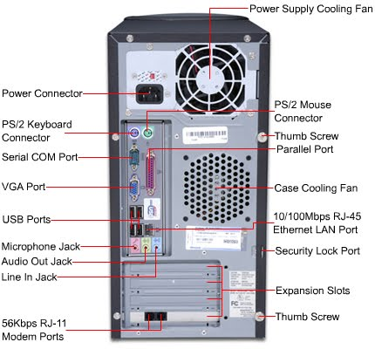

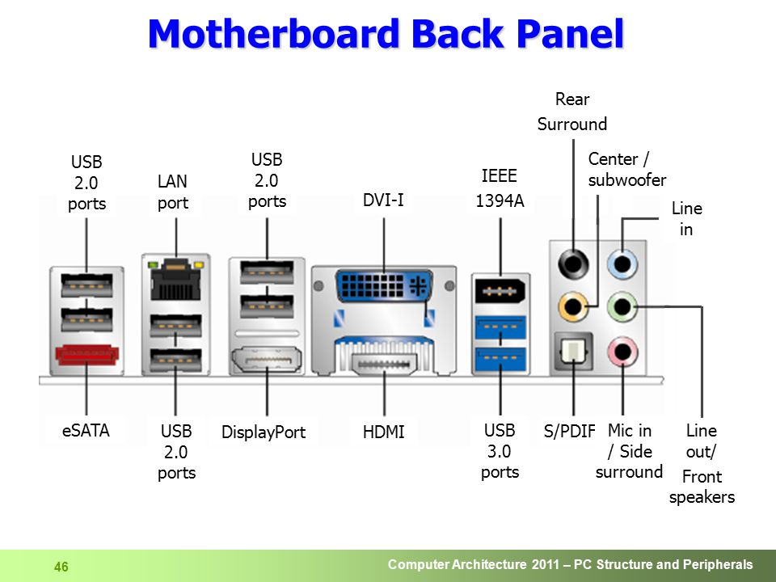

What are the functions of parallel port?

A parallel port is an interface allowing a personal computer (PC) to transmit or receive data down multiple bundled cables to a peripheral device such as a printer. The most common parallel port is a printer port known as the Centronics port.
What is the function of serial port?

What Does Serial Port Mean?

A serial port is an interface that allows a PC to transmit or receive data one bit at a time. It is one of the oldest types of interfaces and at one time was commonly used to connect printers and external modems to a PC.

What is the difference between serial and parallel port?
The main difference between the serial and parallel interfaces is how they transmit data. In serial interface the data is sent or received one bit at a time over a series of clock pulses. In parallel mode the interface sends and receives 4 bits, 8 bits, or 16 bits of data at a time over multiple transmission lines.

Which devices are connected in parallel port?
A parallel port is used in Modems, security cameras, device controllers use serial ports. Printers, Hard Drives, CD drives use parallel ports

What is connected at the serial port of computer?
A socket that connects to a serial interface (one bit following another over one line). Serial ports are widely used by sensors for data acquisition, and they were standard on early computers for connecting a modem, mouse and other peripheral

CABLES
The computer cables can be used to connect various devices to the system and perform several operations. The computer cables can easily transmit the digital and analog signal through it. Some of the computer cables are capable enough to transmit electric power through it like a USB cable. Using a computer cable, one can see movies, play games, listen to music, and do many more things. Ethernet cables can be used to connect the computer system to the internet world

DIFFERENT TYPES OF CABLES

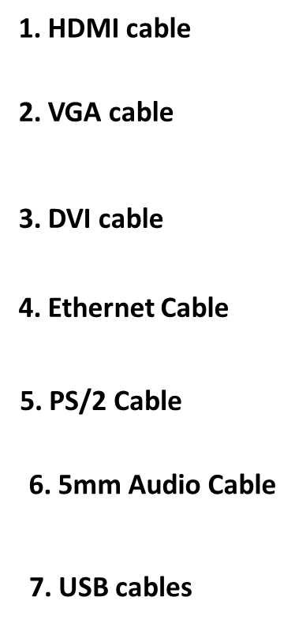

1. HDMI cable
HDMI (High definition Media Interface) is a type of computer cable used to transmit high definition video and audio signals. Using the HDMI cables, the audio and video signal can be easily transmitted without compromising the quality of images and can send crystal clear images using this cable. The HDMI cables are used to connect cable boxes, TVs, DVD players, media streamers and other electronic devices. All types of Av devices can be connected to one standard cable, which is an HDMI cable. Also, one HDMI cable is capable of transmitting both audio and video signals at the same time.

HDMI CABLE 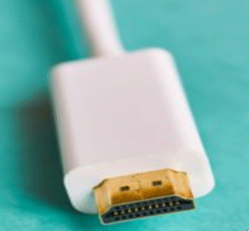

2. VGA cable
VGA (Video Graphics Ray) cable is another type of computer cable which is used for sending video signals and is used to link the monitor and the CPU of a computer. The VGA cable can also be used in HD televisions. All the information displayed on the monitor is coming from the VGA cable. There is a total of 15 pins in the plugin the cable, which have three rows containing 5 pins each. And the cable is easily fitted in the monitor and the other end is fixed in the CPU of a computer system.
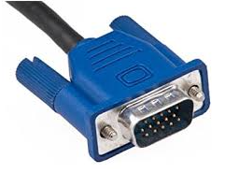VGA CABLE

3. DVI cable
DVI (Digital Visual interface )cables are used to connect the LCD monitor and the video card. Using this cable, the user can see high image quality without having any disturbance. The DVI cable is mostly used in CRT monitors, which have a VGA connection. This cable transmits the digital and analog signals to the computer system. The DVI cable is capable enough of digital connections and analog connections. The DVI cable can be easily distinguished, whether it is analog or digital, by looking if there is any flat pin present on the cable. If the flat pin has four pins around, then it is a DVI analog, and there is only a flat pin, then it is DVI digital.

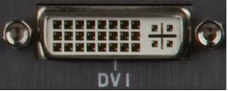 DVI CABLE

4. Ethernet Cable
The Ethernet cable is a type of computer network cable which is used for a wired network. The Ethernet cable is used to connect the switches, monitors, PCs to the LAN (Local Area Network). The length and durability of the Ethernet cable describe the quality of the connection. If the cable is too long and is not durable, it will contain a poor quality of the signal. And due to this factor, there are different types of Ethernet cables present in the market. The Ethernet cables are plugged into the Ethernet port present on the motherboard. The Ethernet cable looks like a phone cable but contains more wires than phone cables. There are eight wires in the Ethernet cable, and they can be available in different colors in the market.
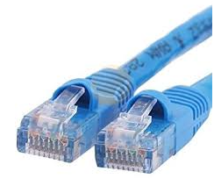 ETHERNET CABLE
5. PS/2 Cable
The PS/2 cable is a standard cable to connect the mouse and keyboard to the computer system. The length of the PS/2 cable is long enough so that the user can easily connect the mouse and keyboard to the system and use the system. There are a total of 6 pins in PS/2 cables and have a round connector. There are majorly two sizes of PS/2 cable. The smaller size is the most common cable, but some adaptors can be used to convert it into a larger size. This cable is now replaced with USB cables as they are universal cables and can be easily plugged into any system.
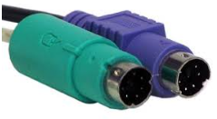 PS/2 Cable

6. 5mm Audio Cable
The 3.5mm audio cables are a type of computer cables that are used in computer audio applications. This cable can be used for connecting a mini-stereo audio device, PC sound card or any portable CD player to any multimedia speaker. This cable can also be used to connect earphones and headphones to the system.
The green port is for headphones and computer speakers. Blue port is for DVD player, MP3 player and pink port Is used for connecting microphones.
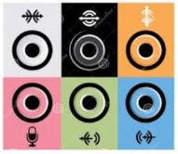 5mm Audio cable

7. USB cables
The USB (Universal Serial Bus) cable is a standard cable used to connect universal devices or personal computers. It is mainly used for short-distance digital communication. The digital data can be transferred using a USB cable. Nowadays, the USB cable is used to charge devices like smartphones, Bluetooth speakers, trimmers and many more. The USB cables can be used to connect two devices directly. The USB cable is connected to the USB port present in the computer system. The mouse and keyboard are also connected to a USB port as they have USB cables. As the device is connected through the USB cable, the unplugging of the USB cable when a device is running can cause damage to a device, so whenever there is a need of removing the USB cable, first it should be eject safely and then it should be removed from the system

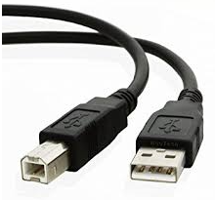 USB CABLES

HDMI connectors are available in three sizes: standard, mini and micro.
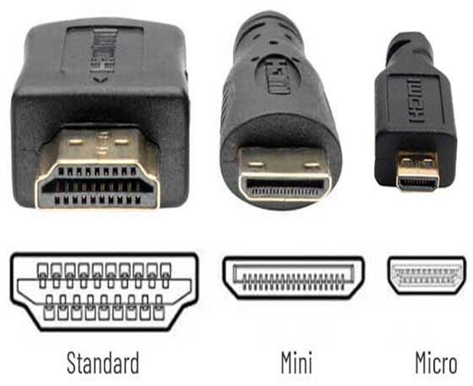

The Standard HDMI connector (Type A) is the most widely used of the five HDMI connector types. These 19-pin connectors can be found on almost every brand of TV, computer monitor, game console, streaming device and desktop computer.
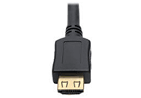

Mini HDMI connectors (Type C) also have 19-pins and support the same features as the full-sized Type A connector in a smaller, more compact form factor. Because of its smaller size, it is typically used on portable devices such as DSLR cameras and tablets.
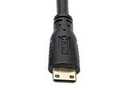
The smallest HDMI connector, Micro HDMI (Type D), is about half the width of the Mini HDMI connector yet still retains the full functionality of its larger siblings. Micro HDMI connectors are used on small, portable devices such as phones.
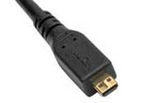

PHERIPHERAL CABLES
What are SATA Cables?
Serial Advanced Technology Attachment (SATA) or Serial ATA cables are used to connect devices in computer cable assemblies, such as storage devices, for example.
The SATA technology itself is a connecter interface primarily used for computer bus connections in storage applications. In this application, the cables are used to connect a mass storage device (e.g. hard disk drives, optical drives, solid-state memory drives) to a host bus adapter such as a motherboard.
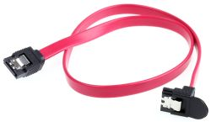

Parallel ATA (Parallel Advanced Technology Attachment or PATA) is a standard for connecting hard drives into computer systems. As its name implies, PATA is based on parallel signaling technology, unlike serial ATA (SATA) devices that use serial signaling technology. Parallel ATA dates back to the 1980s. Integrated Drive Electronics ( IDE ) drives operate according to this standard.

The connections for PATA devices were originally made using 40-conductor ribbon cables.

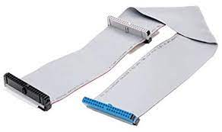

Small Computer System Interface (SCSI, /ˈskʌzi/ SKUZ-ee) is a set of standards for physically connecting and transferring data between computers and peripheral devices. The SCSI standards define commands, protocols, electrical, optical and logical interfaces.

SCSI ports were designed for Apple Macintosh and Unix computers, but also can be used with PCs. Although SCSI was popular in the past, today it has largely been superseded by faster connection types, such as SATA.

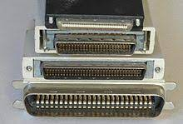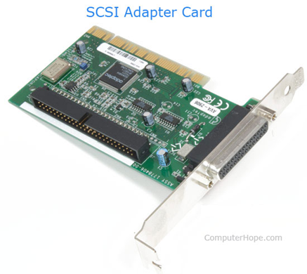

ADAPTERS DVI TO HDMI

Creates a pure bi-directional digital connection between a DVI-enabled source and an HDMI-enabled display or an HDMI-enabled source and DVI-enabled display.
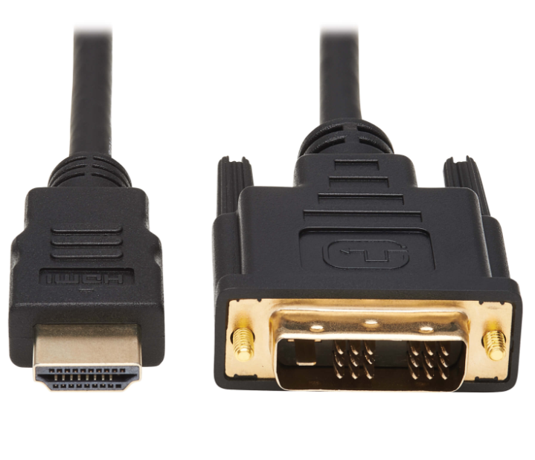

DVI TO VGA
A DVI to VGA adapter is used to connect a VGA/SVGA monitor or TV to a DVI-I connection, like on a laptop.

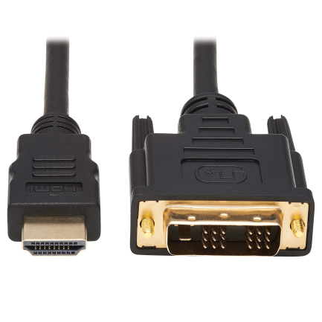

USB TO EHTERNET
Ethernet adapter is used connect your device to a router, modem, or network switch to deliver high-speed Ethernet to your network connection.
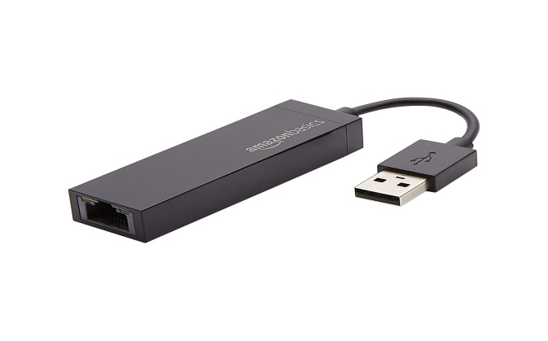
Installation of printers
- Download the Printer drivers
- Extract the files
- Double click the Setup File
- Check the printer is on and connected to PC
- Answer the wizard
- After the Installation is complete
- Test the Printer

UNMOUNT THE POWER SUPPLY FROM PC
TOOLS REQURIED —pair of gloves and head screw driver antistatic wrist strap
1. Start by unplugging from the wall all of the cables connected to your computer
2. If your power supply unit (PSU) includes a power switch accessible on the rear of
your PC, flip it to the off position,
3, Then remove the side panel of your case so you can access the PSU.
4. Disconnect all different power connectors lead from the power supply unit
Remove all power cables connected from SMPS to Mother Board , Hardisk, CDROM drive
5. Remove all the screw connected to SMPS.
6. Slide the SMPS Carefully.
Mount the power supply into PC

1. Select the Best power supply
2. Slide the SMPS carefully
3. Fix the screws to SMPS
4. Connect all different power connectors lead from the power supply unit
Connect all power cables connected from SMPS to Mother Board , Hardisk, CDROM drive
5. Slide the CPU case and fix it.
6. Fix the power cable the swich on the power button.

Identify Output volAge using colour coding
ATX connector. As you can see in the image, it is a 24-pin connector which is used to supply DC supply to the motherboards. Various color-coded wires connect to this connector and each colored wire supplies distinct DC voltage which is explained in the chart below.
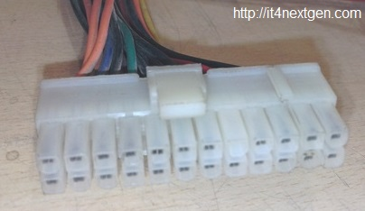
Wire colour | DC Voltage
Red | +5 V
Yellow | +12V
Black | Ground
Blue | -12V
Grey | Power Good
Green | Power On
Purple | +5V StandBy
Orange | +3.3V
Brown/Orange | +3.3V Sense
White | -5V (optional)
ATX-12V connector. Latest SMPS power supplies are accompanied by an extra 4-pin connector which supplies 12 volts to energize the central processing unit and other components of the motherboard.
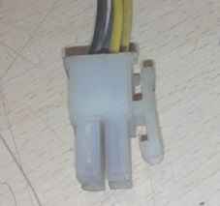
AT Connectors. Earlier motherboards used to support AT connectors( 6-pin each) also called P8 and P9 connectors to supply power to these motherboards(upto 486 boards).
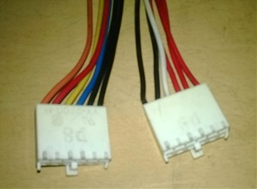
Wire Colour | DC Voltage
Red | +5V
White | -5V
Black | Ground or 0V
Blue | -12V
Yellow | +12V
Orange | + 5V ( PG)
4-PIN connectors. There are multiple 4-pin connectors that draw out from the SPMS unit. These connectors are used to supply DC power to various peripherals of computer like a floppy disk drive, hard disk drive or DVD-writers.
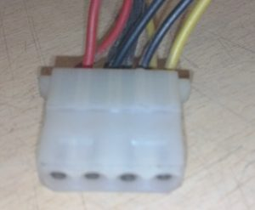
Wire Colour | DC Voltage | Used For
Yellow | +12 V | Motors
Black | GND
Black | GND
Red | +5V | Logic circuit

SATA-output connector. To feed the power to latest SATA hard drives, these connectors are used.
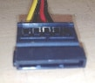
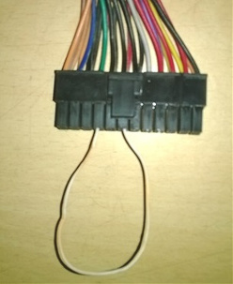
To check the supply, whether it is working properly or not, you can test it before fitting it in the cabinet. There is a simple way to test the SMPS, you just have to short the green wired connector to any black colored(ground) connector. If the SMPS is working perfectly, the fan of the supply will start working.

Measuring voltage levels using multimeter
Step 1. Before you begin, read some important PC repair safety tips because of the dangers involved with the process. Manually testing a power supply involves working closely with high voltage electricity.
Step 2. Open your computer's case. In short, this involves turning off the computer, removing the power cable, and unplugging anything else connected to the outside of your computer
To make testing your power supply easier, you should also move your disconnected and open computer case somewhere easy to work like on a table or other flat, non-static surface.
Step 3. Unplug the power connectors from each and every internal device.
Step 4. Group all of the power cables and connectors together for easy testing.
Step 5. Short out pins 15 and 16 on the 24-pin motherboard power connector with a small piece of wire.
You'll probably need to take a look at the ATX 24-pin 12V Power Supply Pinout table to determine the locations of these two pins.
Step 6. Plug the PSU into a live outlet and flip the switch on the back of the power supply. Assuming that the power supply is at least minimally functional and that you've properly shorted the pins in Step 5, you should hear the fan begin to run.
Step 7. Turn on your multimeter and turn the dial to the VDC (Volts DC) setting.
Step 8. Test the 24-pin motherboard power connector:
Connect the negative probe on the multimeter (black) to any ground wired pin and connect the positive probe (red) to the first power line you want to test. The 24-pin main power connector has +3.3 VDC, +5 VDC, -5 VDC (optional), +12 VDC, and -12 VDC lines across multiple pins.
NOTE : You'll need to reference the ATX 24-pin 12V Power Supply Pinout for the locations of these pins.
Step 9. Repeat Step 7 and 8, testing and documenting the voltages for other
power connectors like the 4-pin peripheral power connector, the 15-pin SATA power connector, and the 4-pin floppy power connector.
- Step 10. Once your testing is complete, turn off and unplug the PC and then put the cover back on the case.

Troubleshoot power supply through SMPS FAN
- Turn off the computer completely
2. Remove the screws that are present in the side panel of your computer.
3. Connect the Power cable and Power on the SMPS.
4. The SMPS Fan Will Spin, if it is working.

5. The same can be confirmed by hearing the fan spinning noise or air coming out of the fan.

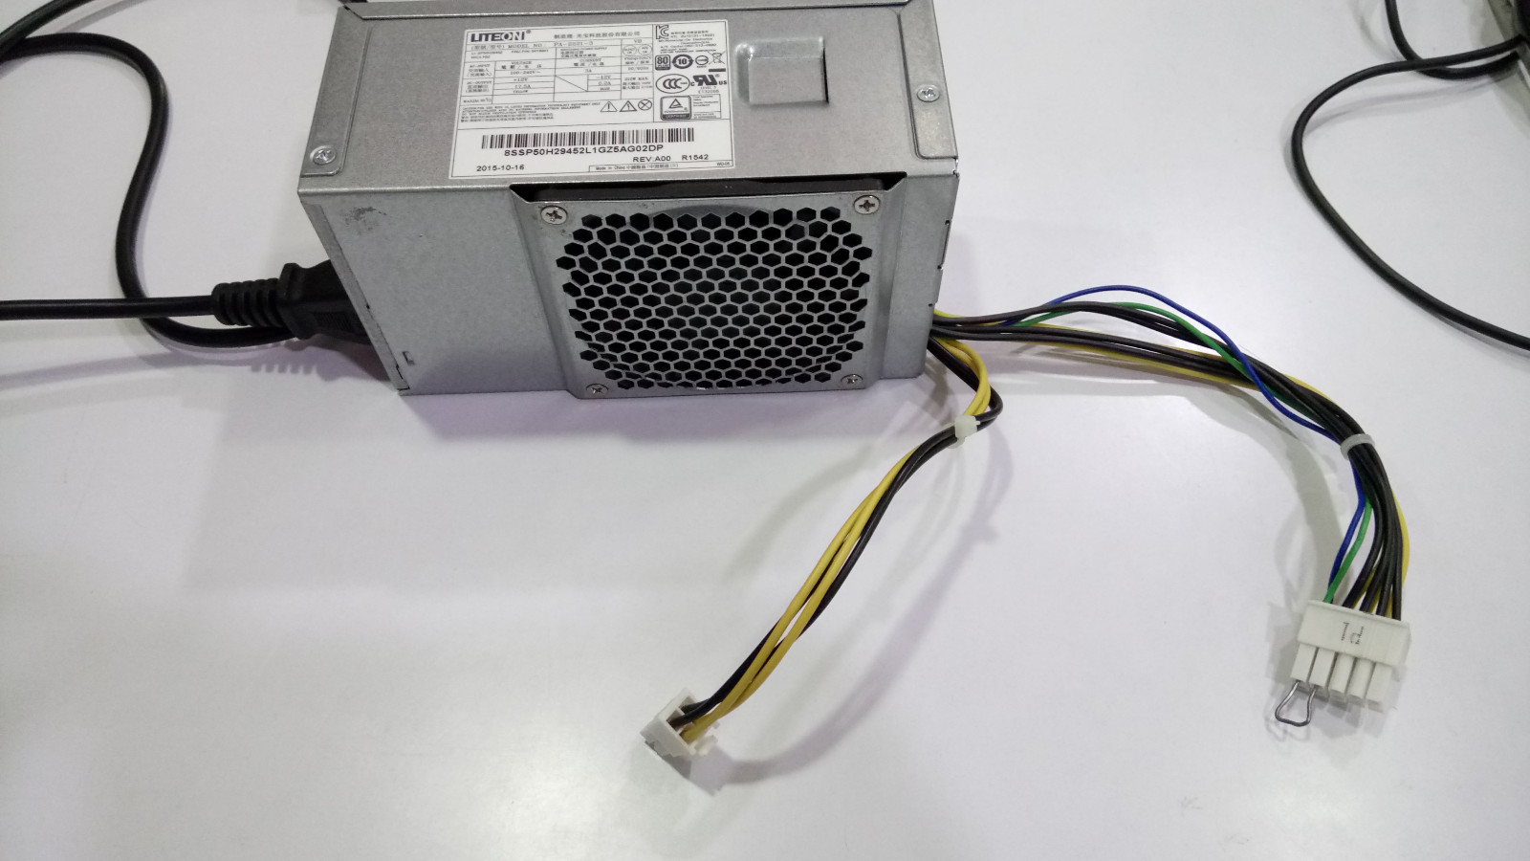

Instructions to Use a PSU Tester
- Unplug the computer from the main source that means removing the power cable from the backside of the PSU of the PC.
- Now open the cabinet cover. Remove the screws or the plastic latch lock depending upon the type of the cabinet.
- After opening the PC cover, now carefully disconnect all the power connectors from the motherboard and other peripheral parts. Just disconnect only the connectors that are coming from the SMPS, not the other cables from the motherboard.
- Now take the 24-pin/20-in power supply connector and 4/6/8 pin ATX power connector and plug it into the power supply tester.
- Next Turn on the power of the computer that means re-plug the power cable back to the SMPS.
- Now, turn on the PSU tester switch and check any beeps or LED error.
- Next, plug in the other peripheral connector ONE-BY ONE in the tester and note down the readings. Make sure the voltage readings are well-below the prescribed tolerance levels as mentioned on the PSU.

DIAGNOSE POWER SUPPLY FAULTS USING PSU TESTER
The tester can check all the vital voltages necessary to run a computer. It can check +5 VSB(stand-by voltage), +12 Volts, +3.3V, and +5V. it can be powered by 20-pin or 24-pin power connector of SMPS.
The input source consists of 20-PIN and 24-PIN connector. It is capable to test floppy drive voltages, Hard disk drive and SATA connectors
Just connect the 24 PIN connector at the input of the tester and it will give an alarm if the power good signal is either too low or high.
If the PSU is ok, an LED light will glow and will give a short beep
if the power supply is faulty, the tester will neither give a beep and nor any light will blink.
For ease of use, the tester has green LED lights to show the various voltages that include +3.3V, -12V, PG, +5VSB, +12V, -5V, +5V.\

What are the steps involved for the removal of the motherboard from a computer?
- The first step involves powering down the CPU, monitor any other external device connected to the computer.
- All the expansion cards / daughterboard's are removed.
- The keyboard is disconnected from the cpu cabinet
- Now the SMPS`s power connector which is connected to the motherboard is disconnected.
- The cable connecting the front panel buttons / lights is removed.
- Remove any connectors for the floppy, Hard drives, USB ports, serial and parallel ports, this removes all the external devices from the motherboard.
- Remove the graphics accelerator card if available.
- Remove the hard drives and floppy drives to create room for the removal of the motherboard.
- Remove all the screws that are on the motherboard attaching it to the cabinet
- Once all the above steps are done gently remove the motherboard out of the cabinet.

