System requirements for installing Windows 10

These are the basic requirements for installing Windows 10 on a PC
Processor: | 1 gigahertz (GHz) or faster compatible processor or System on a Chip (SoC)
RAM: | 1 gigabyte (GB) for 32-bit or 2 GB for 64-bit
Hard drive size: | 32GB or larger hard disk  Note: See below under “More information on hard drive space to install or update Windows 10” for more details.
Graphics card: | Compatible with DirectX 9 or later with WDDM 1.0 driver
Display: | 800x600
Internet Connection: | Internet connectivity is necessary to perform updates and to download and take advantage of some features. Windows 10

HOW TO PERFORM CLEAN INSTALLATION
- Check your device meets the Windows 10 system requirements.
- 2. Create USB installation media. Visit Microsoft's Windows 10 download page and select “Download tool now” under the “create Windows 10 installation media” section. Transfer the downloaded installer tool to a USB drive.
- . Use your installation media. Insert your installation media into your device and then access the computer’s BIOS or UEFI. These are the systems that allow you to control your computer’s core hardware.
- you'll need to press the F2, F12 or Delete keys as your computer boots up.
- Change your computer's boot order. Select the first boot device as USB
- Restart your device. Save your settings in the BIOS/UEFI and reboot your device.
- Complete the installation. Your device should now load up the Windows 10 installation tool on restart. This will guide you through the rest of the installation process.

UPGRADE WINDOWS 10

If you’re upgrading to Windows 10 from Windows 7 or Windows 8, the process is much easier. Here's how to upgrade from an older version of the Windows operating system.
1. Download the installer tool. Visit Microsoft's Windows 10 download page and select “Download tool now” under the “create Windows 10 installation media” section.
2. Run installer tool. You can just upgrade your version of Windows directly from the installer tool, without creating separate installation media. When you reach the “what do you want to do?” section, select “Upgrade this PC now.”
3. Complete Windows 10 installation. Now the installer tool will guide you through the rest of the process. Just follow the steps to complete the installation process and you'll have Windows 10 installed on your device at the end of it.

How to Get Installation Media and Do a Clean Install of Windows 10
If you don’t want to upgrade from an existing Windows installation, you can download the official Windows 10 installation media for free from Microsoft and perform a clean install. To do this, visit Microsoft’s Download Windows 10 page, click “Download Tool Now”, and run the downloaded file. Select “Create installation media for another PC”.
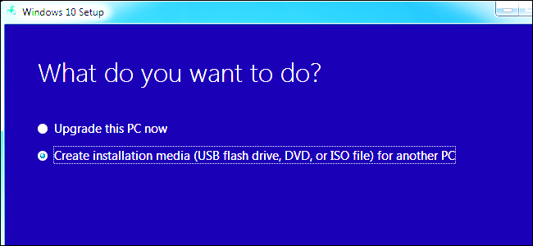
Windows setup
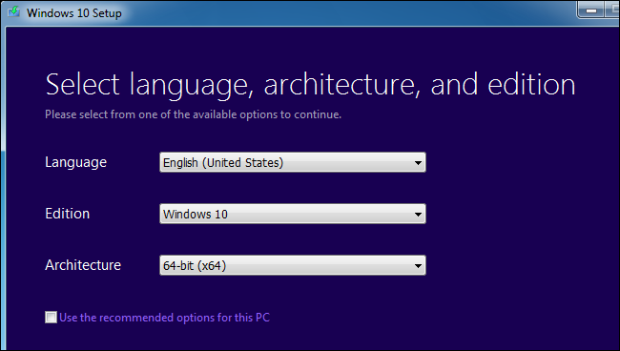

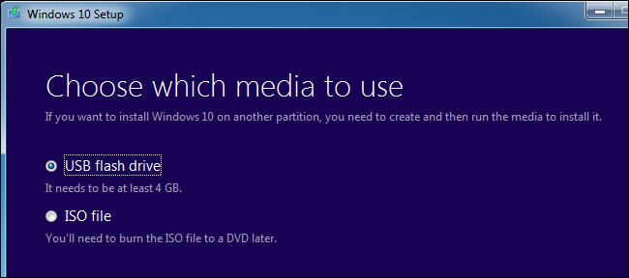


Once you’ve created installation media, you’ll need to insert it into the PC you want to install Windows 10 on. You then boot from the installation media. This may require modifying the boot order in your PC’s BIOS or UEFI firmware.

On the Windows Setup screen, select your language, time and currency format, and keyboard layout. Click “Next” to continue.
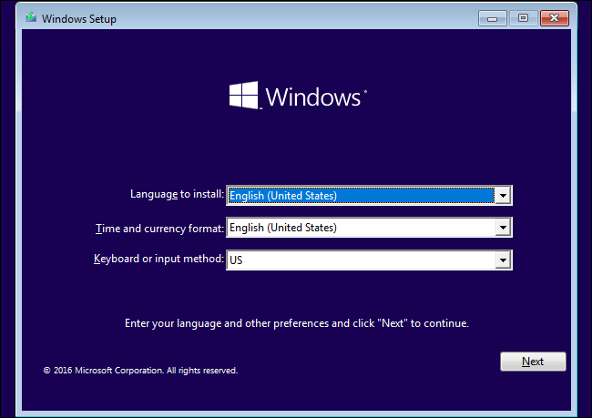

When you reach the installer screen, select “Install Now” and follow the instructions to install Windows 10 on your PC.
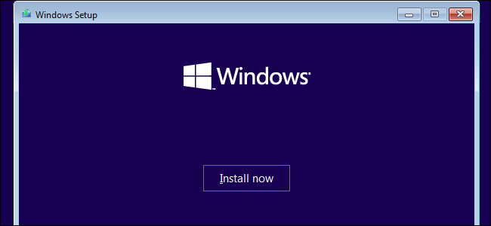
Enter the activation key
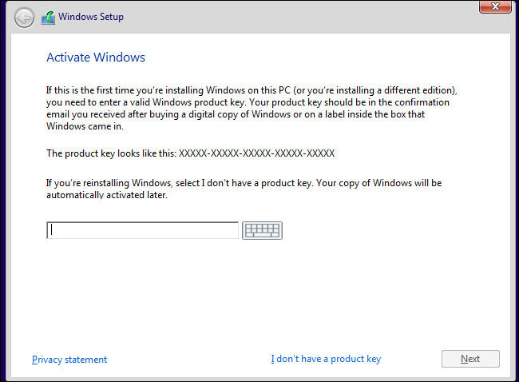
When you reach the “Which type of installation do you want?” screen, click “Custom” to perform a clean installation and remove everything on your PC. (If you’ve changed your mind and want to upgrade your existing installation, you can click “Upgrade”.)
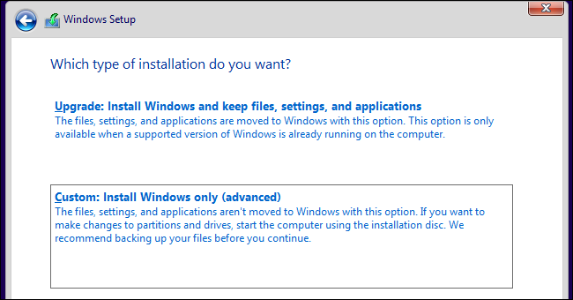
On the next screen, select the hard drive you want to install Windows on and erase it. If you have multiple partitions on that drive, you may want to erase those as well.
Warning: When you delete a partition, you’re also deleting all the files on that partition. Be sure you have backups of any important files before doing this!
When you’re done erasing partitions, you should have a big block of “Unallocated Space”. Select that, click “New”, and once it’s formatted your drive, click Next.
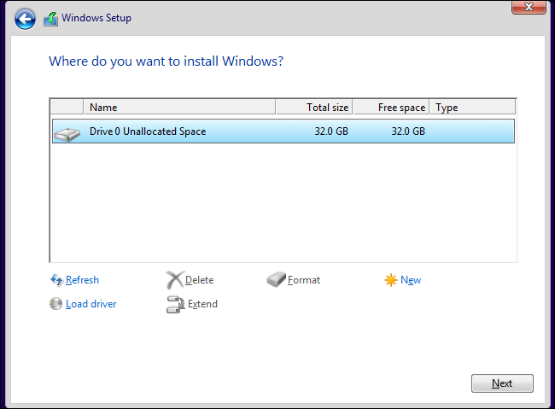
Windows 10 will install itself, and may restart a few times during this process. When it’s done, you’ll see the normal setup interface you see when setting up Windows 10 on any new PC, where you can add user accounts and adjust various settings.
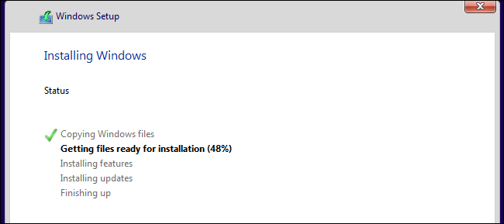

https://www.howtogeek.com/197559/how-to-install-windows-10-on-your-pc/

How to dual boot Windows

Dual booting is where you have two copies of Windows (or even another operating system such as Linux) on the same PC. Here's how to do it.

Create a new partition with Disk management utilies
- If you need to install a Other version of Windows( or linux) on the same hard drive as the first, there needs to be enough free space.

2.Go to the Windows Disk Management utility. To do so hold down the Windows key and press R. This opens a box, into which you type diskmgmt.msc and press enter.
3You’ll now see a list of the partitions on your hard drive. Select the primary partition, usually called (C:), and then right click and select Shrink Volume.

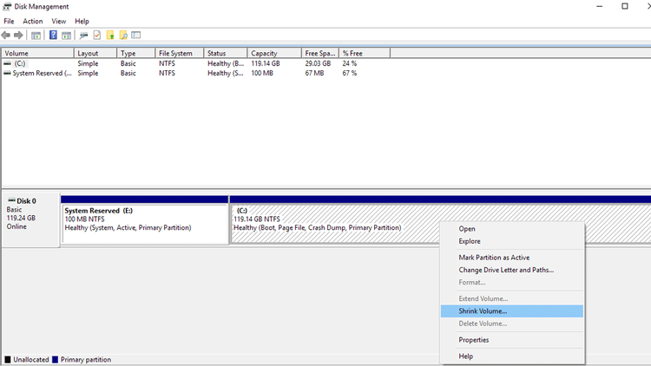
Now you’ll see another window that shows you the size of the partition, and asks you to Enter the amount of space to shrink in MB. To create a 25GB partition you’ll need to enter 25000 then click Shrink. This will modify the partition, allowing you the space you need to install Other O.S
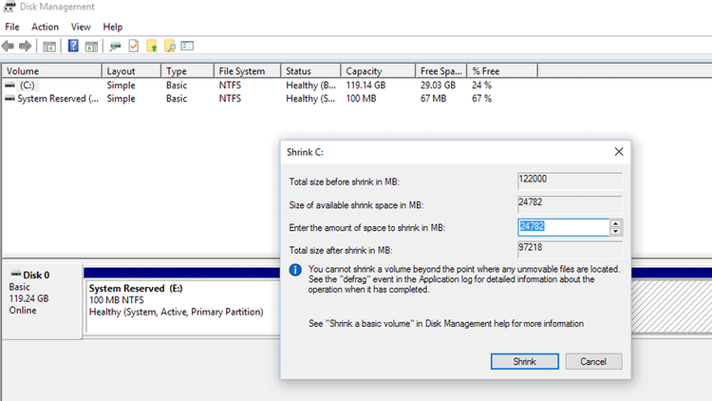
Here are the basic steps before we get to the details:
- Install a new hard drive, or create a new partition on the existing one using the Windows Disk Management Utility
- Plug in the USB stick containing the new version of Windows, then reboot the PC.
3. Place the previously created CD or USB version of Other O.S into your PC and reboot the machine. You should be taken straight to the installation process, but if your machine goes back to your original version of Windows straight away you’ll need to adjust the boot sequence in your BIOS..
4When the install sequence starts
Now the installation process will continue and finish. The next time you power on or reboot your machine you will have the option to choose between the two operating systems.

Windows Recovery Partition
A recovery partition is a portion of your disk drive that is set aside by the manufacturer to hold an image of your system before it was shipped from the factory. Recovery partition contains the files of system backup image and files that guide system restoration.
Although a recovery partition takes up a couple of GBs of disk space, you can save a lot of time finding a way to quickly restore your PC to factory conditions when your PC runs abnormally.
This recovery partition is to hold the Windows Recovery Environment (WinRE), which can be explored if you manually assign a drive letter to it.
The recovery partition on Windows 10 consumes about 450MB, Windows 8/8.1 200MB, and Windows 7 100MB.
This recovery partition is to hold the Windows Recovery Environment (WinRE), which can be explored if you manually assign a drive letter to it. If you delete this partition, you won’t be able to use Windows Recovery options. If you create Windows 10 recovery disk, Windows will give you an option to remove the recovery partition.
Every time when you upgrade Windows to the next version, the upgrade program will create a recovery partition
