Electronic waste, or e-waste, refers to all items of electrical and electronic equipment (EEE) and its parts that have been discarded by its owner as waste without the intent of re-use
E-waste is also referred to as WEEE (Waste Electrical and Electronic Equipment), electronic waste or e-scrap in different regions and under different circumstances in the world.
. It includes a wide range of products – almost any household or business item with circuitry or electrical components with power or battery supply

Different scenarios of e waste management
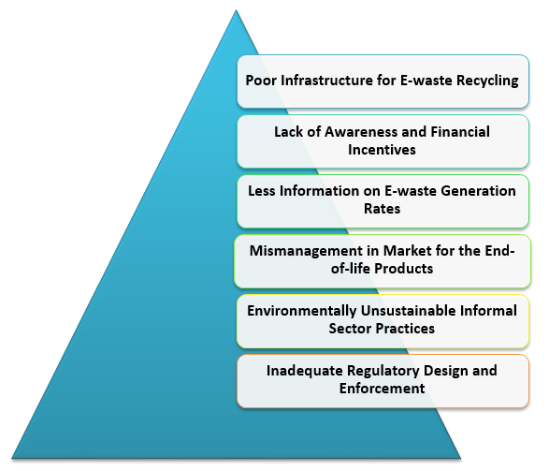
Generally speaking, the e-waste recycling process consists of five basic stages: collection, toxics removal, preprocessing, end processing and disposal

1. Poor Infrastructure for the Recycling of E-waste
There are very few governments approved e-waste recycling centers in the country, which only constitutes about 1/5th of the total amount of e-waste generated each year. India has very limited infrastructure capacity for large-scale management of e-waste
However, the formal sector recycling is limited to manual sorting and mechanical dismantling of e-waste management in India. At present, there is a lack of industrial e-waste managers with an appropriate environmental controls, which are required for large-scale recovery of precious and base metals. A few emerging Indian companies extract metals from e-waste, but they have limited processing capacity. Most of the e-waste processed by a formal sector is exported from other countries with the necessary large-scale infrastructure for metals extraction.

2. Lack of Awareness and Financial Incentives
There is the lack of public awareness of e-waste hazards in India, and recycling is, therefore, very low. Most consumers do not know or have less knowledge about the hazardous nature of e-waste components or the penalties for improper disposal. They do not know about e-waste management in India is done by urban municipal or state government agencies.

3. Less Information on E-waste Generation Rates
It is acknowledged that there is a lack of e-waste inventories and all the responsibility placed on the state-wise e-waste inventories on the respective State Pollution Control Boards (SPCBs)

4. Mismanagement in Market for the End-of-life Products
First, the e-waste recycling is a relatively new business; the potential lack of information on cost-effective recycling technologies could be a market barrier. Second, there is low awareness, partly because of the lack of reliable information on e-waste management among consumers, affects markets’ functioning. However, the public policy will play a greater role in enabling better markets for e-waste.

5. Environmentally Unsustainable Informal Sector Practices
Despite the formal dismantling and recycling sector’s growth, the actual waste processed in the formal sector still very low. Most of these formal facilities are operating below the approved capacities because of inability to source enough waste. The lack of awareness regarding e-waste and the costs of returning the end-of-life equipment to formal collection centres are reducing the willingness of household and institutional consumers to return their waste to the formal sector

6. Inadequate Regulatory Design and Enforcement
The regulations must also specify, elaborate standards and processes for other entities for dismantlers, collectors, recyclers, and bulk consumers and required the agencies to enforce compliance with specific standards. The regulatory authorities must capture benefit from poor enforcement, lack of transparency, unwillingness to publicly share information on compliance and regulatory actions

Solving the E-waste Problem (StEP) is a membership organization that is part of United Nations University and was created to develop solutions to address issues associated with electronic waste.
StEP focuses its projects and activities on five life cycle areas – design, production, usage, reuse and recycling, final disposal - which are carried out by its diverse members network. Project results support three broad domains:
- reduce adverse environmental and human impacts resulting from improper e-waste management
- implement the waste hierarchy by reducing the generation of e-waste, promoting repair and reuse and supporting material recovery
- re-consider the design of products to support repair, re-use and recycling ideally out-designing hazardous elements.

E-waste Contains Toxic Substances
The materials used to build these devices, testing has shown, can poison the soil around the landfill if there’s a lot of lead and mercury in them.
Their components are literally toxic to the environment. Once tossed in a landfill, they’re simply being left to leach into the earth, especially during the summer months. When e-waste is exposed to the heat, toxic chemicals are released into the air damaging the atmosphere; this is one of the biggest environmental impacts of e-waste. Those toxic materials can then seep into the groundwater, affecting both land and sea animals.
Electronic waste can also contribute to air pollution. These are devices that don’t belong in the regular trash since they contain lead, mercury, cadmium, and other potentially harmful chemicals.

Additionally, many pollutants get released from e-waste, and can accumulate in the human body as people inhale contaminated air.

First WHO report on e-waste and child health calls for more effective and binding action to protect children from growing health threat

Effective and binding action is urgently required to protect the millions of children, adolescents and expectant mothers worldwide whose health is jeopardized by the informal processing of discarded electrical or electronic devices according to a new ground-breaking report from the World Health Organization: Children and Digital Dumpsites.
Meanwhile more than 18 million children and adolescents, some as young as 5 years of age, are actively engaged in the informal industrial sector, of which waste processing is a sub-sector. Children are often engaged by parents or caregivers in e-waste recycling because their small hands are more dexterous than those of adults. Other children live, go to school and play near e-waste recycling centres where high levels of toxic chemicals, mostly lead and mercury, can damage their intellectual abilities
Children exposed to e-waste are particularly vulnerable to the toxic chemicals they contain due to their smaller size, less developed organs and rapid rate of growth and development. They absorb more pollutants relative to their size and are less able to metabolize or eradicate toxic substances from their bodies.

Impact of e-waste on human health
Workers, aiming to recover valuable materials such as copper and gold, are at risk of exposure to over 1,000 harmful substances, including lead, mercury, nickel, brominated flame retardants and polycyclic aromatic hydrocarbons (PAHs).
For an expectant mother, exposure to toxic e-waste can affect the health and development of her unborn child for the rest of its life. Potential adverse health effects include negative birth outcomes, such as stillbirth and premature births, as well as low birth weight and length.
Other adverse child health impacts linked to e-waste include changes in lung function, respiratory and respiratory effects, DNA damage, impaired thyroid function and increased risk of some chronic diseases later in life, such as cancer and cardiovascular disease.
e-waste Management
Recycling e-waste not only helps to conserve energy, but it also recycles natural resources like copper, silver, and aluminum. Many of the metals used in our gadgets are rare earth metals that are in limited supply. When they are recycled they can be reused instead of having to mine for new supplies.
That also helps prevent air and water pollution. It’s a win for everyone.
Great Lakes Electronics performing environmentally friendly recycling of electronic products. This includes computers, Circuit Boards, telephone equipment and communications systems.
The Great Lakes Electronics team will disassemble these items into component parts, and the ones that still have value can be sold for reuse. Everything is recycled and other parts are used for metals recovery.

EPR and e waste management in India

Extended Producer Responsibility (EPR) is the responsibility of every producer of electrical and electronic equipment (EEE) for channelisation of e-waste to an authorised dismantler / recycler to ensure environmentally sound management of such waste.

OUR EPR SERVICES
Saahas Zero Waste (SZW) has over 10 years of experience in helping national and multinational brands manage their Extended Producer Responsibility in India. We have developed an extensive collection network that includes consumers and the informal sector. SZW has also formally collaborated with authorised recyclers and end destinations. MIS system enables us to capture data and prepare detailed reports for our customers.
SZW has a well-defined reverse supply chain that allows effective transportation of post-consumer waste to the authorised end destination
SZW has innovative social inclusion models where informal waste workers will be able to meet the costs of compliance through incentives against delivering results.
SZW conducts extensive awareness programmes which include social media campaigns, corporate events and collection drives
SZW SERVICES
Seelampur in Delhi is the largest e-waste dismantling centre of India. Other sectors are in Andhra Pradesh | Daman | Goa | Karnataka | Kerala | Maharashtra | Tamil Nadu | Haryana | Rajasthan | Telangana | Uttar Pradesh | Uttarakhand
SZW is one of the top waste management companies in Bangalore that offers holistic waste management services to schools and colleges to ensure the effective diversion of waste generated at these institutions from landfills.

