Remove malware from your PC in Windows 10
Antivirus is a kind of software used to prevent, scan, detect and delete viruses from a computer. Once installed, most antivirus software runs automatically in the background to provide real-time protection against virus attacks.
Comprehensive virus protection programs help protect your files and hardware from malware such as worms, Trojan horses and spyware, and may also offer additional protection such as customizable firewalls and website blocking.
Malware, short for “malicious software,” is a blanket term that refers to a wide variety of software programs designed to do damage or do other unwanted actions to a computer, server or computer network Common examples include viruses, spyware and trojan horses. Malware can slow down or crash your device or delete files. Criminals often use malware to send spam, obtain personal and financial information and even steal your identity.
Windows Security is a powerful scanning tool that finds and removes malware from your PC. Here's how to use it in Windows 10 to scan your PC.
Important: Before you use Windows Defender Offline, make sure to save any open files and close apps and programs.
- Open your Windows Security settings.
- Select Virus & threat protection > Scan options.
- Select Windows Defender Offline scan, and then select Scan now.
The Windows Defender Offline scan takes about 15 minutes to run, and then your PC will restart.

View the results of your scan
- Open your Windows Security settings.
- Select Virus & threat protection > Protection history.

There are many free antivirus available on internet . They have limited Features
Eg: Avast free antivirus
AVG antivirus
Norton antivirus
McAfee Antivirus
Kaspersky antivirus
You can buy Antivirus such as Net Protector, Quick heal etc
To scan pc using Net Protector
1. Right click on Net protector icon
2. Select Net Proctector Total security option
3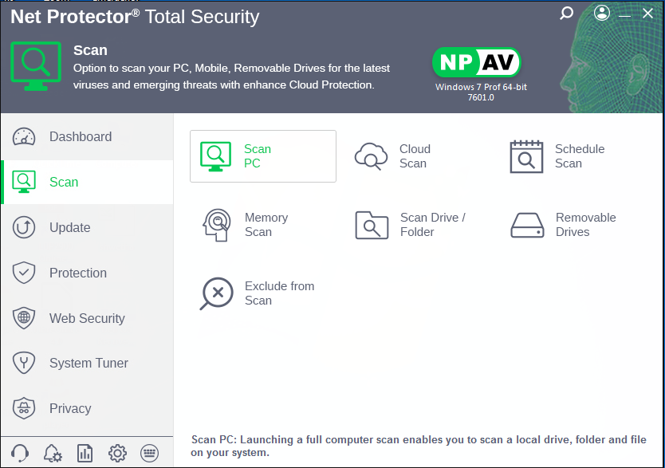

You can scan Pc and Mobile (Connect your Mobile to your PC,) and Select scan

Net Protector Mobile Security for Android
Net Protector Research Lab has launched new Net Protector Mobile Security Software for the Android Mobiles.
Smartphones bring the virtual world closer to you wherever you go Unfortunately, they also bring along various viruses, malware and spyware that can threaten your privacy and cause Ineffaceable damage.
Scan
After clicking on Scan button it will start complete mobile scanning.User can also able abort a scanning by pressing abort button.After completion of scanning process it will display scan summary.
Update
Clicking on Update button on Dashboard it will showing Update Activity,when user will click on Update Antivirus button on same screen it will start updating.After downloding all updates successfully user will get the message Antivirus successfully updated.

